**CODE DROP 2**

select * from at3857.dataset1;

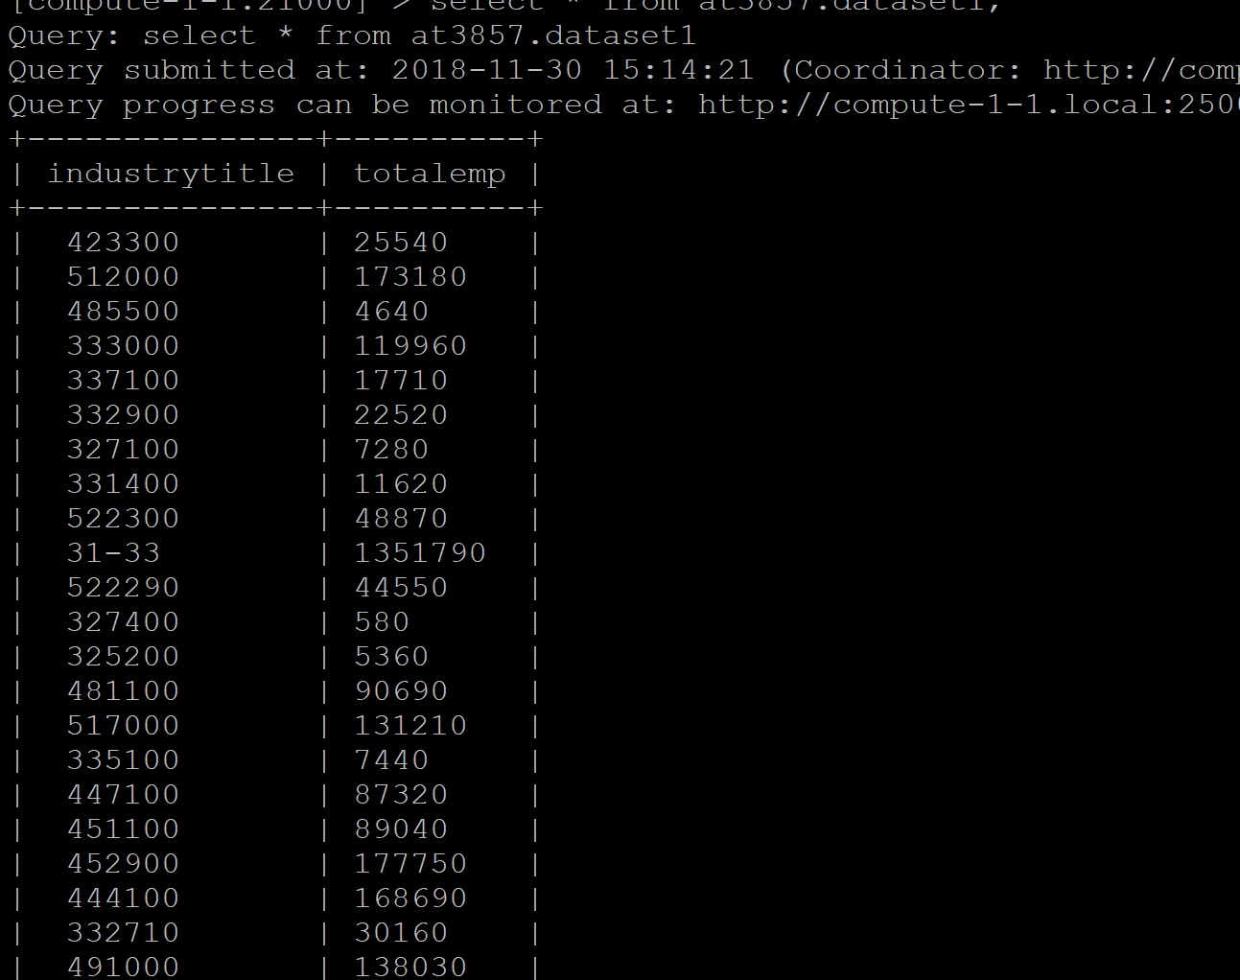

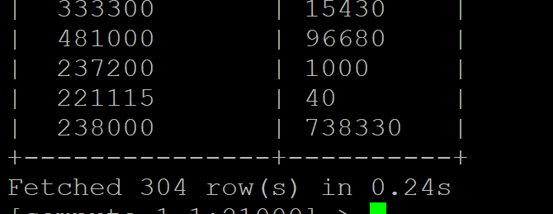

select * from sa4764.dataset2;

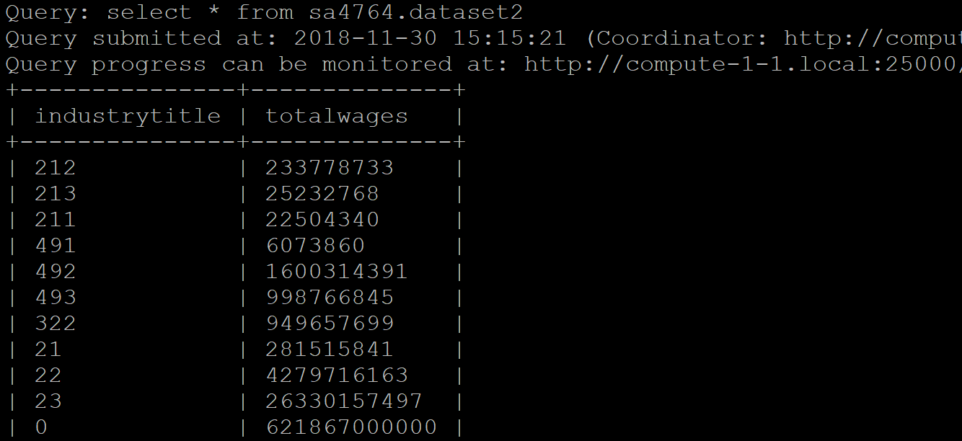



create table akanksha_naics  as (select substr(industrytitle,1,3) as industrycode,totalemp from dataset1 order by industrytitle ASC);

create table sumit_naics  as (select substr(trim(industrytitle),1,2) as industrytitle ,totalwages from sa4764.dataset2  order by industrytitle ASC);

the above tables were created to format naics code as per industry title (for reference <https://www.naics.com/search/> )

create table sumofwages as select trim(industrytitle) as industrytitle ,sum(totalwages) as TotalWages from sumit_naics group by industrytitle;

create table sumofemp as Select trim( industrycode) as industrycode ,sum(totalemp) as TotalEmp from akanksha_naics group by industrycode;

the above tables perform aggregation functions on similar industry codes

Select * from sumofwages

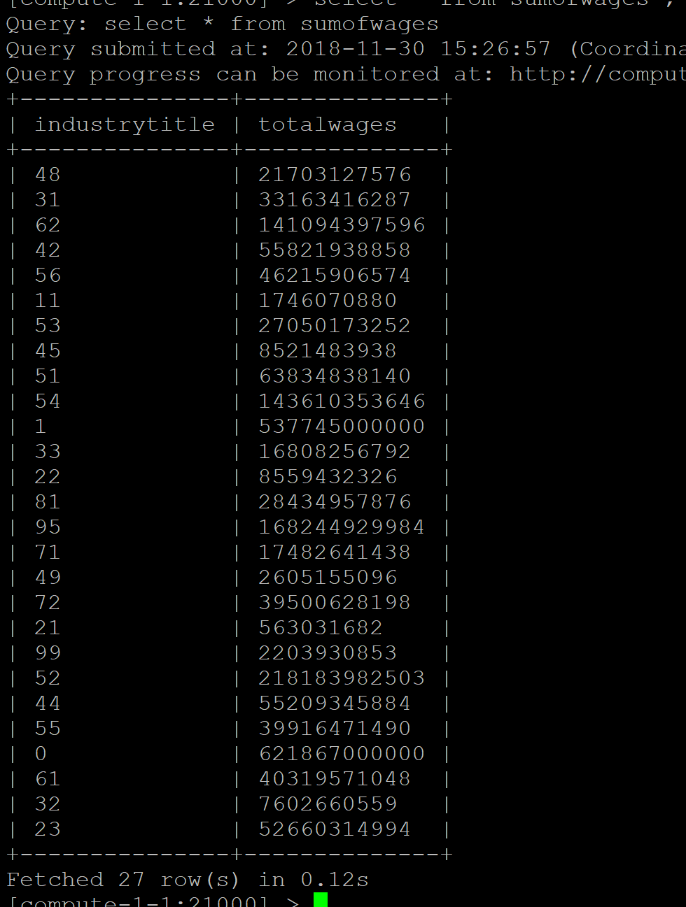

select * from sumofemp;

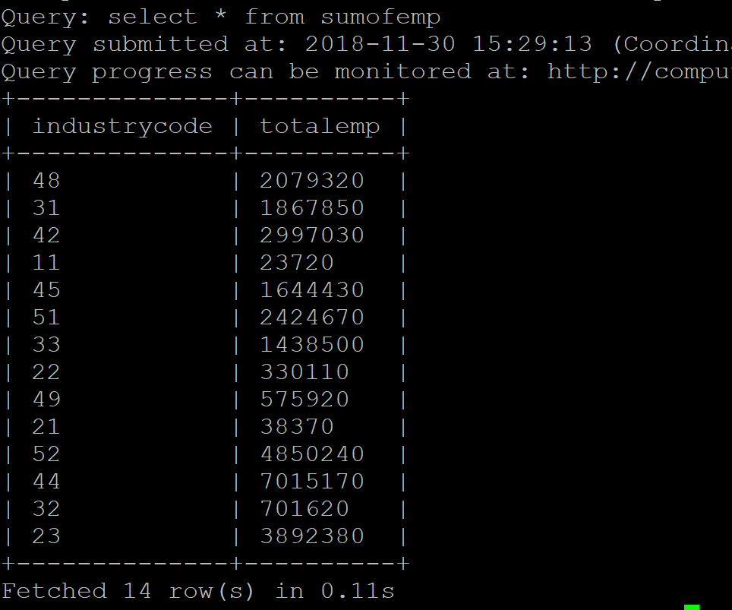

select  sumofemp .industrycode as Naicscode ,  sumofemp.totalemp as totalemp , sumofwages.totalwages as totalwages from sumofemp  join sumofwages

On sumofemp .industrycode =sumofwages .industrytitle;

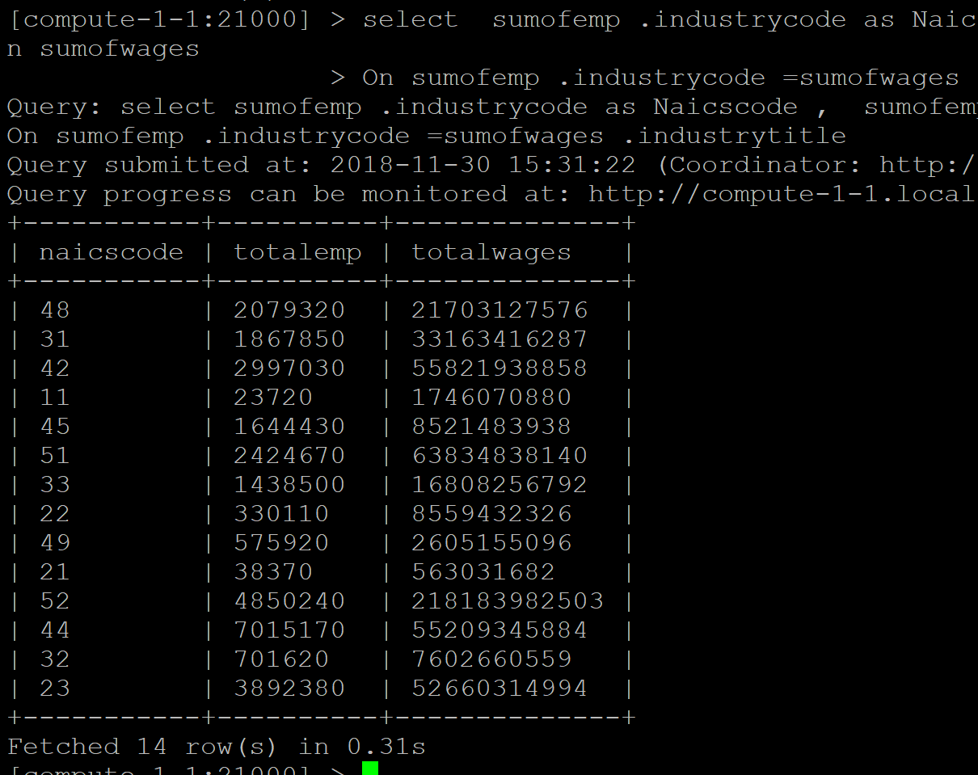

create table naicsemp as select sumofemp .industrycode as Naicscode , sumofemp.totalemp as totalemp , sumofwages .totalwages as totalwages from sumofemp join sumofwages

On sumofemp .industrycode =sumofwages .industrytitle;

Select * from naicsemp;

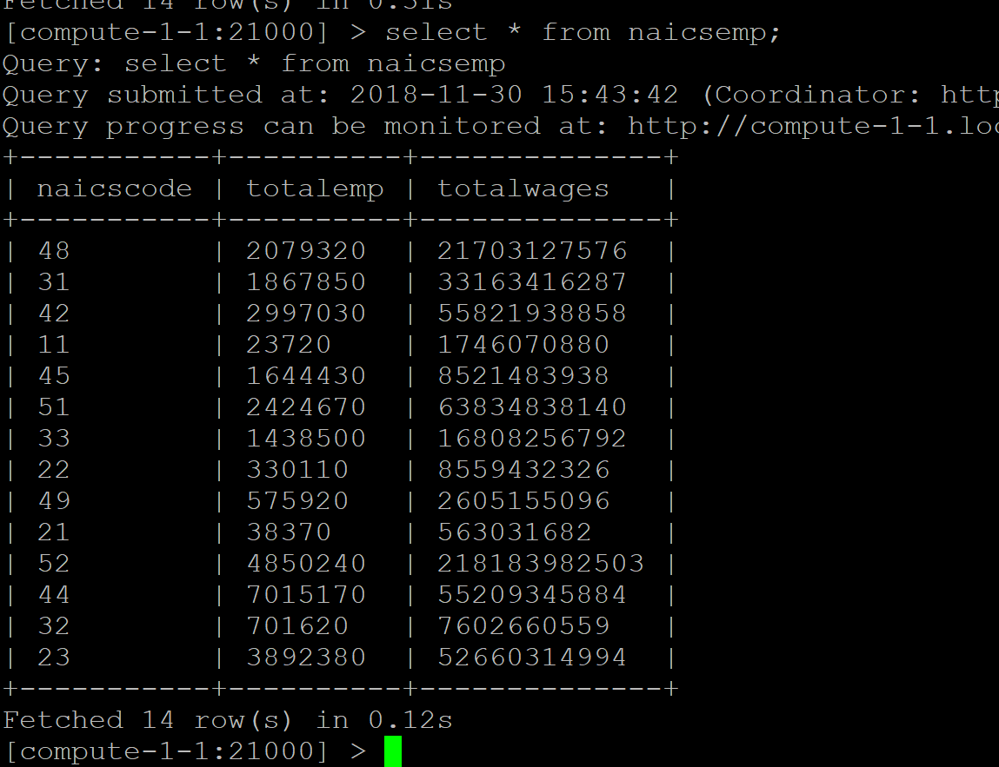

select *, (totalwages/totalemp) as PerPersonWage from naicsemp order by naicscode;

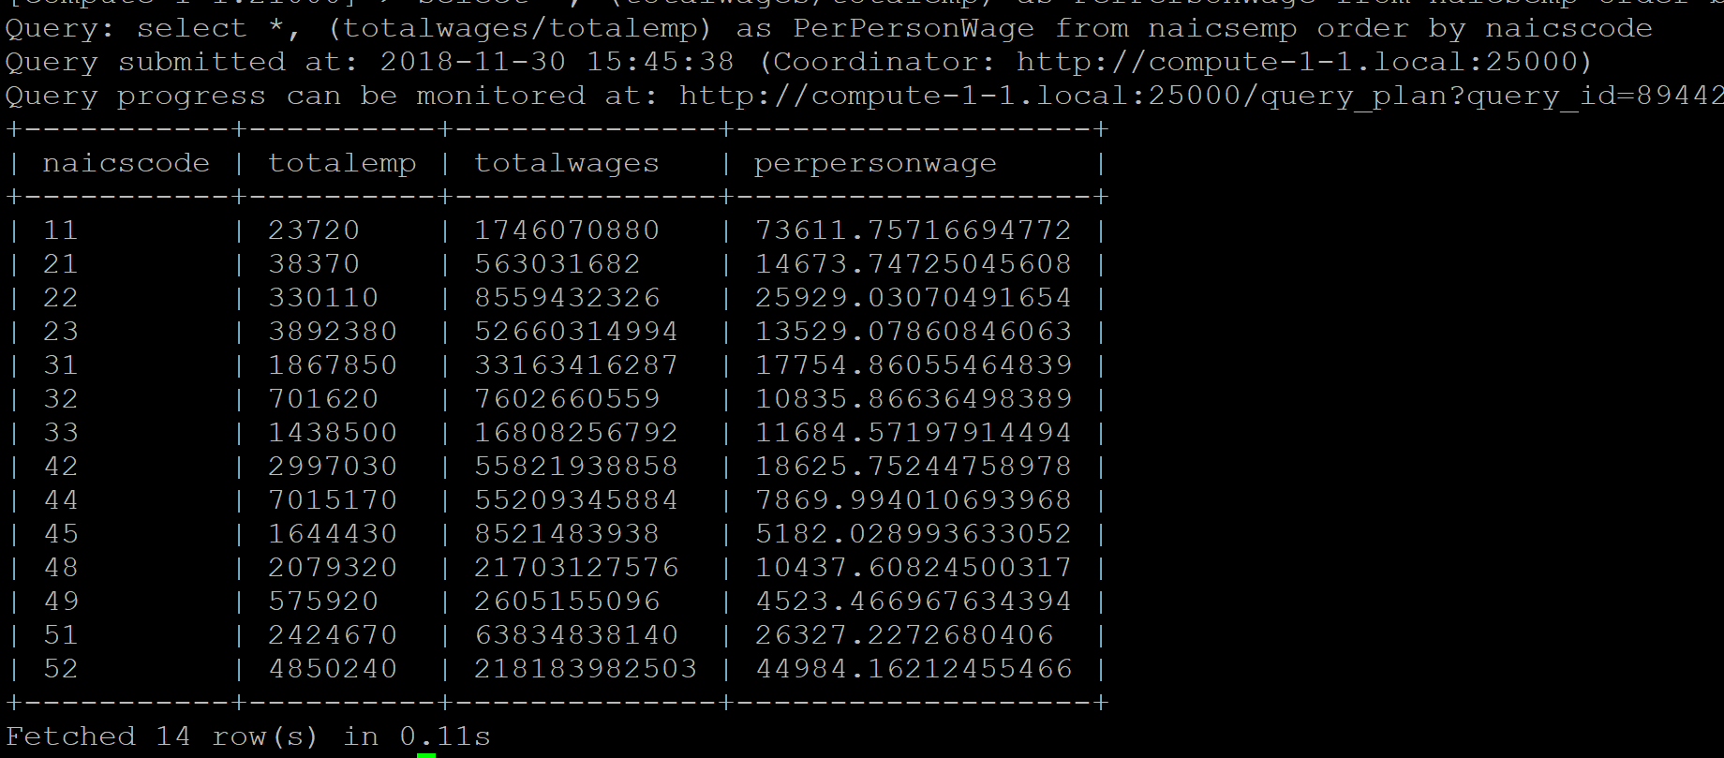

select * from pp1891.dataset3;

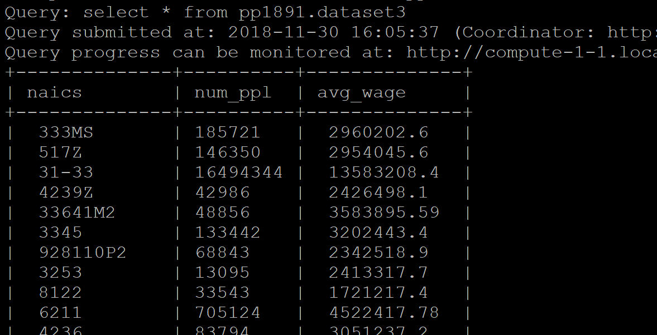

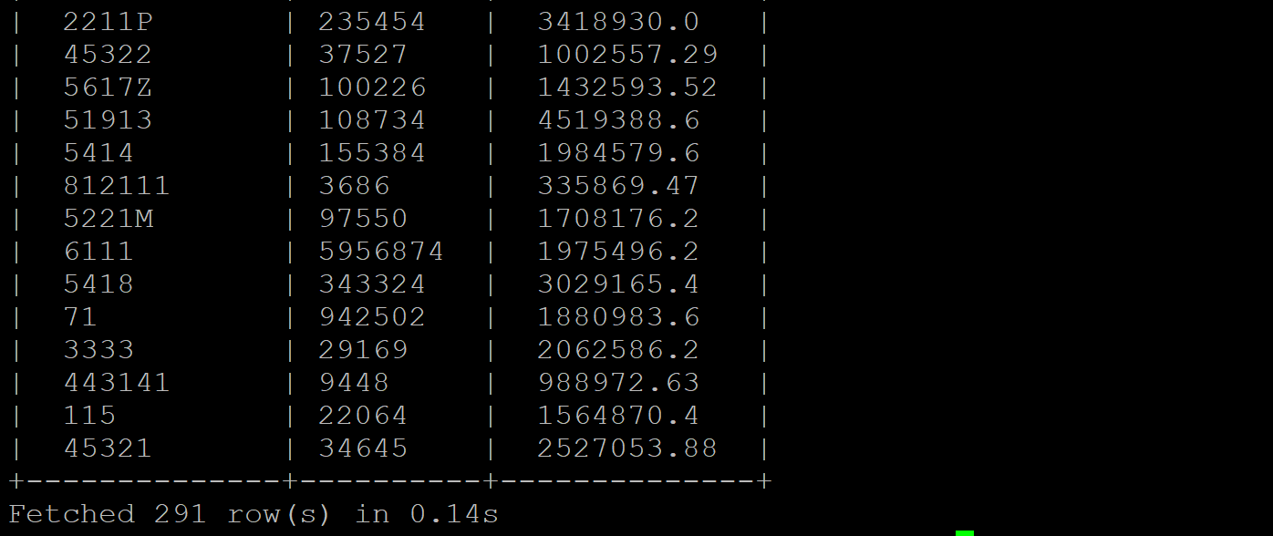

create table pragya_dataset3  as (select substr(trim(naics),1,2) as industrytitle ,num_ppl, avg_wage from pp1891.dataset3  order by naics ASC);

select * from pragya_dataset3;

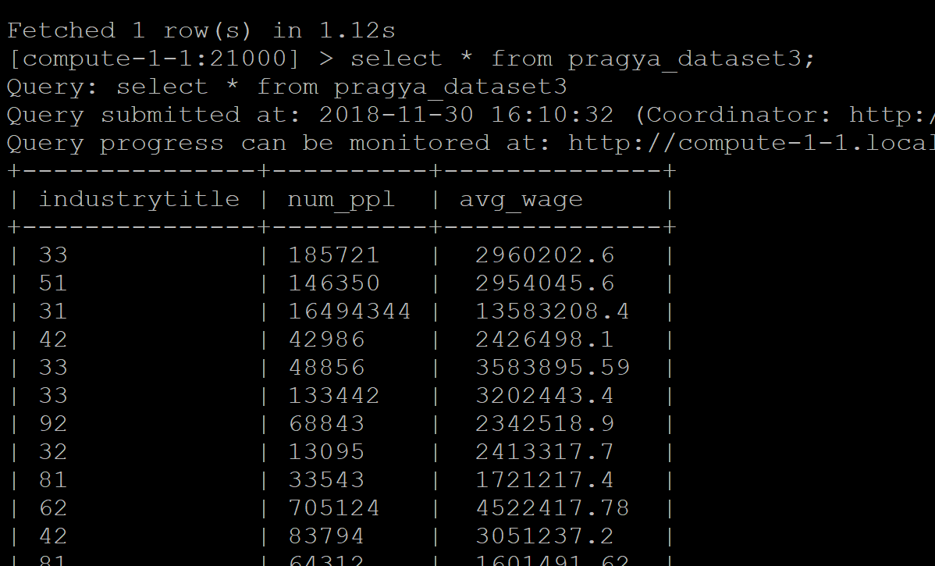

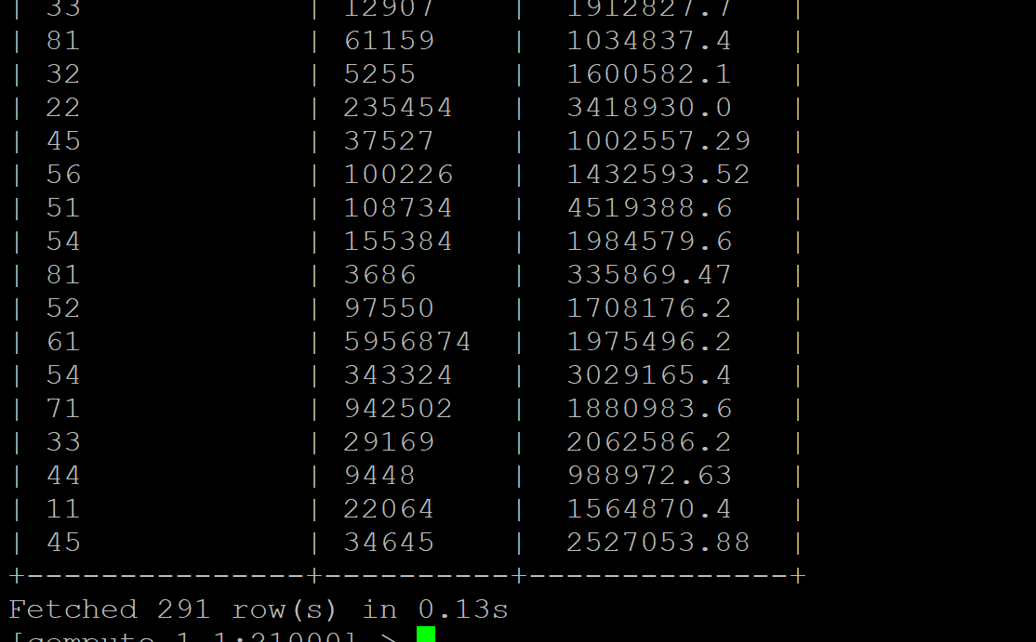

create table studenttable as select trim(industrytitle) as industrytitle ,sum(num_ppl) as totalstudents ,sum (cast(avg_wage as double))as TotalWages from pragya_dataset3 group by industrytitle;

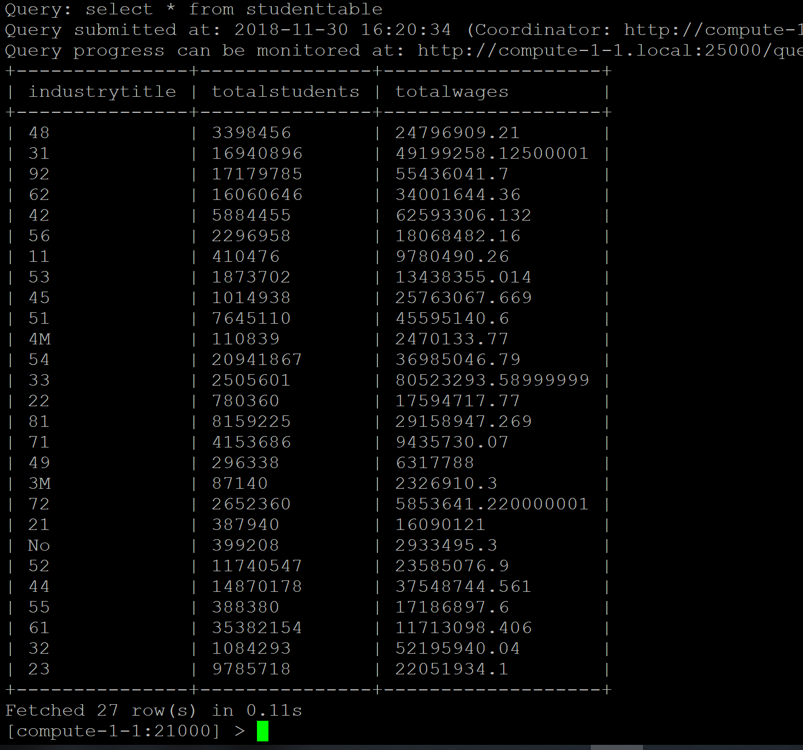

select * from naicsemp join studenttable on naicsemp.naicscode = studenttable.industrytitle;

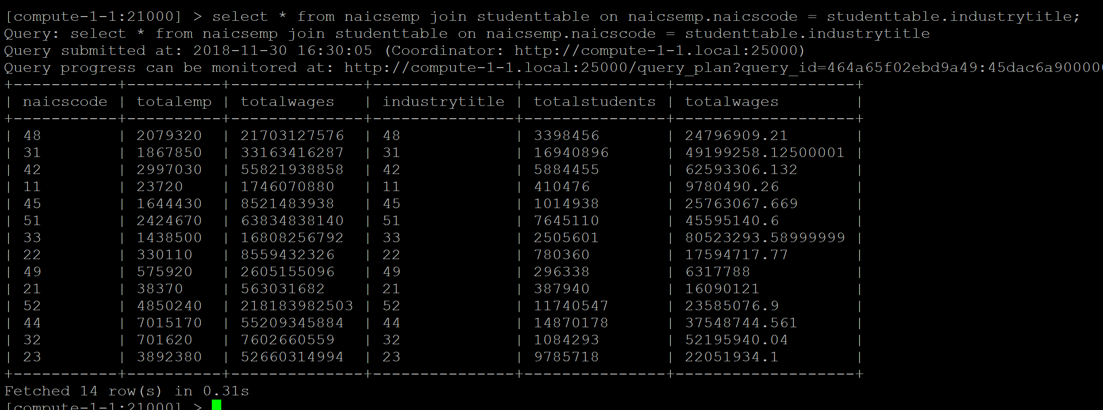

Create table collecteddata as select naicsemp.naicscode as naicscode, naicsemp.totalemp as naicstotalemp, naicsemp.totalwages as naicstotalwages , studenttable.totalstudents as studentstotalemp, studenttable.totalwages as studenttotalwages from naicsemp join studenttable on naicsemp.naicscode = studenttable.industrytitle;

Select * from collecteddata;

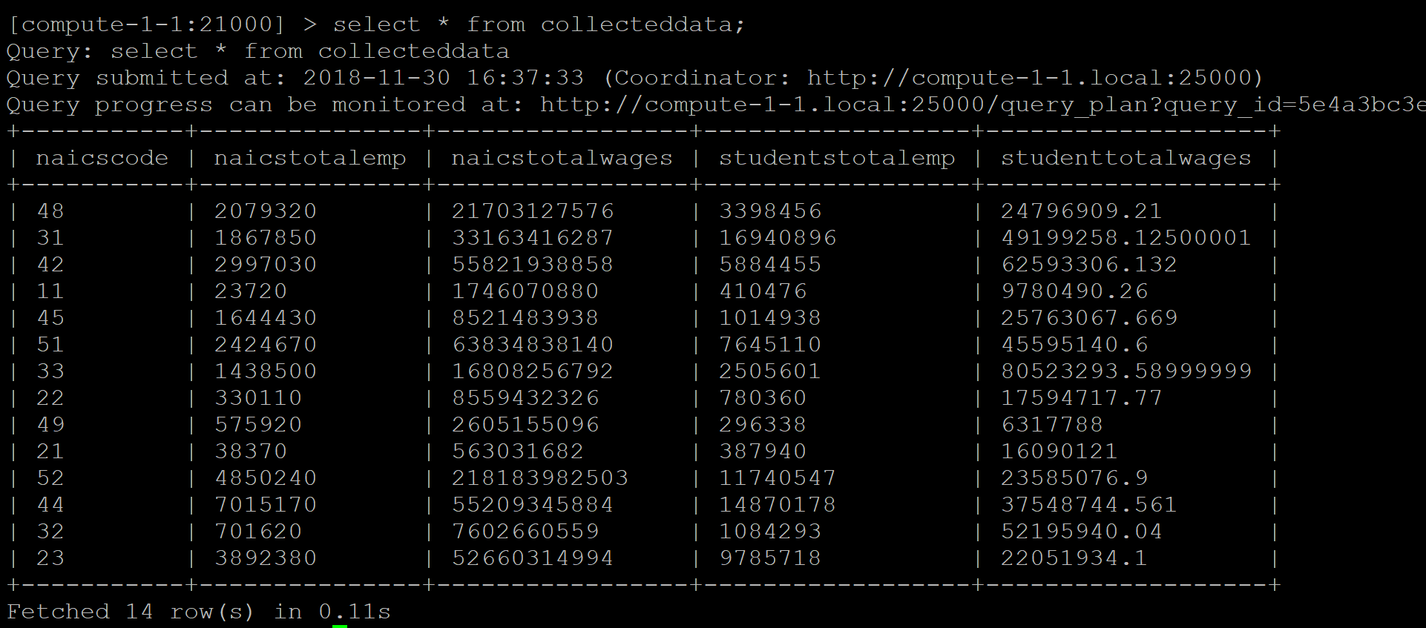

select * , (naicstotalwages/naicstotalemp) as naicsavg , (studenttotalwages/studentstotalemp) as NYUavg from collecteddata;

Create table bundling as select * , (naicstotalwages/naicstotalemp) as naicsavg , (studenttotalwages/studentstotalemp) as NYUavg from collecteddata;

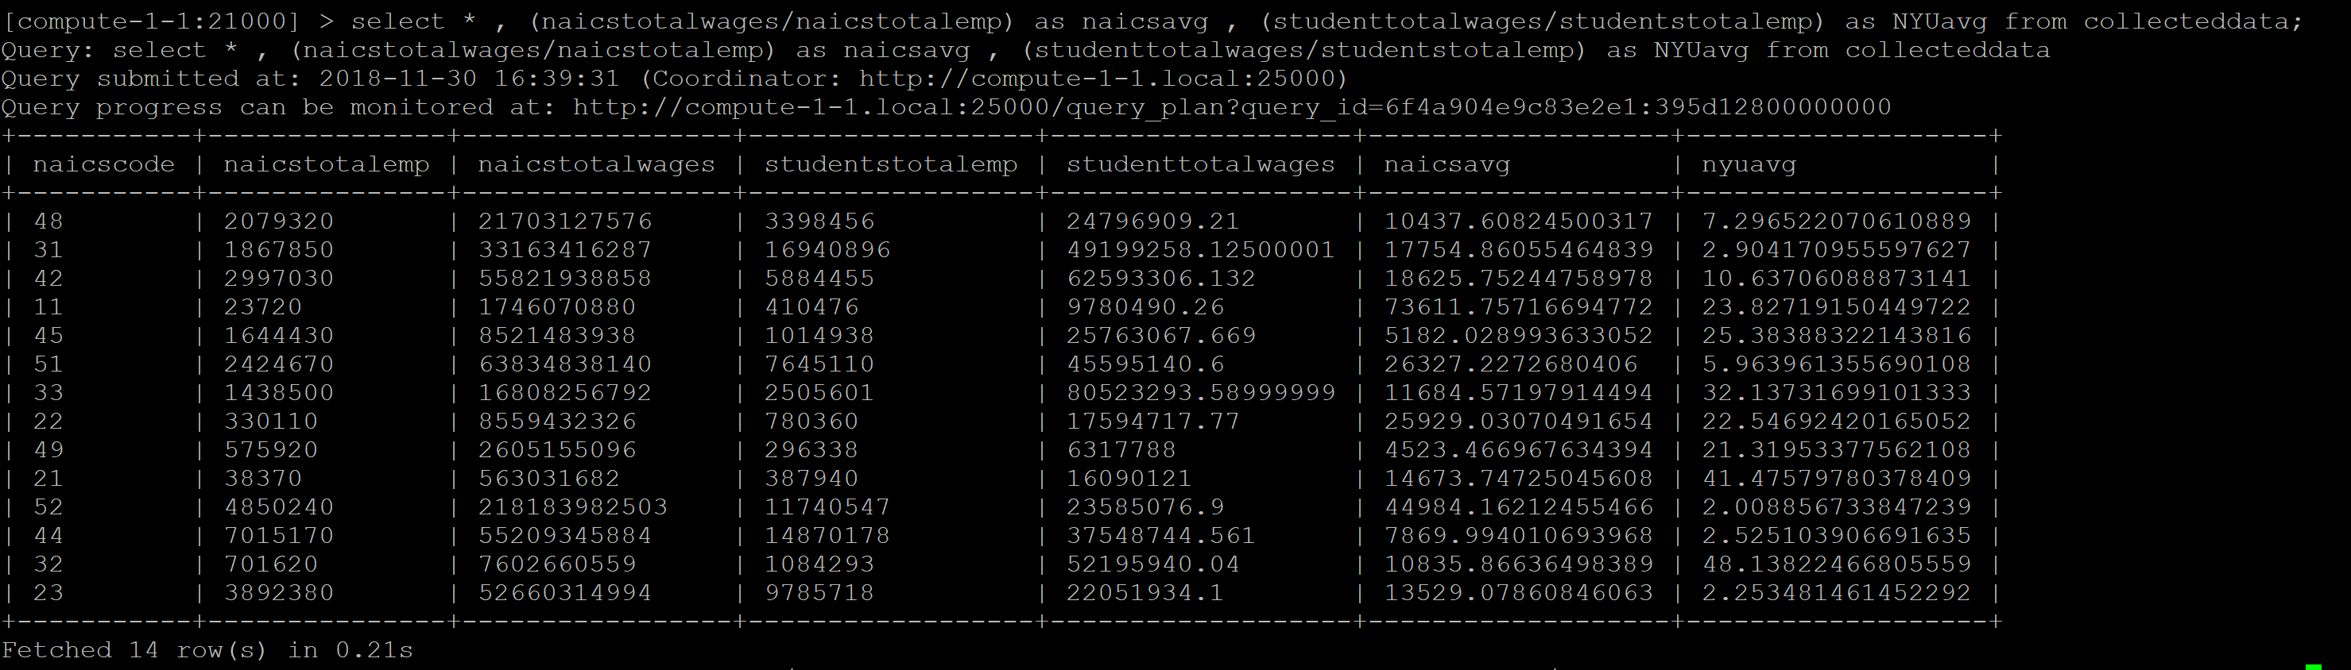

create table bundling2 as select dataset1.industrytitle , dataset1.totalemp , sa4764.dataset2.totalwages ,pp1891.dataset3.num_ppl , pp1891.dataset3.avg_wage from dataset1 join sa4764.dataset2 join pp1891.dataset3 on trim(dataset1.industrytitle) = trim(sa4764.dataset2.industrytitle) and trim(sa4764.dataset2.industrytitle) = trim(pp1891.dataset3.naics); 