**MIT School of Engineering**

**Department of Computer Science and Engineering**

**Project Synopsis**

**Group ID:03**

**Project Title: Machine Learning Algorithm (Unsupervised Learning) for Disease Prediction**

**__________________________________________________________**

**Group Members:**

|  |  |  |  |  |
| --- | --- | --- | --- | --- |
| **Enrollment Number** | **Roll No.** | **Name of student** | **Email Id** | **Contact Number** |
| **MITU21BTCS0009** | **2213066** | **Aarya Kulkarni** | **aaryavakul@gmail.com** | **7840985141** |
| **MITU21BTCS0061** | **2213071** | **Akanksha Prasad** | **akanksha.prasad25@gmail.com** | **9096281778** |
| **MITU21BTCS0284** | **2213090** | **Khushna Kazi** | **khushna.kazi@gmail.com** | **9511674504** |
| **MITU21BTCS0103** | **2213205** | **Anushaka Patil** | **patilanushaka7887@gmail.com** | **7887450938** |

**Problem Statement:** Early detection of Parkinson’s disease using machine learning

**Abstract:**

The synopsis basically describes about the Parkinson's Disease Prediction. Identifying illness that have same presentations is a crucial component of the diagnostic process. It is a progressive neurodegenerative disease characterized by some vocal features. The disease has a specific effect on patients, families, and caregivers through its progressive degenerative effects on mobility and muscle control. The term Parkinson is used to show the motor features of PD, which include resting tremor, bradykinesia, and muscular rigidity. It can be treated through early detection. The likelihood of developing PD increases with age. The detection of PD happens mostly at 60s, but can be detected in young people.

**Literature Survey: Detail survey done**

In 1] authors Nidhi Kosarkar, Pallavi Basuri, Poonam Karamore, Prachi Gawali, Pradnya Badole and Pranjali Jumle have described about the dependency of computers on electronic data in the domain of HealthCare. ML Algorithms have been scientifically proven to be beneficial for giving characteristics and pattern between the clinical features. The Algorithms work primarily on the basis of the data provided by the user.

In 2] the authors Dr. DeMaagd and Dr Philip have describe about Parkinson’s Disease and It’s Management. The paper describes possible causes, symptoms, diagnosis, and goals for treatment of Parkinson’s disease. To Identify problems that have similar presentations is a crucial component of the diagnostic process.

In 3] the authors Aditi Govindua and Sushila Palweb have made researchs on the MDVP aud

PWP and healthy people during training of 4 ML models. Comparison of results of classification by Support Vector (SVM), Random Forest, K-Nearest Neighbors (KNN) and Logistic Regression models, yield Random Forest classification ideal Machine Learning (ML) technique for detection of PD. Random Forest classifier model has a detection accuracy

and sensitivity of 0.95.

**Proposed System (Block Diagram):**

**1)Empathy Chart**

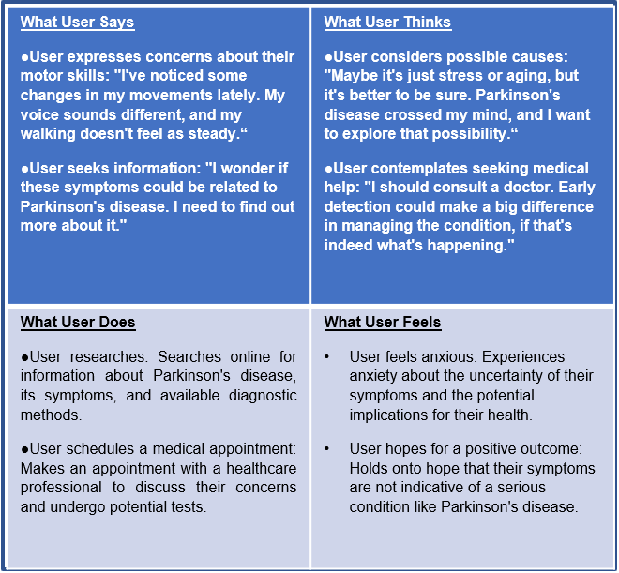

**2)Ideation**

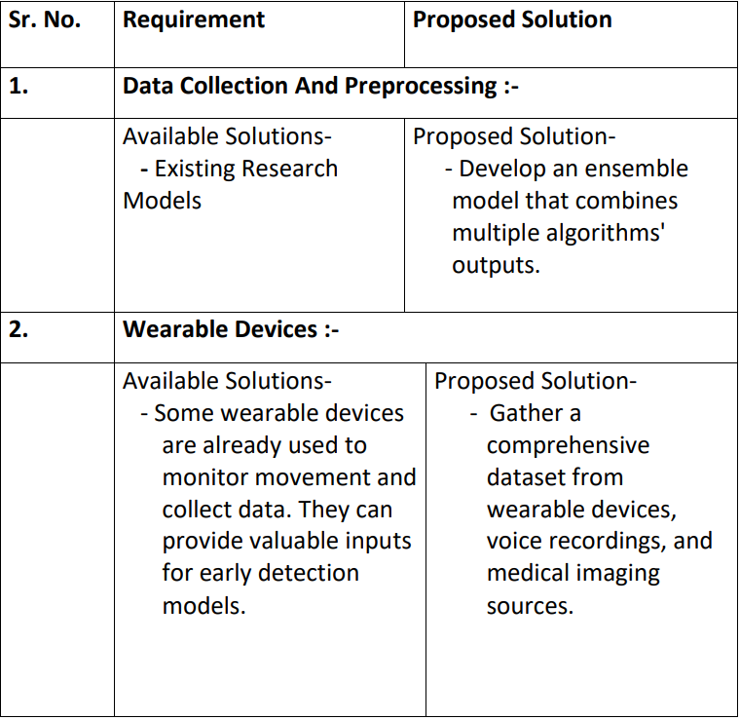

**3)Proposed Architechture**

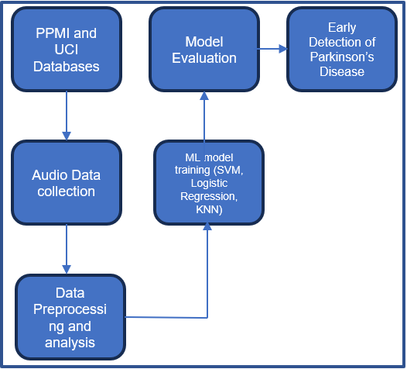

**Conclusion:**

Our System will help users to manage and provide assistance in their day-to-day tasks as well as do basic functions autonomously like information gathering, making calls, surfing the web, setting alarm and reminder as well as answer queries of the users. Apart from this, our system will provide the user with a smooth transition into the urban lifestyle by guiding them through initial phases of changes and helping them throughout their lifetime.

**References:**

1] https://ieeexplore.ieee.org/document/9791739

2]<https://www.ncbi.nlm.nih.gov/pmc/articles/PMC4517533/>

3] <https://www.sciencedirect.com/topics/nursing-and-health-professions/parkinson-disease#:~:text=Parkinson%20disease%20(PD)%20is%20a%20complex%2C%20multisystem%20disorder%20with,and%20which%20progress%20over%20time>.

4] <https://jnnp.bmj.com/content/91/8/795>

5]<https://www.sciencedirect.com/science/article/pii/S1877050923000078>