Project Synopsis

on

**Crop Detection using AI & ML**

Submitted as a part of course curriculum for

**Bachelor of Technology**

in

**Computer Science**



**Submitted by**

Sparsh Dagar (200029010163)

Sumit Agrawal (2000290120167)

Suryansh Shukla (2000290120171)

**Under the Supervision of**

Dr. Harsh Vardhan

Designation: Assistant Professor

**KIET Group of Institutions, Ghaziabad**

**Department of Computer Science**

**Dr. A.P.J. Abdul Kalam Technical University**

**2022-2023**

**DECLARATION**

I hereby declare that the project work entitled "CROP DETECTION USING AI AND ML" is a record of an original work done by us under the guidance of Dr. Harsh Vardhan, Asst. Professor Of Computer Science, KIET Group of Institutions. The results embodied in this thesis have not been submitted to any other University or Institute for the award of any degree or diploma.

Signature of Students

Name: SUMIT AGRAWAL

Roll No.: 2000290120167

Date: 14/11/2022

Signature of Students

Name: SPARSH DAGAR

Roll No.: 2000290120163

Date: 14/11/2022

Signature of Students

Name: SURYANSH SHUKLA

Roll No.: 2000290120171

Date: 14/11/2022

**CERTIFICATE**

This is to certify that Project Report entitled “**CROP DETECTION USING AI AND ML**” which is submitted by **SUMIT AGRAWAL, SPARSH DAGAR and SURYANSH SHUKLA** in partial fulfilment of the requirement for the award of degree B. Tech. in Department of Computer Science of Dr A.P.J. Abdul Kalam Technical University, Lucknow is a record of the candidates own work carried out by them under my supervision. The matter embodied in this report is original and has not been submitted for the award of any other degree.

**Date: Supervisor Signature**

Supervisor Name

(Designation)

**ACKNOWLEDGEMENT**

It gives us a great sense of pleasure to present the synopsis of the B.Tech Mini Project undertaken during B.Tech. Third Year. We owe a special debt of gratitude to Dr Harsh Vardhan WITH DESIGNATION, Department of Computer Science, KIET Group of Institutions, Delhi- NCR, Ghaziabad, for his/her constant support and guidance throughout the course of our work. His sincerity, thoroughness and perseverance have been a constant source of inspiration for us. It is only his/her cognizant efforts that our endeavours have seen the light of the day.

We also take the opportunity to acknowledge the contribution of Dr. Ajay Kumar Shrivastava, Head of the Department of Computer Science, KIET Group of Institutions, Delhi- NCR, Ghaziabad, for his full support and assistance during the development of the project. We also do not like to miss the opportunity to acknowledge the contribution of all the faculty members of the department for their kind assistance and cooperation during the development of our project.

Last but not the least, we acknowledge our friends for their contribution to the completion of the project.

Signature:

Date : 14/11/2022

Name : Sumit Agrawal

Roll No: 2000290120167

Signature:

Date : 14/11/2022

Name : Sparsh Dagar

Roll No: 2000290120163

Signature:

Date : 14/11/2022

Name : Suryansh Shukla

Roll No: 2000290120171

**ABSTRACT**

In India, population is growing at a steady rate. Hence it is essential to increase the agricultural product through advanced technologies. We all know that in India, technology is not used a bit in agriculture. Hence bringing technological advancement in agriculture becomes necessary. Crop detection/Leaf detection through AI and ML are needed. The production of crops gets affected by the presence of pests which results in large scale plant and crop disease. Hence, some methods/techniques are needed to be developed to make some precautionary steps to detect pesticides, crop/plant diseases and quality of crops through advanced technologies like Artificial Intelligence and Machine Learning.

A number of remote agricultural areas are facing food productivity issues that can be resolved by state of the art technologies. Precision agriculture is a newly developed way of agriculture through the use of Artificial Intelligence, remote sensing and Internet of Things (IOT). In this work, we use RNN for the prediction of future plant growth. LSTMs assign data which helps RNNs to either let new information in, forget information or give it importance enough to impact the output. This feature is important to predict the future growth dynamics of crops by previous growth patterns. Simple cameras are used to numerically estimate effect of different factors on plant growth by measuring leaf areas and thereby providing suitable solutions to the identified problem. Then there comes a new term “Agriculture intelligence”.

“Agriculture Intelligence is neither a product nor a system. It is an architecture, which is a collection of integrated operational as well as decision-support components, technologies and databases that provides the agriculture community easy access to agricultural knowledge.”

**ABBREVIATIONS**

* AI Artificial Intelligence
* ANN Artificial Neural Network
* CNN Convolution Neural Network
* KNN K-Nearest Neighbour
* ML Machine Learning
* ORM Object Relational Model
* SVM Support Vector Machine
* UI User Interface
* GPU Graphical Processing Unit
* RNN Recurrent Neural Network
* LSTM Long Short Term Memory Network

**Introduction**

* 1. **Intro**

India loses 35% of the annual crop yield due to plant diseases. Early detection of plant diseases remains difficult due to the lack of lab infrastructure and expertise. We explore the possibility of computer vision approaches for scalable and early plant disease detection. The lack of availability of sufficiently large-scale non-lab data set remains a major challenge for enabling vision based plant disease detection. Against this background, we need a dataset for visual plant disease detection. One of the important sectors of Indian Economy is Agriculture. Employment to almost 50% of the countries workforce is provided by Indian agriculture sector. India is known to be the world's largest producer of pulses, rice, wheat, spices and spice products. Farmer's economic growth depends on the quality of the products that they produce, which relies on the plant's growth and the yield they get. Therefore, in field of agriculture, detection of disease in plants plays an instrumental role. Plants are highly prone to diseases that affect the growth of the plant which in turn affects the ecology of the farmer. In order to detect a plant disease at very initial stage, use of automatic disease detection technique is advantageous. The symptoms of plant diseases are conspicuous in different parts of a plant such as leaves, etc. Manual detection of plant disease using leaf images is a tedious job.

**1.2 Problem Statement**

The production of crops often gets affected by the presence of pests which results in large scale plant and crop diseases. These pests diseases cannot be significantly controlled y using pesticides or burning the infected crops, as burning significantly affects agricultural production and is ineffective in resolving pests problems. Hence methods for the same needs to be developed. And here comes the application of machine learning and deep learning technologies.

* 1. **Objective**

The main objective is to build a crop/leaf disease detection system using methodologies of artificial intelligence and machine learning that will help in detecting pests, disease and quality of crop through image acquisition.

* 1. **Future Scope**

AI and ML in field of agriculture has a very vast future. We can create a technology based on leaf detection system and enhance the system for crop detection through which a farmer can know more about the disease, cure of disease, quality of product, best time to grow a particular product and also the best price of his/her production.

**2. Literature review**

**Research paper 1**

Enabling Precision Agriculture through Embedded Sensing with Artificial Intelligence.

Summary-

Several remote agricultural areas are facing food productivity issues that can be resolved by state-of-the-art technologies. Precision agriculture is a newly developed way of agriculture using Artificial Intelligence, remote sensing, and Internet of Things (IOT). In this work, we use RNN for the prediction of future plant growth.

LSTMs assign data which helps RNNs to either let new information in, forget information or give it importance enough to impact the output.

This feature is important to predict the future growth dynamics of crops vis-à-vis previous growth patterns.

Simple cameras are used to numerically estimate effect of different factors on plant growth by measuring leaf areas and thereby providing suitable solutions to the identified problem.

**Research paper 2**

Improving Rice Productivity in Indonesia with Artificial Intelligence

Summary-

Indonesia is one of the biggest rice producing countries in the world. Rice quality detection and productivity is a major concern in the county. Paddy diseases such as rice blast, false rice smut, brown rice spot, rice bakanae disease and El -Nino phenomena is responsible for the degradation in rice productivity. The El Nino climate event has brought drought Occurrences. ANN architecture is used to predict the optimal planting season. To utilize ANN, we first need to specify some data such as the learning rate, weight factor of each node, and the functions in which the node will try to learn. These variables will get updated as we train our ANN with more and more data fuzzy logic, neural networks, and deep learning are used in this process.

**Research paper 3**

An Artificial Intelligence Based Rainfall Prediction Using LSTM and Neural Network

Summary-

Rainfall is one of the major factors in agricultural productivity. Therefore, it is necessary to have a closer look into rainfall patterns, so that crop can be sown in the appropriate time interval. In our study, we proposed an amount of rainfall prediction model that can be easily determined using artificial intelligence and LSTM techniques. A long short-term memory algorithm is applied to memory sequence data measurement and calculate previous data very fast and create the best prediction. RNN is used to predict the rainfall using windspeed, pressure and temperature.

Therefore, artificial intelligence is used for betterment of the agriculture

**Research paper 4**

Agriculture Intelligence: An Emerging Technology for Farmer Community

Summary-

In this paper a new word is introduced i.e., Agriculture intelligence. “Agriculture Intelligence is neither a product nor a system. It is an architecture, which is a collection of integrated operational as well as decision-support components, technologies and databases that provides the agriculture community easy access to agricultural knowledge.”

Why agriculture intelligence is required?

* To avoid guess work.
* To improve performance.
* To know about customer.
* To know about Competitors Market and enhance Profitability.

‘A data warehouse is a subject-oriented, integrated, Time-variant and non-volatile collection of data in support of Decision making process’.

Proposed Agriculture Intelligence architecture helps all stake holders, particularly to farmer community in Dashboard form to enhance their profitability

**Research paper 5**

Artificial Intelligence in Agriculture

Summary-

Artificial intelligence denotes the imitation of human Intelligence in machines that are designed to think like Humans and replicate their behaviour such as learning and Problem-solving.

Ai in agriculture:

* Crop and soil monitoring.
* Weed management.
* Pest management.
* Disease detection.
* Yield prediction.

APPLICATION OF EXPERT SYSTEM IN AGRICULTURE:

* AGREX - Fruits, Vegetables, paddy.
* TEAPEST – tea.
* JAF expert – jute.
* Rice-Crop Doctor – Rice.
* AMPRAPALIKA – Mango.

**3. Proposed Methodology**

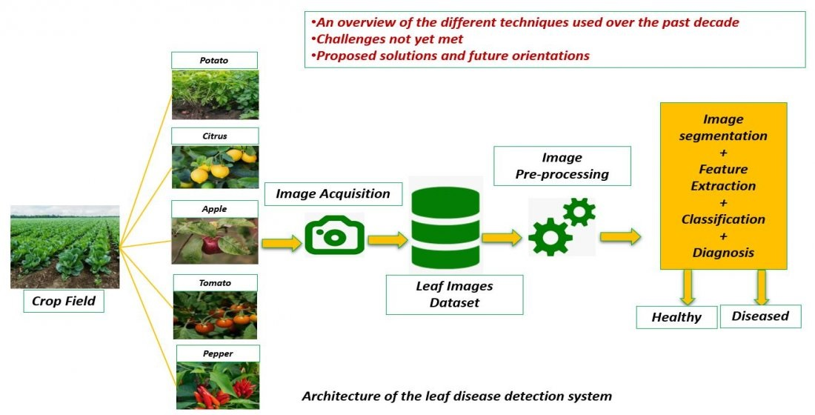

The method by which we can detect the disease of a crop or the amount of pest and water needed by the crop is given above. In the above process we initially take high resolution photos of leaves by drones or cameras. Then a dataset is maintained of the collected leaves. Since many images may be unsuitable for the application of technologies life ANN and RNN, therefore unclear images are filtered out. The final set of collected images are used for further processing.

Technologies like Artificial neural network and Recurrent neural network are then used to study the segmented leaf images. These technologies enable us to predict the results of the inputs that are supplied to the crops and help us to know more about the actual crop needs and demands in future.

**4. Technology used**

1. **ANN** (Artificial Neural Network)

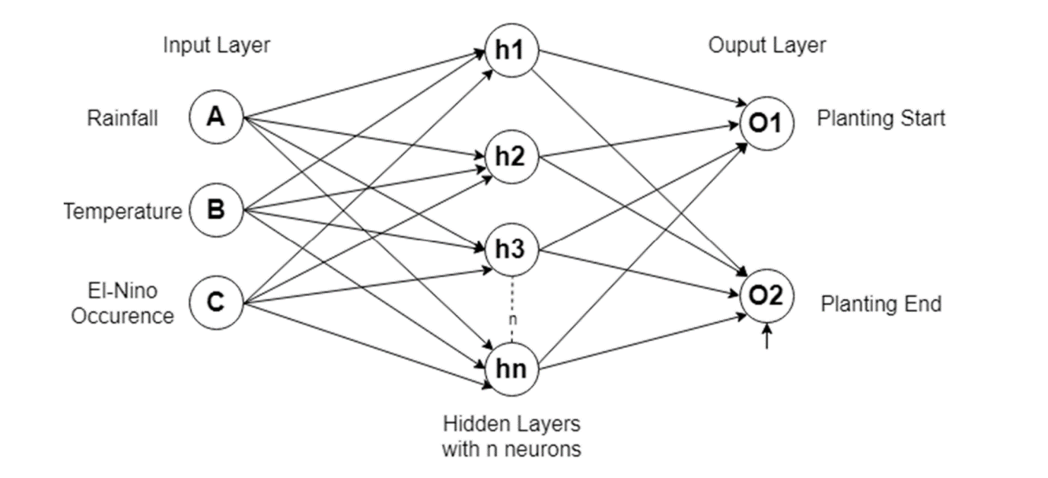

"**Artificial Neural Network"** is derived from Biological neural networks that develop the structure of a human brain. Similar to the human brain that has neurons interconnected to one another, artificial neural networks also have neurons that are interconnected to one another in various layers of the networks.

In leaf detection artificial neural network is used to predict the quantity of pests and water needed by the crop is per its previous requirements which are used as input in the ANN

**B) RNN** (Recurrent Neural Network)

**Recurrent Neural Network (RNN)** are a type of Neural Network where the **output from previous step is fed as input to the current step**. In traditional neural networks, all the inputs and outputs are independent of each other, but in cases like when it is required to predict the next word of a sentence, the previous words are required and hence there is a need to remember the previous words. Thus, 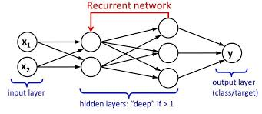RNN came into existence, which solved this issue with the help of a Hidden Layer. The main and most important feature of RNN is **Hidden state**, which remembers some information about a sequence.

**C) Smart sensors -**

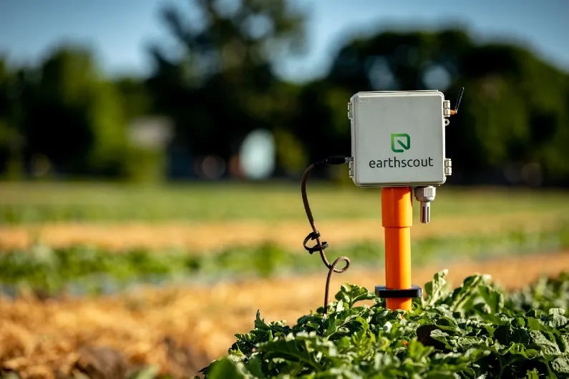

Smart sensors are used in the last second stage of the process to detect the at present composition of leaf. The present composition of pests, water, and bacteria will be used to determine the in future requirements of the crop. Hence making it possible to judge the required amount of pests and fertilizers required by the crops in particular season. RNN will be using the data from smart sensors to supply the current state with the input. The output of the current state will be used as an input for the next stage in RNN.

**5. Diagram**







**6. Conclusion**

The proposed methodology in the following crop/leaf detection system focus on Generating an advance and efficient system which makes the process of creating high yield of crops much more easier for the farmers. The project aims to detect the pests, quality and most common diseases occurring on a crop, using image processing technique under Upbringing technology i.e., machine learning. In easier terms, the farmer will be able to accurately Detect the type of disease a particular plant is having using the image of the plant. The proposed System is based on three important modules namely:

* ANN – Artificial Neural Network
* RNN – Recurrent Neural Network
* Smart sensors

**References :**

1. Plant Leaf Disease Classification and Detection System Using Machine Learning by Geetha1 , S.Samundeswari2, G.Saranya 3,K.Meenakshi 4 and M. Nithya doi:10.1088/1742-6596/1712/1/012012
2. Using Deep Learning for Image-Based Plant Disease Detection by Sharada P. Mohanty 1, 2, 3, David P. Hughes 4, 5, 6 and Marcel Salathé1, 2, 3**\*** doi:10.3389/fpls.2016.01419
3. CHING-JU CHEN1, YA-YU HUANG2, YUAN-SHUO LI2, CHUAN-YU CHANG 3, (Senior Member, IEEE), AND YUEH-MIN HUANG 2, (Senior Member, IEEE)
4. Artificial Intelligence in Agriculture: A Review by Robin Sharma, Dept. of Information Technology, UIIT, Shimla, India Doi : 978-0-7381-1327-2/21/$31.00 ©2021 IEEE