**Experiment No:1**

**Date:**

**Roll No:**

**Title: Program on parameter passing**

Q.1 Write a program on passing by value type

using System;

using System.Collections.Generic;

using System.Linq;

using System.Text;

namespace Value_Type

{

class program

{

static void Main(string[] args)

{

int a = 4;

squareVal(a);

Console.WriteLine("number is : "+a);

Console.ReadKey();

}

Static void squareVal(int valParameter)

{

valParameter *= valParameter;

}

}

}

**Output:**



## Q2.Write a program on passing by reference type .

using System;

using System.Collections.Generic;

using System.Linq;

using System.Text;

namespace Passing_by_referance

{

class Program

{

static void Main(string[] args)

{

int a;

Console.WriteLine("enter the number :-");

a = Convert.ToInt32(Console.ReadLine()); squareRef(ref a);

Console.WriteLine(a); Console.ReadKey();

}

static void squareRef(refintrefpar)

{

refpar *= refpar;

}

}

}

**Output:**

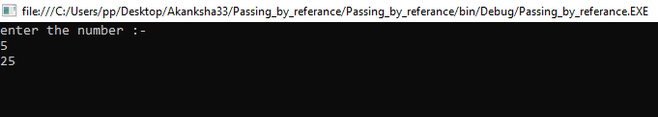

Q3.Write a program on passing by out parameter

using System;

using System.Collections.Generic;

using System.Linq;

using System.Text;

namespace Out_Parameter

{

class Program

{

static void Main(string[] args)

{

int i;

Addition(out i);

Console.WriteLine("Addition is :-" + i); Console.ReadKey();

}

static void Addition(outint i)

{

i = 10;

i += i;

}

}

}

**Output:**

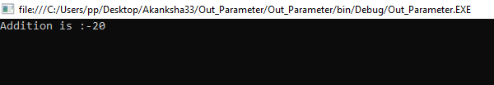

**Experiment No:2**

**Date:**

**Roll No:**

**Title: Program on command line argument**

Q1.Write a program on command line string argument

using System;

using System.Collections.Generic;

using System.Linq;

using System.Text;

namespace String_Argument

{

class Program

{

static void Main(string[] args)

{

Console.WriteLine("First Name is :- " + args[0]);

Console.WriteLine("Last Nmae is :- " + args[1]);

Console.ReadKey();

}

}

}

**Output:**

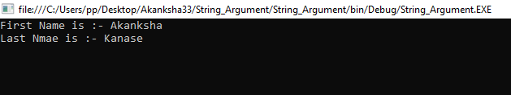

Q2.Write a program on command line integer arguments

using System;

using System.Collections.Generic;

using System.Linq;

using System.Text;

namespace Integer_Argument

{

class Program

{

static void Main(string[] args)

{

int a = Convert.ToInt32(args[0]);

Console.WriteLine("Arguments in integer :- "+args[0]);

Console.WriteLine("Arguments in double :- " + args[1]);

double b = Convert.ToDouble(args[1]);

Console.ReadLine();

}

}

}

**Output:**

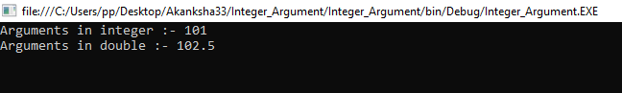

**Experiment No:3**

**Date:**

**Roll No:**

**Title: Program on type casting**

## Q1.Write a program on implicit typecasting.

using System;

using System.Collections.Generic;

using System.Linq;

using System.Text;

namespace Implicit_Typecasting

{

class Program

{

static void Main(string[] args)

{

int i = 100;

long l = i;

long f = l;

Console.WriteLine("int value is : " + i);

Console.WriteLine("Long value is : " + l);

Console.WriteLine("Floating value is : " + f);

Console.ReadKey();

}

}

}

**Output:**

## Q2.Write a program on explicit typecasting.

using System;

using System.Collections.Generic;

using System.Linq;

using System.Text;

namespace Explicit_Typecasting

{

class Program

{

Static void Main(string[] args)

{

double d = 785.45;

int i = (int)d;

Console.WriteLine("Double value is : "+d);

Console.WriteLine("Int value is : "+i);

Console.ReadKey();

}

}

}

## **Output:**

## 

## 

**Experiment No:4**

**Date:**

**Roll No:**

**Title: Program on looping statement**

## Q1.Write a program to display 0 to 9 numbers using while loop.

using System;

using System.Collections.Generic;

using System.Linq;

using System.Text;

namespace while_loop

{

class Program

{

static void Main(string[] args)

{

int a = 0; while (a <= 9)

{

Console.WriteLine(a); a++;

}

Console.ReadKey();

}

}

}

## **Output:**

## 

## Q2. Write a program to calculate factorial using forloop.

using System;

using System.Collections.Generic;

using System.Linq;

using System.Text;

namespace For_Loop

{

class Program

{

static void Main(string[] args)

{

int a;

int factorial = 1;

Console.WriteLine("Enter the number : ");

a = Convert.ToInt32(Console.ReadLine());

for (int i = 1; i <= a; i++)

{

factorial *= i;

}

Console.WriteLine("Factorial of number is :- " + factorial);

Console.ReadKey();

}

}

}

## **Output:**

## 

## Q3.Write a program to display table 0 to 7using dowhile loop.

using System;

using System.Collections.Generic;

using System.Linq;

using System.Text;

namespace Do_While

{

class Program

{

static void Main(string[] args)

{

int i = 7; int t = 1; do

{

Console.WriteLine("{0} * {1} = {2}", i, t, i * t);

t++;

}

while (t <= 10);

Console.ReadKey();

}

}

}

**Output:**

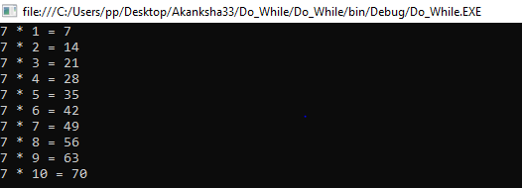

## Q4.Write a program using continue statement .

using System;

using System.Collections.Generic;

using System.Linq;

using System.Text;

namespace Continue1

{

classProgram

{

staticvoid Main(string[] args)

{

(int i = 0; i <= 5; i++)

{

if (i == 3)

{

continue;

}

Console.WriteLine(i);

}

Console.ReadKey();

}

}

}

**Output:**

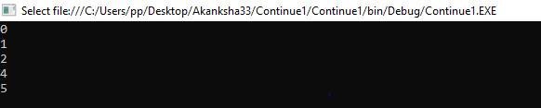

**Experiment No:5**

**Date:**

**Roll No:**

## **Title: Program on control structure**

## Q1.Write a program to display string using single if statement.

using System;

using System.Collections.Generic;

using System.Linq;

using System.Text;

namespace If

{

class Program

{

static void Main(string[] args)

{

string name = "Wellcome to BCS-3";

if (name == "Wellcome to BCS-3")

{

Console.WriteLine("WELLCOME TO BCS THIRD YEAR .");

Console.ReadKey();

}

}

}

}

**Output:**

## 

## Q2.Write a program to find even or odd number using if else statement .

using System;

using System.Collections.Generic;

using System.Linq;

using System.Text;

namespace If_else

{

class Program

{

static void Main(string[] args)

{

int a = 7;

if (a % 2 == 0)

{

Console.WriteLine(a + " is even number.");

}

else

{

Console.WriteLine(a + " is odd number.");

}

Console.ReadKey();

}

}

}

## **Output:**

## 

## 

## Q3.Write a program to calculate given numbers is equal or not using if else ladder statement.

using System;

using System.Collections.Generic;

using System.Linq;

using System.Text;

namespace If_else_ladder

{

class Program

{

static void Main(string[] args)

{

int a, b, c;

Console.WriteLine("Enter the three numbers :- ");

a = Convert.ToInt32(Console.ReadLine());

b = Convert.ToInt32(Console.ReadLine());

c = Convert.ToInt32(Console.ReadLine());

if (a > b && a > c)

{

Console.WriteLine(a + " is bigest number.");

}

elseif (b > a && b > c)

{

Console.WriteLine(b + " is bigest number.");

}

elseif (c > a && c > b)

{

Console.WriteLine(c + " isbigest number.");

}

else

{

Console.WriteLine("All numbers are equals.");

}

Console.ReadKey();

}

}

}

**Output:**

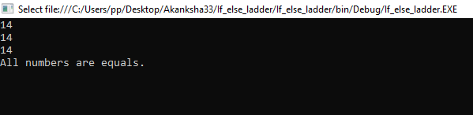

## Q4.Write a program using nested if else statement.

using System;

using System.Collections.Generic;

using System.Linq;

using System.Text;

namespace Nested_if

{

class Program

{

static void Main(string[] args)

{

int a = 50; if (a > 10)

{

if (a < 100)

{

Console.WriteLine(a + " is less than 100.");

}

else

{

Console.WriteLine(a + " is greater than 100.");

}

}

else

{

Console.WriteLine(a+" is less than 10.");

}

Console.ReadKey();

}

}

}

Output:

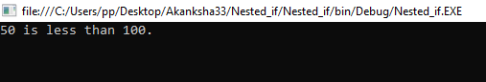

## Q5.Write a program to display months using switch statements.

using System;

using System.Collections.Generic;

using System.Linq;

using System.Text;

namespace Switch

{

class Program

{

static void Main(string[] args)

{

int monthno;

Console.WriteLine("Enter the month number :- ");

monthno = Convert.ToInt32(Console.ReadLine());

switch (monthno)

{

case 1 :

Console.WriteLine("JANUARY"); break;

case 2:

Console.WriteLine("FEBRUARY"); break;

case 3:

Console.WriteLine("MARCH"); break;

case 4:

Console.WriteLine("APRIL"); break;

case 5:

Console.WriteLine("MAY"); break;

case 6:

Console.WriteLine("JUNE"); break;

case 7:

Console.WriteLine("JULLY"); break;

case 8:

Console.WriteLine("AUGUST"); break;

case 9:

Console.WriteLine("SEPTEMBER"); break;

case 10:

Console.WriteLine("OCTOBER"); break;

case 11:

Console.WriteLine("NOVEMBER"); break;

case 12:

Console.WriteLine("DECEMBER"); break;

default:

Console.WriteLine("PLEASE ENTER VALID NUMBER.");

break;

}

Console.ReadKey();

}

}

}

**Output**:

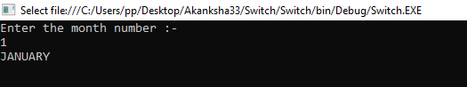

**Experiment No:6**

**Date:**

**Roll No:**

**Title: Program On Array**

## Q1.Write a program to display week using 1-Darray.

using System;

using System.Collections.Generic;

using System.Linq;

using System.Text;

namespace 1D_Array

{

class Program

{

static void Main(string[] args)

{

string[] weekDays;

weekDays = newstring[] { "Sunday", "Monday", "Tuesday", "Wednesday", "Thursday", "Friday", "satursday" };

foreach (string day inweekDays)

Console.WriteLine(day + " ");

Console.ReadKey();

}

}

}

## **Output:**

## 

## Q2.Write a program to display computer language using 1-Darray.

using System;

using System.Collections.Generic;

using System.Linq;

using System.Text;

namespace 1D_Array2

{

class Program

{

static void Main(string[] args)

{

string[] Books = newstring[5];

Books[0] = "C Programming";

Books[1] = "C++";

Books[2] = "Java";

Books[3] = "C#";

Books[4] = "PHP";

Console.WriteLine("All elements of Books array is:\n\n");

inti=0;

Console.Write("\t1\t2\t3\t4\t5\n\n\t");

for(i=0;i<5;i++)

{

Console.Write("{0}\t",Books[i]);

}

Console.ReadLine();

}

}

}

**Output:**

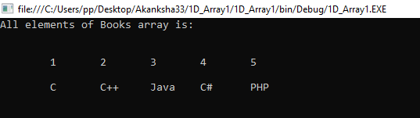

## Q3.Write a program to display book name using multi-dimensional array.

using System;

using System.Collections.Generic;

using System.Linq;

using System.Text;

namespace Multi_dimensional_array

{

class Program

{

static void Main(string[] args)

{

int i, j;

String[,] Books = newString[3, 3];

for (i = 0; i< 3; i++)

{

for (j = 0; j < 3; j++)

{

Console.WriteLine("\n Enter Book name for{0} Row and Column {1} \t ", i, i + 1, j + 1);

Books[i, j] = (Console.ReadLine());

}

}

Console.WriteLine("\n \n ------------");

Console.WriteLine("All elements of Book array is \n \n ");

Console.Write(" \t1 \t2 \t3 \n \n ");

for (i = 0; i< 3; i++)

{

Console.Write(" {0} \t ", i + 1);

for (j = 0; j < 3; j++)

{

Console.Write("{0}\t ", Books[i, j]);

}

Console.Write("\n ");

}

Console.WriteLine("\n \n -----------------");

Console.ReadLine();

}

}

}

**Output:**

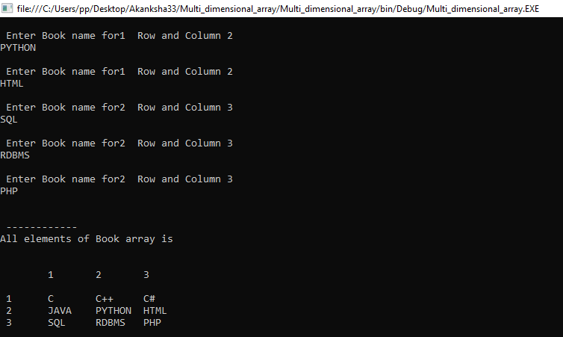

**Experiment No:7**

**Date:**

**Roll No:**

**Title: Program on abstract class**

## Q1.Write a program to implements abstract class.

using System;

using System.Collections.Generic;

using System.Linq;

using System.Text;

namespace Abstract_class

{

public abstract class Shape

{

public abstract tvoid draw();

}

public class Rectangle : Shape

{

public override void draw()

{

Console.WriteLine("DRAWING RECTANGLE.... ");

}

}

public class Circle : Shape

{

public override void draw()

{

Console.WriteLine("DRAWING CIRCLE.... ");

}

}

public class Myclass

{

public static void Main(string[] args)

{

Shape s;

s = newRectangle(); s.draw();

s = newCircle();

s.draw(); Console.ReadKey();

}

}

}

**Output**:

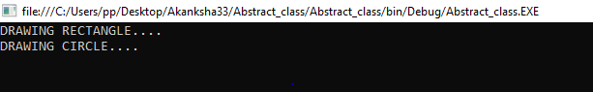

**Experiment No:8**

**Date:**

**Roll No:**

**Title: Program on partial class**

## Q1.Write a program to implements partial class.

using System;

using System.Collections.Generic;

using System.Linq;

using System.Text;

namespace Partialclass

{

class program

{

static void Main(string[] args)

{

Student Partialobj = new StudentPartial();

obj.FirstName = "Akanksha";

obj.LastName = "Kanase";

Console.WriteLine("Your Complete name is : " + obj.Get Complete Name());

Console.ReadLine();

}

}

}

using System;

using System.Collections.Generic;

using System.Linq;

using System.Text;

namespace Partialclass

{

public partialclass StudentPartial

{

public String Get Complete Name()

{

return FirstName + " " + LastName;

}

}

}

using System;

using System.Collections.Generic;

using System.Linq;

using System.Text;

namespace Partialclass

{

public partialclass StudentPartial

{

Private String firstName;

Private String lastName;

Private string value;

public String FirstName

{

set

{

firstName = value;

}

get

{

return firstName;

}

}

public String LastName

{

get

{

return lastName;

}

}

}

}

**Output:**



 