**Experiment No : 1**

**Date :**

**Roll No :**

**Title: Passing by**

Q.1) Write a program to display value using value type.

using System;

usingSystem.Collections.Generic;

usingSystem.Linq;

usingSystem.Text;

namespace Value

{

classProgram

{

Staticvoid Main(string[] args)

{

Intarg;

arg = 4;

squareval(arg);

Console.WriteLine(arg);

Console.ReadKey();

}

staticvoidsquareval(intvalParameter)

{

valParameter *= valParameter;

}

}

}

**Output :**

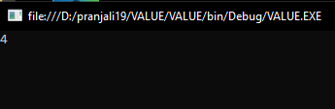

Q.2) Write a program to display value using reference type.

using System;

usingSystem.Collections.Generic;

usingSystem.Linq;

usingSystem.Text;

namespaceReferance_Type

{

classProgram

{

staticvoid Main(string[] args)

{

intarg;

arg = 5;

squareRef(refarg);

Console.WriteLine(arg);

Console.ReadKey();

}

staticvoidsquareRef(refintrefParameter)

{

refParameter *= refParameter;

}

}

}

**Output :**

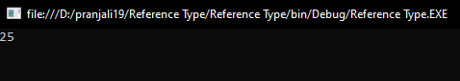

Q.3) Write a program to display addition using out parameter.

using System;

usingSystem.Collections.Generic;

usingSystem.Linq;

usingSystem.Text;

namespaceOut_parameter

{

classProgram

{

staticvoid Main(string[] args)

{

inti;

Addition(outi);

Console.WriteLine("Addition is {0}",i);

Console.ReadKey();

}

publicstaticvoidAddition(outinti)

{

i = 15;

i += i;

}

}

}

**Output :**

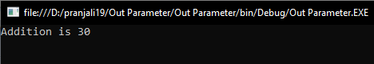

**Experiment No : 2**

**Date :**

**Roll No :**

**Title: Command Line Argument**

Q.1) Write a program to display name using string.

using System;

usingSystem.Collections.Generic;

usingSystem.Linq;

usingSystem.Text;

namespace @string

{

classProgram

{

staticvoid Main(string[] args)

{

Console.WriteLine("First Name is "+args[0]);

Console.WriteLine("Last Name is " + args[1]);

Console.ReadKey();

}

}

}

**Output :**

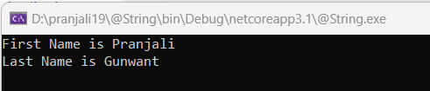

Q.2) Write a program to display value using argument.

using System;

usingSystem.Collections.Generic;

usingSystem.Linq;

usingSystem.Text;

namespace Argument

{

classProgram

{

int argument1 = Convert.ToInt32(args[0]);

Console.WriteLine("Argument in Integer is: " + argument1);

double argument2 = Convert.ToDouble(args[1]);

Console.WriteLine("Argument in Double is: " + argument2);

Console.ReadKey();

}

}

**Output :**

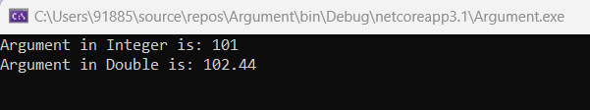

**Experiment No : 3**

**Date :**

**Roll No :**

**Title: Type Casting**

Q.1) Write a program to display value using Implicit.

using System;

usingSystem.Collections.Generic;

usingSystem.Linq;

usingSystem.Text;

namespace Implicit

{

classProgram

{

publicstaticvoidMain(String [] args)

{

inti = 100;

long l = i;

float f = l;

Console.WriteLine("Int value " + i);

Console.WriteLine("Long value "+l);

Console.WriteLine("float value " + f);

Console.ReadLine();

}

}

}

**Output :**

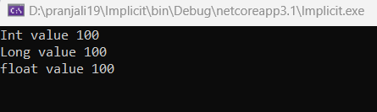

Q.2) Write a program to value using Explicit value.

using System;

usingSystem.Collections.Generic;

usingSystem.Linq;

usingSystem.Text;

namespace Explicit1

{

classProgram

{

staticvoid Main(string[] args)

{

doubledb = 7896.45;

intxy;

xy=(int) db;

Console.WriteLine("value of xy=" + xy);

Console.ReadKey();

}

}

}

**Output :**

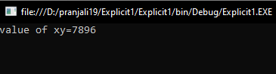

**Experiment No :4**

**Date :**

**Roll No :**

**Title: Looping Statement**

Q.1) Write a program to display 0 to 9 using while loop.

using System;

usingSystem.Collections.Generic;

usingSystem.Linq;

usingSystem.Text;

namespaceWhile_loop

{

classProgram

{

staticvoid Main(string[] args)

{

int number = 0;

int target = 10;

while (number<target)

{

Console.WriteLine("" + number);

number++;

}

Console.ReadKey();

}

}

}

**Output :**

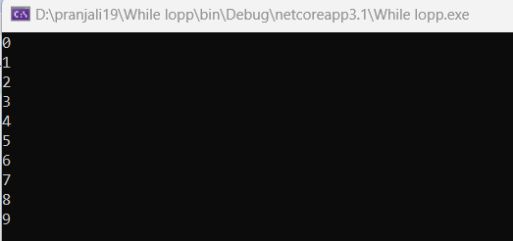

Q.2) Write a program to factorial using for loop.

using System;

usingSystem.Collections.Generic;

usingSystem.Linq;

usingSystem.Text;

namespaceFor_loop

{

classProgram

{

staticvoid Main(string[] args)

{

inti, fact = 1, a;

Console.WriteLine("Enter number");

a = Convert.ToInt16(Console.ReadLine());

for(i=1;i<=a;i++)

{

fact=fact*i;

}

Console.WriteLine("Factorial of number is="+fact);

Console.ReadKey();

}

}

}

**Output :**

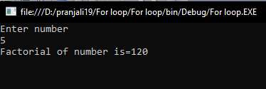

Q.3) Write a program to display table of 5 using do while loop.

using System;

usingSystem.Collections.Generic;

usingSystem.Linq;

usingSystem.Text;

namespaceDo_while_loop

{

classProgram

{

staticvoid Main(string[] args)

{

int n = 5, i = 1, product;

do

{

product = n * i;

Console.WriteLine("{0}*{1}={2}", n, i, product);

i++;

}

while (i<= 10);

Console.ReadKey();

}

}

}

**Output :**

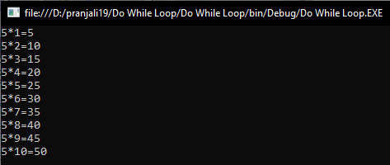

Q.4) Write a program to print i using continue statement.

using System;

usingSystem.Collections.Generic;

usingSystem.Linq;

usingSystem.Text;

namespaceContinue_Statement

{

classProgram

{

staticvoid Main(string[] args)

{

for (inti = 0; i< 10; i++)

{

if (i == 4)

{

continue;

}

Console.WriteLine(i);

}

Console.ReadKey();

}

}

}

**Output :**

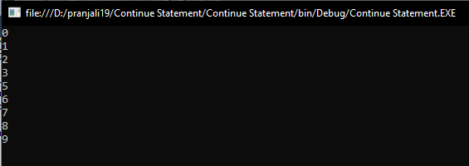

**ExperimentNo :5**

**Date :**

**Roll No :**

**Title: Control Structure**

Q.1) Write a program to display name using If Statement.

using System;

usingSystem.Collections.Generic;

usingSystem.Linq;

usingSystem.Text;

namespaceIf_Statement

{

classProgram

{

staticvoid Main(string[] args)

{

string name = "Welcome to BCS";

if (name == "Welcome to BCS")

{

Console.WriteLine("Welcome to BCS3");

Console.ReadKey();

}

}

}

}

**Output :**

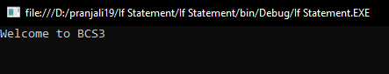

Q.2) Write a program to display even or odd using If else statement.

using System;

usingSystem.Collections.Generic;

usingSystem.Linq;

usingSystem.Text;

namespaceeven_or_odd

{

classProgram

{

Staticvoid Main(string[] args)

{

int a = 2;

if (a % 2 == 0)

{

Console.WriteLine("a is even");

Console.ReadLine();

}

else

{

Console.WriteLine("a is odd");

Console.ReadLine();

}

}

}

}

**Output :**

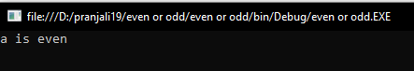

Q.3) Write a program to display number is equal to using If else if ladder statement.

using System;

usingSystem.Collections.Generic;

usingSystem.Linq;

usingSystem.Text;

namespaceIf_else_if_ladder

{

classProgram

{

staticvoid Main(string[] args)

{

inti = 101;

if (i == 100)

{

Console.WriteLine("i is equal to 100");

}

elseif (i == 101)

{

Console.WriteLine("i is equal to 101");

}

else

{

Console.WriteLine("i is not present");

}

Console.ReadKey();

}

}

}

**Output :**

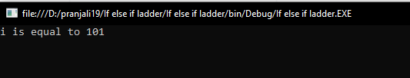

Q.4) Write a program to display number using Nested if statement.

using System;

usingSystem.Collections.Generic;

usingSystem.Linq;

usingSystem.Text;

namespaceNested_if_statement

{

classProgram

{

staticvoid Main(string[] args)

{

inti = 20;

if (i == 20)

{

if (i> 60)

{

Console.WriteLine("i is smaller than 10");

}

else

{

Console.WriteLine("i is greater than 50");

}

}

Console.ReadKey();

}

}

}

**Output :**

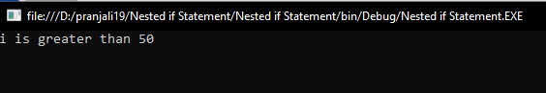

Q.5) Write a program to display month using Switch statement.

using System;

usingSystem.Collections.Generic;

usingSystem.Linq;

usingSystem.Text;

namespace Month

{

classProgram

{

staticvoid Main(string[] args)

{

int month = 11;

switch (month)

{

case 1: Console.WriteLine("January");

break;

case 2: Console.WriteLine("February");

break;

case 3: Console.WriteLine("March");

break;

case 4: Console.WriteLine("April");

break;

case 5: Console.WriteLine("May");

break;

case 6: Console.WriteLine("June");

break;

case 7: Console.WriteLine("July");

break;

case 8: Console.WriteLine("August");

break;

case 9: Console.WriteLine("September");

break;

case 10: Console.WriteLine("Octomber");

break;

case 11: Console.WriteLine("November");

break;

case 12: Console.WriteLine("December");

break;

default:

Console.WriteLine("Invalid month no");

break;

}

Console.ReadLine();

}

}

}

**Output :**

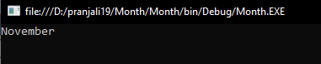

**Experiment No :6**

**Date :**

**Roll No :**

**Title: Array**

Q.1) Write a program to display week using One-Dimensional Array.

using System;

usingSystem.Collections.Generic;

usingSystem.Linq;

usingSystem.Text;

namespaceone_dimensional_array

{

classProgram

{

staticvoid Main(string[] args)

{

string[] weekDays;

weekDays = newstring[] { "Sunday", "Monday", "Tuesday", "Wednesday", "Thursday", "Friday", "satursday" };

foreach (string day inweekDays)

Console.WriteLine(day + " ");

Console.ReadKey();

}

}

}

**Output :**

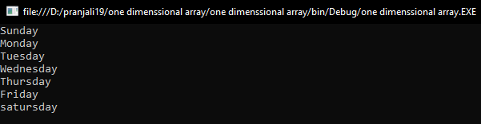

Q.2) Write a program to display Computer Languages using one-dimensional array.

using System;

usingSystem.Collections.Generic;

usingSystem.Linq;

usingSystem.Text;

namespaceComputer_languages

{

classProgram

{

staticvoid Main(string[] args)

{

string[] Books = newstring[5];

Books[0] = "C";

Books[1] = "C++";

Books[2] = "Java";

Books[3] = "C#";

Books[4] = "PHP";

Console.WriteLine("All elements of Books array is:\n\n");

inti=0;

Console.Write("\t1\t2\t3\t4\t5\n\n\t");

for(i=0;i<5;i++)

{

Console.Write("{0}\t",Books[i]);

}

Console.ReadLine();

}

}

}

**Output :**

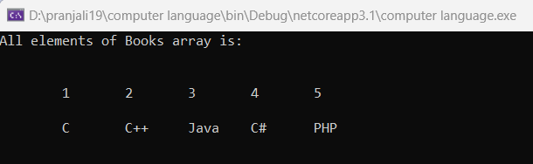

Q.3) Write a program to display books using Multi-Dimensional Array.

using System;

usingSystem.Collections.Generic;

usingSystem.Linq;

usingSystem.Text;

namespaceMulti_dimensional_array

{

classProgram

{

staticvoid Main(string[] args)

{

inti, j;

String[,] Books = newString[3, 3];

for (i = 0; i< 3; i++)

{

for (j = 0; j < 3; j++)

{

Console.WriteLine("\n Enter Book name for{0} Row and Column {1} \t ", i, i + 1, j + 1);

Books[i, j] = (Console.ReadLine());

}

}

Console.WriteLine("\n \n ------------");

Console.WriteLine("All elements of Book array is \n \n ");

Console.Write(" \t1 \t2 \t3 \n \n ");

for (i = 0; i< 3; i++)

{

Console.Write("{0}\t ", i + 1);

for (j = 0; j < 3; j++)

{

Console.Write("{0}\t ", Books[i, j]);

}

Console.Write("\n ");

}

Console.WriteLine("\n \n -----------------");

Console.ReadLine();

}

}

}

**Output :**

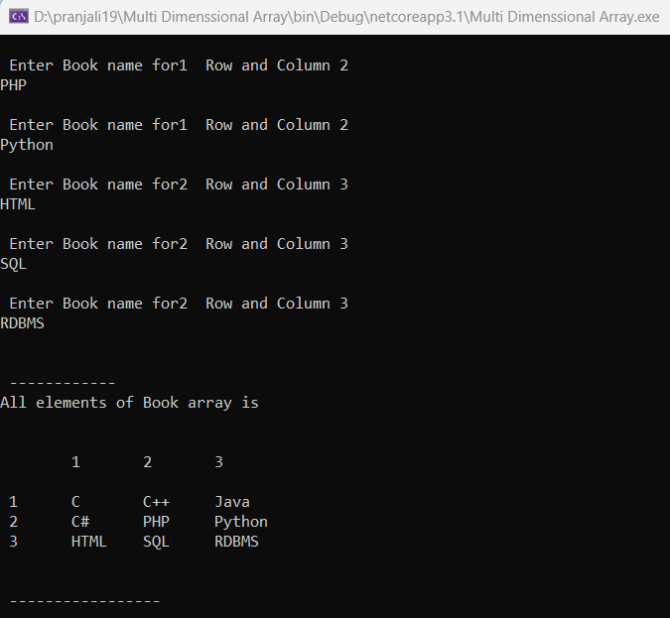

**Experiment No :7**

**Date :**

**Roll No :**

**Title: Abstract Class**

Q.1) Write a program to display shape using abstract class.

using System;

usingSystem.Collections.Generic;

usingSystem.Linq;

usingSystem.Text;

namespace Shape

{

classProgram

{

PublicabstractclassShape

{

publicabstractvoiddraw();

}

publicclassRectangle:Shape

{

publicoverridevoiddraw()

{

Console.WriteLine("drawing Rectangle...");

}

}

publicclassCircle :Shape

{

publicoverridevoiddraw()

{

Console.WriteLine("drawing Circle...");

}

}

publicclassTestAbstract

{

publicstaticvoidMain()

{

Shape s;

s = newRectangle();

s.draw();

s = newCircle();

s.draw();

Console.ReadLine();

}

}

}

}

**Output :**

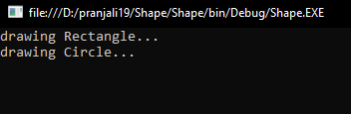

**Experiment No :8**

**Date :**

**Roll No :**

**Title: PartialClass**

Q.1) write a program to find partial class.

using System;

using System.Collections.Generic;

using System.Linq;

using System.Text;

namespace Partialclass3

{

publicpartialclassStudentPartial

{

privatestring firstName;

privatestring lastName;

publicstring FirstName

{

set

{

firstName=value;

}

get

{

return firstName;

}

}

publicstring LastName

{

get

{

return lastName;

}

set

{

lastName=value;

}

}

}

}

using System;

using System.Collections.Generic;

using System.Linq;

using System.Text;

namespace Partialclass3

{

publicpartialclassStudentPartial

{

publicstring GetCompleteName()

{

return firstName + " " + lastName;

}

}

}

using System;

using System.Collections.Generic;

using System.Linq;

using System.Text;

namespace Partialclass3

{

classProgram

{

staticvoid Main(string[] args)

{

StudentPartial obj = newStudentPartial();

obj.FirstName = "Pranjali";

obj.LastName = "Gunwant";

Console.WriteLine("Your Complete Name is:" + obj.GetCompleteName());

Console.ReadLine();

}

}

}

**Output:**

