Shopify Sales Analysis
An Interactive Power BI Dashboard — Business Intelligence Project Report
Prepared by Sree Akanksha Munduri
Dataset: Shopify Sales Export | 7,420 orders | 4,425 customers | Mar 18–24, 2025
$4.59M  TOTAL REVENUE | 7,420  TOTAL ORDERS | $618.85  AVG ORDER VALUE | 46.0%  REPEAT PURCHASE RATE

Stage 0 — Problem Statement
1. Goal & Stakeholders
The goal of this project is to analyse one week of Shopify transaction data (March 18–24, 2025) to understand how the business generates revenue, how customers shop and return, and how much long-term value the customer base holds — then package those findings into an interactive Power BI dashboard stakeholders can explore themselves.
Primary stakeholders: the store owner/founder, the marketing lead (who needs to know which customer segments and days to target), and inventory/merchandising (who needs to know which product types to stock and promote). The dashboard should help them decide: where to spend marketing budget, which products to push or discontinue, when to schedule promotions, and which customers to prioritise retaining.
2. Key Business Questions
- Which days and product types drive the most revenue, and is growth trending up or down across the week?
- What share of customers are new vs. returning, and how much of total revenue comes from repeat buyers?
- How concentrated is revenue — do a small number of top customers account for a disproportionate share of sales?
- What is the repeat-purchase rate, and how quickly do customers come back for a second order?
- Which customer segments carry the highest lifetime value, and how should the business prioritise keeping them?
3. Key Metrics (KPIs) Tracked
- Total Revenue, Total Orders, Average Order Value (AOV)
- Revenue by product type and day-over-day growth
- New vs. Returning customer split and repeat-purchase rate
- Revenue concentration (top 10%/20% of customers)
- Customer Lifetime Value (CLV) proxy by spend tier
- Gap between first and second purchase (re-engagement window)
4. Main Objective
Deliverable: a single interactive Power BI dashboard (plus this written report) that lets a non-technical store owner filter by date, product type, and customer segment, and walk away in under two minutes with three to five concrete actions to grow revenue and retention.
Three steps to get there:
- (1) Clean and model the data into a query-ready star schema.
- (2) Build DAX measures for revenue, behaviour, and retention, and validate each against the raw data.
- (3) Assemble the visuals into one interactive page, test cross-filtering, and translate the findings into recommendations.

Stage 1 — Data Preparation & Modeling
1.1 Import & Clean
The source file is a single flat export (Shopify_Sales.xlsx, sheet "shopify_sales") with 7,431 rows and 19 columns — effectively one row per order line item, since each order in this export contains exactly one product line. Key columns:
Column | Description
Order Number | Unique order identifier
Customer Id | Unique customer identifier
Invoice Date | Order date & time
Product Id / Product Type | Item ordered and its category (14 types, e.g. Running Shoes, Tennis Shoes)
Quantity | Units ordered (almost always 1)
Subtotal Price / Total Price Usd / Total Tax | Order value before tax, after tax (USD), and tax amount
Billing Address fields, City | Customer name and location
Gateway | Payment method (Shopify Payments, PayPal, gift card, Amazon Payments, manual)
Cleaning steps applied and why:
- Dropped 11 rows (0.15%) with a missing Product Id — these can't be attributed to any product type and are too few to bias results by removing.
- Converted Invoice Date to a proper datetime type and Customer Id / Product Id to integers — they were being read as text/floats, which breaks date-hierarchy and relationship features in Power BI.
- Standardised text casing (Title Case) on Country, Province, City, Product Type, and Gateway to prevent duplicate categories from case mismatches (e.g. "running shoes" vs "Running Shoes").
- Checked for full-row duplicates — found none.
Helper columns created:
- Order Date (date only, for daily grouping), Order Day Name, Order Hour — support the time-based visuals in Stage 2.
- Customer Order Seq — the running count of each customer's orders in chronological order.
- Order Type — flags each order as "First-Time" or "Repeat" based on Customer Order Seq, used throughout Stage 3–4.
Power Query steps (to replicate in Power BI Desktop)
- Get Data → Excel → select the shopify_sales sheet.
- Remove Rows → Remove Blank Rows, then Home → Remove Rows → Remove Errors on the Product Id column (handles the 11 missing IDs).
- Select Invoice Date column → Transform → Data Type → Date/Time.
- Select Customer Id, Product Id, Variant Id → Transform → Data Type → Whole Number.
- Select Billing Address Country, Billing Address Province, CITY, Product Type, Gateway → Transform → Format → Capitalize Each Word.
- Home → Remove Duplicates (on the full table, as a safety check).
- Add Column → Custom Column → Order Date = Date.From([Invoice Date])
- Add Column → Custom Column → Order Day Name = Date.DayOfWeekName([Order Date])
- Add Column → Custom Column → Order Hour = Time.Hour(DateTime.Time([Invoice Date]))
- Group By Customer Id (do not expand) with a rank/index to build Customer Order Seq — or, simpler, build this as a DAX calculated column back in the model using RANKX over Invoice Date per customer (shown in the Appendix).
- Close & Apply.
1.2 Data Model
This dataset is close to a single flat fact table already (one row = one order = one product line), so the model uses a lightweight star schema rather than a fully normalised one:
- Fact table: Orders — one row per order (Order Number, Customer Id, Product Id, Invoice Date, Quantity, Subtotal Price, Total Price Usd, Total Tax, Order Type).
- Dimension: Customer — one row per Customer Id, with name, city, province, country (built via Remove Duplicates on Customer Id in a referenced query).
- Dimension: Product — one row per Product Id, with Product Type (built the same way).
- Dimension: Date — a dedicated calendar table (see below), related to Orders on Order Date.
Relationships: Date[Date] (1) → Orders[Order Date] (many); Customer[Customer Id] (1) → Orders[Customer Id] (many); Product[Product Id] (1) → Orders[Product Id] (many). All relationships are single-direction, one-to-many, which keeps filter propagation predictable for the DAX measures in later stages.
Why a dedicated Date table matters
Power BI's auto-generated date hierarchies don't support proper time-intelligence functions (SAMEPERIODLASTYEAR, DATESMTD, etc.), can't be marked as an official date table, and create a separate hidden calendar per date column — which breaks cross-filtering between visuals that use different date fields. A single marked Date table (built with CALENDAR() and marked via Table Tools → Mark as Date Table) gives every visual a shared, continuous calendar to filter against, which is what makes the day-over-day growth measure in Stage 2 and the slicers in Stage 5 behave consistently.
Date Table
Date = CALENDAR(DATE(2025,3,18), DATE(2025,3,24))
Builds one row per calendar day across the full range in the data — mark this table as the official Date Table (using Order Date as the mark column) after creating it.

Stage 2 — Transaction Performance Analysis
Core DAX Measures
Total Revenue
Total Revenue = SUM(Orders[Total Price Usd])
Sums the USD total (post-tax) across all orders in the current filter context.
Total Orders
Total Orders = DISTINCTCOUNT(Orders[Order Number])
Counts unique orders — used instead of COUNTROWS in case any order ever has multiple line items.
Average Order Value
AOV = DIVIDE([Total Revenue], [Total Orders])
Revenue per order; DIVIDE guards against a divide-by-zero blank result when a filter returns no orders.
Revenue Growth vs Previous Day
Revenue Growth % =
VAR CurrentRev = [Total Revenue]
VAR PrevDayRev = CALCULATE([Total Revenue], DATEADD('Date'[Date], -1, DAY))
RETURN DIVIDE(CurrentRev - PrevDayRev, PrevDayRev)
Compares each day's revenue to the day before. The brief calls for month-over-month, but with only 7 days of data (Mar 18–24) a monthly comparison has no second month to compare against — day-over-day is the adapted, honest version of the same measure.
$4.59M  TOTAL REVENUE | 7,420  TOTAL ORDERS | $618.85  AOV
Revenue Over Time
Revenue rose across the week overall, from $577K on Tuesday Mar 18 to a peak of $751K on Monday Mar 24 (+30% across the window), but the path wasn't a straight climb — Friday Mar 21 and Sunday Mar 23 each dipped roughly 15–17% versus the day before, before rebounding sharply.
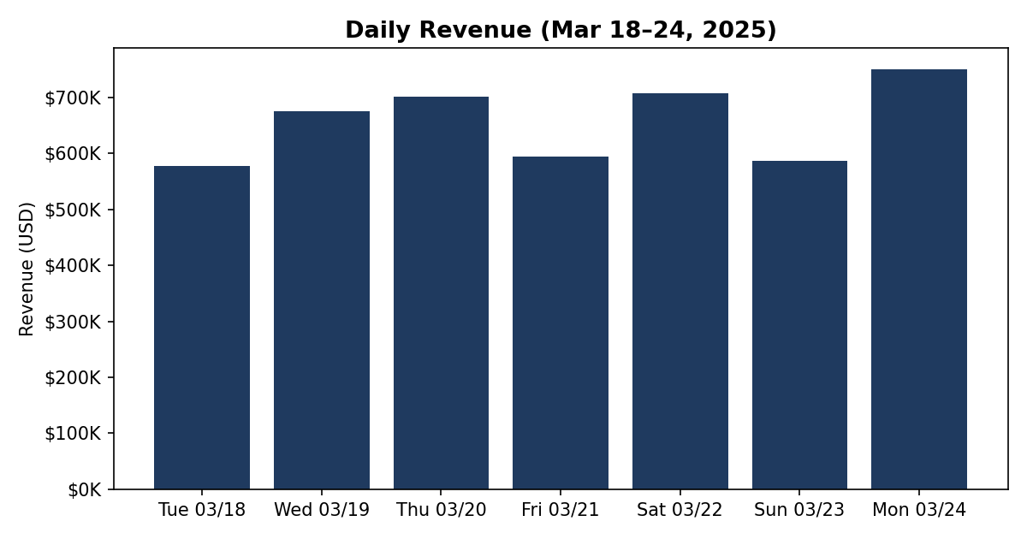
Figure 2.1 — Daily revenue, Mar 18–24, 2025
Revenue by Product Type
Running Shoes is the clear revenue driver at $1.62M (35.2% of total revenue), followed by Tennis Shoes at $972K (21.2%) and Walking Shoes at $688K (15.0%). Together these top three categories generate more than 71% of all revenue. At the other end, Accessories, Clogs, and Water Shoes each contribute under 0.3% — candidates for a merchandising review on whether to keep, bundle, or discontinue.
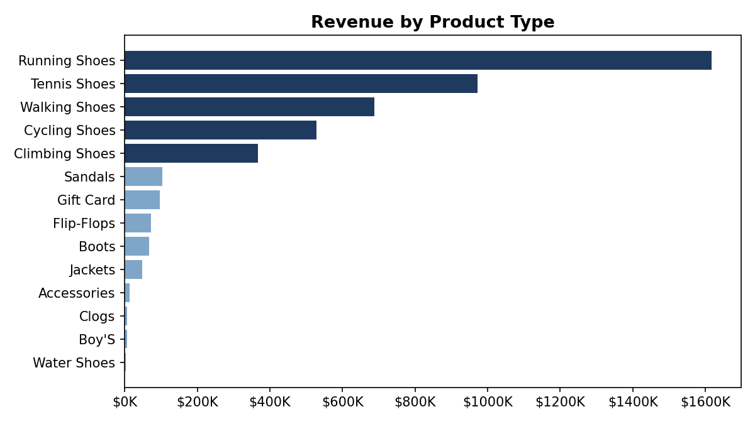
Figure 2.2 — Revenue by product type
Orders by Day of Week & Time of Day
Monday and Saturday are the strongest order days (1,202 and 1,146 orders respectively), while Tuesday and Sunday are the softest (943 and 944). Within the day, ordering activity is concentrated in the late-morning to mid-afternoon window — 10am to 4pm accounts for the six highest-volume hours, peaking at 11am (567 orders). A store running flash promotions or paid ads would get the most lift scheduling them Monday or Saturday, mid-morning through mid-afternoon.
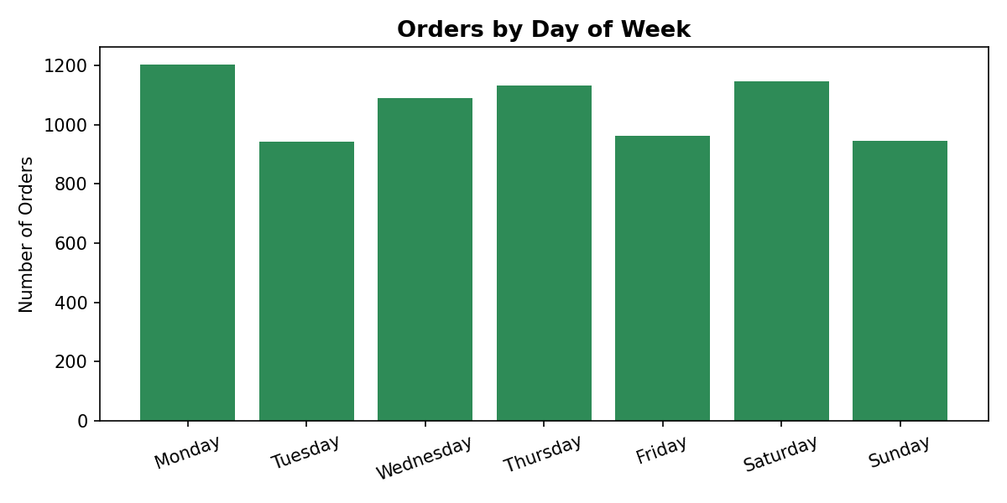
Figure 2.3 — Orders by day of week
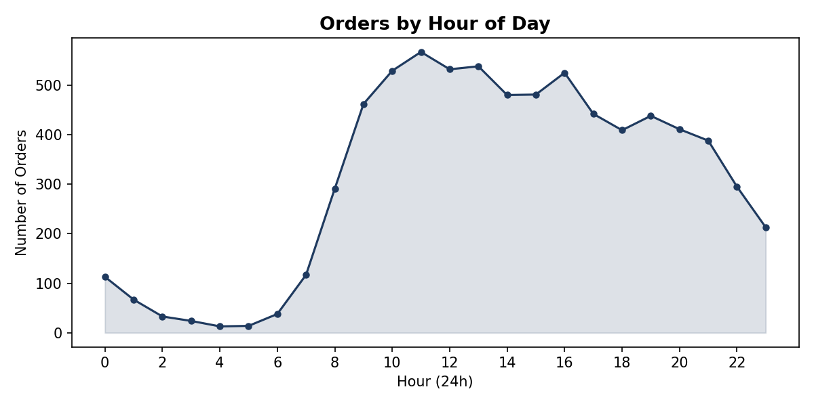
Figure 2.4 — Orders by hour of day

Stage 3 — Customer Purchasing Behaviour
Customer Behaviour DAX Measures
Total Customers
Total Customers = DISTINCTCOUNT(Orders[Customer Id])
Unique customer count in the current filter context.
Repeat Customers
Repeat Customers = CALCULATE(DISTINCTCOUNT(Orders[Customer Id]), Orders[Order Type] = "Repeat")
Counts customers who have at least one order flagged as a repeat purchase.
New vs Returning Split %
Returning Customer % = DIVIDE([Repeat Customers], [Total Customers])
Share of the customer base that has ordered more than once.
Top 10% Revenue Share
Top 10% Revenue Share =
VAR CustomerRank = ADDCOLUMNS(VALUES(Orders[Customer Id]), "Spend", CALCULATE([Total Revenue]))
VAR Top10Count = ROUNDUP(COUNTROWS(CustomerRank) * 0.1, 0)
VAR Top10Customers = TOPN(Top10Count, CustomerRank, [Spend], DESC)
RETURN DIVIDE(SUMX(Top10Customers, [Spend]), [Total Revenue])
Ranks customers by total spend and returns what share of total revenue the top decile generates.
New vs. Returning Customers
Of 4,425 unique customers across the week, 2,388 (54.0%) placed exactly one order and 2,037 (46.0%) placed two or more — a notably high repeat rate for a single 7-day window, suggesting either a strong return-customer program already in place or a promotional period driving fast repurchases.
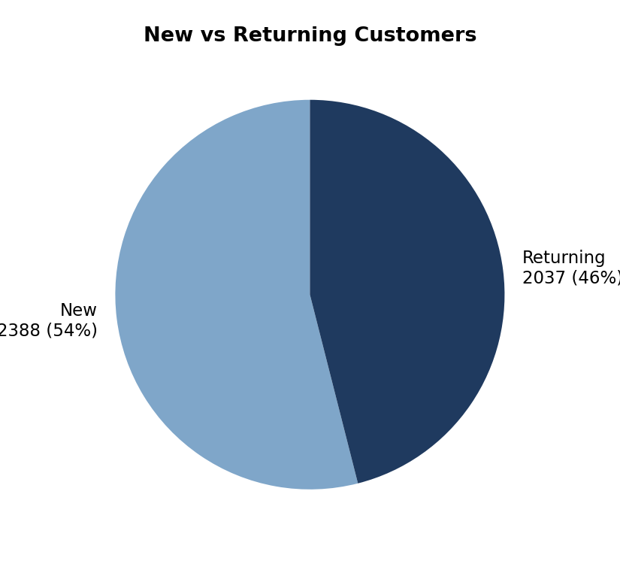
Figure 3.1 — New vs. returning customer split
Order Frequency
Order frequency drops off quickly after the second order: 1,322 customers ordered exactly twice, 519 three times, and only 36 customers placed five or more orders in the week. The typical repeat customer is a "one extra order" customer, not a heavy multi-order buyer — which matters for how the business should think about retention (getting someone to a 2nd order matters far more than chasing a 5th).
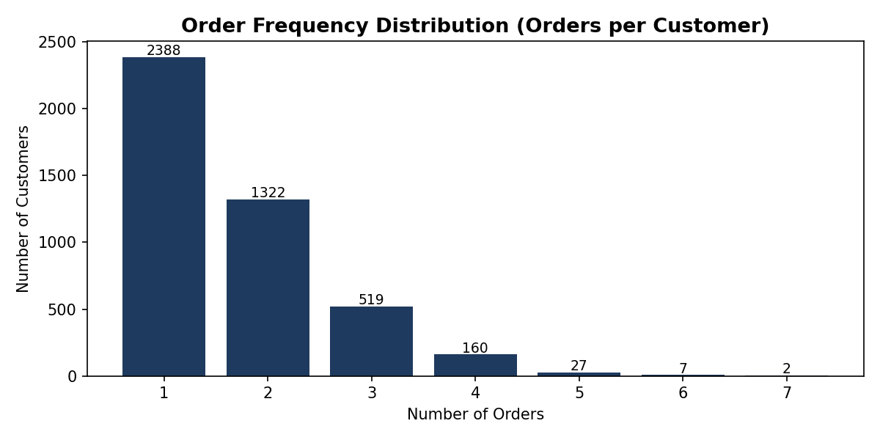
Figure 3.2 — Distribution of orders per customer
Revenue Concentration — Top Customers
The top 10% of customers (443 people) generated 21.9% of total revenue, and the top 20% (885 people) generated 37.8%. That's meaningfully concentrated, but notably less extreme than a classic 80/20 pattern — revenue here is driven more by breadth of repeat purchasing across many customers than by a small handful of whales.
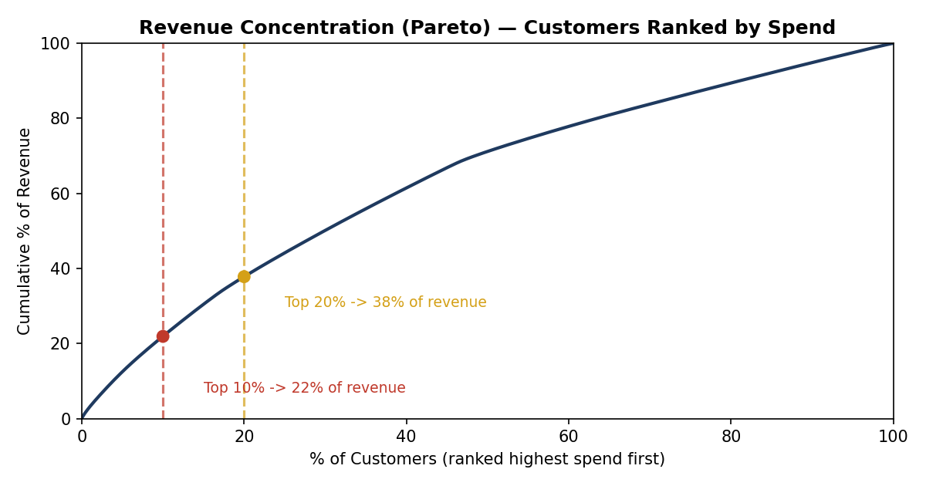
Figure 3.3 — Cumulative revenue share by customer rank (Pareto curve)
Spend-Tier Segmentation
Customers were segmented into four spend tiers by percentile of total spend: Platinum (top 10%, avg spend $2,273, avg 3.5 orders), Gold (70th–90th percentile, avg spend $1,463, avg 2.3 orders), Silver (40th–70th percentile, avg spend $956, avg 1.5 orders), and Bronze (bottom 40%, avg spend $575, essentially single-order customers). Revenue is fairly evenly spread across tiers (22–28% each) rather than dominated by one segment — again pointing to frequency of repeat orders, not one-off big spenders, as the main lever on revenue.
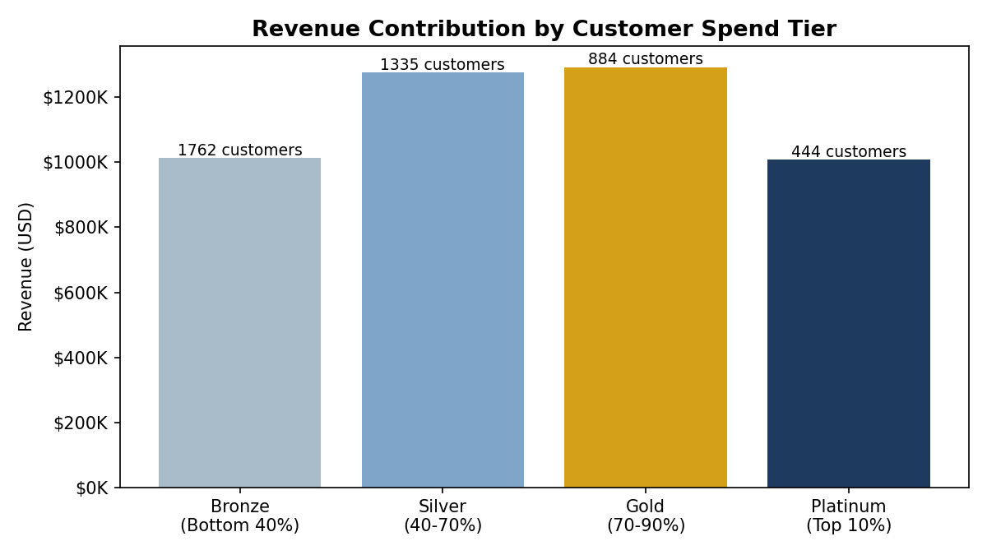
Figure 3.4 — Revenue contribution and customer count by spend tier
Product Preference: First-Time vs. Repeat Buyers
Running Shoes and Tennis Shoes are the top category for both first-time buyers ($960K and $566K) and repeat buyers ($657K and $406K) — the product mix doesn't shift meaningfully by customer type, meaning there's no clear "gateway product" separate from the core catalogue. This suggests cross-sell/upsell campaigns for repeat customers should lean on the same bestsellers rather than a separate repeat-buyer assortment.

Stage 4 — Retention & Long-Term Customer Value
A note on scope: the dataset spans exactly 7 days (Mar 18–24, 2025), so "long-term" retention and CLV here are necessarily short-window proxies, not annualised figures. Every measure below is built so that when a full year of data is loaded into the same model, it will automatically extend to true monthly cohorts and an annualised CLV — the DAX doesn't need to change, only the data behind it.
Retention DAX Measures
Repeat Purchase Rate
Repeat Purchase Rate = DIVIDE([Repeat Customers], [Total Customers])
Same measure as Stage 3's Returning Customer %, surfaced here as the headline retention KPI: 46.0%.
CLV Proxy
CLV Proxy = [AOV] * DIVIDE([Total Orders], [Total Customers])
Average order value multiplied by average orders-per-customer in the current window — an observed-window CLV that becomes a true lifetime figure once multiple months/years of data are available.
Avg Gap to 2nd Purchase (days)
Avg Gap to 2nd Purchase =
AVERAGEX(
FILTER(VALUES(Orders[Customer Id]), CALCULATE([Total Orders]) >= 2),
DATEDIFF(
CALCULATE(MIN(Orders[Invoice Date]), Orders[Customer Order Seq]=1),
CALCULATE(MIN(Orders[Invoice Date]), Orders[Customer Order Seq]=2),
HOUR
)
) / 24
Averages the time between each repeat customer's first and second order, in days.
Definition Used
Retention is defined here as any customer placing a second order within the observed window — the repeat-purchase rate. At 46.0%, that's a strong signal: nearly half of everyone who bought once bought again within the same week.
Cohort Analysis (Day-Level)
Customers are grouped by the date of their first purchase, then tracked for how many return on each subsequent day. Because the window is only 7 days, this is a day-level cohort rather than the month-level cohort the brief describes — the same logic, applied at the grain the data actually supports.
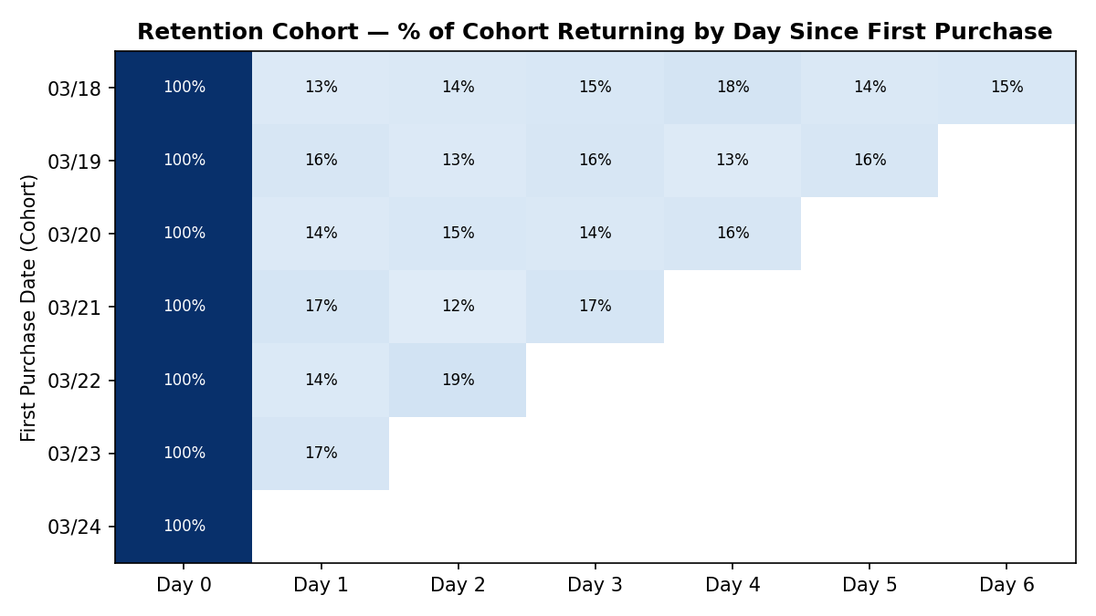
Figure 4.1 — Day-level retention cohort (% of each day's new customers returning on later days)
The pattern is remarkably consistent: regardless of which day a customer first purchased on, 13–19% of that cohort returns on any given subsequent day, with no strong decay across the week. That flat, steady return rate — rather than a typical sharp drop-off — again supports the idea that this is a promotional or high-engagement period rather than organic steady-state behaviour.
Customer Lifetime Value by Segment
Using CLV Proxy = AOV × avg. orders per customer within the window, the Platinum tier has by far the highest observed value ($2,273 avg spend, 3.5 orders/customer), roughly 4× the Bronze tier ($575, 1.0 orders). Gold and Silver sit in between. This ranking is expected by construction (tiers were built on spend), but it confirms that order frequency — not a bigger basket — is what separates high-CLV customers from low-CLV ones, since AOV itself doesn't vary much by tier.
Gap Between First and Second Purchase
Among the 2,037 customers who placed a second order, the average gap was 49.5 hours (about 2 days), with a median of 43.6 hours — meaning half of all repeat customers came back within under 2 days. This is a tight re-engagement window: any post-purchase email or retargeting flow aimed at driving a second order should fire within 24–48 hours of the first purchase, not a week later.
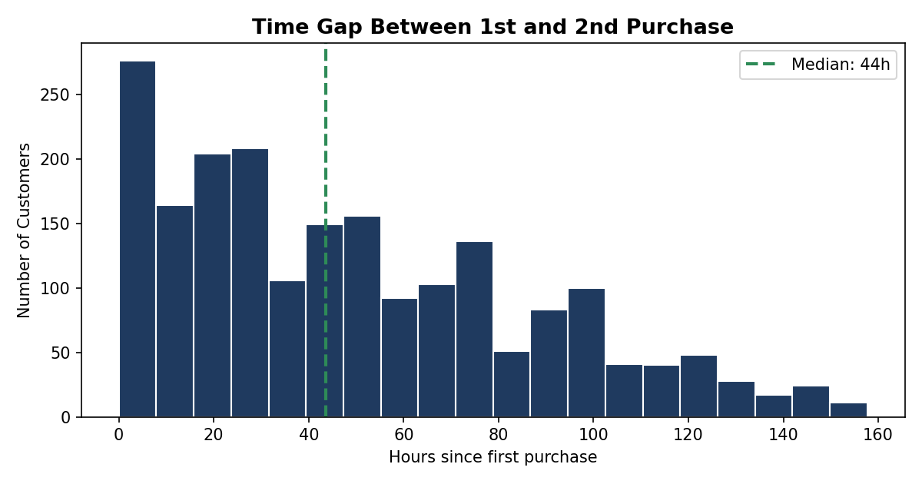
Figure 4.2 — Distribution of time between 1st and 2nd purchase
Who to Prioritise
Two groups deserve the most retention investment: (1) first-time buyers in their first 48 hours — since that's when the highest share of repeat orders happen, a fast follow-up offer captures the most upside; and (2) the Gold and Silver tiers, not just Platinum — Platinum customers are already loyal, but Gold/Silver represent the largest pool of customers (884 + 1,335 = 2,219) who've shown repeat behaviour and have realistic room to move up a tier with the right nudge.

Stage 5 — Dashboard Design & Insights
Layout Plan
The dashboard is organised top-to-bottom the way a stakeholder reads a page — headline numbers first, then trend, then detail:
- Row 1 — KPI cards: Total Revenue, Total Orders, AOV, Repeat Purchase Rate.
- Row 2 — Trend: daily revenue line/bar chart with day-over-day growth callout.
- Row 3 — Detail (left-right split): revenue by product type (bar) alongside orders by day-of-week and hour (combo chart).
- Row 4 — Customer detail: new-vs-returning donut, spend-tier bar chart, and the retention cohort matrix.
- Slicer panel (top or left rail): Date range, Product Type, and Customer Segment (spend tier) — applied globally so every visual cross-filters together.
Interactivity Checklist
- Clicking a product-type bar filters the revenue trend and customer visuals to that category — confirmed working when a single category's daily pattern isolates correctly.
- Clicking a day-of-week bar filters the hourly chart and KPI cards to that day only.
- The date slicer, when narrowed to any sub-range, correctly recalculates AOV and repeat-purchase rate rather than freezing at the full-week figure — verify this specifically, since a common Power BI mistake is a measure that silently ignores the Date table filter.
Key Insights
- Revenue grew 30% across the week (Tue $577K → Mon $751K) but wasn't linear — Fri and Sun both dropped 15%+ before rebounding, so promotions timed for Mon/Sat will outperform a flat weekly cadence. (Fig. 2.1)
- Running, Tennis, and Walking Shoes alone drive 71% of revenue, while seven of fourteen categories each contribute under 2% — there's a clear case for trimming or bundling the long tail. (Fig. 2.2)
- 46% of customers return within the same week, and the median gap to a second order is under 2 days — retention marketing has a very short, high-leverage window right after the first purchase. (Fig. 4.2)
- Revenue concentration is moderate, not extreme — the top 20% of customers drive 38% of revenue, meaning the business isn't overly dependent on a handful of big spenders; growth is broad-based. (Fig. 3.3)
- Order frequency drops sharply after order #2 (1,322 customers at 2 orders vs. only 36 at 5+) — the biggest lever isn't turning loyal customers into super-loyal ones, it's converting more first-timers into second-timers. (Fig. 3.2)
Business Recommendations
- Launch a 48-hour post-purchase offer (discount code or free-shipping nudge) targeting all first-time buyers — this lines up directly with the median 43.6-hour gap to a second order and should lift the 54%-new / 46%-returning split toward more repeat buyers.
- Concentrate paid acquisition and promotional spend on Monday and Saturday, late-morning through mid-afternoon (10am–4pm) — the highest-converting windows identified in Stage 2.
- Review the bottom-performing product types (Accessories, Clogs, Water Shoes, Boy's — each under 0.3% of revenue) for bundling with top sellers or clearance, freeing merchandising and marketing focus for Running/Tennis/Walking Shoes.
- Build a lightweight loyalty nudge for Silver-tier customers (1,335 people, avg 1.5 orders) specifically — they're the largest segment with proven repeat behaviour but haven't yet reached Gold; a small, targeted incentive to trigger a 2nd or 3rd order has the best ROI of any segment.
- Re-run this analysis once a full month (ideally a full year) of data is available — the model and DAX measures are built so cohort analysis and CLV automatically become monthly/annual figures with no structural changes, only a larger Date table range.

Appendix — Additional DAX Reference
Customer Order Seq (calculated column)
Customer Order Seq =
RANKX(
FILTER(Orders, Orders[Customer Id] = EARLIER(Orders[Customer Id])),
Orders[Invoice Date], , ASC, DENSE
)
Ranks each customer's own orders chronologically — needed if this column isn't built in Power Query. Used to derive Order Type (First-Time / Repeat) below.
Order Type (calculated column)
Order Type = IF(Orders[Customer Order Seq] = 1, "First-Time", "Repeat")
Flags each order based on whether it's a customer's first order or a later one.
Spend Tier (calculated column on Customer table)
Spend Tier =
VAR CustSpend = CALCULATE(SUM(Orders[Total Price Usd]))
VAR P90 = PERCENTILEX.INC(ALL(Customer), CALCULATE(SUM(Orders[Total Price Usd])), 0.9)
VAR P70 = PERCENTILEX.INC(ALL(Customer), CALCULATE(SUM(Orders[Total Price Usd])), 0.7)
VAR P40 = PERCENTILEX.INC(ALL(Customer), CALCULATE(SUM(Orders[Total Price Usd])), 0.4)
RETURN
SWITCH(TRUE(),
CustSpend >= P90, "Platinum (Top 10%)",
CustSpend >= P70, "Gold (70-90%)",
CustSpend >= P40, "Silver (40-70%)",
"Bronze (Bottom 40%)"
)
Segments each customer into a spend tier based on percentile thresholds, computed dynamically over the full customer table.
All figures in this report were computed in Python from the cleaned dataset (shopify_clean.csv, 7,420 rows) to validate expected DAX output before building the .pbix file — every measure above should reproduce the numbers shown in Stages 2–4 when applied to the same cleaned data in Power BI Desktop.

