A PROJECT REPORT

on

“CS-BOTS”

Submitted to

KIIT Deemed to be University

In Partial Fulfilment of the Requirement for the Award of

BACHELOR’S DEGREE IN

COMPUTER SCIENCE AND ENGINEERING

BY

ADITYA
AKANKSHA SHRIVASTAVA

1605004
1605006

UNDER THE GUIDANCE OF

DR. SAURABH BILGAIYAN


SCHOOL OF COMPUTER ENGINEERING

KALINGA INSTITUTE OF INDUSTRIAL TECHNOLOGY

BHUBANESWAR, ODISHA - 751024

April 2020

A PROJECT REPORT

On

“CS-BOTS”

Submitted to

KIIT Deemed to be University

In Partial Fulfilment of the Requirement for the Award of

BACHELOR’S DEGREE IN COMPUTER SCIENCE AND ENGINEERING

BY

ADITYA
AKANKSHA SHRIVASTAVA

1605004
1605006

UNDER THE GUIDANCE OF

DR. SAURABH BILGAIYAN

SCHOOL OF COMPUTER ENGINEERING

KALINGA INSTITUTE OF INDUSTRIAL TECHNOLOGY

BHUBANESWAR, ODISHA -751024

April 2020

KIIT Deemed to be University

School of Computer Engineering
Bhubaneswar, ODISHA 751024

CERTIFICATE

This is certify that the project entitled

“CS-BOTS“

Submitted by

ADITYA
AKANKSHA SHRIVASTAVA

1605004
1605006

is a record of bonafide work carried out by them, in the partial fulfilment of the requirement for the award of Degree of Bachelor of Engineering (Computer Science & Engineering OR Information Technology) at KIIT Deemed to be university, Bhubaneswar. This work is done during year 2019-2020, under our guidance.

Date: 29/03/2020

(Prof. Co-Guide Name) (Prof. Guide Name)
Project Co-Guide Dr. Saurabh Bilgaiyan

Acknowledgements

We are profoundly grateful to Dr. Saurabh Bilgaiyan for his expert guidance and continuous encouragement throughout to see that this project rights its target since its commencement to its completion on 31st March, 2020.

ADITYA
AKANKSHA SHRIVASTAVA
ABSTRACT

In this day and age, as the internet gets increasingly cluttered for content, the comprehension of generated huge texts is growingly becoming a source of major inconvenience for a normal viewer and classifying it is another gruesome task. Text summarization and classification proves to be a boon as it abridges and categorize the massive text into sizeable length without removing the key information within it and assign it to its genre.

In this paper, the authors have tried to implement the abstractive type of summarization using Sequence-to-Sequence RNN. Using this model, the output perceived is a summary which is short, lossy, and whose length does not necessarily depend on source text length and then the authors have used Bidirectional LSTM to find the best one to assign a particular genre. Both the models are made into RESTful APIs and then Client-Server Architecture (React.js-Python) is used to implore their end-user application.

Keywords: text summarization, RNN, Sequence-to-Sequence models, lossy text, text classification, Bidirectional LSTM, Machine Learning, RESTful APIs

Contents

1 | Introduction |  | 2
 | 1.1 | SOFTWARE END-GOAL INTRODUCTION | 2
 |  | 1.1.1 TEXT-SUMMARIZATION | 2
 |  | 1.1.2 TEXT-CLASSIFICATION | 2
2 | Literature Survey |  | 3
 | 2.1 | RELATED WORKS | 3
3 | Software Requirements Specification |  | 4
 | 3.1 | SPECIFICATION DISTRIBUTION | 4
 |  | 3.1.1 SPECIFICATION (HARDWARE)  3.1.2 SPECIFICATION (SOFTWARE) | 4
4 | Requirement Analysis |  | 5
 | 4.1 | PROJECT REQUIREMENT ANALYSIS | 5
5 | System Design |  | 6
 | 5.1 | CS-BOTS DESIGN | 6
 | 5.2 | CLIENT-SERVER ARCHITECTURE | 6
 | 5.3 | MACHINE LEARNING MODELS | 6
6 | System Testing |  | 7
 | 6.1 | Test Cases and Test Results . . . . . . . . . . . . . . . . . . . . . . | 7
7 | Project Planning |  | 8
 | 7.1 | SECTION1.............................. | 8
8 | Implementation |  | 9
9 | Screenshots of Project |  | 10
 | 9.1 | SECTION NAME........................... | 10
10 | Conclusion and Future Scope |  | 12
 | 10.1 | Conclusion . . . . . . . . . . . . . . . . . . . . . . . . . . . . . . | 12
10.2 Future Scope . . . . . . . . . . . . . . . . . . . . . . . . . . . . . |  |  | 12
11 References

List of Figures

1.1 | IMAGECAPTION ......................... | 2
8.1 | IMAGECAPTION ......................... | 9

CS-BOTS

Chapter 1

Introduction

1.1 SOFTWARE END-GOAL INTRODUCTION

1.1.1 TEXT-SUMMARIZATION

Text summarization is the process of abridging very large texts into a concise and fluent summary while keeping the key information and overall meaning intact [1]. The area of implementation of text summarization is becoming increasingly popular because be it anything, a small institution, a hefty website, a business firm, all require shortening of the vast texts into readable summaries [2, 3]. It could be anywhere from machine translation to speech recognition, from image captioning to language identification, etc. [4].

Text Summarization are of two types: Extractive Summarization and Abstractive Summarization [3]. In extractive summarization, important sections of the text are identified and then a summary is generated which is a subset of the sentences from the original text [3]. It has been a widely researched subject and people have extensive work in this area and has almost reached its maturity stage [1]. The world is now turning towards abstractive text summarization [1]. In contrast to extractive summarization, abstractive approach involves understanding the intent and writes the summary in one's words, meaning rephrasing of words is used.

Abstractive summarization is further classified into Structure-Based, Semantic-Based, Deep-Learning with Neural Network Based and Discourse and Rhetoric Based Structure Based Summarization [1, 3].

In the project, the authors have implemented the Sequence-to-Sequence RNN to summarize the target text into a short, lossy precis and whose length does not necessarily depend on source text length.

School of Computer Engineering, KIIT, BBSR 1

CS-BOTS

1.1.2 TEXT-CLASSIFICATION

Text Classification is the process of assigning the text into one or better-defined categories. It is one of the most widely and extensively used natural language processing applications [6]. Some of the examples of text classification are understanding audience sentiment from social media, detection of spam and non-spam emails, auto tagging of customer queries, categorization of news articles into defined topics, health related classification using social media in public health surveillance, language identification, etc. [6, 7]. There are several types of text classification methods which include: (1) Support Vector Machines, (2) Naive Bayes, (3) Rough Set-Based Classifier, (4) Instantaneously Trained Neural Networks, etc. [6, 7].

In this project, the authors have implemented Bidirectional LSTM to classify processed summary and assign its genre or category [6].

All in all, this was all about the technology implemented in the project which takes this theoretical algorithm to a Full-Stack Web Application which runs a voice-synthesized bot system to interact with end-user.

School of Computer Engineering, KIIT, BBSR 2

CS-BOTS

Chapter 2

Literature Survey

2.1 RELATED WORKS

The authors are proposing a model for text classification and summarization of huge text using Sequence-to-Sequence RNN and Bidirectional LSTM. There are many researches already done in this field but the task was to merge both the broad scenarios and provide results at one singular place.

The paper also elucidates several explanations about Text Summarization. The work by Gupta, et al. is an overview in which they have clarified the facts about abstractive text summarization [1]. They have thoroughly demonstrated the broad categories of techniques of Text Summarization and have explained them in-depth [2, 3]. The paper also infers similar work done by Islam et al. in which they used Sequence-to-Sequence RNN to translate Bangla text [4]. They have furthered their study LSTM and have worked to implement this technique in Python framework [4]. The work in this paper is largely inspired work from the paper of Nallapati et al. where they proposed the system to Attention Encoder-Decoder RNN, and achieve state-of-the-art performance and were able to address many critical problems in summarization [5].

Azmi et al. have implemented this to convert Arabic text using user granularity [8]. The text is segmented text topic wise and applied to an enhanced extractive summarizer inferred to as rules-based sentence reduction technique or RST- based extractive summarizer and the length of the extract summary was modified to control the size of predicted summary. The results were better in comparison to an abstractive model. In the work of Bhargava et al., the authors have implemented the sentiment infusion to implement abstractive text summarization [9]. The work done by Sahoo et al. implements sentence clustering using Markov clustering principle followed by sentence ranking [10]. The then top ranked sentences from the clusters are worked through linguistic rules to form the summary. Text summarization was also implemented in the work of Negi et al. in which the authors have used NLP and ML to implement a mix of syntactic featuring to comprehend the writing style of incoming reports for supporting timely report monitoring and perceive authoritative statements [11].

School of Computer Engineering, KIIT, BBSR 3

CS-BOTS

On the other hand, work by Mirończuk et al. demonstrates the type of text classification techniques available and how can they be used [6]. Liu et al. have worked to implement bidirectional LSTM with attention mechanism and convolutional layer to classify text [7]. This is another approach for classifying text which provided better results than normal supervised techniques. The semantic text classification done by Altinel et al. demonstrates advantages of semantic text classification over text classification which included extraction and using in-words latent relationship and textual semantic understanding, etc [12]. The work also compares performance comparison of knowledge-based approaches [13].

School of Computer Engineering, KIIT, BBSR 3

CS-BOTS

Chapter 3

Software Requirements Specification

3.1 SPECIFICATION DISTRIBUTION

3.1.1 SPECIFICATION (HARDWARE)

For hardware,
3.1.2 SPECIFICATION (SOFTWARE)

School of Computer Engineering, KIIT, BBSR 3

School of Computer Engineering, KIIT, BBSR 3

School of Computer Engineering, KIIT, BBSR 4

CS-BOTS

School of Computer Engineering, KIIT, BBSR 3

CS-BOTS

Chapter 4

Requirement Analysis

4.1 SECTION NAME

WRITE HERE.

School of Computer Engineering, KIIT, BBSR 4

CS-BOTS

Chapter 5

System Design

5.1 SECTION NAME IOT based Health-care

WRITE HERE.

School of Computer Engineering, KIIT, BBSR 5

NAME OF PROJECT

Chapter 6

System Testing

WRITE HERE.

6.1 Test Cases and Test Results

Test | Test Case Title | Test Condition | System Behavior | Expected Result
ID
T01 | AAAA | BBBB | CCCC | DDDD
T02 | AAAA | BBBB | CCCC | DDDD
T03 | AAAA | BBBB | CCCC | DDDD

Note: Testing should be performed manually

School of Computer Engineering, KIIT, BBSR 6

CS-BOTS

Chapter 7

Project Planning

7.1 SECTION 1

WRITE HERE.

School of Computer Engineering, KIIT, BBSR 7

CS-BOTS

Chapter 8

Implementation

WRITE HERE, PARAGRAPH 1.

WRITE HERE, PARAGRAPH 2.
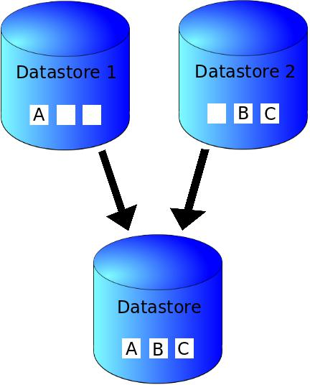

Figure 8.1: IMAGE CAPTION

1 PASTE YOUR CODE HERE

School of Computer Engineering, KIIT, BBSR 8

CS-BOTS

Chapter 9

Screen shots of Project

9.1 SECTION NAME

Figure 9.1: IMAGE CAPTION

School of Computer Engineering, KIIT, BBSR 9

CS-BOTS
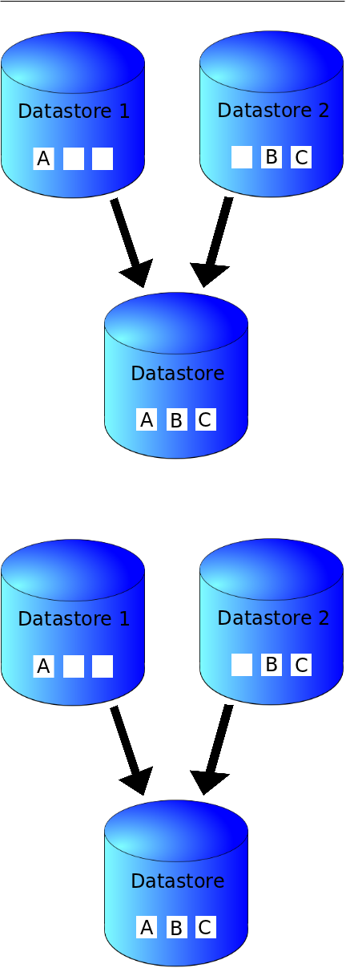

Figure 9.2: IMAGE CAPTION

School of Computer Engineering, KIIT, BBSR 10

CS-BOTS

Chapter 10

Conclusion and Future Scope

10.1 Conclusion

WRITE HERE.

10.2 Future Scope

WRITE HERE.

ITEM 1 ITEM 2 ITEM 3

School of Computer Engineering, KIIT, BBSR 11

CS-BOTS

References

All references should be numbered and cited in the content.

sxkjsjclksjlcxjslkx

School of Computer Engineering, KIIT, BBSR 12

CS-BOTS

SAMPLE INDIVIDUAL CONTRIBUTION REPORT:

<TITLE OF THE PROJECT IN FONT SIZE 14, FONT STYLE TIMES NEW ROMAN, BOLD AND CENTERED>

<Student Name (in capital letters in font size 12, Times New Roman and centered>
<Student Roll number (font size 12, Times New Roman and centered>

Abstract: A short description of the aim and objective of the project work carried out in 3-4 lines. This part should be common to all students in the group. The font size and style will remain same from this point onwards. The font size will be 12 and font style will be Times New Roman. The line spacing will be 1.5.
This report should be prepared in A4 page format with ‘default’ option under ‘Margin’ of the ‘Page Layout’ tab in Microsoft Word. Word limit for this section is 80.

Individual contribution and findings: The student should clearly indicate his/her role in the project group and the contribution in implementing the project work. The student should also outline his /her planning involved in implementing his/her part in the work. This contribution report should be different for every student in the group. The student would also write his./her technical findings and experience while implementing the corresponding part of the project. The overall contribution report should not be less than 1 page for each student. The Student should provide both the soft copy and signed hard copy to the project supervisor.

Individual contribution to project report preparation: Student should mention his/her role in preparing the group project report indicating which chapter and portions contributed.

Individual contribution for project presentation and demonstration: Student should mention his/her role in preparing presentations and part of the project demonstrated.

Full Signature of Supervisor: Full signature of the student:
……………………………. ……………………………..

School of Computer Engineering, KIIT, BBSR 14

TURNITIN PLAGIARISM REPORT
(This report is mandatory for all the projects and plagiarism
must be below 25%)

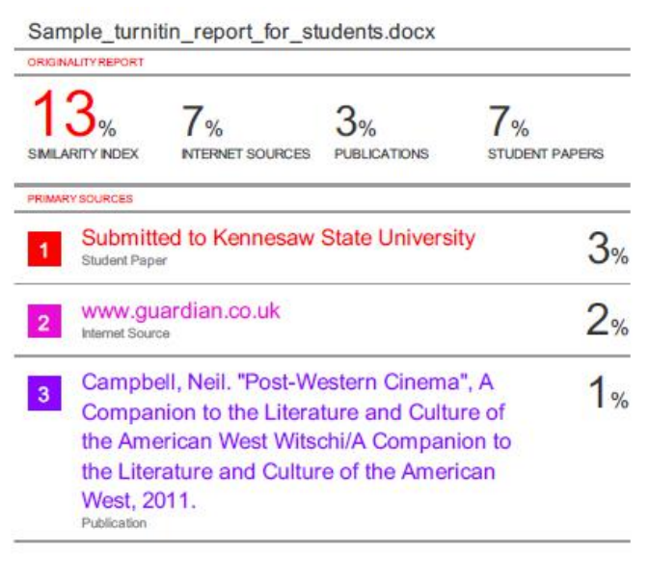

School of Computer Engineering, KIIT, BBSR 15

