***Stage 2***

***Team Name: Vivacious Vanquishers App Name: GoGirl!***

***Team Leader Name: Akanksha Bodhankar College Name: Keshav Memorial Institute Technology***

***Team Leader Mail ID: GitHub Link: https://github.com/AkankshaBodhankar/GoGirl***

***Describe your solution from the End User Perspective:***

***1. End user functionality of the App? (Example: Create recurring schedules, reminders, suggestions etc.) \****

The app has been divided into modules. The functionalities below are organized according to that:

One time login using name and email id

Slide-in menu to choose the module which are given below

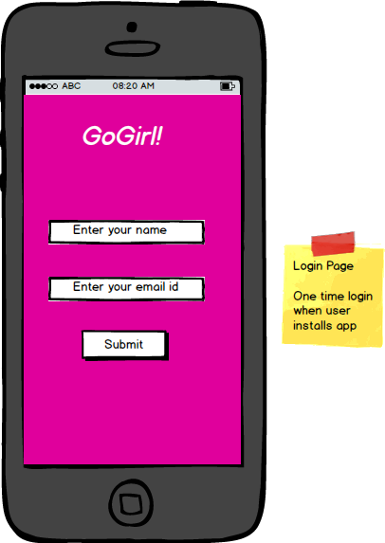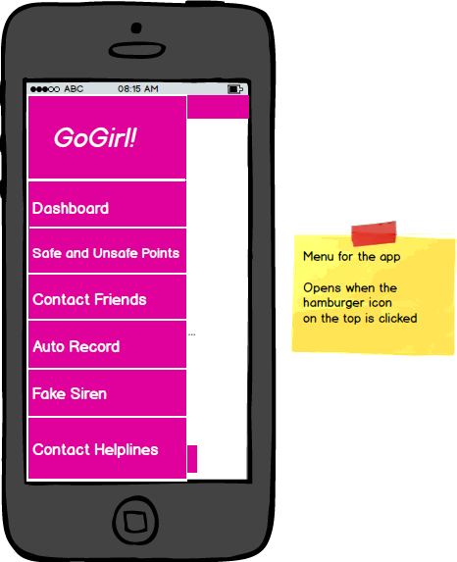

1. Dashboard

View move of the day (tactics for self-defense)

Edit profile if necessary

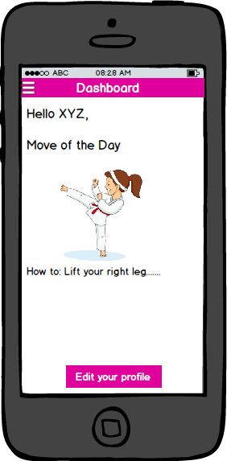

2. Safe and Unsafe Points

View safe points and unsafe points on the entire map (These will be marked by the users, all users can view all the points marked by others as well)

Add/Delete safe point (Green mark-indicates safe)

Add/Delete unsafe point (Red mark-indicates unsafe)

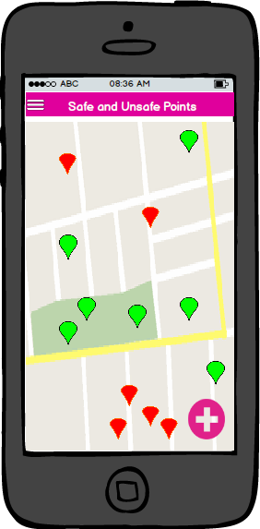

3. Contact Friends

Contact friends on one-click (sends location and an emergency message)

Add contacts from mobile (1-5 contacts)

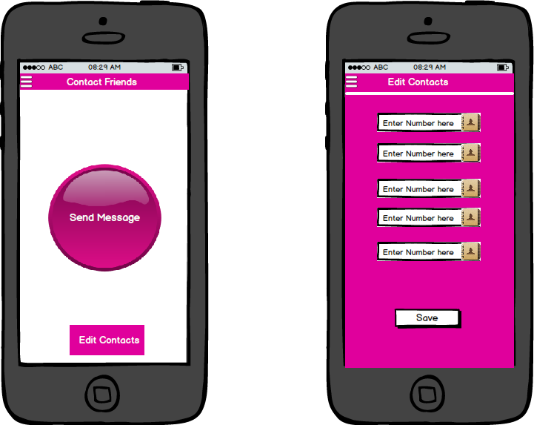

4. Auto-Record

Start audio record during emergency situations (Works as a proof of crime)

5. Fake Siren

Start a police fake siren audio when needed

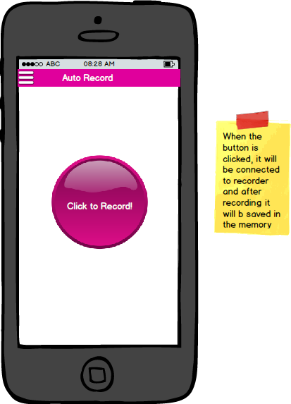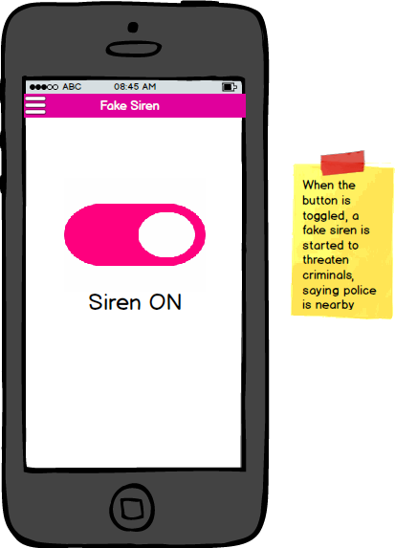

6. Contact Helplines

Call helplines directly from application (Police, Hospitals, She teams etc.)

***2. End user Benefits of the App? – (Example: It understands the user’s behavioral and automates most of the work because of which he could be more productive in other areas*** ***etc.)\****

>One time login (No need to login every time)

>Select contacts directly from address book and can also add phone numbers explicitly

>Automatically move of the day will be updated according to UTC 00:00

>View safe/unsafe points according to user location (Also, user can view points in entire map using Zoom in and Zoom out)

>Contact well-wishers on single click

>Application starts audio recording on one-click and the recording will be saved in memory automatically

>Calling the helplines directly without the need to search for the helpline numbers

\***Elaborate your answers**

***Describe your solution from the Technology Perspective:***

***1. What Languages, Libraries and frame work are going to be used to create the app? (Example: Python, c, java, IOT)\****

>Android (User Interface)

>PHP (To communicate with database server)

>Database (MySQL)

>Apache Tomcat (Backend Server)

>Google Maps API for marking safe and unsafe points

Platform used: Android Studio, XAMPP

***2. How to develop it? (Test Driven)\****

The project will be developed using **AGILE METHODOLOGY**

As the application is divided into modules, we plan to use agile methodology and develop each module at once. One module will be developed and tested thoroughly and only then, the next module will be started.

*The procedure goes as follows:*

>Divide project into modules (Login, menu, feature1, feature 2 etc.)

>Divide time into timeframes (weekly timeframes or 5 day time frames)

>Develop each module in one time frame

>At the end of each timeframe write tests for the developed module and test it

>Move to the next module in the next timeframe and continue the process

As a team, we plan to use *‘Kanban Flow’* for dividing the tasks and track the project progress. It will look something like this:

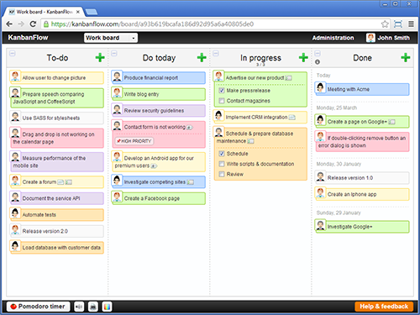

***3. What is your deployment Strategy? (Cloud or Device)\****

Our Android application will be deployed as a device app which communicates with the server for data management and processing.

We have our own running server

The android app will be deployed on Playstore

***4. What are the layers will be there in your application? (Example: Presentation layers, Database, Server)\****

The layers will be as follows:

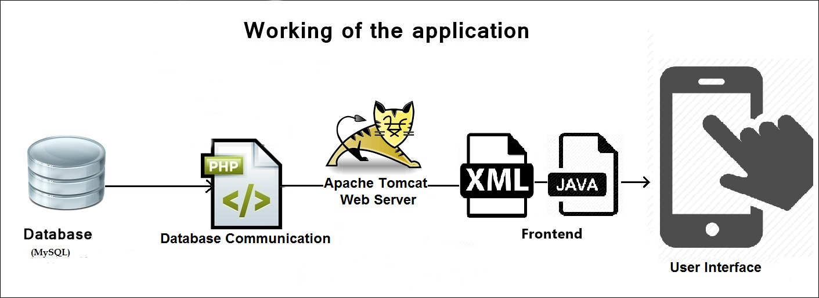

***5. What’s in it for the developer? (Example: Return On investment, Value Proposition)\****

After deploying the application on Google Playstore, the returns will be made as the downloads increase. We plan to promote the application after deployment so maximum profits will be made.

Also, we have developed this application for the good of society. Once it is put to use the satisfaction will be immense that, a girl was saved.

**Note:**

***Register yourself in*** [***www.github.com***](http://www.github.com) ***, create a repository and share you repository link. You will be using this repository for writing your code in third stage. Without the GitHub link you cannot proceed further.***

\***Elaborate your answers**