Colocacion: Job Recommendation System

Submitted by

IV CSE-A

Akanksha Bodhankar – 13BD1A0502

Anoosha Chandra – 13BD1A0509

Sai Matha – 13BD1A0516

Myneni Pravallika – 13BD1A0534

**Project Description**

Colocation is a Job Recommendation System which recommends jobs on the basis of applicant’s profile and calibre. The recommendation will be based on the following data:

* User’s basic profile (Educational background, interests, skills etc.)
* Jobs liked by users having similar skills and preferences
* User’s response to various questionnaires conducted through the portal
* Basic filters such as salary range, location, experience etc.

Existing Systems

There aren’t many existing portals which retrieve relevant and efficient results. The results are generally based on basic details such as educational background. However, there is a need to have a finer filter which scrutinises the interest and calibre of the applicant as well. This will increase the efficiency of results and also maximize user satisfaction.

Problem Statement

There is a need to increase the efficiency of the recommendation systems. The cold start problem is very evident in the existing systems. If only collaborative filtering techniques are used the results are not efficient until there is good input data. To overcome this problem a hybrid system must be built which uses content based techniques when there is no data available and switches to collaborative when there is sufficient dataset available. Particularly, it is important to retrieve a result which is relevant as well as satisfies the user. Using enhanced input and better algorithms a better recommendation of jobs is our goal.

Objectives

1. To display the jobs using recommendation systems
2. Improve results by including a questionnaire portal
3. To improve the existing recommendation algorithms
4. To enhance the input so as to increase efficiency of results

Technologies used

* HTML5, CSS3 and Javascript(Front end)
* Python Django(Backend language)
* SQlite (Database)
* Machine Learning Algorithms

Modules of the app

* Login and Registration

The portal can be accessed using authenticated login. Registration will be done once during the first visit

* User Profile

Maintains personal and professional information of the user

* Questionnaires Portal

Conduct various tests to evaluate the calibre and ability of the candidate

* Dashboard

Display the results retrieved by the portal

Overview of Machine Learning Algorithms used

* User’s basic profile (Educational background, interests, skills etc.)

Content – based Filtering Algorithm

* Using basic preferences of salary range, location etc.

Content – based Filtering Algorithm

* Jobs liked by users having similar skills and preferences

Collaborative Filtering Algorithm

* Jobs liked/applied by the user in the past

Collaborative Filtering Algorithm

* User’s response to various questionnaires conducted through the portal

Basic Algorithm using programming tools

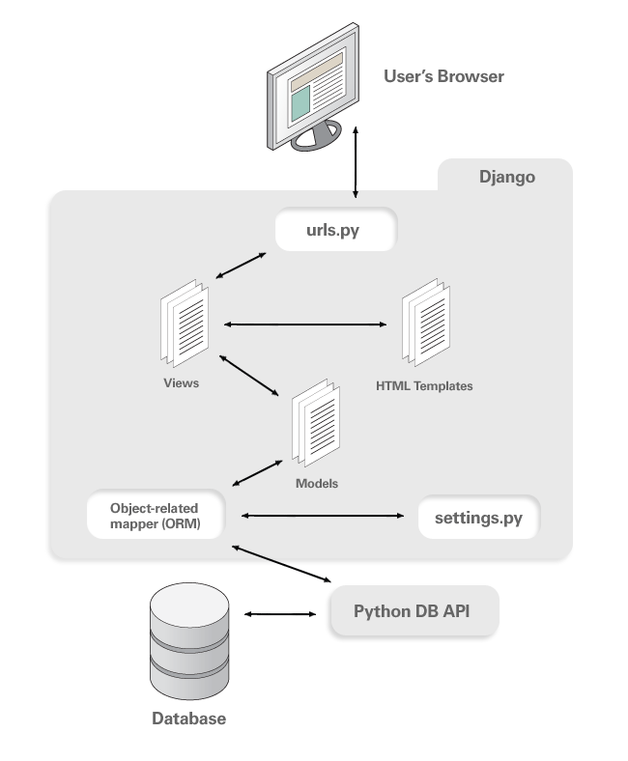

Architecture

Fig.no. 1

Database Design

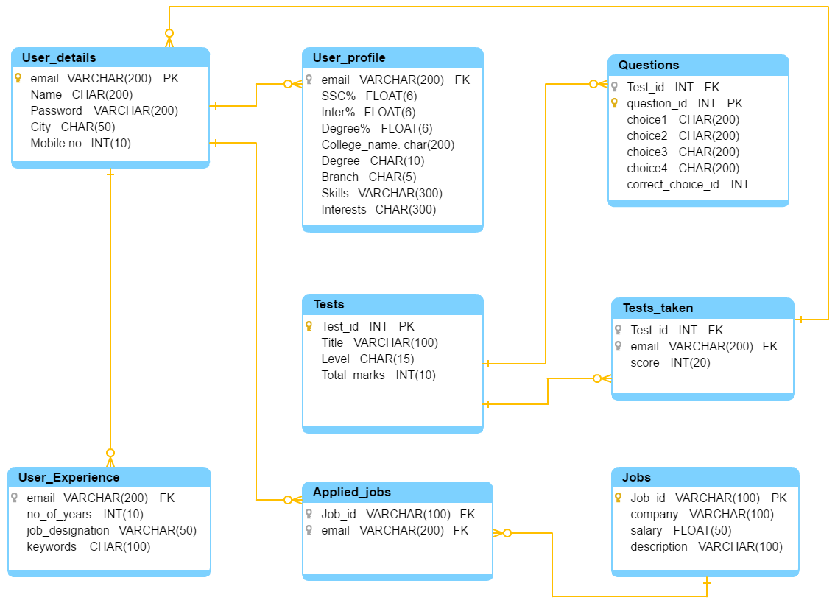

Fig.2. Database Architecture

**Logical Design of the Project**

Use Case Diagram

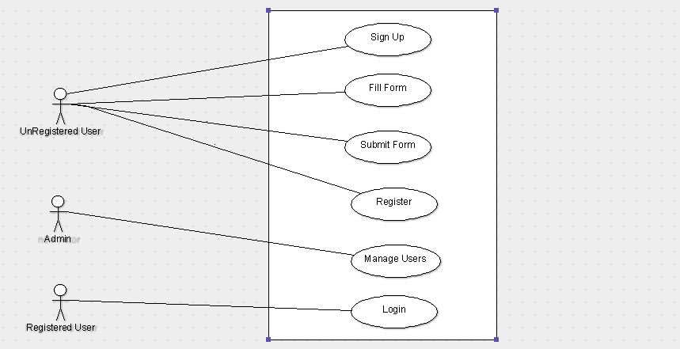

Fig.3. Login and Registration

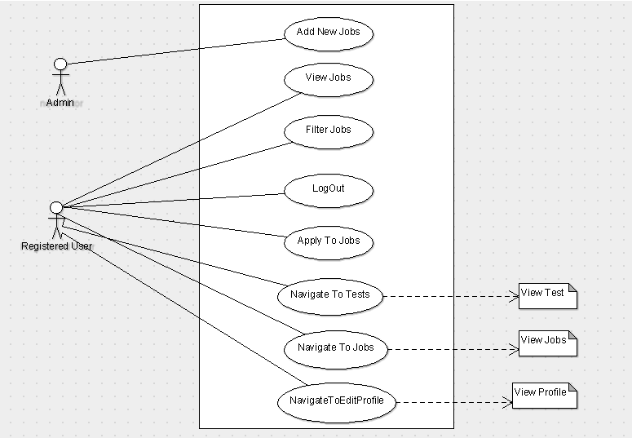

Fig.4. Dashboard

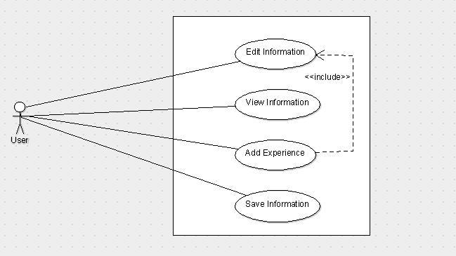

Fig.5. Profile

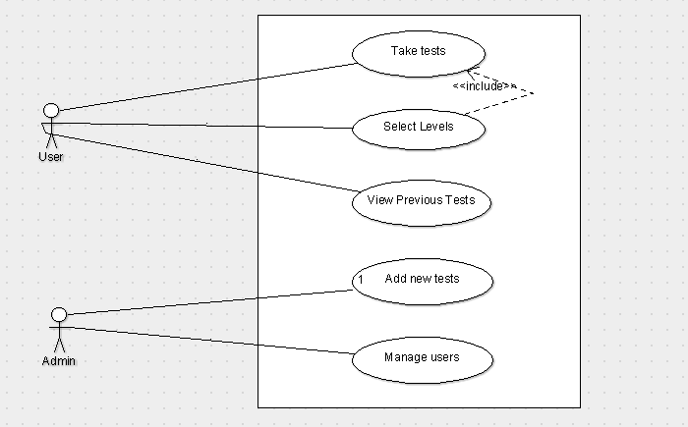

Fig.6. Tests

Sequence Diagrams

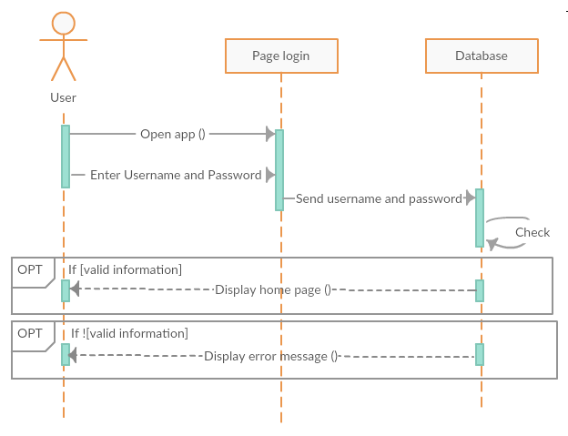

Fig.7. Login

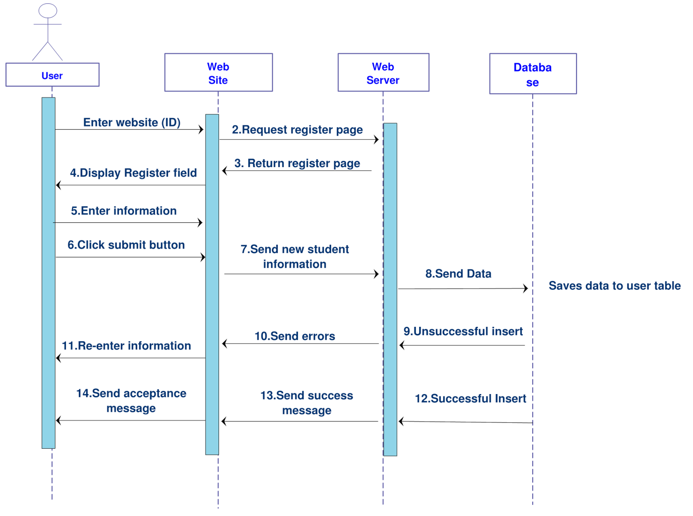

Fig.8. Registration

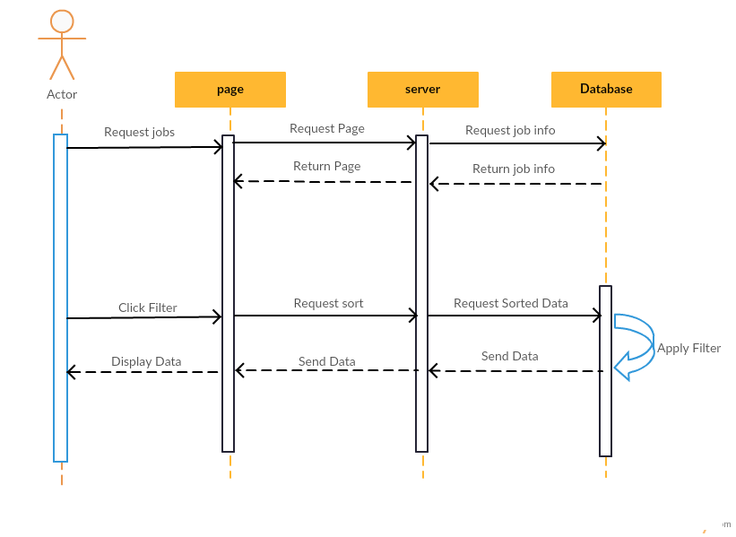Fig.9. Jobs

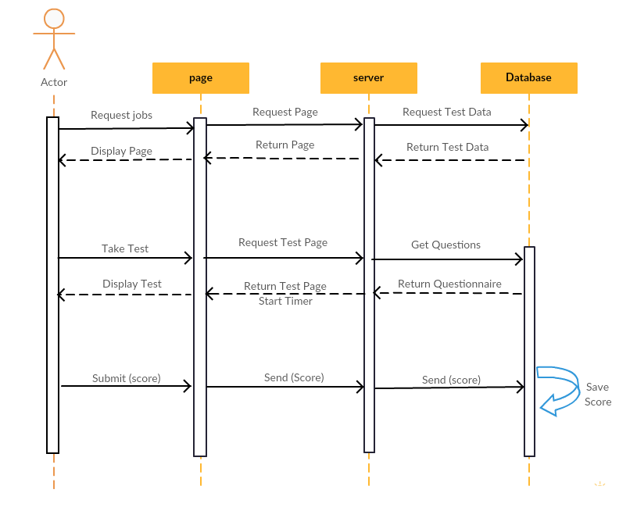

Fig.10. Tests

Activity Diagram

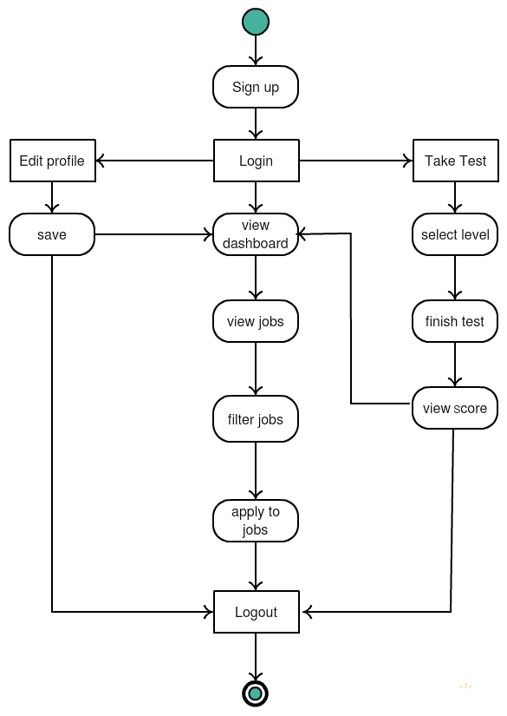

Fig.11. Overall activity diagram

Component Diagram

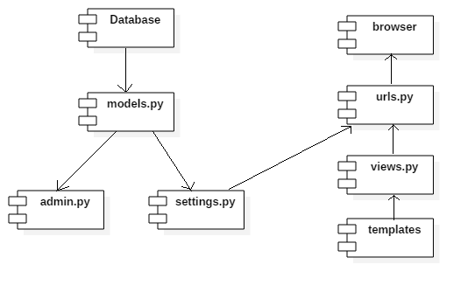

Fig.12. components

Deployment Diagram

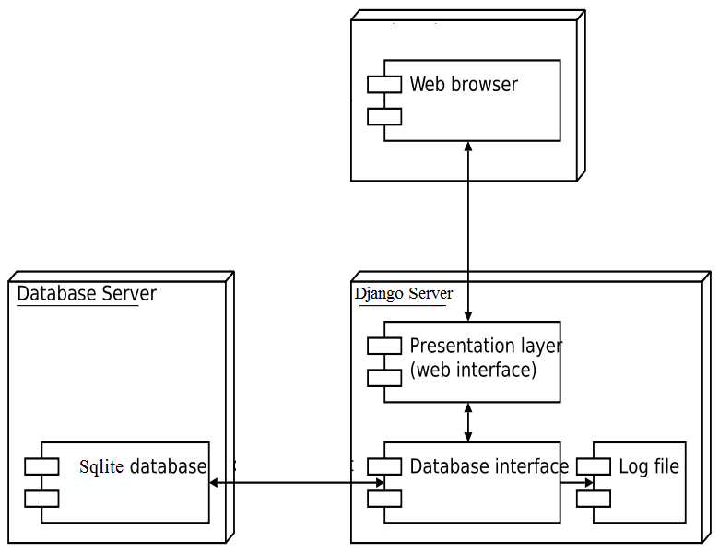

Fig.13. deployment nodes