Internship Task-2
Introduction
The Motion Detection Home Security System Using PIR Sensor is an Arduino-based embedded systems project designed to improve home safety by detecting human movement. It uses a Passive Infrared (PIR) sensor to sense changes in infrared radiation emitted by the human body. When motion is detected, the PIR sensor sends a signal to the Arduino Uno, which activates an LED and a buzzer to provide visual and audible alerts. When no motion is detected, both the LED and buzzer remain OFF. This project is simple, cost-effective, and reliable, making it suitable for home security, office security, and smart automation applications. It also helps in understanding sensor interfacing, embedded programming, and real-time monitoring using Arduino.
Features
• Detects human motion using a PIR sensor.
• Provides instant visual alert through an LED.
• Generates an audible alert using a buzzer.
• Real-time motion detection and monitoring.
• Low-cost and easy to build.
• Low power consumption.
• Reliable and accurate motion sensing.
• Easy to interface with Arduino Uno.
• Suitable for home and office security.
• Can be upgraded with IoT modules for remote monitoring.

LED ON Condition:
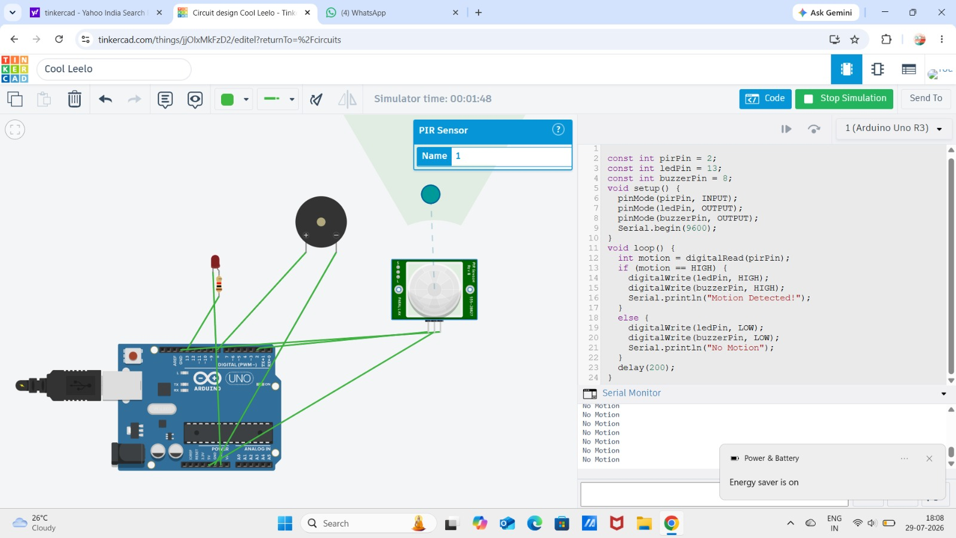

When no movement is present within the PIR sensor’s detection range, the sensor sends a LOW signal to the Arduino Uno. The Arduino keeps the LED and buzzer OFF, indicating that no motion has been detected. The Serial Monitor displays the message “No Motion”.

Motion detection Condition:
When a person enters the detection range of the PIR sensor, it senses the change in infrared radiation and sends a HIGH signal to the Arduino Uno. The Arduino immediately turns ON the LED and the buzzer, indicating that motion has been detected. The Serial Monitor displays the message “Motion Detected!”.
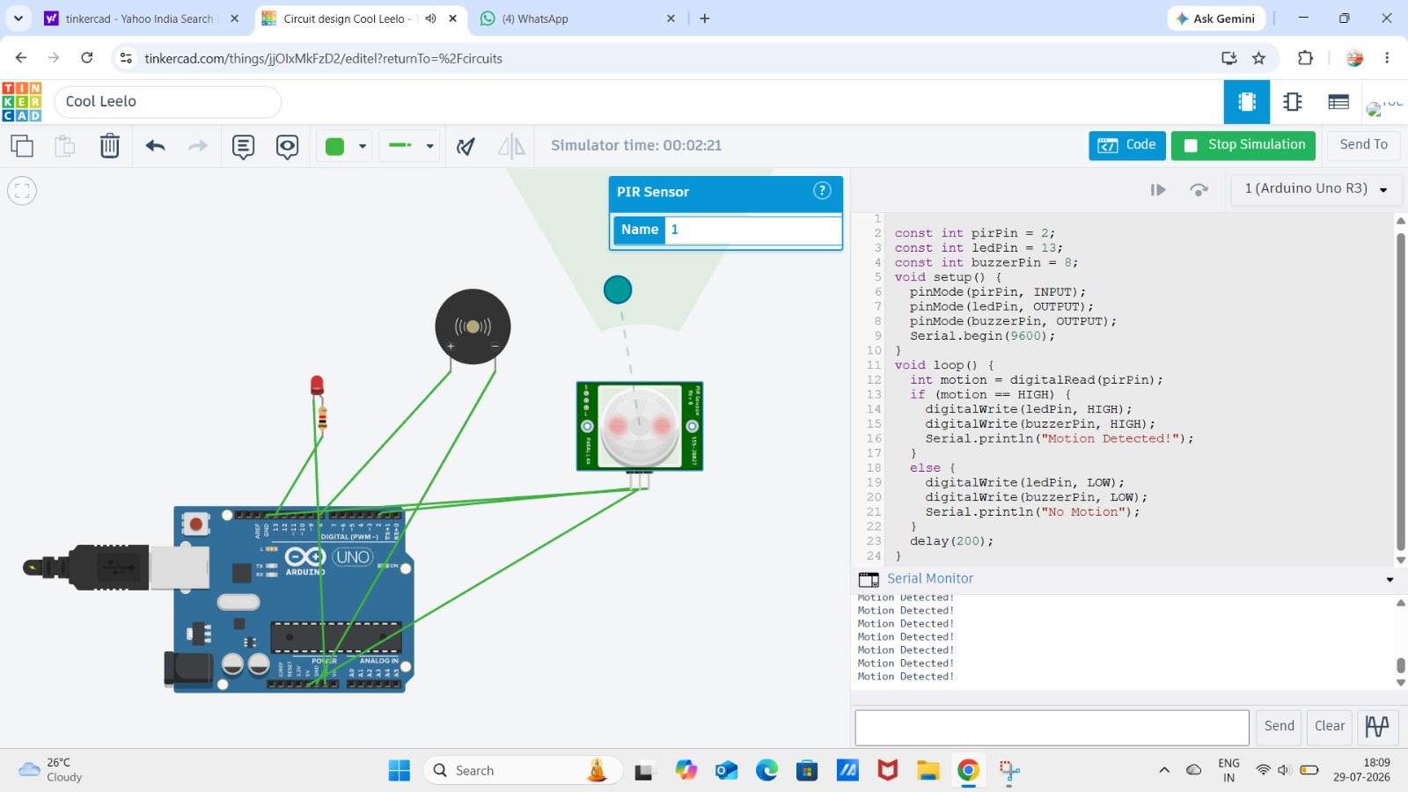
Source code :
// Home Security System using PIR Motion Sensor, LED and Buzzer
Const int pirPin = 2; // PIR sensor connected to Digital Pin 2
Const int ledPin = 13; // LED connected to Digital Pin 13
Const int buzzerPin = 8; // Buzzer connected to Digital Pin 8
Void setup() {

pinMode(pirPin, INPUT); // Set PIR pin as input
pinMode(ledPin, OUTPUT); // Set LED pin as output
pinMode(buzzerPin, OUTPUT); // Set buzzer pin as output
Serial.begin(9600); // Start Serial Monitor }
Void loop() {
// Read PIR sensor output
Int motion = digitalRead(pirPin)
If (motion == HIGH)
digitalWrite(ledPin, HIGH); // Turn ON LED
digitalWrite(buzzerPin, HIGH); // Turn ON Buzzer
Serial.println(“Motion Detected!”);
} else {
// No motion detected
digitalWrite(ledPin, LOW); // Turn OFF LED
digitalWrite(buzzerPin, LOW); // Turn OFF Buzzer
Serial.println(“No Motion”);
}
Delay(200); // Wait for 200 milliseconds
}

