

iView XML Interface Document
NexTone Communications, Inc.
9700 Great Seneca Highway
Rockville, Maryland 20850
www.nextone.com

NexTone Communications
22-0610001-001-A
April 14, 2001

Copyright © 2001 NexTone Communications

All rights reserved. This publication and its contents are proprietary to NexTone Communications. No part of this publication may be reproduced, distributed or modified in any form or by any means without the written permission of NexTone Communications, 9700 Great Seneca Highway, Rockville, Maryland 20850.
The information in this document is subject to change without notice. NexTone Communications makes no warranty of any kind with regard to this material, including, but not limited to, the implied warranties of merchantability and fitness for a particular purpose.

Trademarks

NexTone iEdge 1000 and NexTone iServer are trademarks of NexTone Communications. Other trademarks, marks, names, or product names referenced in this publication are the property of their respective owners, and NexTone Communications neither endorses nor sponsors any such products or services referred to herein.
- Revision History
Revision | Date | Description
001-A | 4/14/2001 | Initial Revision

1. Revision History 3
2. References 5
3. Introduction 6
4. System Overview 7
5. Message Flows 9
5.1 Hello/Registration 10
5.2 Configuring Data 11
5.3 Reading Data 12
5.4 Download Code 14
6. Message Definitions 15
6.1 HELLO Message 16
6.2 REGISTRATION Message 17
6.3 DownloadCodeReq Message 19
6.4 Status Message 20
6.5 PasswordConfigure Message 21
6.6 H323Configure Message 23
6.7 SIPConfigure Message 26
6.8 SWDownloadConfigure Message 28
6.9 GetCommand Message 30
6.10 H323Response Message 31
6.11 SIPResponse Message 33
6.12 SWDownloadResponse Message 35
A. Integration of Third Party Devices 37

- References
The following references are not required reading but will help the user to understand the formats used in defining the messages.

Reference | Description | Author
http://www.xml.org | Various XML definitions | N/A
http://www.w3.org | Various XML definitions | N/A

- Introduction

Using NexTone’s iServer architecture, service providers can quickly provision customer endpoints and add new services and applications. The value of this architecture is not just in the just in the number of new services that can be offered but also in the speed at which they can be introduced. Some in the industry refer to this as service velocity — the ability to try out new applications on end-users and to quickly deploy on a mass scale, those applications identified to be “killer apps”.

The iServer architecture consists of the NexTone Application Switch, the NexTone family of Application Servers and NexTone Service Portal. This application-driven architecture is shown in the figure below.
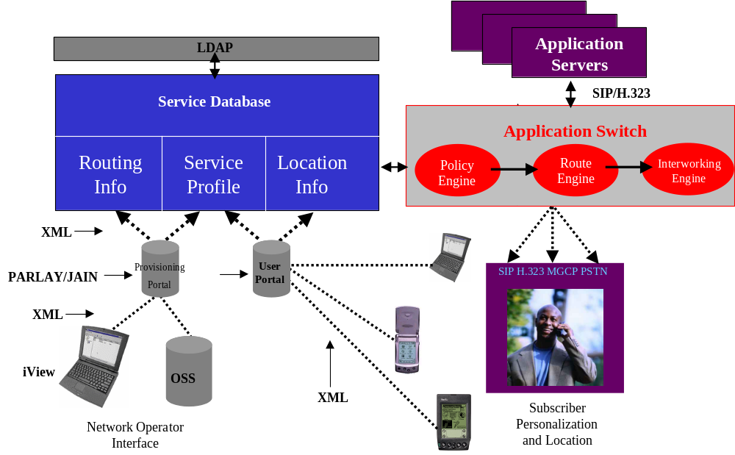
Figure 1. iServer Architecture.

The NexTone Application Switch provides application connectivity between IP endpoints. This platform provides the policy-based call routing and signaling interworking (SIP, H.323) needed to deploy applications in an on-net IP environment while also interoperating with softswitch and media gateway platforms for off-net calls to and from the PSTN. The NexTone family of Application Servers provides enhanced services such as voice VPNs, PAM and unified messaging. Within this environment, the NexTone Service Portal drives the creation of new applications. The iView System Console presents a service provisioning front-end for the network operator. However, for the end-user, service creation can be accomplished through a web browser. This web browser communicates with the NexTone Service Portal, which executes Java APIs to communicate with the Service Database and the Application Switch to enable applications.
The use of open interfaces within the iServer architecture allows a broader vendor community to participate in a service creation model that is centered on a user controlled service creation engine. Vendors of network based application platforms (e.g. teleconference, unified messaging, and other media servers) and customer premise devices can use protocols like SIP, H.323, XML and SMTP to quickly socket new applications and platforms into the iServer architecture. This open approach provides service providers with a technology strategy to rapidly create applications for new or existing markets.

This document focuses on how providers of customer premise solutions can interface with the NexTone iView Provisioning Server (simply known as iView). The iView provisioning model provides a highly scalable and easy-to-use framework for the deployment and provisioning of thousands of network endpoints. Specifically, this document details the format and content of messages used to interact with iView and indicates both the mandatory and optional content of each message. It should be noted that mandatory fields and messages must be implemented to interact with iView. A subset of the messages allow vendor specific parameters to be added. The example XML code and associated DTD give examples and indications of their use.

- System Overview
iView provides the user with the ability to configure network based devices either on the local LAN or on a remote network.

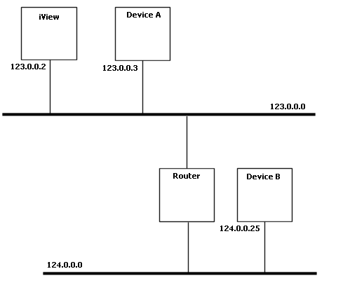
The devices on the local LAN can be automatically discovered by iView. Any remotely located devices need to be added to the map as static devices.

The devices on the map periodically have their health checked using a polling mechanism.

The following diagram shows an iView map with static and discovered devices.
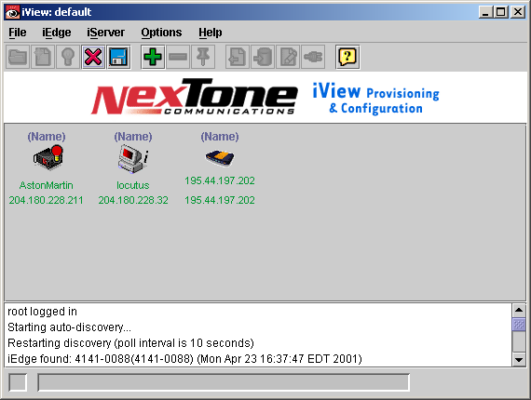

- Message Flows
The following diagrams depict scenarios used to interact with iView.

  - Hello/Registration

Description
iView uses HELLO messages to discover devices on the local network and also to check the health of remote devices.
If discovery is enabled, iView will send Multicast messages to the local network using address 224.0.1.20 [This is to change when the IANA registration comes through].
For remote devices the HELLO message is sent as a unicast message. Remote devices are defined as devices that are statically added to the map on iView.
The REGISTRATION message shall be returned as a Unicast message to iView.
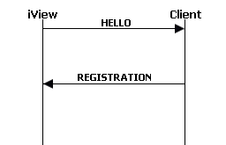
Example Messages
<?xml version="1.0" encoding="ISO-8859-1"?>
<!DOCTYPE NexToneMsg SYSTEM ".\Hello.dtd">
<NexToneMsg version="1.0" cmd="Hello">
<ReadPasswd>1234ABC</ReadPasswd>
<WritePasswd>1234ABC</WritePasswd>
</NexToneMsg>

<?xml version="1.0" encoding="ISO-8859-1"?>
<!DOCTYPE NexToneMsg SYSTEM ".\Registration.dtd">
<NexToneMsg version="1.0" cmd="Registration">
<SoftwareVersion>1.0</SoftwareVersion>
<ConfigVersion>1.0</ConfigVersion>
<RegistrationID>Test iEdge</RegistrationID>
<DeviceType type="iEdge1000">
<Manufacturer>NexTone</Manufacturer>
</DeviceType>
<SerialNumber>1000-0001</SerialNumber>
<FQDN>ie1000.nextone.com</FQDN>
<Mode mode="OPERATIONAL"/>
<NeedIP required=”true”/>
<VendorData>
<T1Status id=”1” status=”ip”/>
</VendorData>
</NexToneMsg>

  - Configuring Data

Description
Devices are configured using a command response pair. The configuration data is sent as a delta, i.e only the information that has changed is transmitted. The DTD for configuring data specifies which fields are mandatory and which are optional.
The Configure message can comprise more than one set of data i.e. it could contain both the SIP and H323 configurations.
The Client responds with a status indication indicating either success or failure.
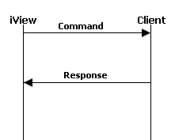
Example Messages
<?xml version="1.0" encoding="ISO-8859-1"?>
<NexToneMsg version="1.0" cmd="Config">
<ReadPassword>1234ABC</ReadPassword>
<WritePassword>1234ABC</WritePassword>
<H323Data>
<H323Gateway>192.168.0.1</H323Gateway>
<GatewayConfig>
<CountryCode>44</CountryCode>
<AreaCode>1229</AreaCode>
<ExchangeCode>830</ExchangeCode>
</GatewayConfig>
</H323Data>
<SIPData protocol="udp">
<ProxyServer>
<Address>192.168.0.1</Address>
<Port>6090</Port>
</ProxyServer>
</SIPData>
</NexToneMsg>

<?xml version="1.0" encoding="ISO-8859-1"?>
<NexToneMsg version="1.0" cmd="Status">
<Status status="success"></Status>
</NexToneMsg>

  - Reading Data
Description
The current configuration is read from a device using a request and a response. The request identifies the data to be retrieved. The response will return the requested data in its specific format, or an indication of a failure.
The format of the message is similar to that of the configuration messages. The difference between the two is that all the fields are required to be present when reading the data. When configuring the data, only the fields that have been modified (and are not mandatory) are sent.
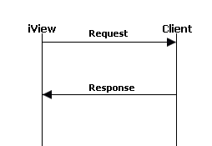

Example Messages
<?xml version="1.0" encoding="ISO-8859-1"?>
<NexToneMsg version="1.0" cmd="GetCommand">
<ReadPassword>1234ABC</ReadPassword>
<WritePassword>1234ABC</WritePassword>
<Request data="H323"/>
<Request data="SIP"/>
</NexToneMsg>

<?xml version="1.0" encoding="ISO-8859-1"?>
<!DOCTYPE NexToneMsg SYSTEM ".\Response.dtd">
<NexToneMsg version="1.0" cmd="Response">
<H323Data>
<H323Gateway>192.168.0.1</H323Gateway>
<GatewayConfig>
<CountryCode>44</CountryCode>
<AreaCode>1229</AreaCode>
<ExchangeCode>830</ExchangeCode>
</GatewayConfig>
<GatekeeperConfig addressType="static">
<Gatekeeper role="primary">
<Address> </Address>
<ID></ID>
</Gatekeeper>
<Gatekeeper role="secondary">
<Address> </Address>
<ID> </ID>
</Gatekeeper>
</GatekeeperConfig>
</H323Data>
<SIPData protocol="tcp">
<Domain>NexTone</Domain>
<Registrar>192.168.0.1</Registrar>
<Registration enable="true">192.168.0.1</Registration>
<ProxyServer>
<Address>192.168.0.1</Address>
<Port>6090</Port>
</ProxyServer>
</SIPData>
</NexToneMsg>

  - Download Code

Description
Downloading Code is a feature of both manual configuration and also the Download Server (automatic configuration).
The mechanism used requires that the client uses FTP or TFTP to retrieve its configuration when it receives a Download Code Request.
The client must be capable of retrieving the code and also performing a reboot on completion. The reboot must result in the client resuming the state prior to the upgrade.
The parameters for determining the filename and server parameters are configured prior to the download using a SWDownloadConfigure message (TODO:REF).
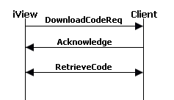
The mechanism for retrieving the code (FTP or TFTP) need not be defined at this level.

Example Messages
<?xml version="1.0" encoding="ISO-8859-1"?>
<NexToneMsg version="1.0" cmd="DownloadCodeRequest">
<ReadPassword>1234ABC</ReadPassword>
<WritePassword>1234ABC</WritePassword>
<Reboot enable="true"/>
</NexToneMsg>

<?xml version="1.0" encoding="ISO-8859-1"?>
<NexToneMsg version="1.0" cmd="Status">
<Status status="success"> </Status>
</NexToneMsg>

Download will now occur.
- Message Definitions
The following section describes the messages in XML format. With each message is a short description followed by an XML example and the associated Document Type Definition (DTD).
  - HELLO Message
Description
This message is transmitted on the local network during the discovery phase. Devices that receive this message and have matching device passwords must respond with a REGISTRATION message.
Parameter Descriptions
Parameter | Required | Description
ReadPassword | ✓ | The password used to gain read permission to the device
WritePassword | ✓ | The password used to gain write permission to the device

Example Format
<?xml version="1.0" encoding="ISO-8859-1"?>
<!DOCTYPE NexToneMsg SYSTEM ".\Hello.dtd">
<NexToneMsg version="1.0" cmd="Hello">
<!-- The READ password for the device -->
<ReadPasswd>read</ReadPasswd>
<!-- The WRITE password for the device -->
<WritePasswd>write</WritePasswd>
</NexToneMsg>
DTD
<?xml version="1.0" encoding="ISO-8859-1"?>
<!-- HELLO Message -->
<!ELEMENT NexToneMsg (ReadPasswd, WritePasswd)>
<!ATTLIST NexToneMsg
version CDATA #REQUIRED
cmd CDATA #FIXED "Hello"
>
<!ELEMENT ReadPasswd (#PCDATA)>
<!ELEMENT WritePasswd (#PCDATA)>

  - REGISTRATION Message
Description
This message must be transmitted by the device in response to an HELLO message. The device should ignore the HELLO message if the passwords provided in it do not match the passwords configured on the local device.
The REGISTRATION message provides iView with an indication that the device is healthy. It also provides information to allow iView to customize the icon displayed depending on the current state of the device.
Parameter Descriptions
Parameter | Required | Description
SoftwareVersion | ✓ | The current version of the software
ConfigVersion | ✓ | The current version of configuration (defined by the download server).  Default 0.
RegistrationID | ✓ | A unique identifier for the device. Used to identify the device on the iView map.
DeviceType | ✓ | Defines the device type from an enumerated list. TODO list of devices.
Manufacturer | ✓ | The manufacturers name
SerialNumber | ✓ | The serial number of the device. This needs to be unique from all other manufacturers devices.
FQDN | ✓ | The Fully Qualified Domain Name of the device. Can be an empty string but the element is required.
Mode | ✓ | The mode of the device. This is an enumerated list
NeedIP | ✓ | This indicates that the device failed to get an IP address (DHCP) at startup.
VendorData | ✓ | This section can be filled with vendor specific data. This data must be specified by the vendor for it to be used by iView.

Example Format
<?xml version="1.0" encoding="ISO-8859-1"?>
<!DOCTYPE NexToneMsg SYSTEM ".\Registration.dtd">
<NexToneMsg version="1.0" cmd="Registration">
<SoftwareVersion>1.0</SoftwareVersion>
<ConfigVersion>1.0</ConfigVersion>
<RegistrationID>Test iEdge</RegistrationID>
<DeviceType type="iEdge1000">
<Manufacturer>NexTone</Manufacturer>
</DeviceType>
<SerialNumber>1000-0001</SerialNumber>
<FQDN>ie1000.nextone.com</FQDN>
<Mode mode="OPERATIONAL"/>
<NeedIP required=”true”/>
<VendorData>Vendor specific tags</VendorData>
</NexToneMsg>
DTD
<?xml version="1.0" encoding="ISO-8859-1"?>
<!ELEMENT NexToneMsg (SoftwareVersion, ConfigVersion, RegistrationID, DeviceType, SerialNumber, FQDN, Mode, NeedIP, VendorData?)>
<!ATTLIST NexToneMsg
version CDATA #REQUIRED
cmd CDATA #FIXED "Registration"
>
<!ELEMENT SoftwareVersion (#PCDATA)>
<!ELEMENT ConfigVersion (#PCDATA)>
<!ELEMENT RegistrationID (#PCDATA)>
<!ELEMENT DeviceType (Manufacturer)>
<!ATTLIST DeviceType
type CDATA #REQUIRED
>
<!ELEMENT FQDN (#PCDATA)>
<!ELEMENT Manufacturer (#PCDATA)>
<!ELEMENT Mode EMPTY>
<!ATTLIST Mode
mode CDATA #REQUIRED
>
<!ELEMENT Name (#PCDATA)>
<!ELEMENT SerialNumber (#PCDATA)>
<!ELEMENT SpanStatus EMPTY>
<!ATTLIST SpanStatus
status (OPERATIONAL | MAINTENANCE | NO_STATUS) #REQUIRED
>
<!ELEMENT VendorData (#PCDATA)>
<!ELEMENT SpecialID (#PCDATA)>

  - DownloadCodeReq Message
Description
This message is transmitted to the device to request an upgrade of the operating software/firmware. The Reboot enable flag is used to indicate whether the device should reboot after upgrading.
Parameter Descriptions
Parameter | Required | Description
ReadPassword | ✓ | The password used to gain read permission to the device.
WritePassword | ✓ | The password used to gain write permission to the device.
Reboot | ✓ | Indicate whether the device should be rebooted after downloading the code.
Example Format
<?xml version="1.0" encoding="ISO-8859-1"?>
<!DOCTYPE NexToneMsg SYSTEM ".\DownloadCodeRequest.dtd">
<NexToneMsg version="1.0" cmd="DownloadCodeRequest">
<ReadPassword>read</ReadPassword>
<WritePassword>write</WritePassword>
<Reboot enable="true"/>
</NexToneMsg>
DTD
<?xml version="1.0" encoding="ISO-8859-1"?>
<!ELEMENT NexToneMsg (ReadPassword, WritePassword, Reboot)>
<!ATTLIST NexToneMsg
version CDATA #REQUIRED
cmd CDATA #FIXED "DownloadCodeRequest"
>
<!ELEMENT Reboot EMPTY>
<!ATTLIST Reboot
enable (true | false) #REQUIRED
>
<!ELEMENT ReadPassword (#PCDATA)>
<!ELEMENT WritePassword (#PCDATA)>
  - Status Message
Description
This message is transmitted in response to a configuration request. The content describes the result of the request.
Parameter Descriptions
Parameter | Required | Description
Status | ✓ | The status of the request [success|fail]. An optional description of the response. This can be used to carry failure indications.
Example Format
<?xml version="1.0" encoding="ISO-8859-1"?>
<!DOCTYPE NexToneMsg SYSTEM ".\Status.dtd">
<NexToneMsg version="1.0" cmd="Status">
<Status status="success">Description of status if required</Status>
</NexToneMsg>
DTD
<?xml version="1.0" encoding="ISO-8859-1"?>
<!ELEMENT NexToneMsg (Status)>
<!ATTLIST NexToneMsg
version CDATA #REQUIRED
cmd CDATA #FIXED "Status"
>
<!ATTLIST Status
status (success | fail) #REQUIRED
>
<!ELEMENT Status (#PCDATA)>
  - PasswordConfigure Message
Description
This message is used to configure the passwords to be used by the device.
Parameter Descriptions
Parameter | Required | Description
ReadPassword | ✓ | The password used to gain read permission to the device.
WritePassword | ✓ | The password used to gain write permission to the device.

Example Format
<?xml version="1.0" encoding="ISO-8859-1"?>
<!DOCTYPE NexToneMsg SYSTEM ".\Configure.dtd">
<NexToneMsg version="1.0" cmd="Config">
<ReadPassword>read</ReadPassword>
<WritePassword>write</WritePassword>
<Passwords>
<!--New Values -->
<ReadPassword>read</ReadPassword>
<WritePassword>write</WritePassword>
</Passwords>
</NexToneMsg>
DTD
<?xml version="1.0" encoding="ISO-8859-1"?>
<!-- Common DTD for configure messages -->
<!-- A configure message can comprise the configuration data for a number of features -->
<!ELEMENT NexToneMsg (ReadPassword, WritePassword, H323Data?, SIPData?, SWDownload?, Passwords?)>
<!ATTLIST NexToneMsg
version CDATA #REQUIRED
cmd CDATA #FIXED "Config"
>
<!ELEMENT H323Data (H323Gateway?, GatewayConfig?, GatekeeperConfig?, VendorData?)>
<!ELEMENT SIPData (Domain?, Registrar?, Registration?, ProxyServer?, VendorData?)>
<!ATTLIST SIPData
protocol (tcp | udp) #REQUIRED
>
<!ELEMENT SWDownload (ServerAddress?, ServerPort?, Mode?, Username?, Password?, Filepath?, Filename?)>
<!ELEMENT GatewayConfig (CountryCode?, AreaCode?, ExchangeCode?)>
<!ELEMENT GatekeeperConfig (Gatekeeper*)>
<!ATTLIST GatekeeperConfig
addressType (static | discover) #REQUIRED
>
<!ELEMENT Gatekeeper (Address?, ID?)>
<!ATTLIST Gatekeeper
role (primary | secondary) #REQUIRED
>
<!ELEMENT Passwords (ReadPassword, WritePassword)>
<!ELEMENT Address (#PCDATA)>
<!ELEMENT AreaCode (#PCDATA)>
<!ELEMENT CountryCode (#PCDATA)>
<!ELEMENT ExchangeCode (#PCDATA)>
<!ELEMENT H323Gateway (#PCDATA)>
<!ELEMENT ID (#PCDATA)>
<!ELEMENT VendorData (#PCDATA)>
<!ELEMENT ReadPassword (#PCDATA)>
<!ELEMENT WritePassword (#PCDATA)>
<!ELEMENT Domain (#PCDATA)>
<!ELEMENT Registrar (#PCDATA)>
<!ELEMENT Registration (#PCDATA)>
<!ATTLIST Registration
enable (true | false) #REQUIRED
>
<!ELEMENT ProxyServer (Address, Port)>
<!ELEMENT Port (#PCDATA)>
<!ELEMENT ServerAddress (#PCDATA)>
<!ELEMENT ServerPort (#PCDATA)>
<!ELEMENT Mode (#PCDATA)>
<!ELEMENT Username (#PCDATA)>
<!ELEMENT Password (#PCDATA)>
<!ELEMENT Filepath (#PCDATA)>
<!ELEMENT Filename (#PCDATA)>
  - H323Configure Message
Description
This message is used to send H323 configuration data to the device. The message will contain only the values that have changed from the data read from the device.
The Vendor Specific element is used to transport any vendor specific parameters that may be required.
Parameter Descriptions
Parameter | Required | Description
ReadPassword | ✓ | The password used to gain read permission to the device.
WritePassword | ✓ | The password used to gain write permission to the device.
H323Gateway |  | The H323 gateway to be used by the device.
GatewayConfig |  | Gateway configuration parameters.
CountryCode |  | The country code for the gateway.
AreaCode |  | The area code for the gateway.
ExchangeCode |  | The exchange code for the gateway.
GatekeeprConfig |  | Gatekeeper configuration parameters.
Gatekeeper |  | The gatekeeper parameters and the gatekeepers role.
Address |  | The address of the gatekeeper.
ID |  | The ID of the gatekeeper.
VendorData |  | This section can be filled with vendor specific data. This data must be specified by the vendor for it to be used by iView.

Example Format
<?xml version="1.0" encoding="ISO-8859-1"?>
<!DOCTYPE NexToneMsg SYSTEM ".\Configure.dtd">
<NexToneMsg version="1.0" cmd="Config">
<ReadPassword>read</ReadPassword>
<WritePassword>write</WritePassword>
<H323Data>
<H323Gateway>Gateway</H323Gateway>
<GatewayConfig>
<CountryCode>code</CountryCode>
<AreaCode>code</AreaCode>
<ExchangeCode>code</ExchangeCode>
</GatewayConfig>
<GatekeeperConfig addressType="static">
<Gatekeeper role="primary">
<Address>address</Address>
<ID>ID</ID>
</Gatekeeper>
<Gatekeeper role="secondary">
<Address>address</Address>
<ID>ID</ID>
</Gatekeeper>
</GatekeeperConfig>
<VendorData>Vendor specific elements</VendorData>
</H323Data>
</NexToneMsg>
DTD
<?xml version="1.0" encoding="ISO-8859-1"?>
<!-- Common DTD for configure messages -->
<!-- A configure message can comprise the configuration data for a number of features -->
<!ELEMENT NexToneMsg (ReadPassword, WritePassword, H323Data?, SIPData?, SWDownload?, Passwords?)>
<!ATTLIST NexToneMsg
version CDATA #REQUIRED
cmd CDATA #FIXED "Config"
>
<!ELEMENT H323Data (H323Gateway?, GatewayConfig?, GatekeeperConfig?, VendorData?)>
<!ELEMENT SIPData (Domain?, Registrar?, Registration?, ProxyServer?, VendorData?)>
<!ATTLIST SIPData
protocol (tcp | udp) #REQUIRED
>
<!ELEMENT SWDownload (ServerAddress?, ServerPort?, Mode?, Username?, Password?, Filepath?, Filename?)>
<!ELEMENT GatewayConfig (CountryCode?, AreaCode?, ExchangeCode?)>
<!ELEMENT GatekeeperConfig (Gatekeeper*)>
<!ATTLIST GatekeeperConfig
addressType (static | discover) #REQUIRED
>
<!ELEMENT Gatekeeper (Address?, ID?)>
<!ATTLIST Gatekeeper
role (primary | secondary) #REQUIRED
>
<!ELEMENT Passwords (ReadPassword, WritePassword)>
<!ELEMENT Address (#PCDATA)>
<!ELEMENT AreaCode (#PCDATA)>
<!ELEMENT CountryCode (#PCDATA)>
<!ELEMENT ExchangeCode (#PCDATA)>
<!ELEMENT H323Gateway (#PCDATA)>
<!ELEMENT ID (#PCDATA)>
<!ELEMENT VendorData (#PCDATA)>
<!ELEMENT ReadPassword (#PCDATA)>
<!ELEMENT WritePassword (#PCDATA)>
<!ELEMENT Domain (#PCDATA)>
<!ELEMENT Registrar (#PCDATA)>
<!ELEMENT Registration (#PCDATA)>
<!ATTLIST Registration
enable (true | false) #REQUIRED
>
<!ELEMENT ProxyServer (Address, Port)>
<!ELEMENT Port (#PCDATA)>
<!ELEMENT ServerAddress (#PCDATA)>
<!ELEMENT ServerPort (#PCDATA)>
<!ELEMENT Mode (#PCDATA)>
<!ELEMENT Username (#PCDATA)>
<!ELEMENT Password (#PCDATA)>
<!ELEMENT Filepath (#PCDATA)>
<!ELEMENT Filename (#PCDATA)>

  - SIPConfigure Message
Description
This message is used to send SIP configuration data to the device. The message will contain only the values that have changed from the data read from the device.
The Vendor Specific element is used to transport any vendor specific parameters that may be required.
Parameter Descriptions
Parameter | Required | Description
ReadPassword | ✓ | The password used to gain read permission to the device.
WritePassword | ✓ | The password used to gain write permission to the device.
SIPData |  | The SIP data and required protocol [tcp|udp]
Domain |  | The SIP domain for the device.
Registrar |  | The address of the SIP Registrar.
ProxyServer |  | The Proxy Server.
Address |  | The Proxy Server Address.
Port |  | The Proxy Server Port.
VendorData |  | This section can be filled with vendor specific data. This data must be specified by the vendor for it to be used by iView.
Example Format
<?xml version="1.0" encoding="ISO-8859-1"?>
<!DOCTYPE NexToneMsg SYSTEM ".\Configure.dtd">
<NexToneMsg version="1.0" cmd="Config">
<ReadPassword>read</ReadPassword>
<WritePassword>write</WritePassword>
<SIPData protocol="tcp">
<Domain>domain</Domain>
<Registrar>address</Registrar>
<Registration enable="true">address</Registration>
<ProxyServer>
<Address>proxy address</Address>
<Port>proxy port</Port>
</ProxyServer>
<VendorData>Vendor Specific data</VendorData>
</SIPData>
</NexToneMsg>
DTD
<?xml version="1.0" encoding="ISO-8859-1"?>
<!-- Common DTD for configure messages -->
<!-- A configure message can comprise the configuration data for a number of features -->
<!ELEMENT NexToneMsg (ReadPassword, WritePassword, H323Data?, SIPData?, SWDownload?, Passwords?)>
<!ATTLIST NexToneMsg
version CDATA #REQUIRED
cmd CDATA #FIXED "Config"
>
<!ELEMENT H323Data (H323Gateway?, GatewayConfig?, GatekeeperConfig?, VendorData?)>
<!ELEMENT SIPData (Domain?, Registrar?, Registration?, ProxyServer?, VendorData?)>
<!ATTLIST SIPData
protocol (tcp | udp) #REQUIRED
>
<!ELEMENT SWDownload (ServerAddress?, ServerPort?, Mode?, Username?, Password?, Filepath?, Filename?)>
<!ELEMENT GatewayConfig (CountryCode?, AreaCode?, ExchangeCode?)>
<!ELEMENT GatekeeperConfig (Gatekeeper*)>
<!ATTLIST GatekeeperConfig
addressType (static | discover) #REQUIRED
>
<!ELEMENT Gatekeeper (Address?, ID?)>
<!ATTLIST Gatekeeper
role (primary | secondary) #REQUIRED
>
<!ELEMENT Passwords (ReadPassword, WritePassword)>
<!ELEMENT Address (#PCDATA)>
<!ELEMENT AreaCode (#PCDATA)>
<!ELEMENT CountryCode (#PCDATA)>
<!ELEMENT ExchangeCode (#PCDATA)>
<!ELEMENT H323Gateway (#PCDATA)>
<!ELEMENT ID (#PCDATA)>
<!ELEMENT VendorData (#PCDATA)>
<!ELEMENT ReadPassword (#PCDATA)>
<!ELEMENT WritePassword (#PCDATA)>
<!ELEMENT Domain (#PCDATA)>
<!ELEMENT Registrar (#PCDATA)>
<!ELEMENT Registration (#PCDATA)>
<!ATTLIST Registration
enable (true | false) #REQUIRED
>
<!ELEMENT ProxyServer (Address, Port)>
<!ELEMENT Port (#PCDATA)>
<!ELEMENT ServerAddress (#PCDATA)>
<!ELEMENT ServerPort (#PCDATA)>
<!ELEMENT Mode (#PCDATA)>
<!ELEMENT Username (#PCDATA)>
<!ELEMENT Password (#PCDATA)>
<!ELEMENT Filepath (#PCDATA)>
<!ELEMENT Filename (#PCDATA)>
  - SWDownloadConfigure Message
Description
This message is used to send Software Download configuration data to the device. The message will contain only the values that have changed from the data read from the device.
The Vendor Specific element is used to transport any vendor specific parameters that may be required.
Parameter Descriptions
Parameter | Required | Description
ReadPassword | ✓ | The password used to gain read permission to the device.
WritePassword | ✓ | The password used to gain write permission to the device.
ServerAddress |  | The address of the server.
ServerPort |  | The port number to use on the server.
Mode |  | The transfer mode to use (if applicable).
Username |  | The user name used to authenticate with the server (if applicable).
Password |  | The password used to authenticate with the server (if applicable).
Filepath |  | The path on the server of the file to be retrieved.
Filename |  | The name of the file on the server to be retrieved.
Example Format
<?xml version="1.0" encoding="ISO-8859-1"?>
<!DOCTYPE NexToneMsg SYSTEM ".\SWDownloadConfigure.dtd">
<NexToneMsg version="1.0" cmd="SWDownloadConfigure">
<ReadPassword>read</ReadPassword>
<WritePassword>write</WritePassword>
<ServerAddress>server address</ServerAddress>
<ServerPort>port number</ServerPort>
<Mode>bin</Mode>
<Username>user</Username>
<Password>password</Password>
<Filepath>/file/path</Filepath>
<Filename>filename</Filename>
</NexToneMsg>
DTD
<?xml version="1.0" encoding="ISO-8859-1"?>
<!-- Common DTD for configure messages -->
<!-- A configure message can comprise the configuration data for a number of features -->
<!ELEMENT NexToneMsg (ReadPassword, WritePassword, H323Data?, SIPData?, SWDownload?, Passwords?)>
<!ATTLIST NexToneMsg
version CDATA #REQUIRED
cmd CDATA #FIXED "Config"
>
<!ELEMENT H323Data (H323Gateway?, GatewayConfig?, GatekeeperConfig?, VendorData?)>
<!ELEMENT SIPData (Domain?, Registrar?, Registration?, ProxyServer?, VendorData?)>
<!ATTLIST SIPData
protocol (tcp | udp) #REQUIRED
>
<!ELEMENT SWDownload (ServerAddress?, ServerPort?, Mode?, Username?, Password?, Filepath?, Filename?)>
<!ELEMENT GatewayConfig (CountryCode?, AreaCode?, ExchangeCode?)>
<!ELEMENT GatekeeperConfig (Gatekeeper*)>
<!ATTLIST GatekeeperConfig
addressType (static | discover) #REQUIRED
>
<!ELEMENT Gatekeeper (Address?, ID?)>
<!ATTLIST Gatekeeper
role (primary | secondary) #REQUIRED
>
<!ELEMENT Passwords (ReadPassword, WritePassword)>
<!ELEMENT Address (#PCDATA)>
<!ELEMENT AreaCode (#PCDATA)>
<!ELEMENT CountryCode (#PCDATA)>
<!ELEMENT ExchangeCode (#PCDATA)>
<!ELEMENT H323Gateway (#PCDATA)>
<!ELEMENT ID (#PCDATA)>
<!ELEMENT VendorData (#PCDATA)>
<!ELEMENT ReadPassword (#PCDATA)>
<!ELEMENT WritePassword (#PCDATA)>
<!ELEMENT Domain (#PCDATA)>
<!ELEMENT Registrar (#PCDATA)>
<!ELEMENT Registration (#PCDATA)>
<!ATTLIST Registration
enable (true | false) #REQUIRED
>
<!ELEMENT ProxyServer (Address, Port)>
<!ELEMENT Port (#PCDATA)>
<!ELEMENT ServerAddress (#PCDATA)>
<!ELEMENT ServerPort (#PCDATA)>
<!ELEMENT Mode (#PCDATA)>
<!ELEMENT Username (#PCDATA)>
<!ELEMENT Password (#PCDATA)>
<!ELEMENT Filepath (#PCDATA)>
<!ELEMENT Filename (#PCDATA)>
  - GetCommand Message
Description
This message is sent to the device as a request to retrieve configuration data. The device returns either the requested Response message, or a failure indication in a status message.
The command can request more than one set of values from the device. This is indicated by the Request element in the message.
Parameter Descriptions
Parameter | Required | Description
ReadPassword | ✓
WritePassword | ✓
Example Format
<?xml version="1.0" encoding="ISO-8859-1"?>
<!DOCTYPE NexToneMsg SYSTEM ".\GetCommand.dtd">
<NexToneMsg version="1.0" cmd="GetCommand">
<ReadPassword>read</ReadPassword>
<WritePassword>write</WritePassword>
<!-- An example of multiple requests in a single message -->
<Request data="H323"/>
<Request data="SIP"/>
</NexToneMsg>
DTD
<?xml version="1.0" encoding="ISO-8859-1"?>
<!ELEMENT NexToneMsg (ReadPassword, WritePassword, Request+)>
<!ATTLIST NexToneMsg
version CDATA #REQUIRED
cmd CDATA #FIXED "GetCommand"
>
<!ELEMENT ReadPassword (#PCDATA)>
<!ELEMENT WritePassword (#PCDATA)>
<!ELEMENT Request (#PCDATA)>
<!ATTLIST Request
data (H323 | SIP | SWDownload) #REQUIRED
>
  - H323Response Message
Description
The configuration data from the device is received in this message. This is similar in content to the H323Configure message, but all fields must be present.
The Vendor Specific element is used to transport any vendor specific parameters that may be required.
Parameter Descriptions
Parameter | Required | Description
H323Gateway | ✓ | The H323 gateway to be used by the device.
GatewayConfig | ✓ | Gateway configuration parameters.
CountryCode | ✓ | The country code for the gateway.
AreaCode | ✓ | The area code for the gateway.
ExchangeCode | ✓ | The exchange code for the gateway.
GatekeeprConfig | ✓ | Gatekeeper configuration parameters.
Gatekeeper | ✓ | The gatekeeper parameters and the gatekeepers role.
Address | ✓ | The address of the gatekeeper.
ID | ✓ | The ID of the gatekeeper.
VendorData | ✓ | This section can be filled with vendor specific data. This data must be specified by the vendor for it to be used by iView.

Example Format
<?xml version="1.0" encoding="ISO-8859-1"?>
<!DOCTYPE NexToneMsg SYSTEM ".\Response.dtd">
<NexToneMsg version="1.0" cmd="Response">
<H323Data>
<H323Gateway>Gateway</H323Gateway>
<GatewayConfig>
<CountryCode>code</CountryCode>
<AreaCode>code</AreaCode>
<ExchangeCode>code</ExchangeCode>
</GatewayConfig>
<GatekeeperConfig addressType="static">
<Gatekeeper role="primary">
<Address>address</Address>
<ID>ID</ID>
</Gatekeeper>
<Gatekeeper role="secondary">
<Address>address</Address>
<ID>ID</ID>
</Gatekeeper>
</GatekeeperConfig>
<VendorData>Vendor specific elements</VendorData>
</H323Data>
</NexToneMsg>
DTD
<?xml version="1.0" encoding="ISO-8859-1"?>
<!ELEMENT NexToneMsg (H323Data?, SIPData?, SWDownload?)>
<!ATTLIST NexToneMsg
version CDATA #REQUIRED
cmd CDATA #FIXED "Response"
>
<!ELEMENT H323Data (H323Gateway, GatewayConfig, GatekeeperConfig, VendorData)>
<!ELEMENT SIPData (Domain, Registrar, Registration, ProxyServer, VendorData)>
<!ATTLIST SIPData
protocol (tcp | udp) #REQUIRED
>
<!ELEMENT SWDownload (ServerAddress, ServerPort, Mode, Username, Password, Filepath, Filename)>
<!ELEMENT GatewayConfig (CountryCode, AreaCode, ExchangeCode)>
<!ELEMENT GatekeeperConfig (Gatekeeper+)>
<!ATTLIST GatekeeperConfig
addressType (static | discover) #REQUIRED
>
<!ELEMENT Gatekeeper (Address, ID)>
<!ATTLIST Gatekeeper
role (primary | secondary) #REQUIRED
>
<!ELEMENT Address (#PCDATA)>
<!ELEMENT AreaCode (#PCDATA)>
<!ELEMENT CountryCode (#PCDATA)>
<!ELEMENT ExchangeCode (#PCDATA)>
<!ELEMENT H323Gateway (#PCDATA)>
<!ELEMENT ID (#PCDATA)>
<!ELEMENT Domain (#PCDATA)>
<!ELEMENT VendorData (#PCDATA)>
<!ELEMENT Port (#PCDATA)>
<!ELEMENT ProxyServer (Address, Port)>
<!ELEMENT Registrar (#PCDATA)>
<!ELEMENT Registration (#PCDATA)>
<!ELEMENT ServerAddress (#PCDATA)>
<!ELEMENT ServerPort (#PCDATA)>
<!ELEMENT Mode (#PCDATA)>
<!ELEMENT Username (#PCDATA)>
<!ELEMENT Password (#PCDATA)>
<!ELEMENT Filepath (#PCDATA)>
<!ELEMENT Filename (#PCDATA)>
<!ATTLIST Registration
enable (true | false) #REQUIRED
>
  - SIPResponse Message
Description
The configuration data from the device is received in this message. This is similar in content to the SIPConfigure message, but all fields must be present.
The Vendor Specific element is used to transport any vendor specific parameters that may be required.
Parameter Descriptions
Parameter | Required | Description
ReadPassword | ✓ | The password used to gain read permission to the device.
WritePassword | ✓ | The password used to gain write permission to the device.
SIPData | ✓ | The SIP data and required protocol [tcp|udp]
Domain | ✓ | The SIP domain for the device.
Registrar | ✓ | The address of the SIP Registrar.
ProxyServer | ✓ | The Proxy Server.
Address | ✓ | The Proxy Server Address.
Port | ✓ | The Proxy Server Port.
VendorData |  | This section can be filled with vendor specific data. This data must be specified by the vendor for it to be used by iView.
Example Format
<?xml version="1.0" encoding="ISO-8859-1"?>
<!DOCTYPE NexToneMsg SYSTEM ".\Response.dtd">
<NexToneMsg version="1.0" cmd="Response">
<SIPData protocol="tcp">
<Domain>domain</Domain>
<Registrar>address</Registrar>
<Registration enable="true">address</Registration>
<ProxyServer>
<Address>proxy address</Address>
<Port>proxy port</Port>
</ProxyServer>
<VendorData>Vendor Specific data</VendorData>
</SIPData>
</NexToneMsg>
DTD
<?xml version="1.0" encoding="ISO-8859-1"?>
<!ELEMENT NexToneMsg (H323Data?, SIPData?, SWDownload?)>
<!ATTLIST NexToneMsg
version CDATA #REQUIRED
cmd CDATA #FIXED "Response"
>
<!ELEMENT H323Data (H323Gateway, GatewayConfig, GatekeeperConfig, VendorData)>
<!ELEMENT SIPData (Domain, Registrar, Registration, ProxyServer, VendorData)>
<!ATTLIST SIPData
protocol (tcp | udp) #REQUIRED
>
<!ELEMENT SWDownload (ServerAddress, ServerPort, Mode, Username, Password, Filepath, Filename)>
<!ELEMENT GatewayConfig (CountryCode, AreaCode, ExchangeCode)>
<!ELEMENT GatekeeperConfig (Gatekeeper+)>
<!ATTLIST GatekeeperConfig
addressType (static | discover) #REQUIRED
>
<!ELEMENT Gatekeeper (Address, ID)>
<!ATTLIST Gatekeeper
role (primary | secondary) #REQUIRED
>
<!ELEMENT Address (#PCDATA)>
<!ELEMENT AreaCode (#PCDATA)>
<!ELEMENT CountryCode (#PCDATA)>
<!ELEMENT ExchangeCode (#PCDATA)>
<!ELEMENT H323Gateway (#PCDATA)>
<!ELEMENT ID (#PCDATA)>
<!ELEMENT Domain (#PCDATA)>
<!ELEMENT VendorData (#PCDATA)>
<!ELEMENT Port (#PCDATA)>
<!ELEMENT ProxyServer (Address, Port)>
<!ELEMENT Registrar (#PCDATA)>
<!ELEMENT Registration (#PCDATA)>
<!ELEMENT ServerAddress (#PCDATA)>
<!ELEMENT ServerPort (#PCDATA)>
<!ELEMENT Mode (#PCDATA)>
<!ELEMENT Username (#PCDATA)>
<!ELEMENT Password (#PCDATA)>
<!ELEMENT Filepath (#PCDATA)>
<!ELEMENT Filename (#PCDATA)>
<!ATTLIST Registration
enable (true | false) #REQUIRED
>
  - SWDownloadResponse Message
Description
This message is used to send Software Download configuration data to the device. The message will contain only the values that have changed from the data read from the device.
The Vendor Specific element is used to transport any vendor specific parameters that may be required.
Parameter Descriptions
Parameter | Required | Description
ServerAddress | ✓ | The address of the server.
ServerPort | ✓ | The port number to use on the server.
Mode | ✓ | The transfer mode to use (if applicable).
Username | ✓ | The user name used to authenticate with the server (if applicable).
Password | ✓ | The password used to authenticate with the server (if applicable).
Filepath | ✓ | The path on the server of the file to be retrieved.
Filename | ✓ | The name of the file on the server to be retrieved.
Example Format
<?xml version="1.0" encoding="ISO-8859-1"?>
<!DOCTYPE NexToneMsg SYSTEM ".\Response.dtd">
<NexToneMsg version="1.0" cmd="Response">
<SWDownload>
<ServerAddress>server address</ServerAddress>
<ServerPort>port number</ServerPort>
<Mode>bin</Mode>
<Username>user</Username>
<Password>password</Password>
<Filepath>/file/path</Filepath>
<Filename>filename</Filename>
</SWDownload>
</NexToneMsg>
DTD
<?xml version="1.0" encoding="ISO-8859-1"?>
<!ELEMENT NexToneMsg (H323Data?, SIPData?, SWDownload?)>
<!ATTLIST NexToneMsg
version CDATA #REQUIRED
cmd CDATA #FIXED "Response"
>
<!ELEMENT H323Data (H323Gateway, GatewayConfig, GatekeeperConfig, VendorData)>
<!ELEMENT SIPData (Domain, Registrar, Registration, ProxyServer, VendorData)>
<!ATTLIST SIPData
protocol (tcp | udp) #REQUIRED
>
<!ELEMENT SWDownload (ServerAddress, ServerPort, Mode, Username, Password, Filepath, Filename)>
<!ELEMENT GatewayConfig (CountryCode, AreaCode, ExchangeCode)>
<!ELEMENT GatekeeperConfig (Gatekeeper+)>
<!ATTLIST GatekeeperConfig
addressType (static | discover) #REQUIRED
>
<!ELEMENT Gatekeeper (Address, ID)>
<!ATTLIST Gatekeeper
role (primary | secondary) #REQUIRED
>
<!ELEMENT Address (#PCDATA)>
<!ELEMENT AreaCode (#PCDATA)>
<!ELEMENT CountryCode (#PCDATA)>
<!ELEMENT ExchangeCode (#PCDATA)>
<!ELEMENT H323Gateway (#PCDATA)>
<!ELEMENT ID (#PCDATA)>
<!ELEMENT Domain (#PCDATA)>
<!ELEMENT VendorData (#PCDATA)>
<!ELEMENT Port (#PCDATA)>
<!ELEMENT ProxyServer (Address, Port)>
<!ELEMENT Registrar (#PCDATA)>
<!ELEMENT Registration (#PCDATA)>
<!ELEMENT ServerAddress (#PCDATA)>
<!ELEMENT ServerPort (#PCDATA)>
<!ELEMENT Mode (#PCDATA)>
<!ELEMENT Username (#PCDATA)>
<!ELEMENT Password (#PCDATA)>
<!ELEMENT Filepath (#PCDATA)>
<!ELEMENT Filename (#PCDATA)>
<!ATTLIST Registration
enable (true | false) #REQUIRED
>
- Integration of Third Party Devices
Overview of iView
NexTone’s iView provides the following:
- Automatic discovery of devices on the local network.
- Health monitoring of all devices on the iView map.
- GUI provisioning of devices.
- Offline provisioning of devices.
- Remote upgrade of firmware.
- Remote upgrade of configuration.
- Automated device updates.

The starting point for configuring any device is the map. The map displays both discovered and statically added devices as icons. The following diagram shows the map interface.

Associated with each device on the map is a properties panel. The properties panel provides the means to view/configure an individual device’s properties.

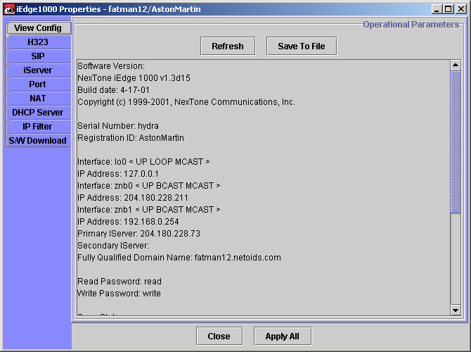

The iView GUI provides various types of display for configuring simple or complex values. The following diagram shows the implementation of a simple interface.

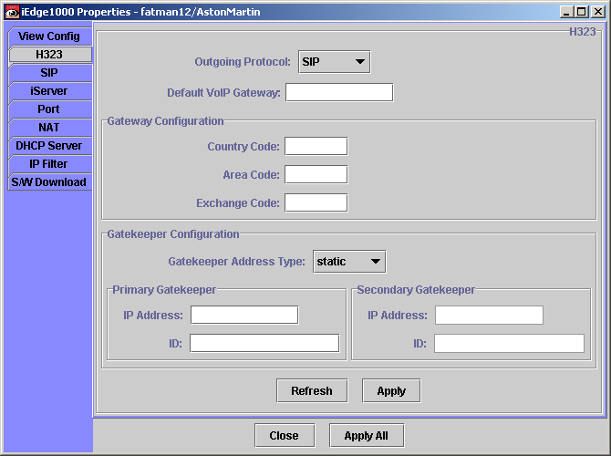

The components on the form directly relate to values in the defined messages.

A complex form can contain trees, tables, menus and dialog boxes. The following form shows the uses of a tree and a table. The tree nodes have related data that can be modified via dialog boxes. The data is validated before being sent to the device to be configured.

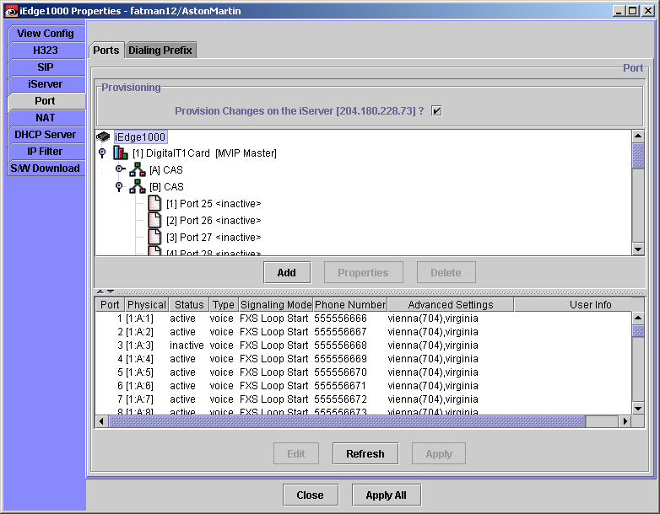

Depending on the content of the messages. The display type can be configured to suit.

Each form is contained within a frame. The frame is specific to the device being configured.

Requirements

The following describes the minimum requirements for integrating third party devices with NexTone’s iView.

- Support for HELLO/REGISTRATION. This allows iView to add the device to the iView map.
- Support READ/WRITE passwords for the device.
- Define Vendor Specific additions to the messages. For existing messages these can be entered within the <VendorData> tags of the messages. For completely new messages the format must follow that described in TODO

The following describes the requirements for integrating third party devices with NexTone’s Download Server.

- Support for HELLO/REGISTRATION. This allows the download server to check the health of the device.
- Define specific configuration messages. The NexTone Download Server is capable of updating the configuration of devices.
- Support for retrieving a code upgrade using either FTP or TFTP. i.e. the device implements the client.

Step by Step Guide
The following guide details the steps required to implement support for iView within the third party device. For the feature to be supported in iView the <VendorData> and any vendor defined messages will need to be provided to NexTone.

- Implement support for receiving the HELLO packet on both Multicast and Unicast addresses.
The device must be configured to receive messages on port 10101.
The device must be configured to listen to the multicast group 224.0.1.20 [TBD].
When an HELLO message is received, check the READ password against the password configured in the device. If the passwords match or there is no password configured on the device the respond with a REGISTRATION message.
Send the REGISTRATION message to the requesting address using the destination port 10102.
- Implement support for configuring READ/WRITE passwords
The READ/WRITE passwords are used to ensure only authorized users can configure a device.
The READ password allows a device to be discovered by iView and the NexTone Download server. IView also uses the READ password to access configuration information.
The WRITE password allows iView to modify the configuration of a device and also allows the NexTone Download server configure the device.
- Vendor Specific Messages
If a Vendor needs to implement a specific interface the following must be adhered to.
For setting parameters, these message must follow the following format and must be well formed documents:
<?xml version="1.0" encoding="ISO-8859-1"?>
<!DOCTYPE NexToneMsg SYSTEM ".\Configure.dtd">
<NexToneMsg version="1.0" cmd="Config">
<!-- The passwords must be given -->
<ReadPassword>read</ReadPassword>
<WritePassword>write</WritePassword>
<!-- The block of parameters must be surrounded by some top level tags -->
<Passwords>
<ReadPassword>read</ReadPassword>
<WritePassword>write</WritePassword>
</Passwords>
</NexToneMsg>
For readin parameters, these message must follow the following format and must be well formed documents:
<?xml version="1.0" encoding="ISO-8859-1"?>
<!DOCTYPE NexToneMsg SYSTEM ".\Configure.dtd">
<NexToneMsg version="1.0" cmd="Config">
<!-- The block of parameters must be surrounded by some top level tags -->
<Passwords>
<ReadPassword>read</ReadPassword>
<WritePassword>write</WritePassword>
</Passwords>
</NexToneMsg>

