**[Graded-Assignment-on-Dockerizing-a-Plain-HTML-Page-With-Nginx](https://github.com/AkankshaJairath/Graded-Assignment-on-Dockerizing-a-Plain-HTML-Page-With-Nginx/tree/main)**

Create ec2 instance and install docker and aws cli

# sudo yum install docker –y

# curl "https://awscli.amazonaws.com/awscli-exe-linux-aarch64.zip" -o "awscliv2.zip"

# unzip awscliv2.zip

# sudo ./aws/install

# aws –version

# aws configure ## configure aws cli by creating token using IAM

EC2 instance:

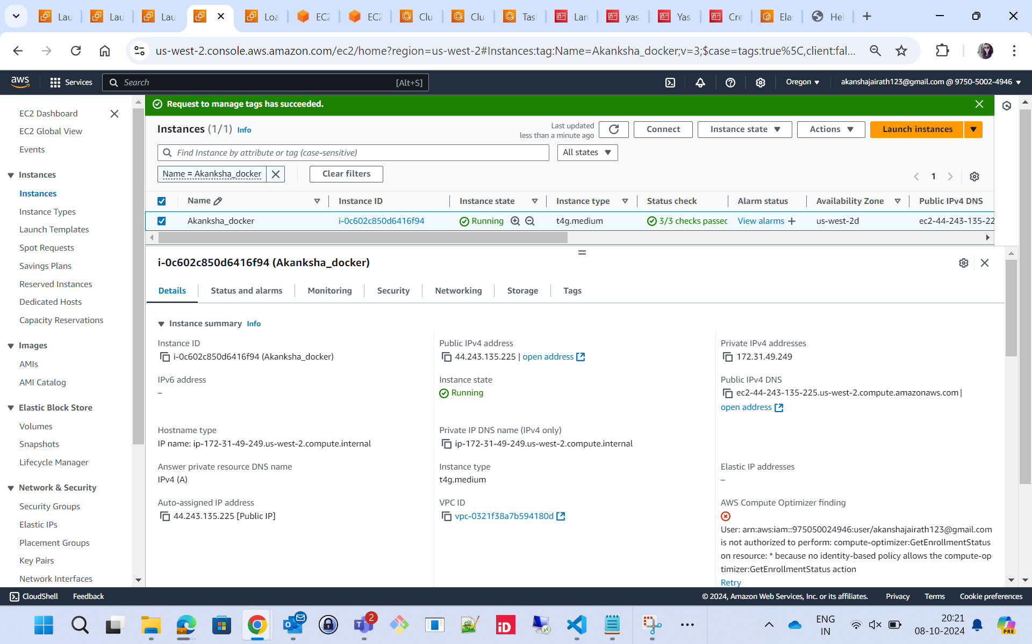

Make sure docker is running  
  
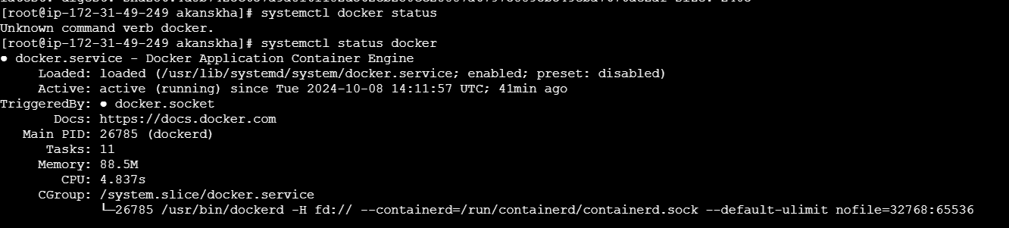

Creating Basic HTML Page index.html

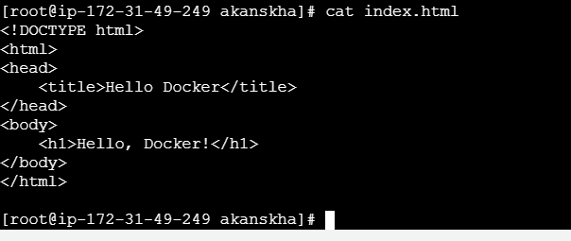

Create the Nginx configuration file nginx.conf to serve the HTML page

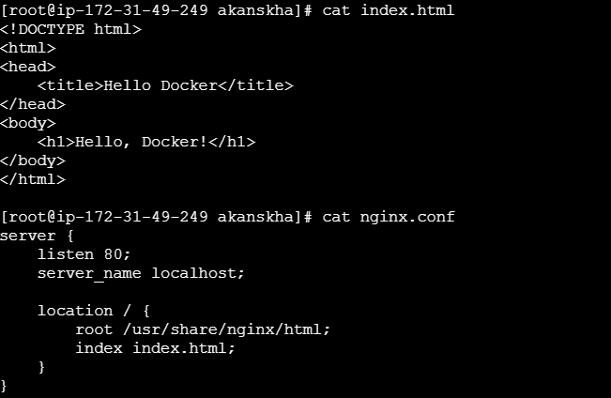

Create the Dockerfile to build the Docker image using the official Nginx base image

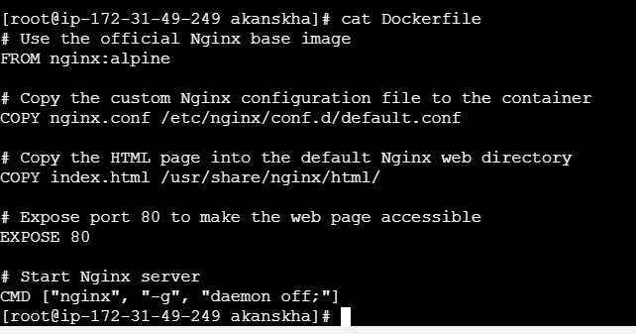

Build the Docker Image

# docker build -t my-nginx-app .

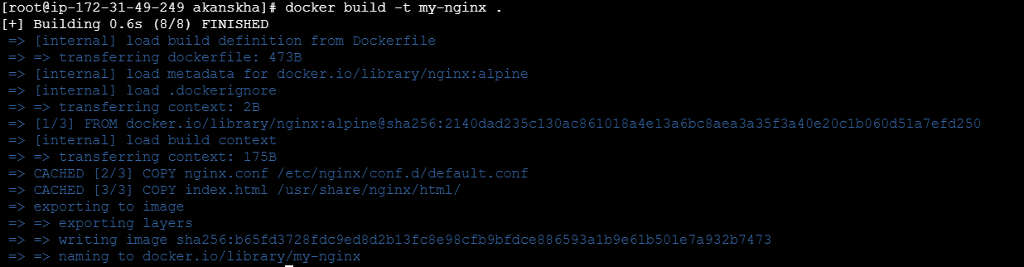

Now go the AWS ECR

create your repo

click on view push commands to get the steps to link to ec2 instances

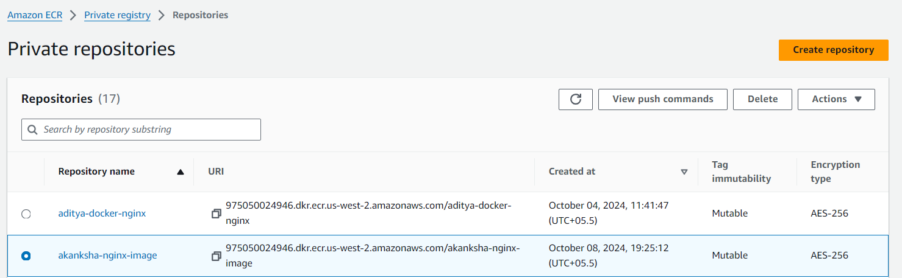

* aws ecr get-login-password --region us-west-2 | docker login --username AWS --password-stdin 975050024946.dkr.ecr.us-west-2.amazonaws.com
* docker build -t akanksha-nginx-image .
* docker tag akanksha-nginx-image:latest 975050024946.dkr.ecr.us-west-2.amazonaws.com/akanksha-nginx-image:latest
* docker tag akanksha-nginx-image:latest 975050024946.dkr.ecr.us-west-2.amazonaws.com/akanksha-nginx-image:latest

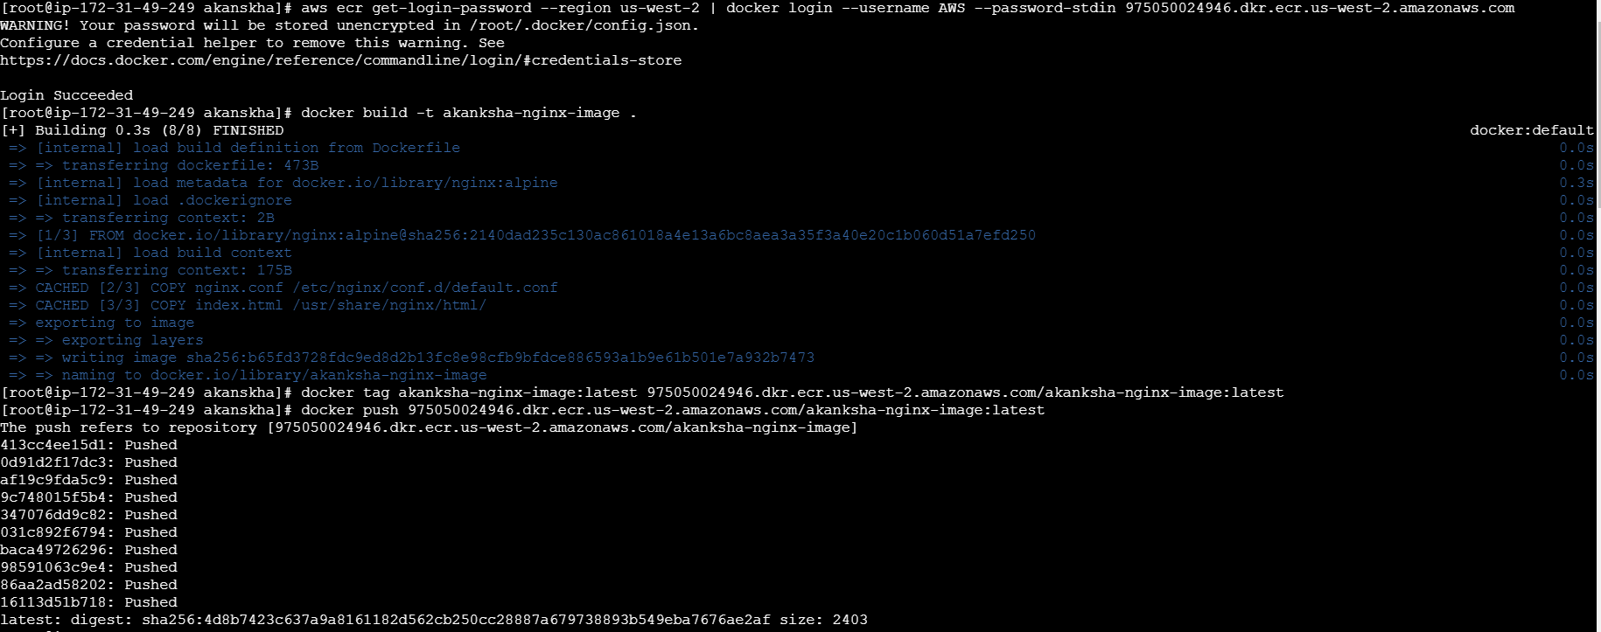

After pushing :  
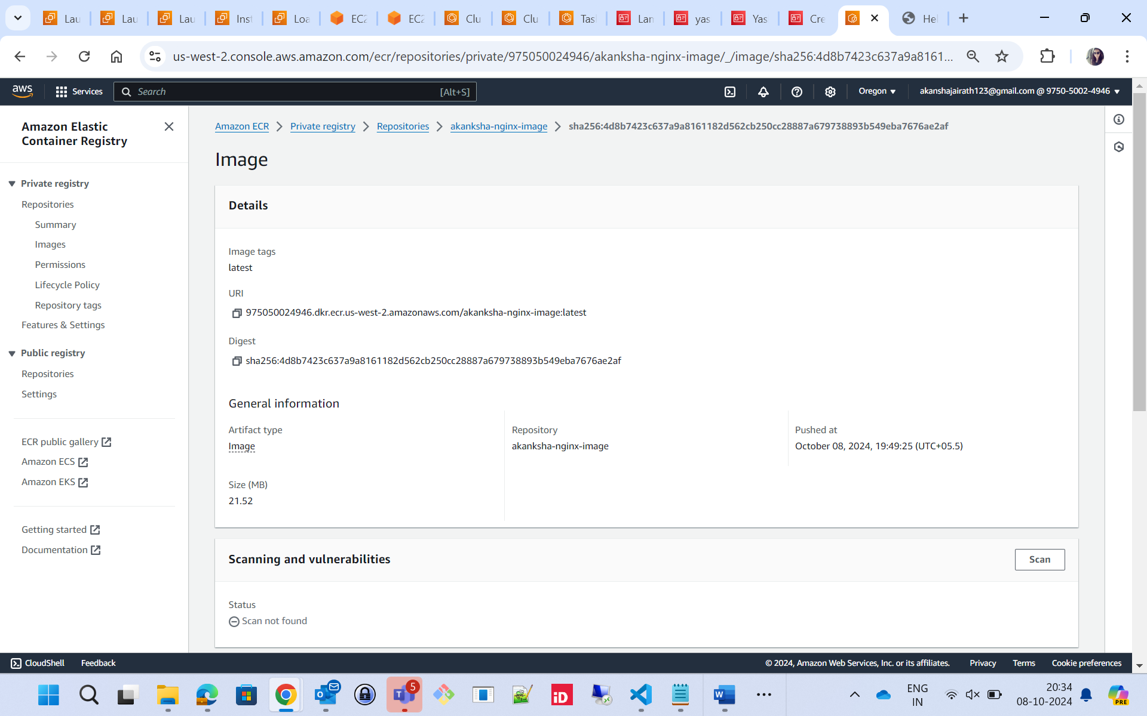

Now go to ECS (Elastic Container Service) and create cluster

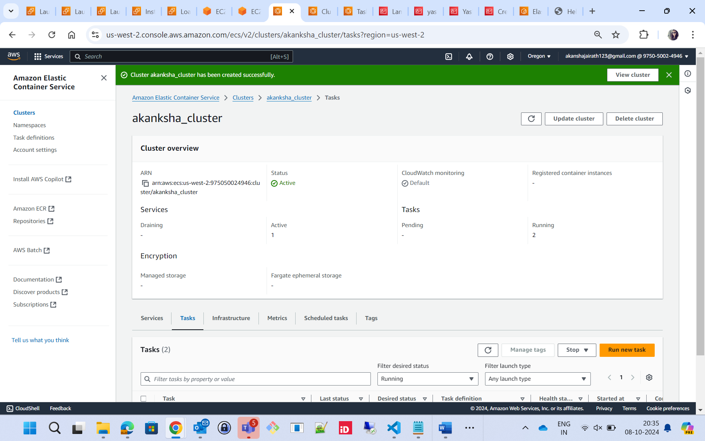

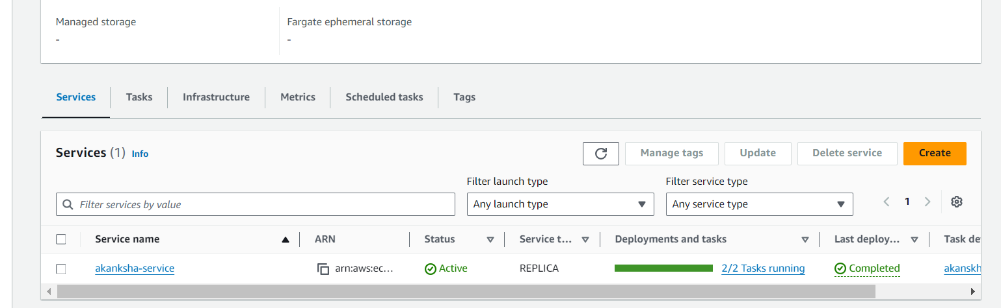

Create a task

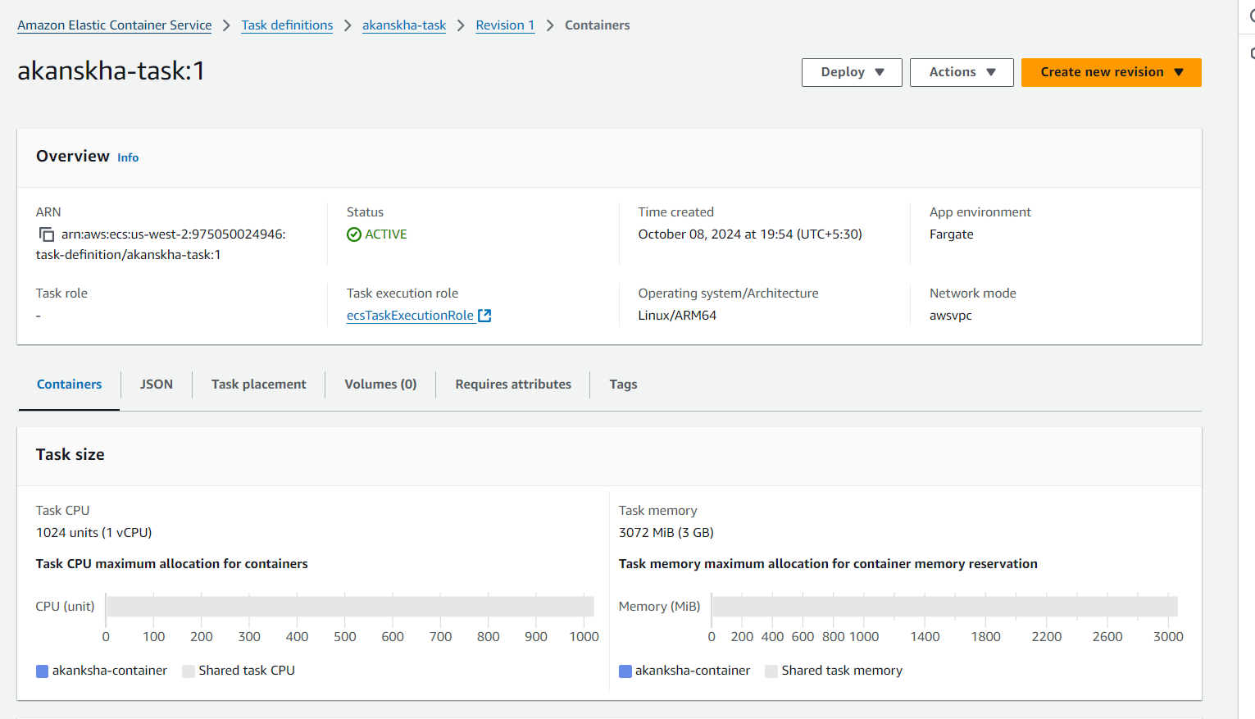

Create service

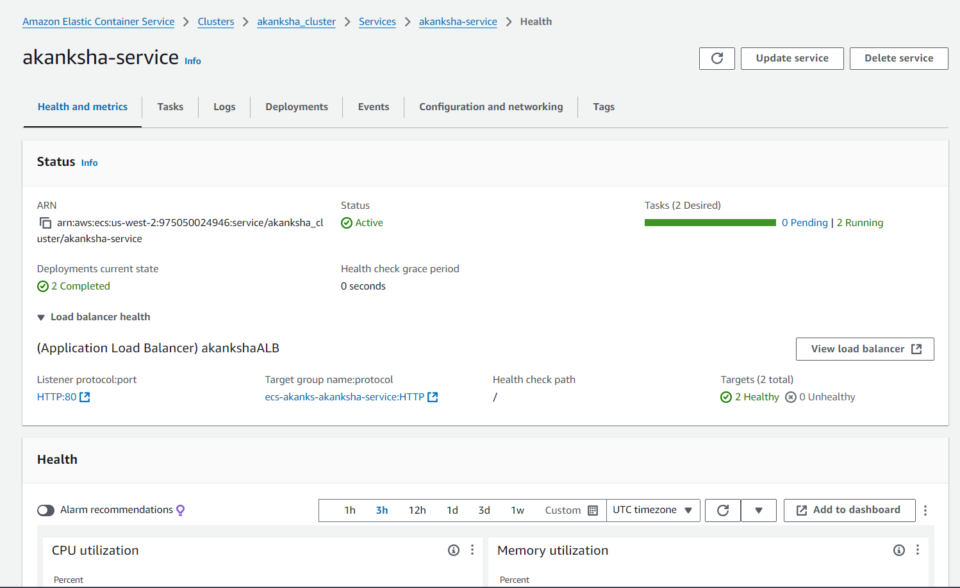

akanksha_cluster with service and tasks

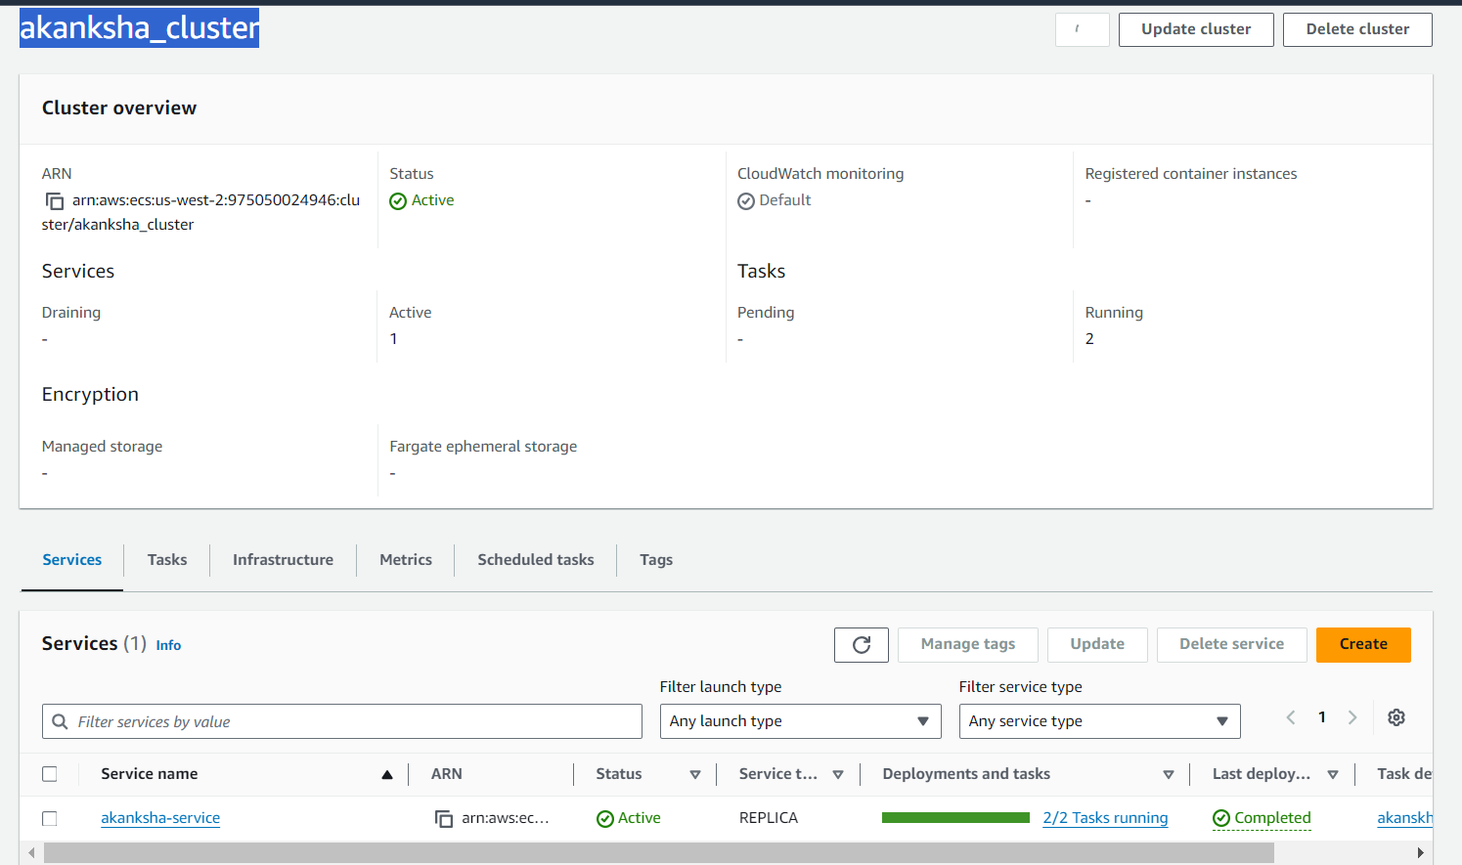

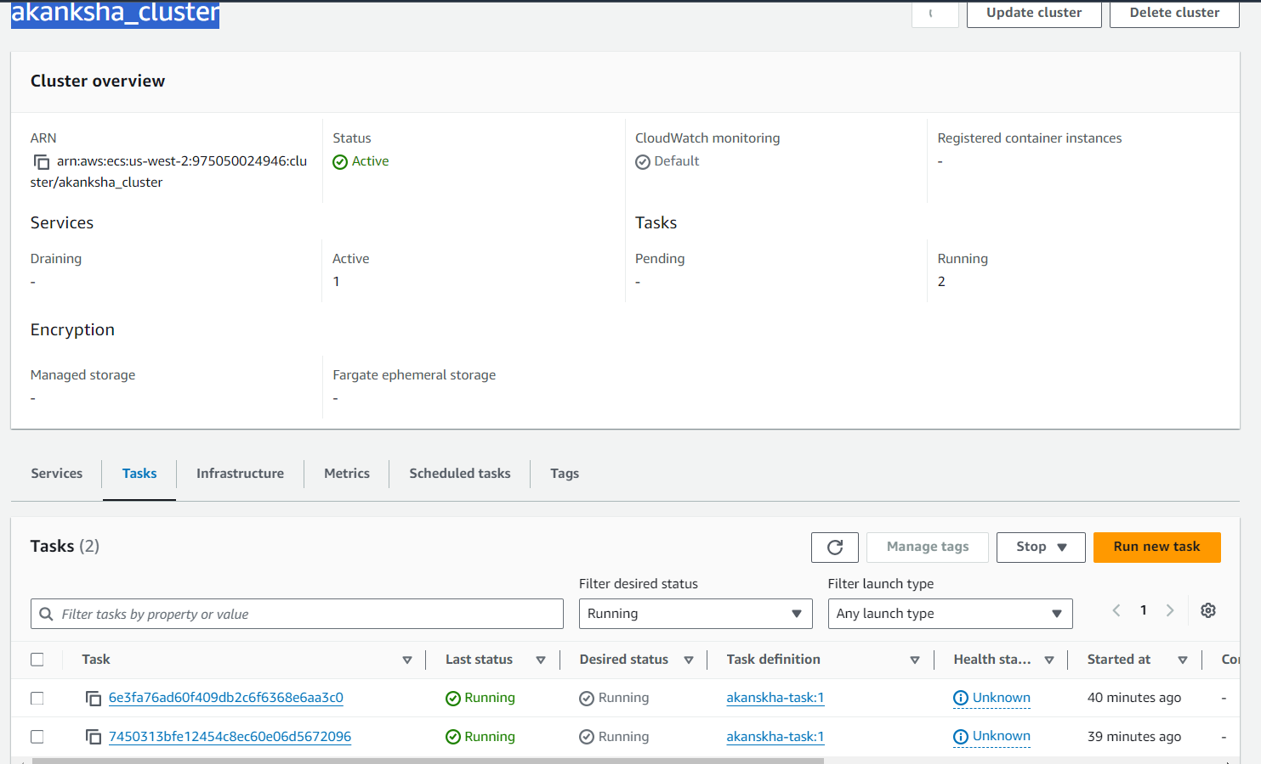

LB created during service

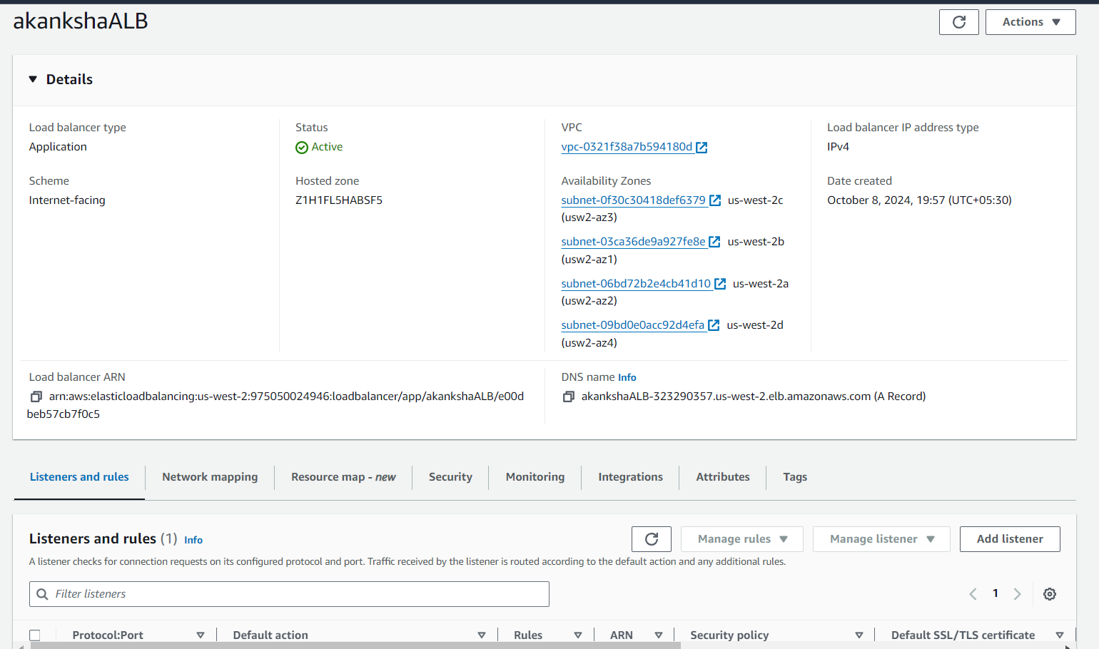

After accessing ALB DNS

