Notification:  
  
Need to keep Below code at the Jenkins File:  
  
post {

success {

mail (

to: 'akanshajairath123@gmail.com',

subject: "SUCCESS: Job '${env.JOB_NAME} [${env.BUILD_NUMBER}]'",

body: """

Good news! The build for '${env.JOB_NAME} [${env.BUILD_NUMBER}]' was successful.

Project: ${env.JOB_NAME}

Build Number: ${env.BUILD_NUMBER}

URL: ${env.BUILD_URL}

""",

mimeType: 'text/html'

)

}

failure {

mail (

to: 'akanshajairath123@gmail.com',

subject: "FAILURE: Job '${env.JOB_NAME} [${env.BUILD_NUMBER}]'",

body: """

Unfortunately, the build for '${env.JOB_NAME} [${env.BUILD_NUMBER}]' failed.

Project: ${env.JOB_NAME}

Build Number: ${env.BUILD_NUMBER}

URL: ${env.BUILD_URL}

""",

mimeType: 'text/html'

)

}

aborted{

mail (

to: 'akanshajairath123@gmail.com',

subject: "Abort: Job '${env.JOB_NAME} [${env.BUILD_NUMBER}]'",

body: """

Unfortunately, the build for '${env.JOB_NAME} [${env.BUILD_NUMBER}]' Aborted.

Project: ${env.JOB_NAME}

Build Number: ${env.BUILD_NUMBER}

URL: ${env.BUILD_URL}

""",

mimeType: 'text/html'

)

}

}  
  
  
Setup:🡪  
  
**Go to Manage Jenkins -> Configure System -> You will find a Email Notification tab. We need to fill in the details here.**

1. Select Advanced.
2. SMTP Server : smtp.gmail.com
3. Select Use SMTP Authentication
4. Username : Your gmail Id
5. Password : Your gmail password
6. Select Use SSL
7. SMTP Port : 465
8. Reply-to-Address : your email id
9. Charset : UTF-8
10. Save

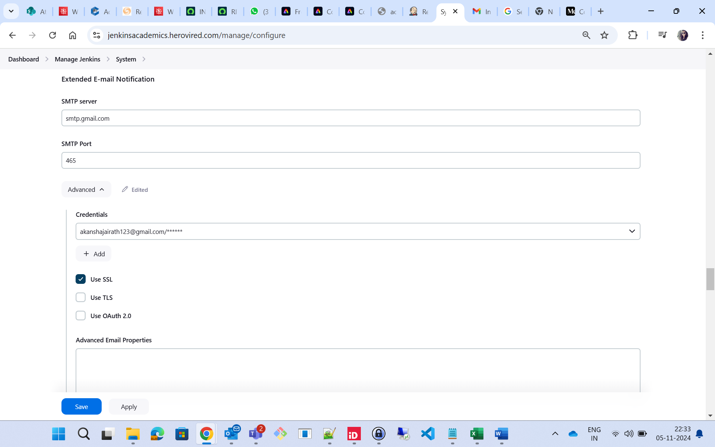  
  
  
OutPut:  
  
