PROGRAM 1

WAP for creating the mini calculator , you have to perform an operation on the basis of user choise until the user press yes to continue (add, mul, sub, div)

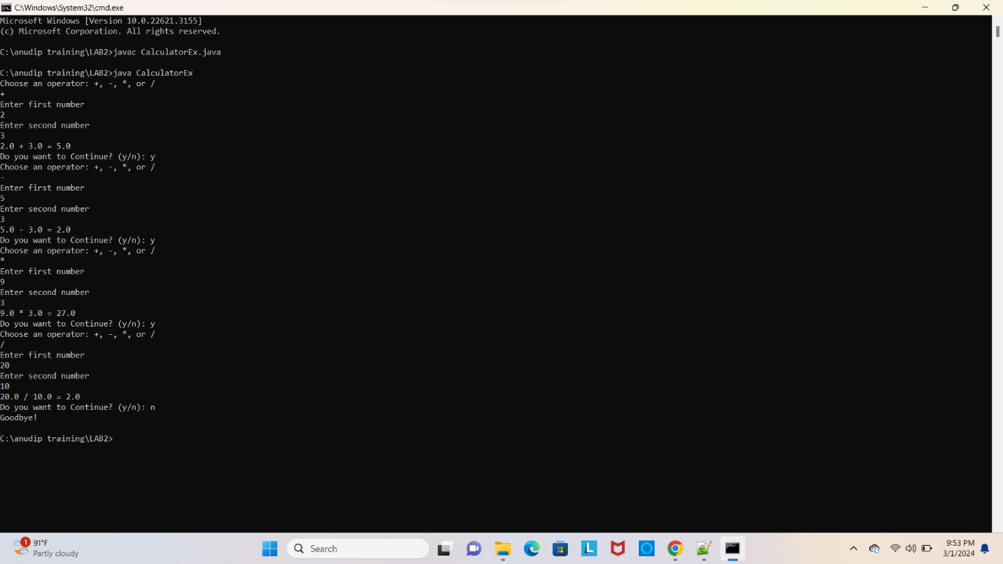

PROGRAM 2

implement a bank account class showing method overloading with methods for deposite, withdrawal, and balance inquiry.

use method overloading to handle different types of transaction.

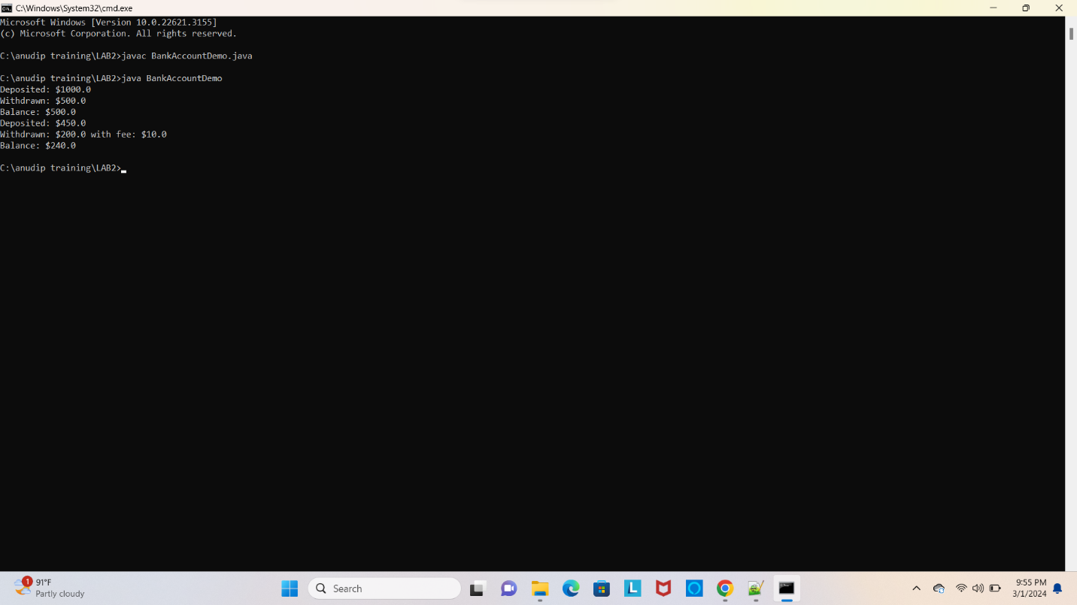

PROGRAM 3

A program that calulates Body Mass index(BML) based on user input of weight and height,

and then catagorizes the BMI into underweight , normal, overweight, or obese categorized using if else statements.

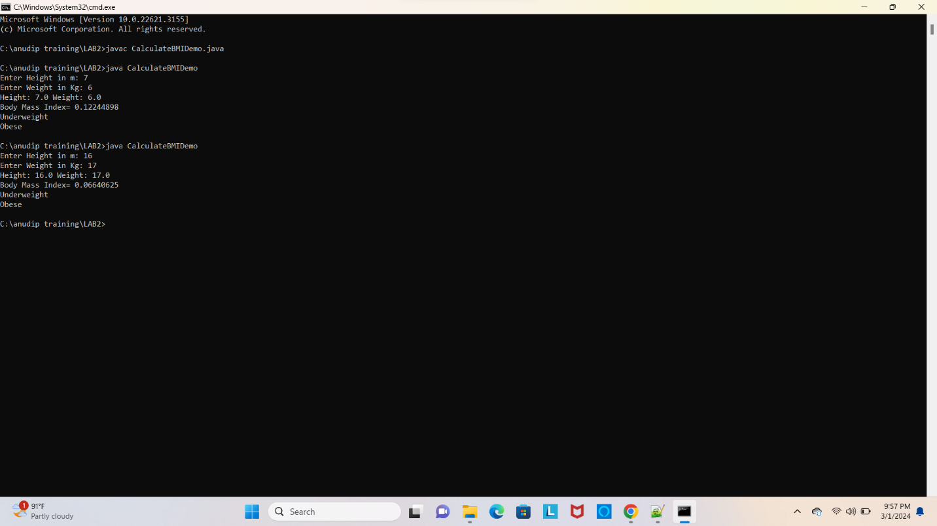

PROGRAM 4

create a class named car with attributes make mode1, year and color.

include a method start() that points "Car Started" and a method stop() that prints "car stopped".

