PROGRAM 1

Define a class Address representing an address with attributes such as street, city, state,and zip code. Provide constructor to initialize these attributes.

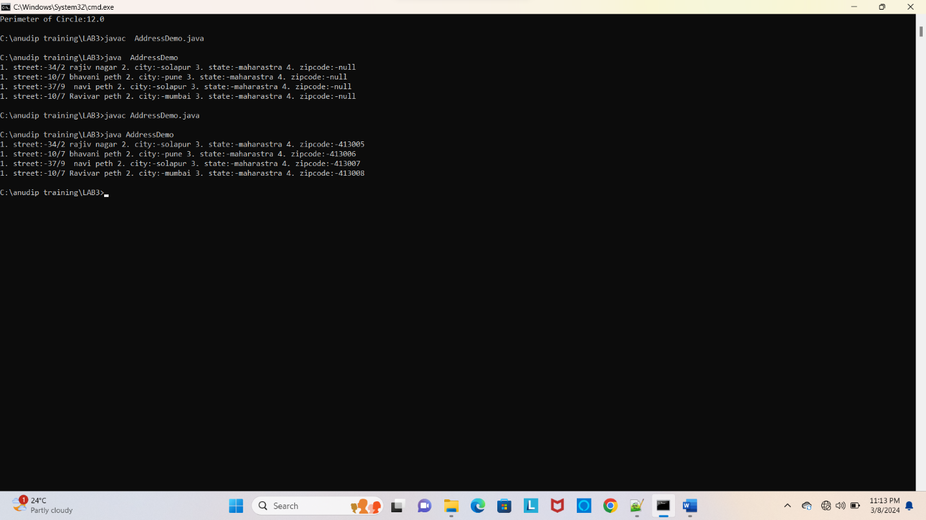

PROGRAM 2

Create a program in java to implement multilevel inheritance and hierachical inheritance.

Take classes like: Doctor, Surgeon and Nurse

Create methods and show method overriding.

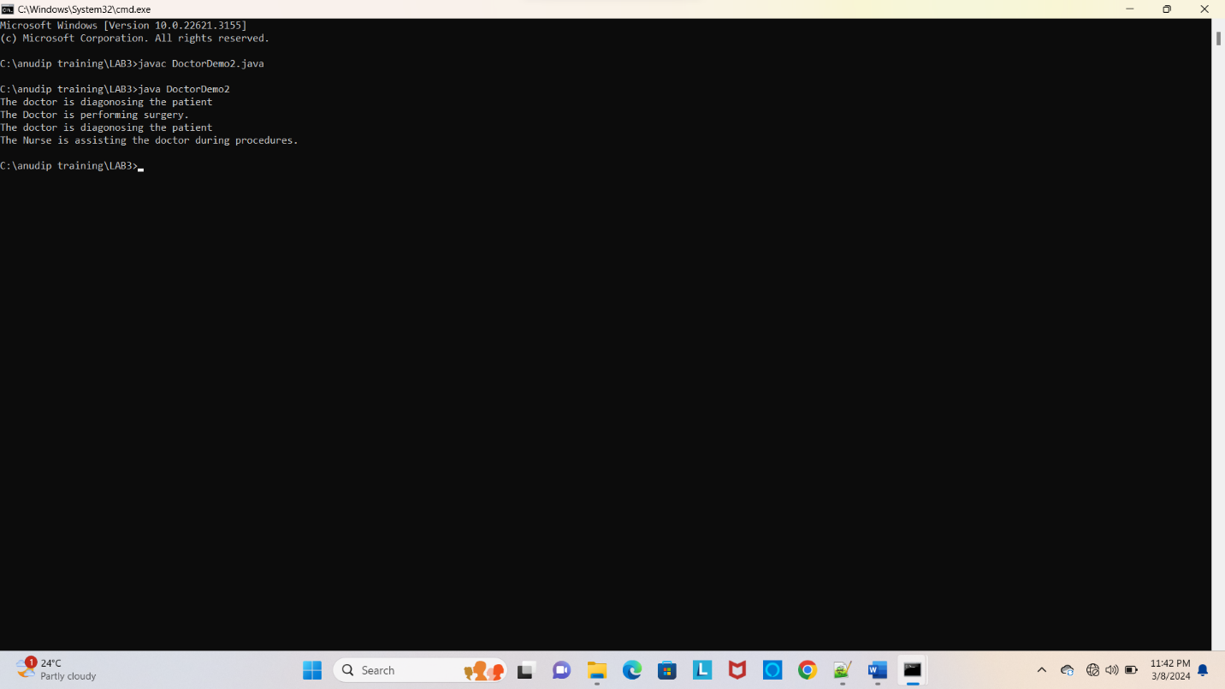

PROGRAM 3

Write a class with the name Perimeter using functions overload that computes the perimeter of a square, a rectangle and a circle.

Formula :

Perimeter of a square= 4 \* s

Perimeter of a rectangle = 2 \* (1 + b)

Perimeter of a circle = 2 \* (22/7) \* r

