PROGRAM1

Create two thread.one thread is finding the average of the first 10 numbers and another thread is printing the square of the number

stored in array arr-(1,20,50,15,30) and make sure both threads can execute simultaneously.

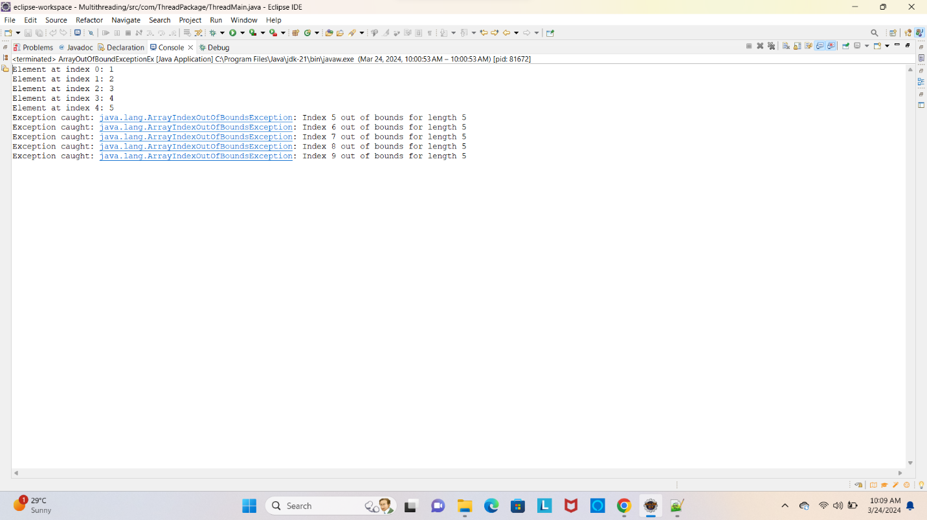

PROGRAM 2

Create a program with a logic that throws the ArrayIndexOutOfBoundsException while accessing elements in an array.

// [Hint: Use array and loop and try to access the element beyond the last index]

