SQL Assignment no 10
Joining tables to itself

1)
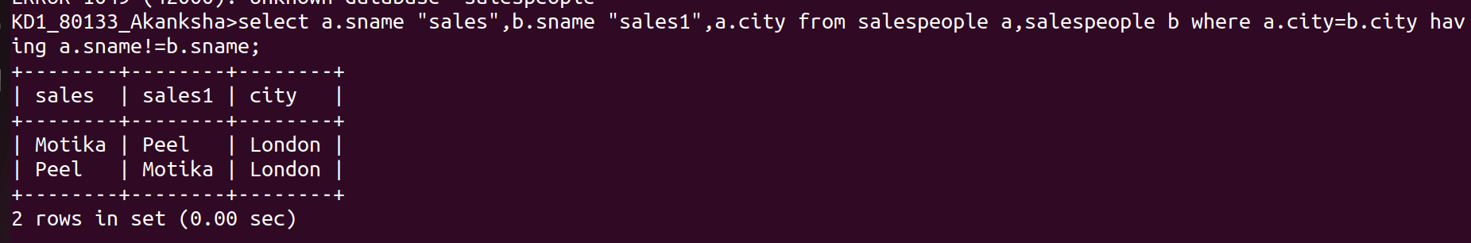

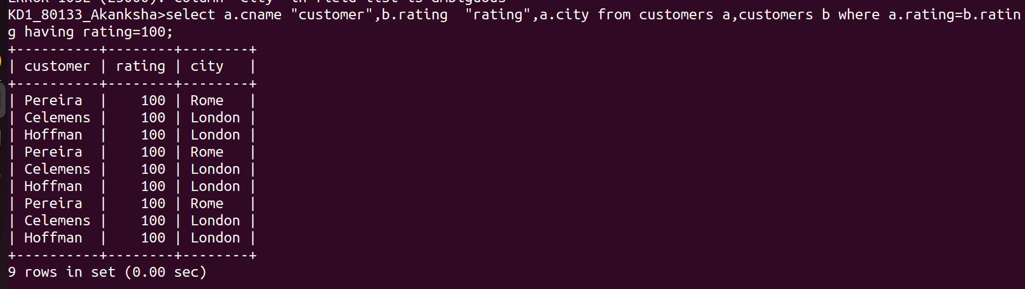

2)

