SQL Assignment no 9
Querying Multiple Tables at Once

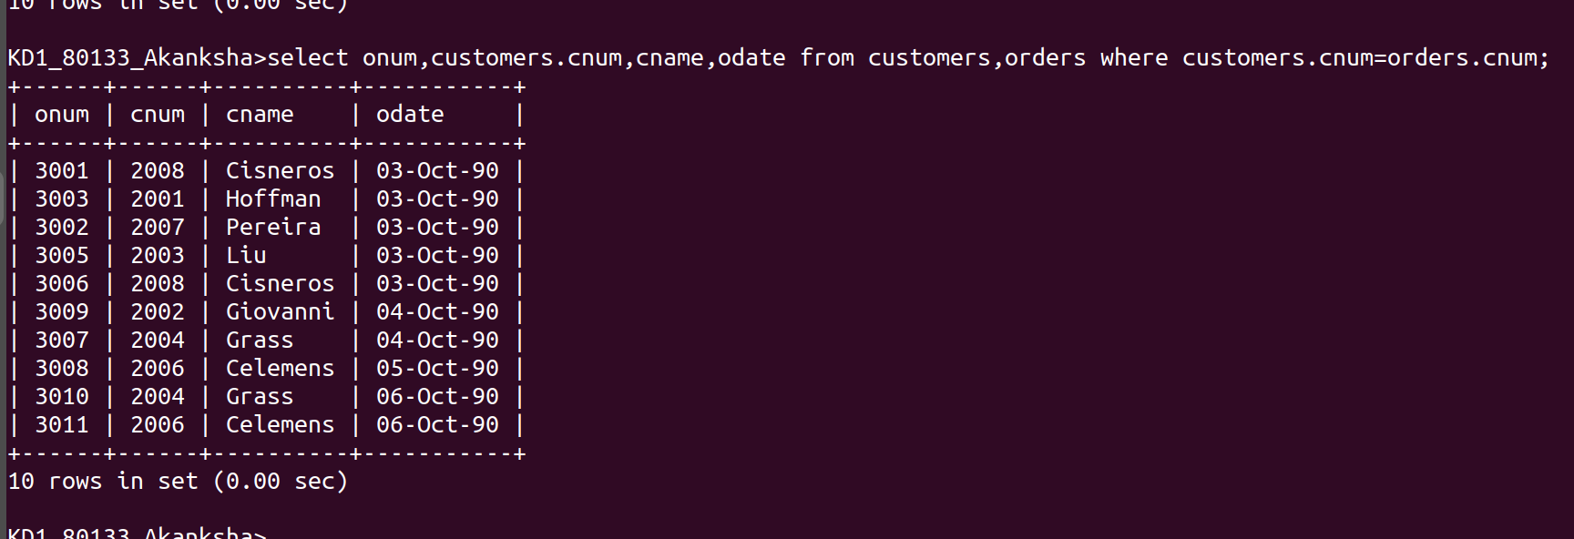
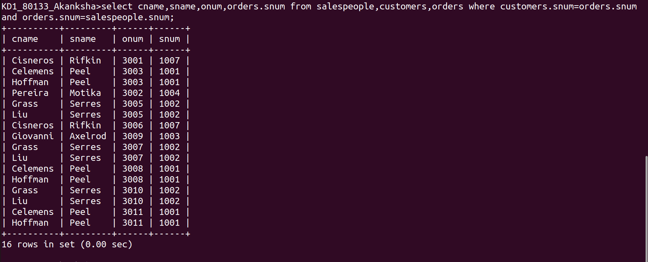
1)
2)

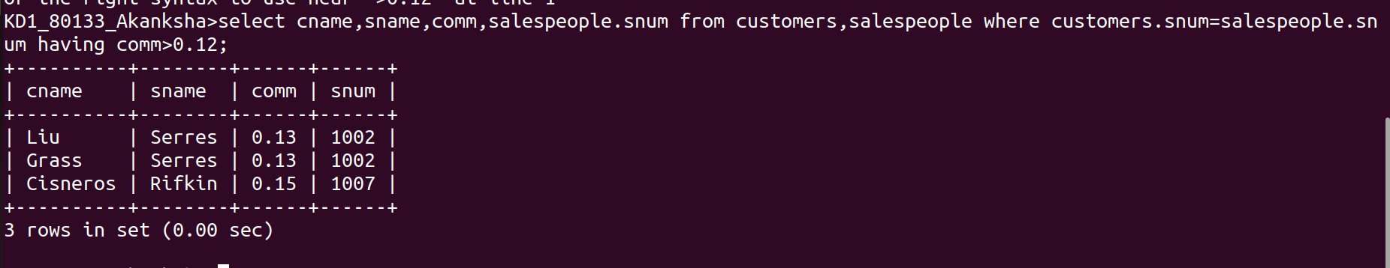

3)

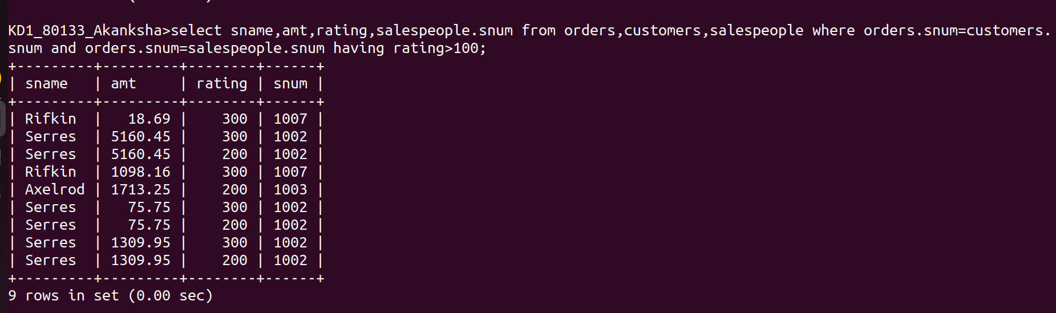
4)

