SQL Assignment 06
Using Special Operators in Conditions.
1)
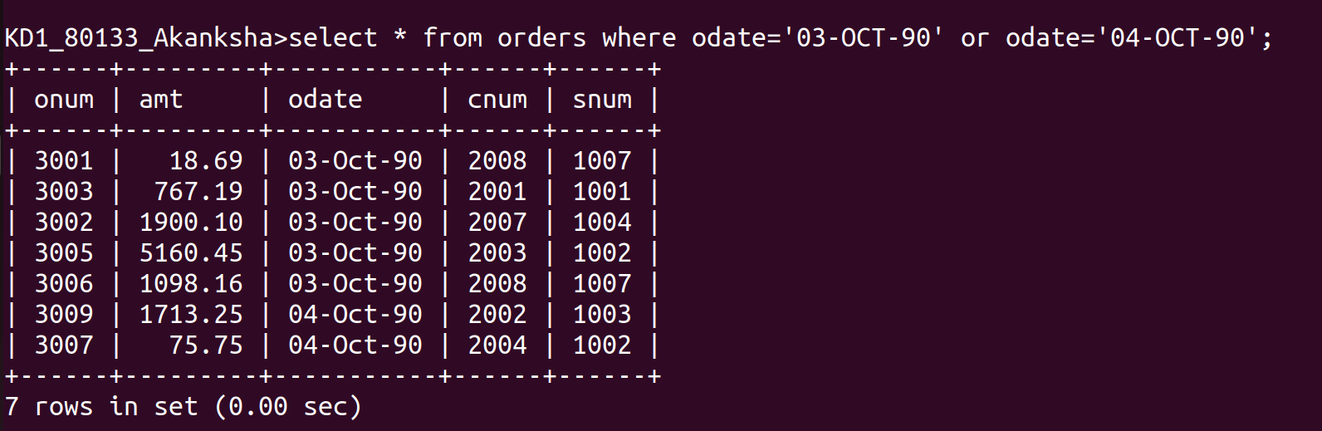
2)
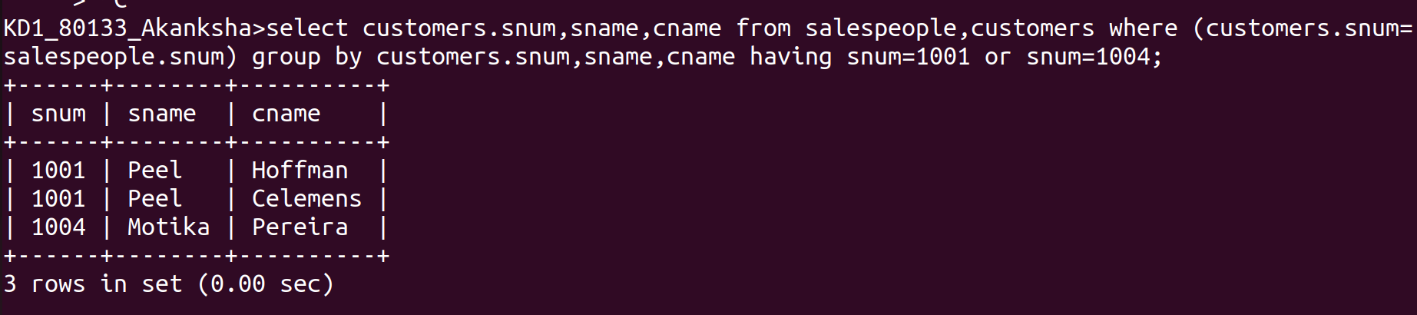
3)


4)

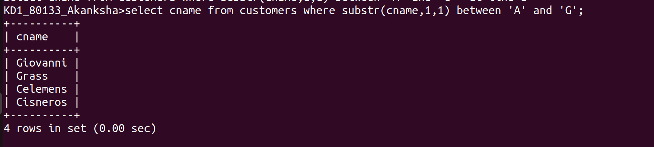
5)

