SQL Assignment no 7

Summarizing data with Aggregate functions.


1)


2)

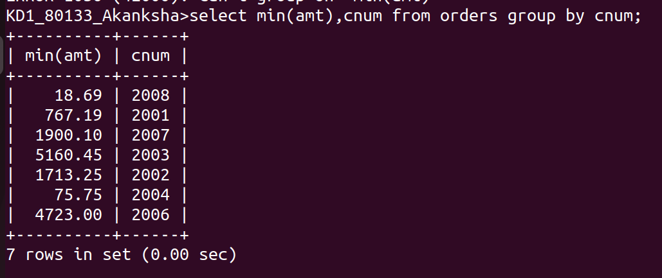
3)

4)

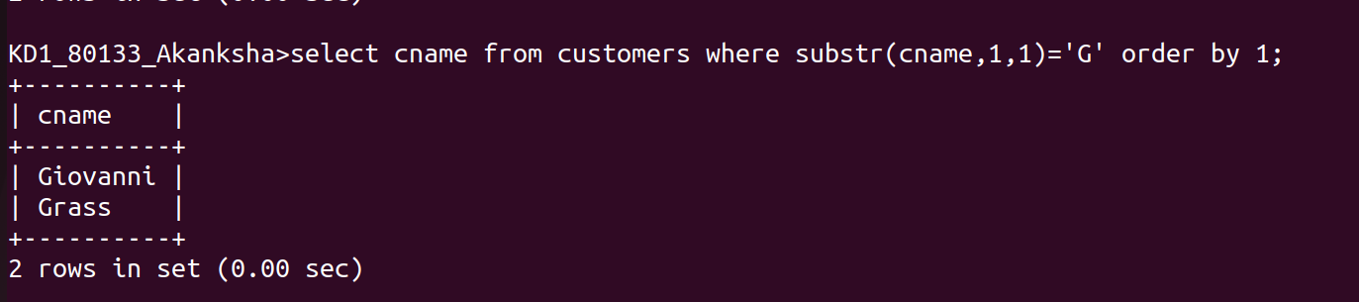
5)
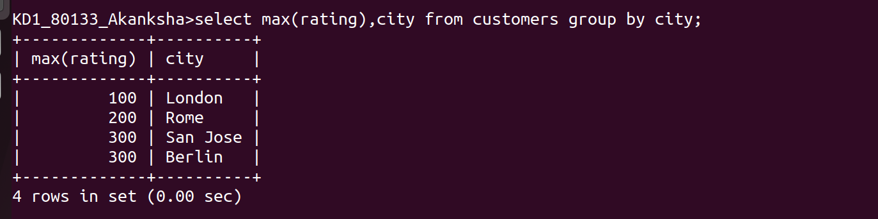

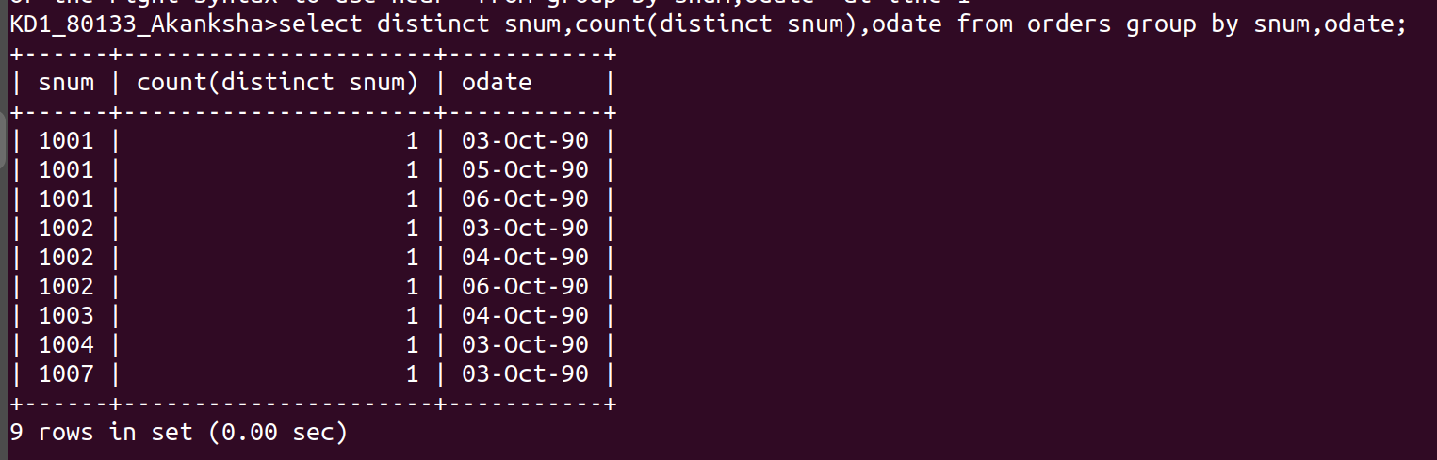
6)

