SQL Assignment no 15
Using subqueries with DML commands
1)
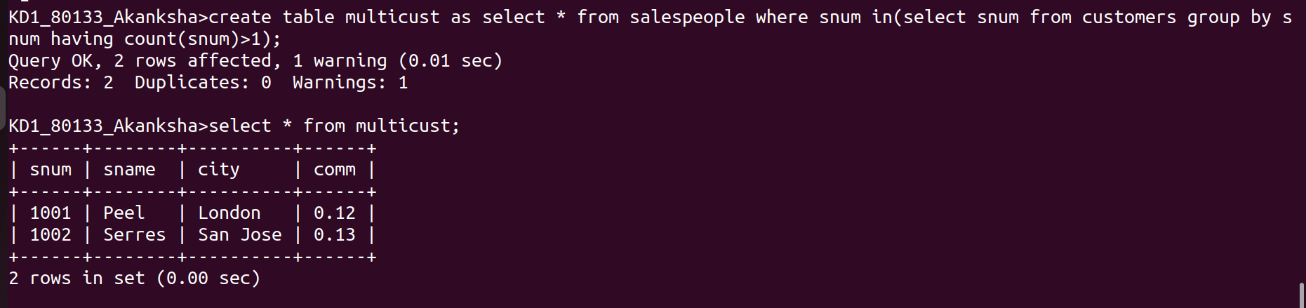
2)
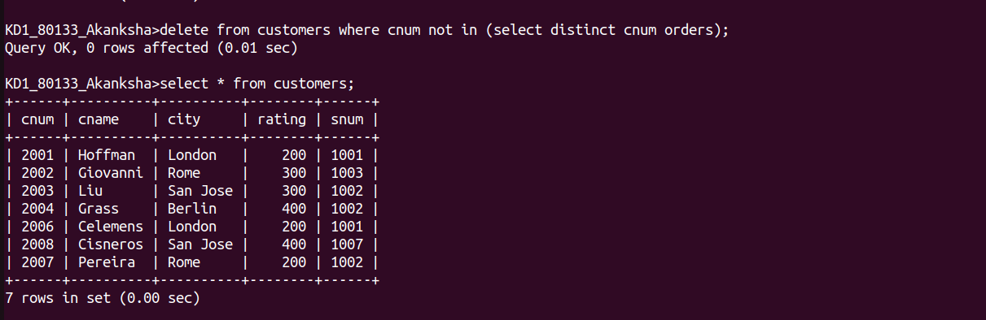
3)
