SQL Assignment no 14
Entering,deleting,and changing field values
1)


2)

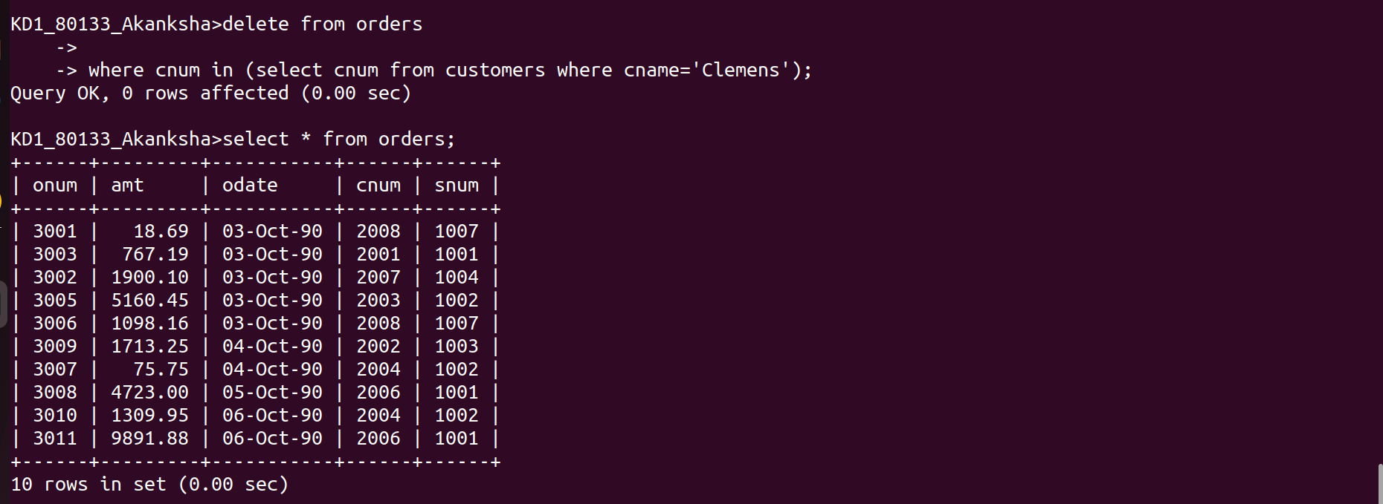

3)


4)
