SQL Assignment no 12
Using the operators IN,ANY,ans ALL
1)
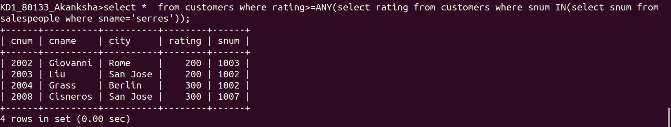
2)
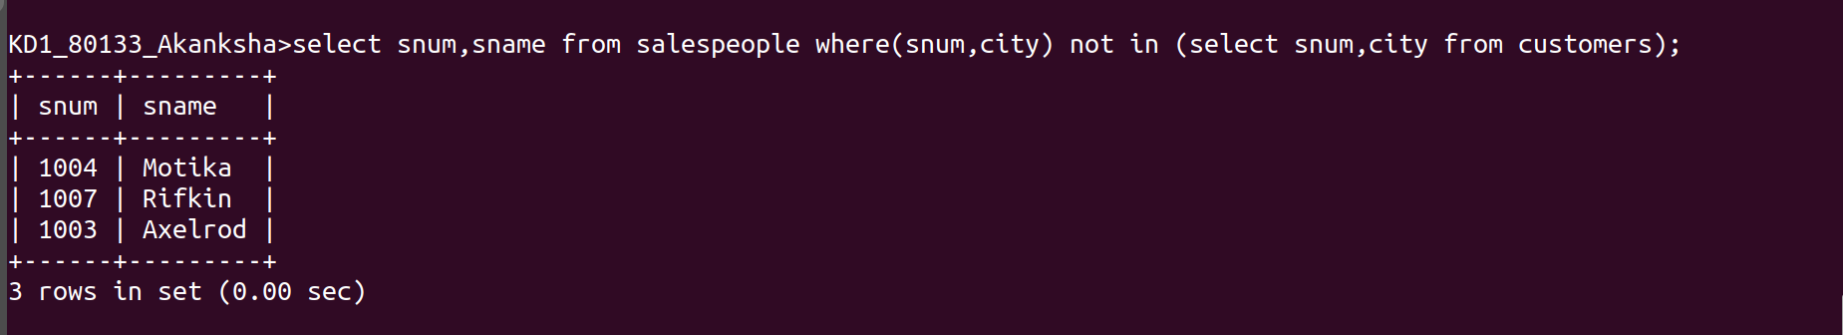
3)
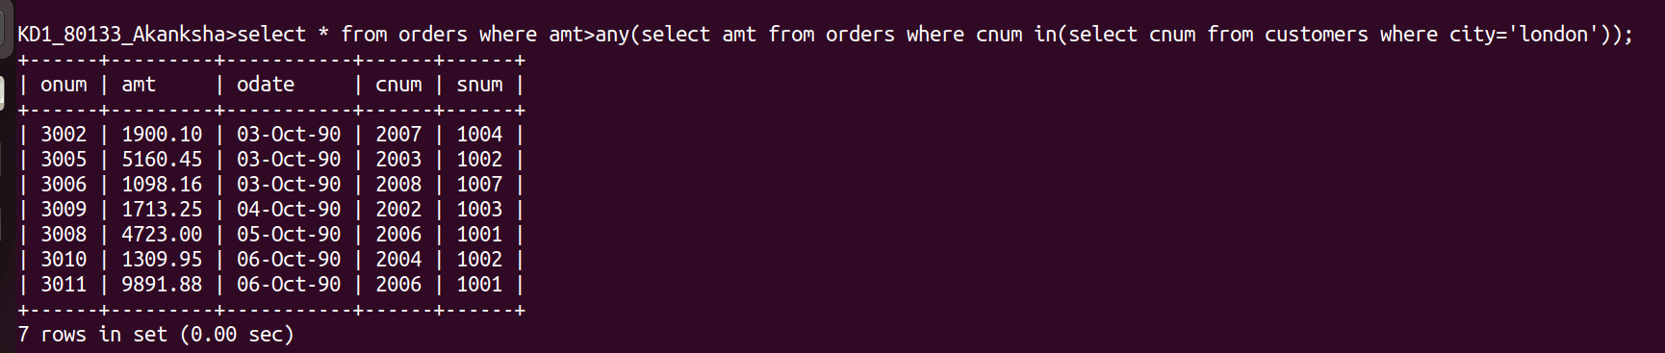
4)
