SQL Assignment no 11
SUBQUERIES

1)
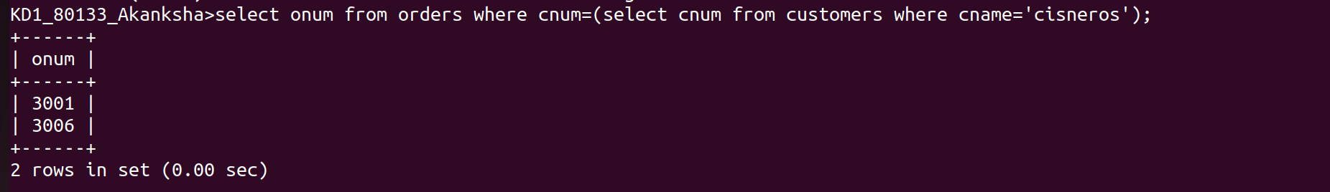

2)
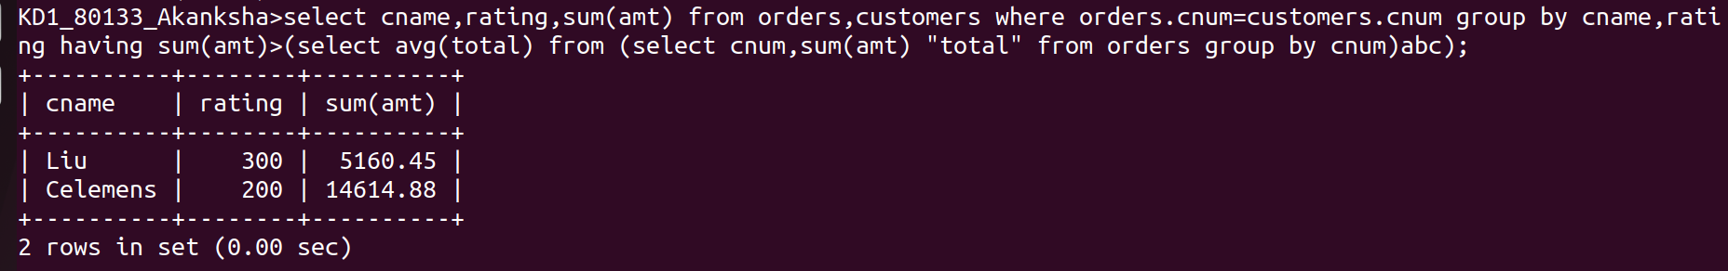
3)
