SQL Assignment no 13
using the UNION clause

1)

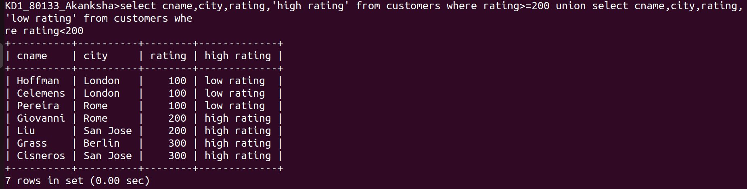
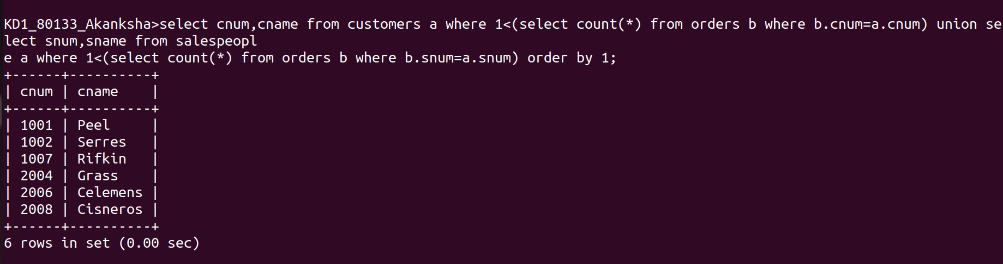

2)

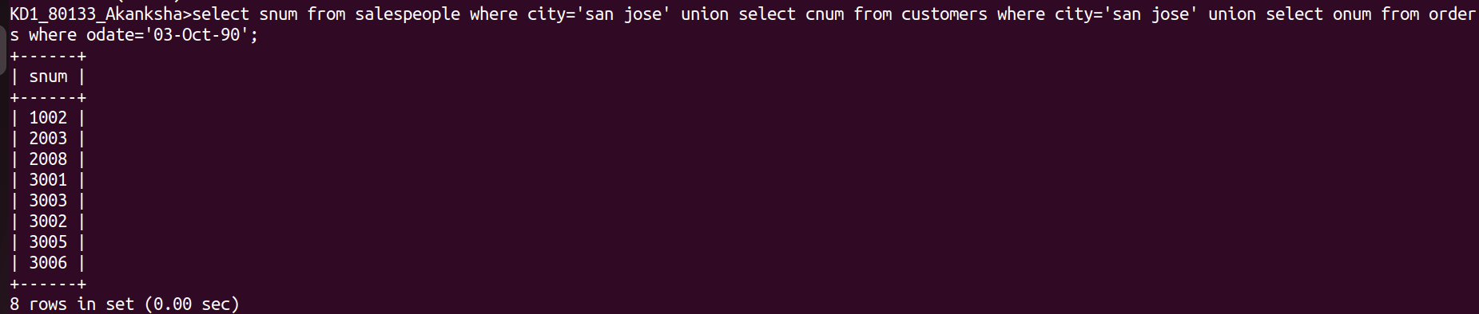
3)

