Assignment 3

**Neural Networks and deep learning**

Name: Akanksha panchaneni

Id: 700740529

1.

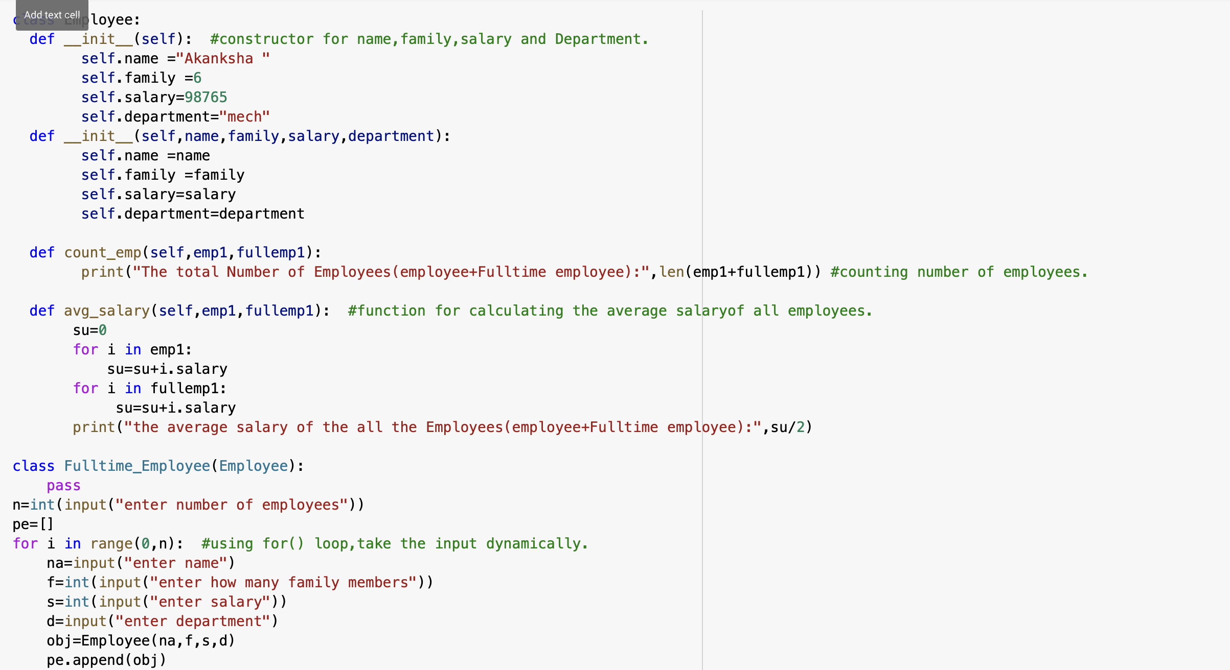

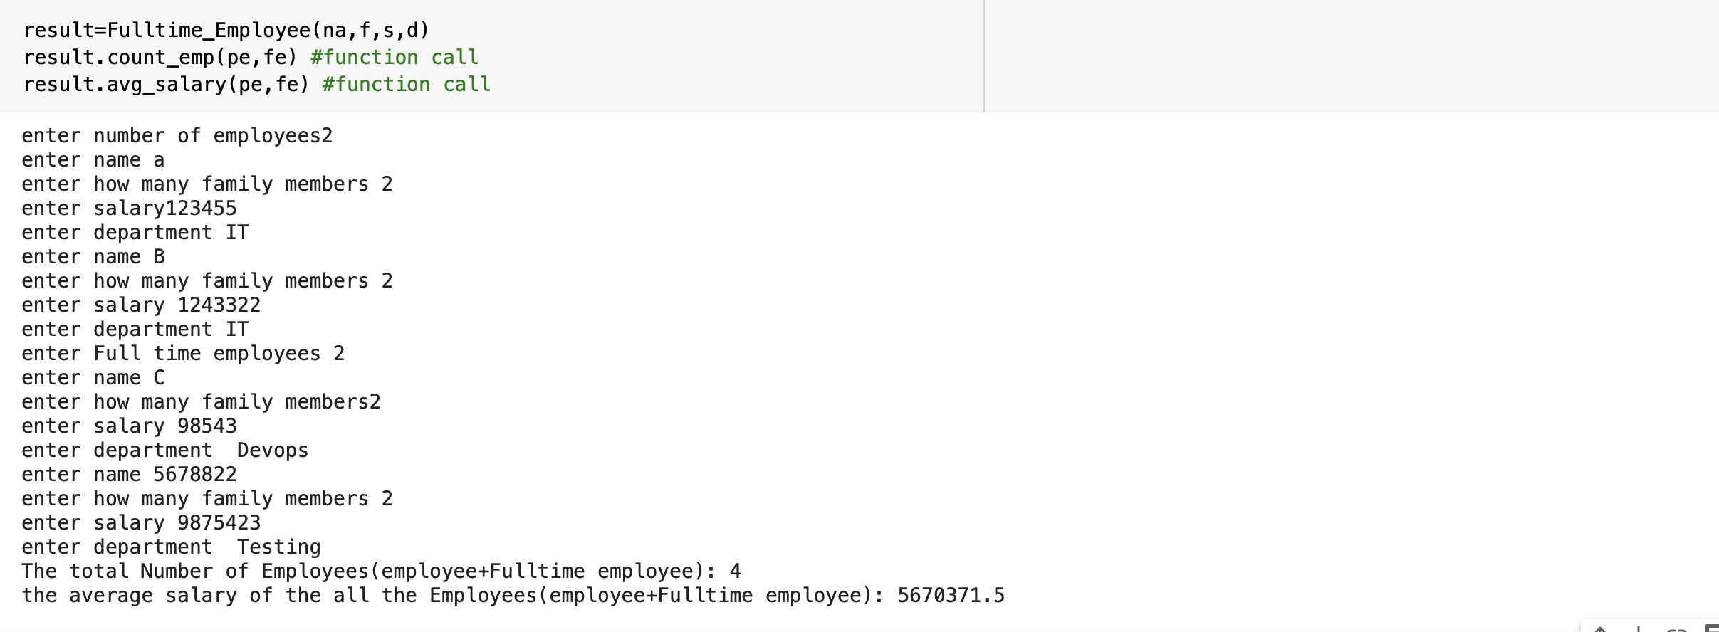

Explanation:

Initially create a class for Employee and Fulltime Employee.

Create a constructor and initialize name,family,salary, and Department.

Write a function to calculate the average salary.

Inherit the employee class properties into FulltimeEmployee class.

Call the members of the function.

2.

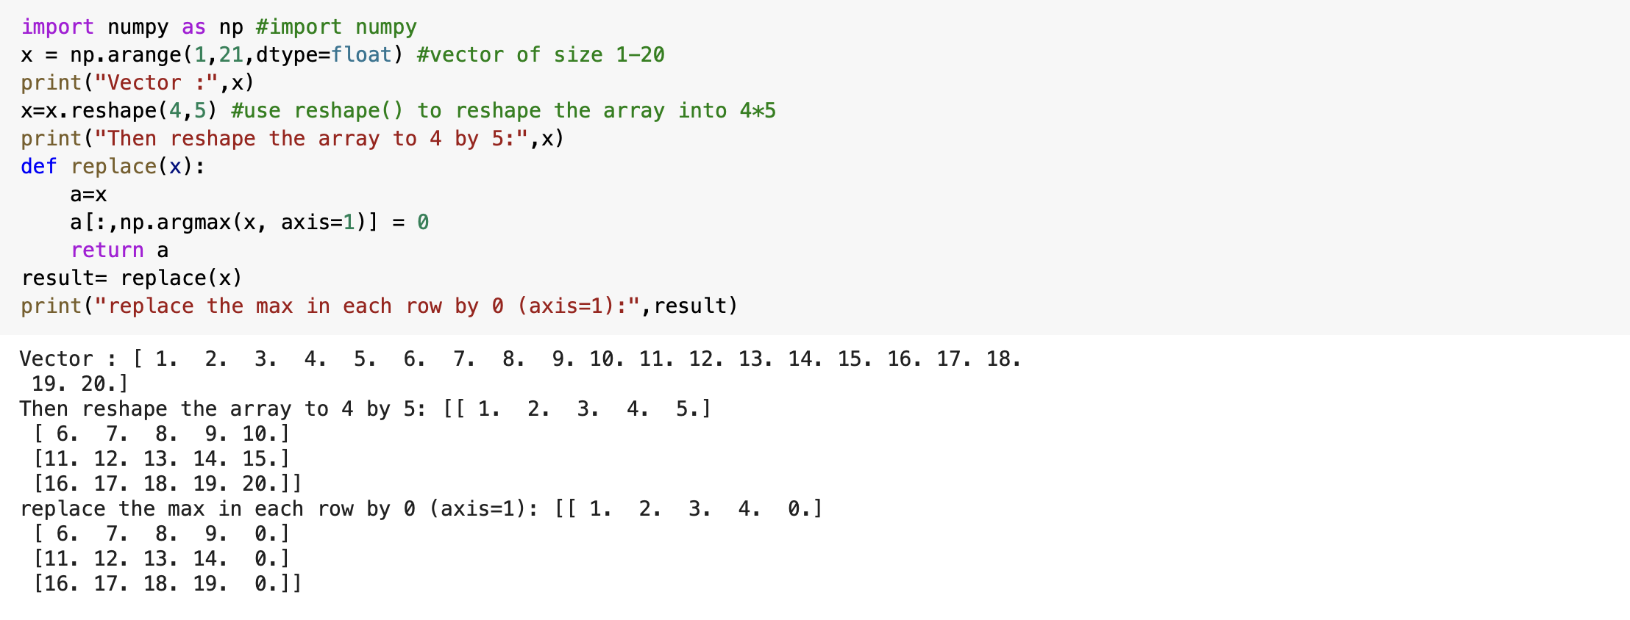

Explanation:

Numpy is used to modify arrays.

Create a vector of size 20.

Use reshape () to reshape the array into 4 by 5.

Replace the max in each row by 0 where axis=1.

Github Link: <https://github.com/AkankshaPanchaneni/Assignment-3>

Video Link: <https://www.loom.com/share/f1fcd38924bf4f9f87fdba355dfbddc7>