**ASSIGNMENT 5**

**Neural Network and Deep Learning**

**Name: Akanksha Panchaneni**

**ID: 700740529**

1. Implementing Naïve Bayes method using scikit-learn library and using the available dataset with name glass

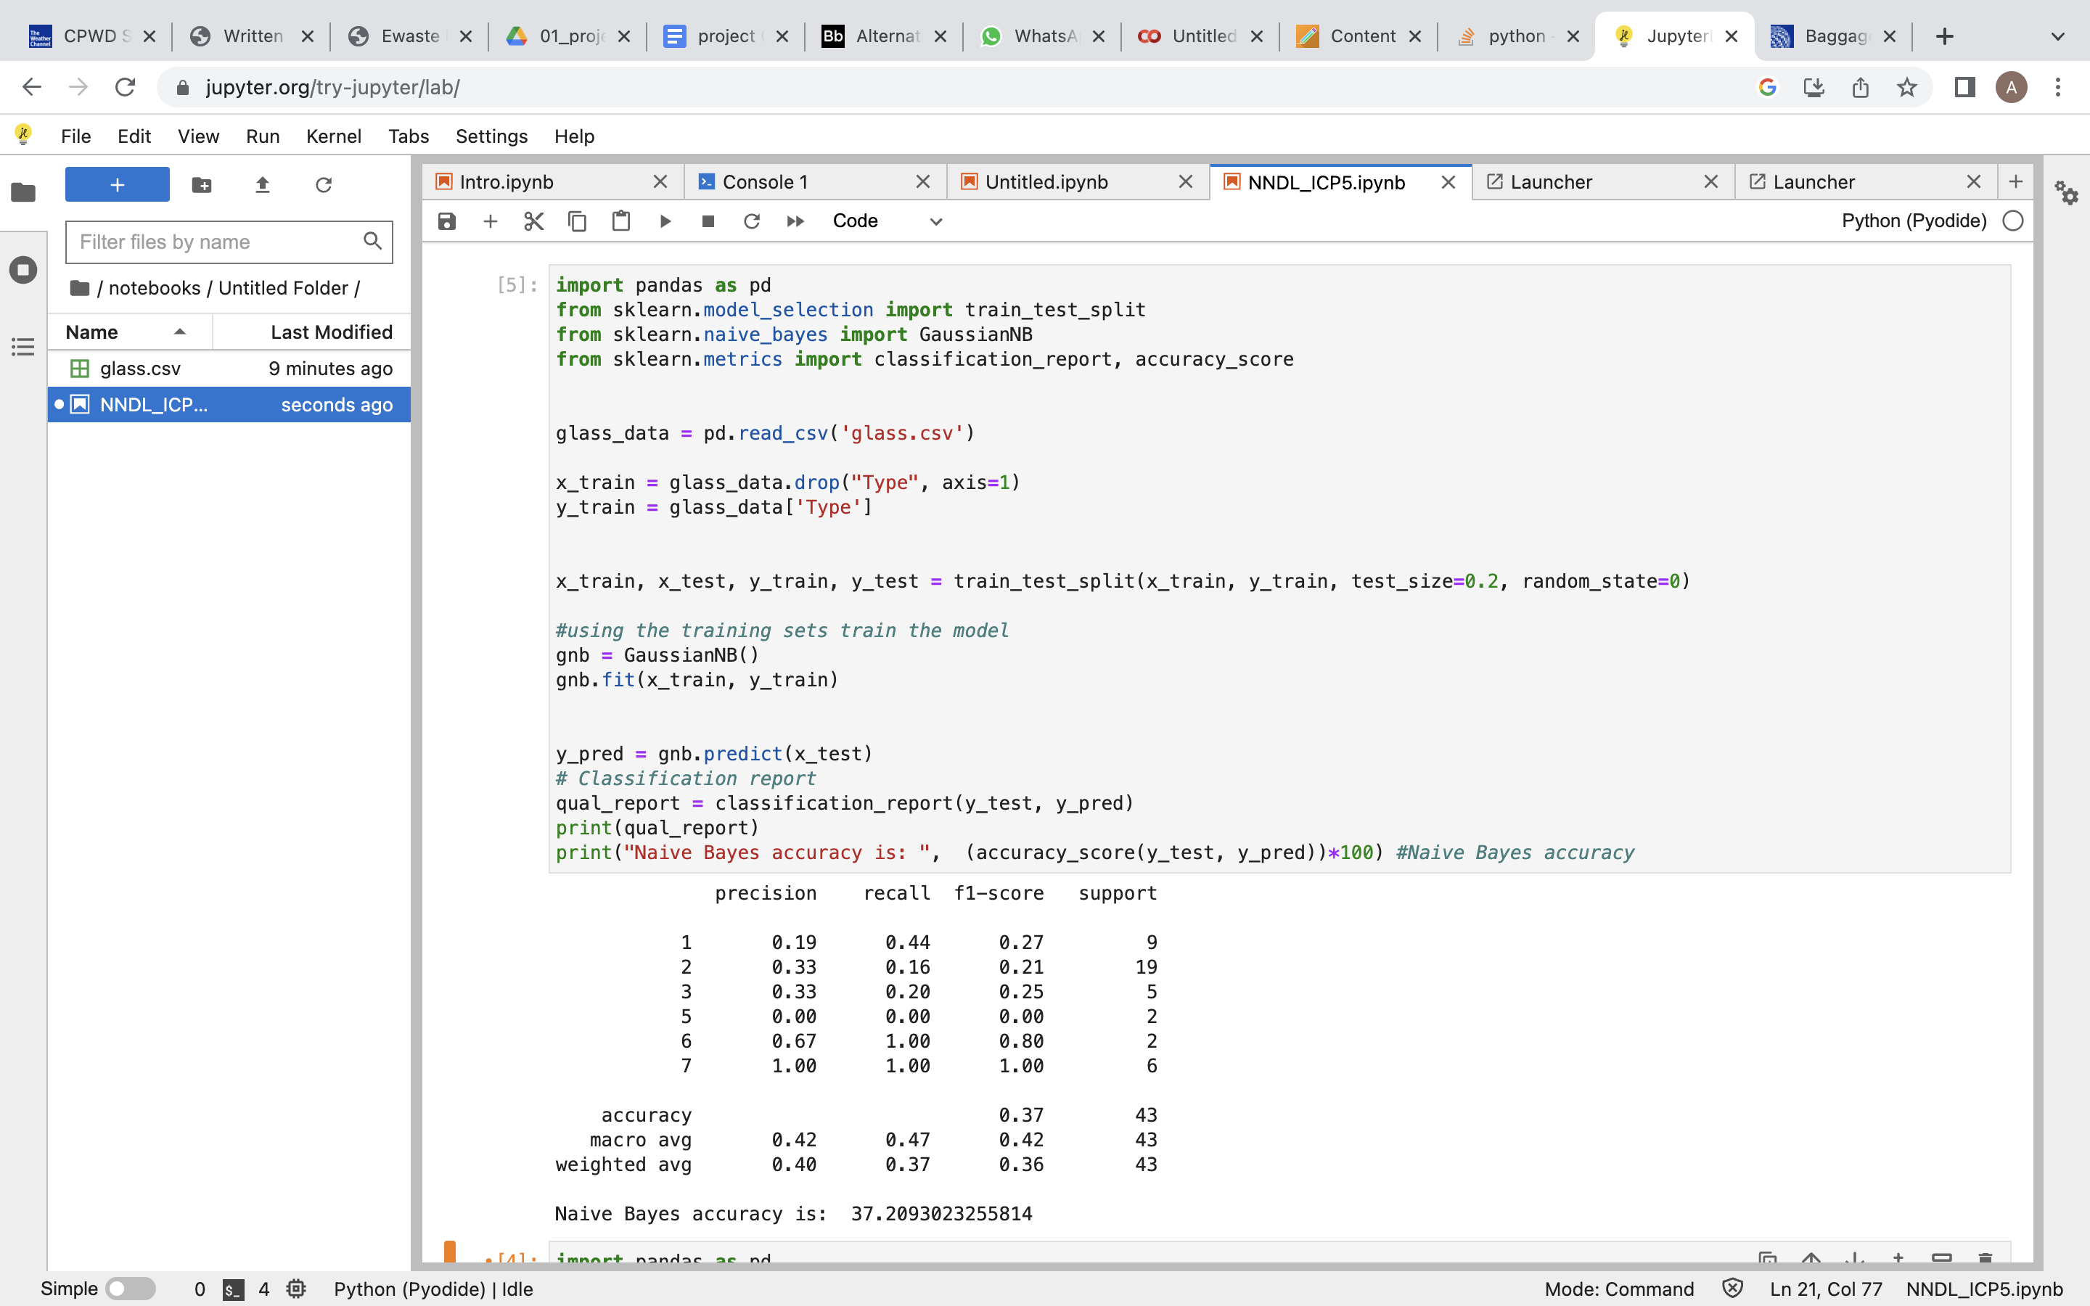

2) Implement linear SVM method using scikit library and using train_test_split to create training and testing part

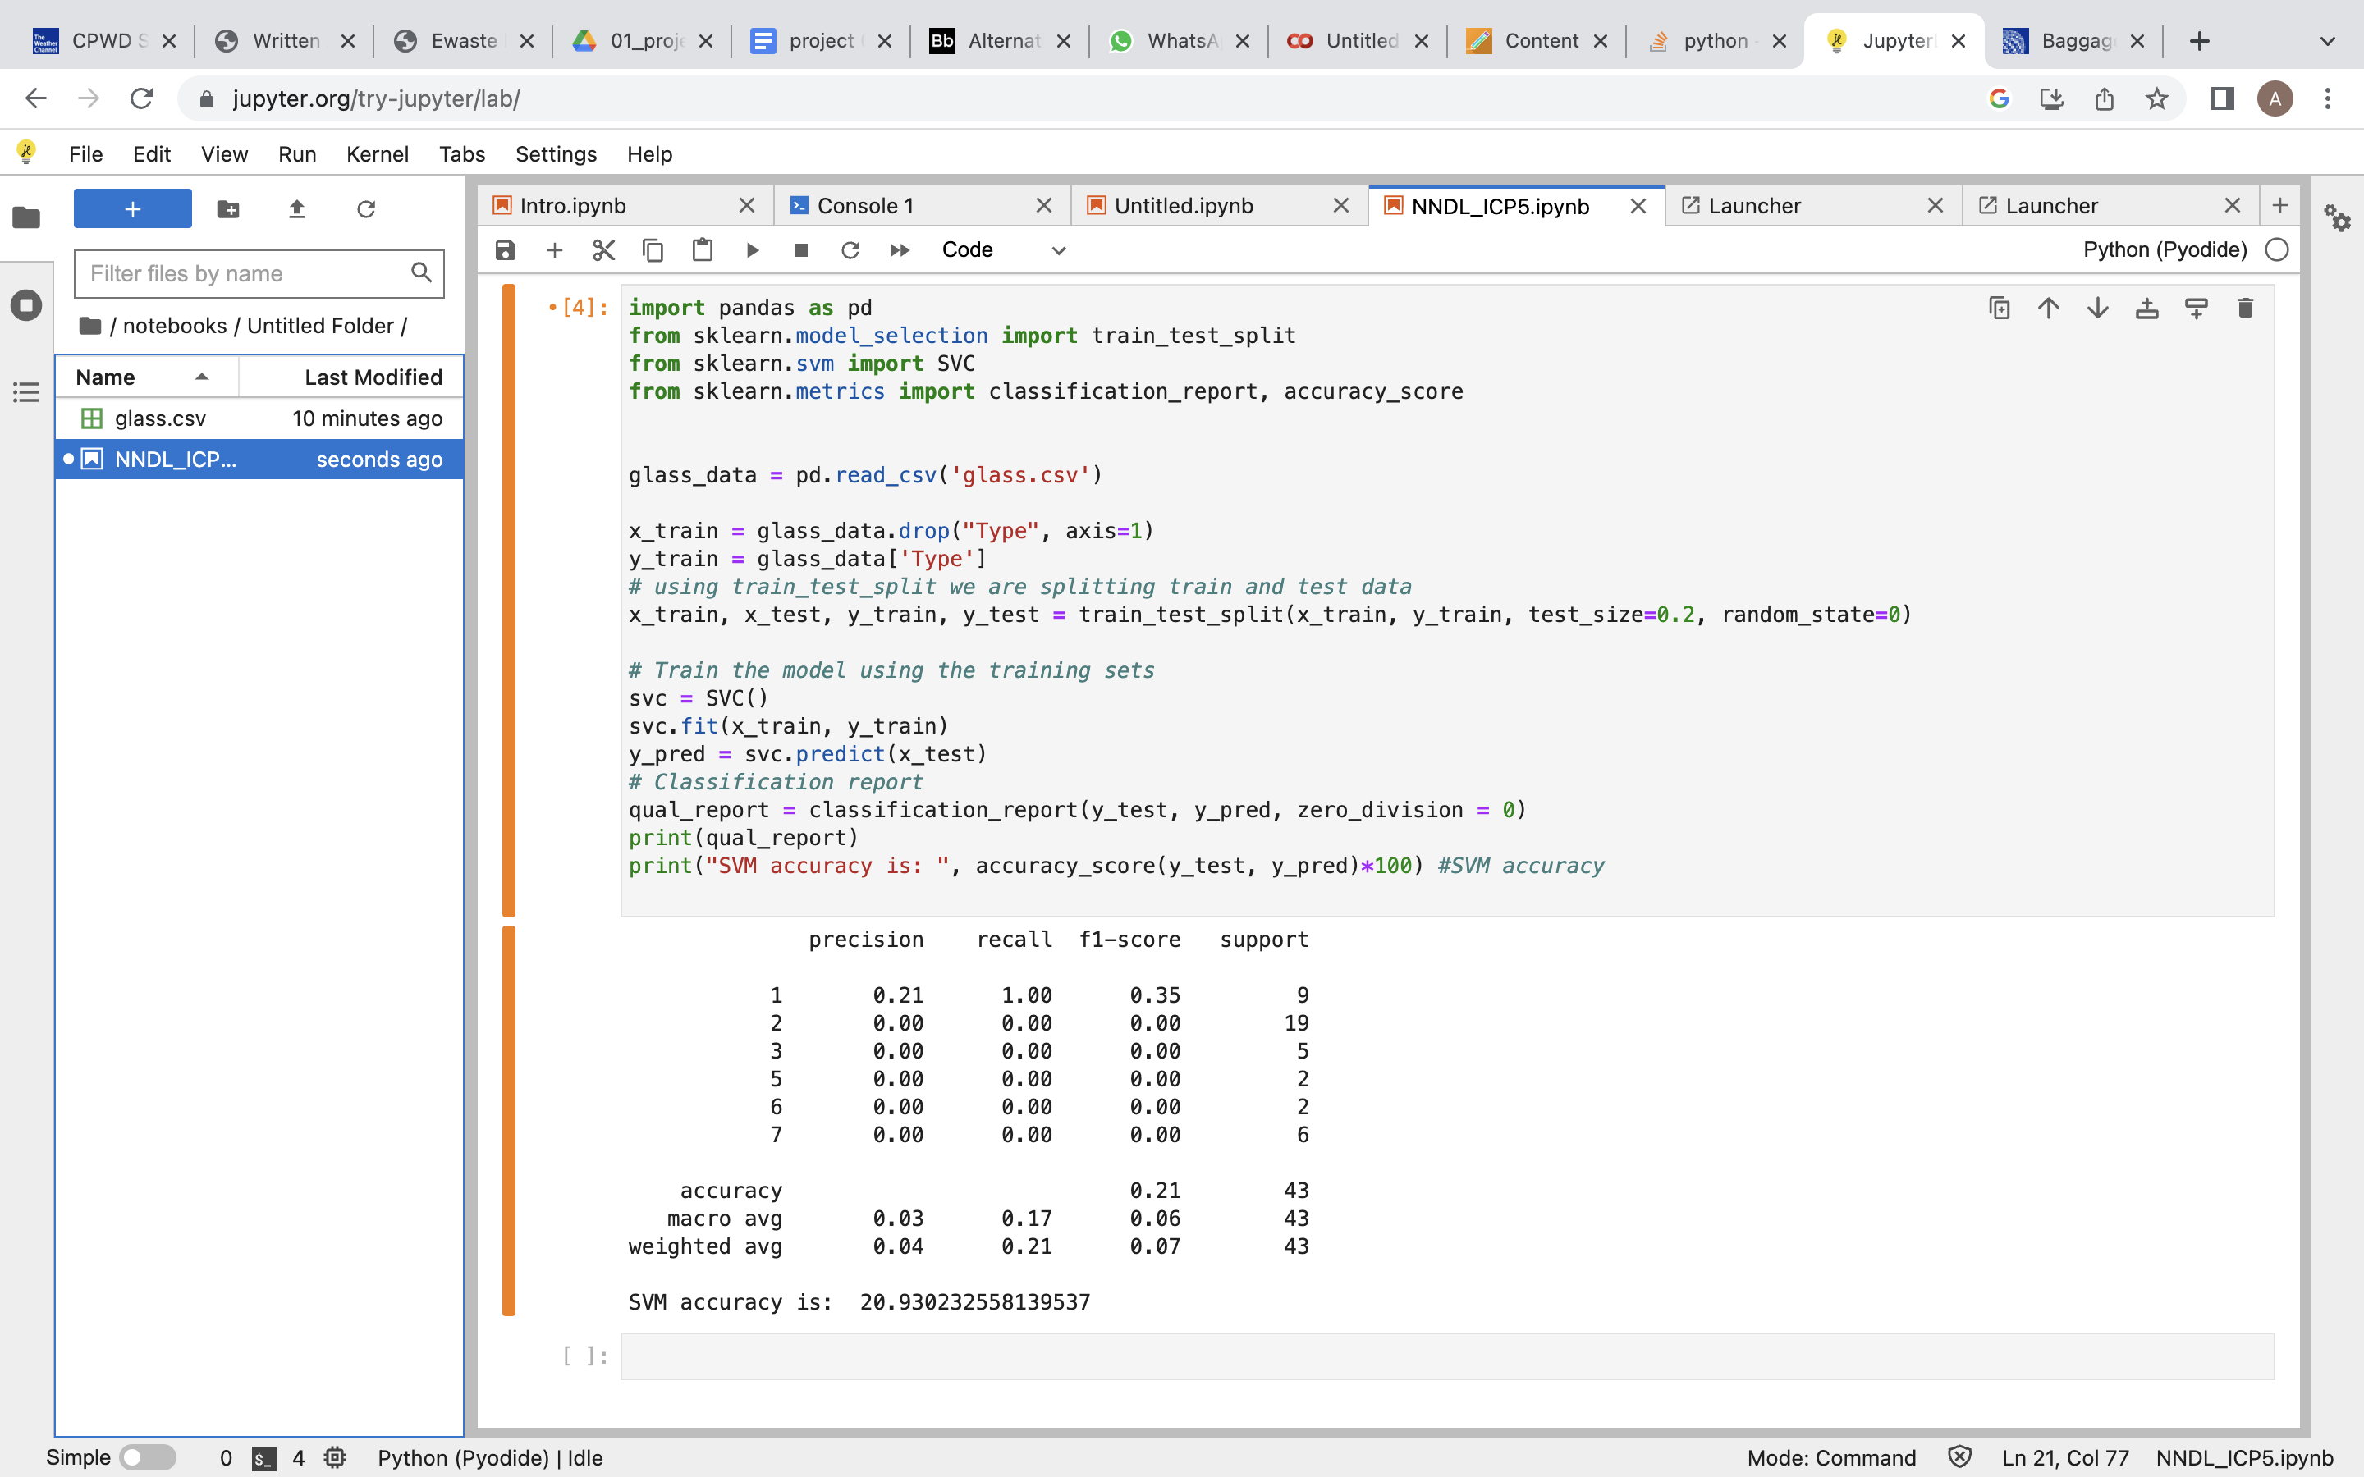

Naïve Bayes algorithm has the best accuracy because the accuracy of Naïve Bayes is greater than the accuracy of linear SVM and moreover the precision, recall and f1 performance of Naïve Bayes is better than SVM.

GITHUB: <https://github.com/AkankshaPanchaneni/NN_ASSIGN5>

AUDIO: <https://www.loom.com/share/9a0e80e1f59640ff82eb381c62f311cc>