ASSIGNMENT-10

NEURAL NETWORK AND DEEP LEARNING

NAME: AKANKSHA PANCHANENI

STUDENT ID: 700740529

1. Save the model and use the saved model to predict on new text data (ex, “A lot of good things are happening. We are respected again throughout the world, and that's a great [thing.@realDonaldTrump](mailto:thing.@realDonaldTrump)”)

The code is a sentiment analysis model that uses LSTM neural networks to classify the sentiment of text data into positive, negative, or neutral categories.It utilizes the Keras library for building and training the model, and the Pandas library for data manipulation and loading.The data is preprocessed by removing non-alphanumeric characters, converting all text to lowercase, and using a tokenizer to convert text data into sequences of integers.The model is trained using a categorical cross-entropy loss function and the Adam optimizer, and evaluated using accuracy metrics.The trained model is saved to a file and can be used to predict the sentiment of new text data.

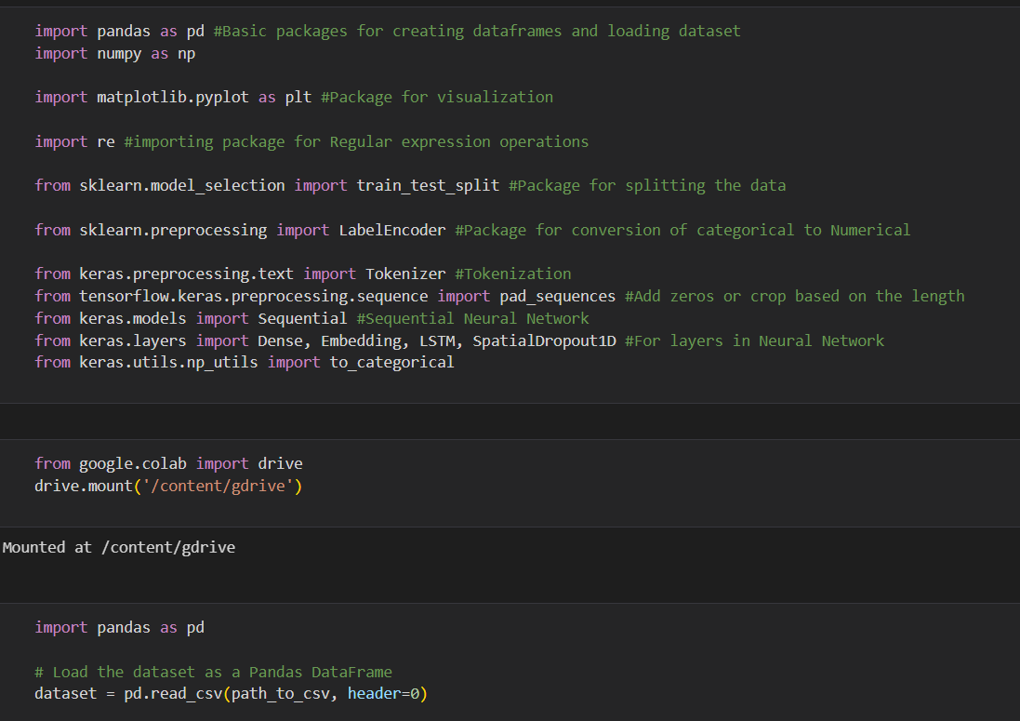

1. Apply GridSearchCV on the source code provided in the class

The code is a sentiment analysis model built using LSTM neural networks in Keras.

The dataset used is "Sentiment.csv" which contains text data and corresponding sentiment labels.The text data is preprocessed by converting all text to lowercase and removing special characters using regular expressions.The LSTM model is trained and evaluated using train-test split and the accuracy achieved is printed.

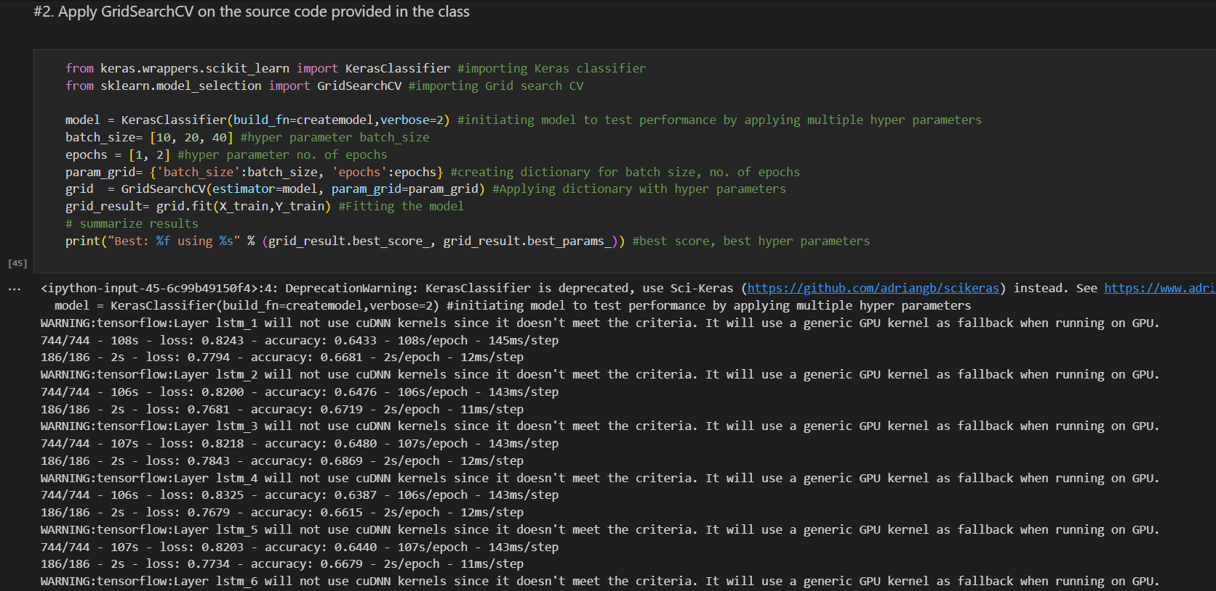

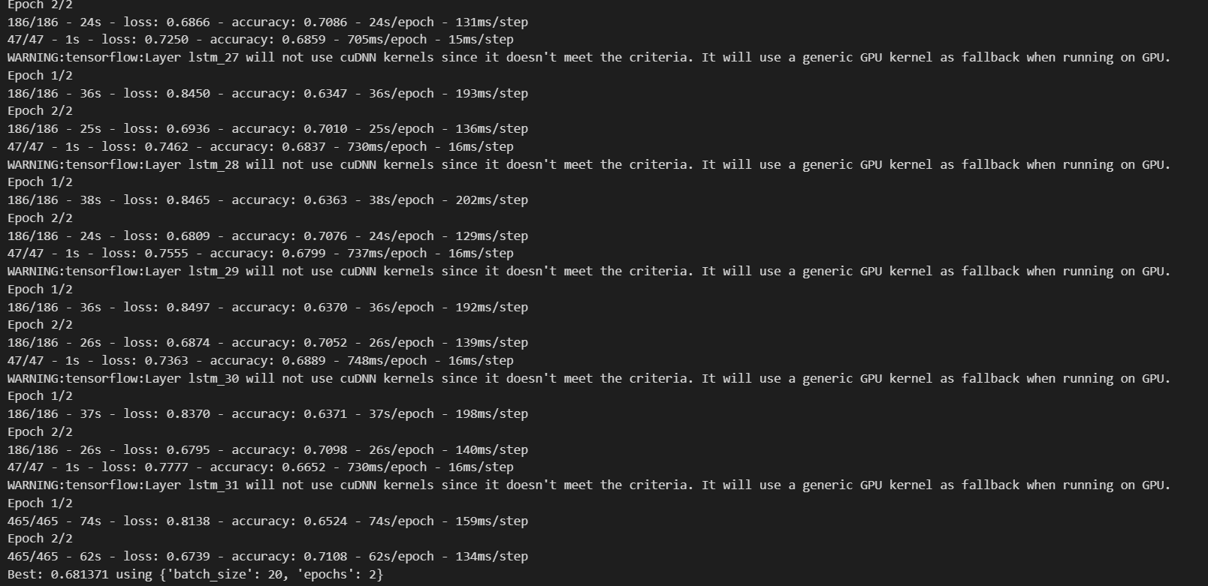

GITHUB LINK: <https://github.com/AkankshaPanchaneni/NN_ASSIGNMENT10>