Windows Registry Key Monitoring using PowerShell

Objective
To monitor changes in Windows Registry keys in real time and log the changes for security and auditing purposes.

Architecture Diagram
Below is the logical architecture of the registry monitoring solution:
+----------------------+
| Windows Registry |
+----------+-----------+
|
v
+----------------------+
| PowerShell Script |
| (WMI + Snapshot) |
+----------+-----------+
|
v
+----------------------+
| CSV Log Files |
| (C:\ Registry Logs) |
+----------+-----------+

Script: Snapshot Comparison Monitoring
This method detects exact registry value changes including old and new values.

Script

$LogFile = "C:\Registry_Detailed_Log.csv"
# Create log file with header if not exists
if (!(Test-Path $LogFile)) {
"Timestamp,ValueName,OldValue,NewValue" | Out-File $LogFile
}
$RegPath = "HKCU:\Control Panel\Desktop"
# Screen saver related keys
$TargetKeys = @(
"SCRNSAVE.EXE",
"ScreenSaveActive",
"ScreenSaveTimeOut",
"ScreenSaverIsSecure"
)
# Function to safely get values (handles missing keys)
function Get-RegValues {
param ($path, $keys)
$result = @{}
$item = Get-ItemProperty -Path $path -ErrorAction SilentlyContinue
foreach ($key in $keys) {
if ($item.PSObject.Properties.Name -contains $key) {
$result[$key] = $item.$key
} else {
$result[$key] = "NULL"
}
}
return $result
}

# Initial baseline
$baseline = Get-RegValues -path $RegPath -keys $TargetKeys
while ($true) {
Start-Sleep -Seconds 5
$current = Get-RegValues -path $RegPath -keys $TargetKeys
foreach ($key in $TargetKeys) {
$oldValue = $baseline[$key]
$newValue = $current[$key]
if ($oldValue -ne $newValue) {
$timestamp = Get-Date -Format "yyyy-MM-dd HH:mm:ss"
$log = "$timestamp,$key,$oldValue,$newValue"
Add-Content $LogFile $log
Write-Host "Changed: $key → $oldValue → $newValue"
}
}
$baseline = $current
}

Screenshots:

- Registry Editor showing monitored key –
Key name: ScreenSaveActive
Current value: 1

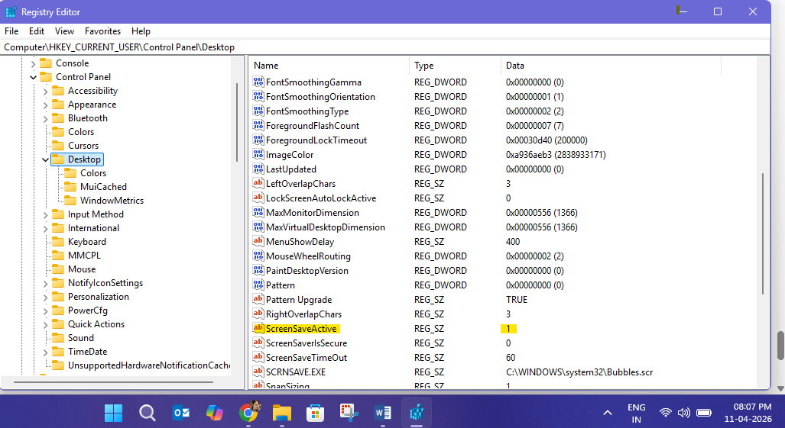

Updated value: 0

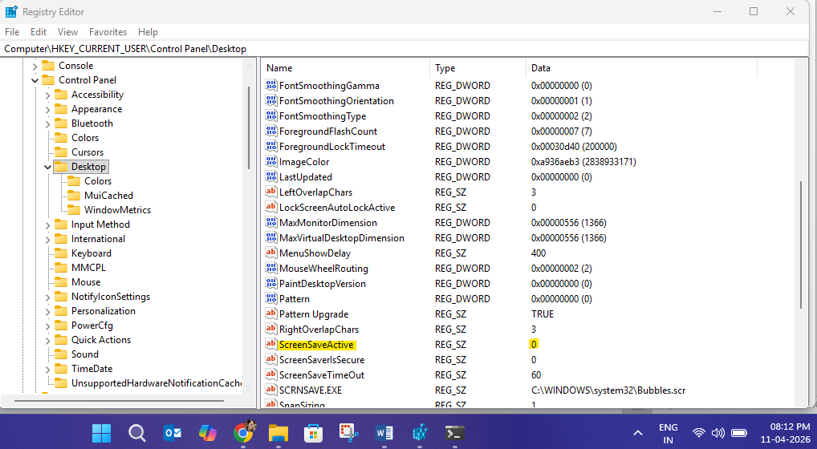

- PowerShell script execution window
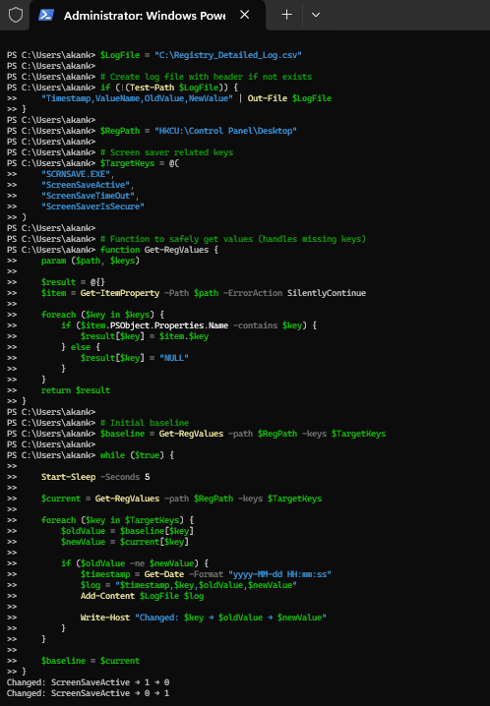

- CSV log file output

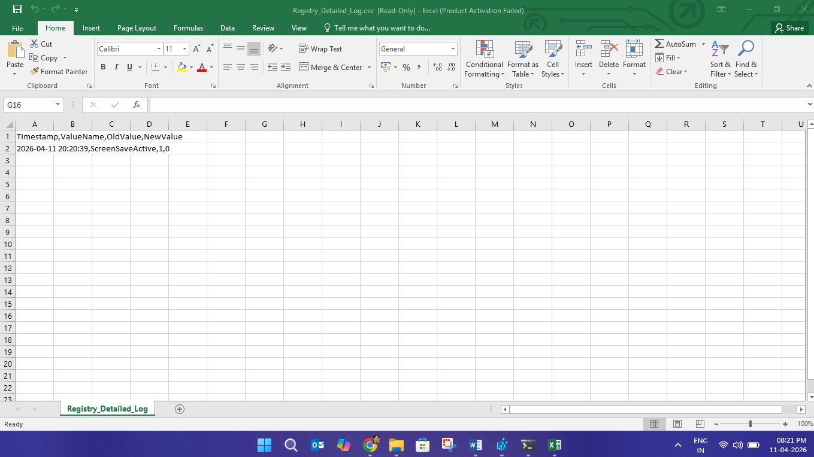

Conclusion
WMI method provides real-time alerts, while snapshot comparison provides detailed insights. A combination of both is recommended for production use.

