# Introduction

Returns are a major challenge for e-commerce platforms. They reduce profit margins, affect customer satisfaction, and strain logistics. This project analyzes return data to find patterns, key reasons for returns, and predicts which orders are likely to be returned. A Power BI dashboard was also built to help decision-makers take action based on the insights.

# Project Summary

We used Python, Power BI, and machine learning to:

* Clean and analyze e-commerce order data
* Build features that highlight customer and product behavior
* Visualize trends in returns
* Predict return risks using a logistic regression model

The goal was to help reduce return rates and improve the shopping experience.

# Tools Used

* Python - For data cleaning, analysis, and modeling (Pandas, Matplotlib, Seaborn, scikit-learn)
* Power BI - For building an interactive dashboard
* Jupyter Notebook - For step-by-step code and analysis
* GitHub - To manage the codebase and version control

# Key Steps in the Project

* 1. **Data Cleaning:**
* Removed duplicates and fixed missing values
* Standardized column names
* Created new features like: Customer_Return_Rate, Supplier_Return_Rate, Return_Rate_Per_Category
  1. **Feature Engineering:**
* Encoded categorical variables
* Scaled numerical values
* Created a binary target: Is_Returned
  1. **Exploratory Data Analysis:**
* Clothing & Accessories had the highest return rate
* Common reasons: Defective, Wrong Product, Changed Mind
* High discount items often returned
* Minimal shipping method impact on returns

# Visualization: Return Rate by Product Category

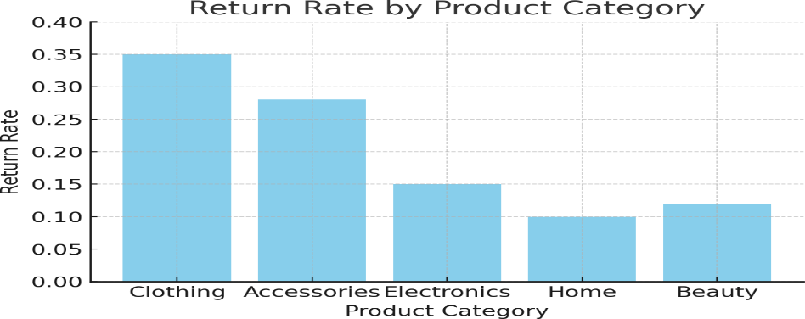

* 1. **Predictive Modeling**
* Used logistic regression to predict return probability
* Accuracy: 50% - suggests potential for improvement
* Future models: Random Forests, XGBoost, and better feature engineering

# 4.6 Power BI Dashboard Features

* KPIs for overall, customer, and supplier return rates
* Charts for return reasons and product category trends
* Drill-through for detailed product/customer analysis
* Slicers to filter data by city, category, and payment method

# Conclusion

This project uncovered key reasons for returns and built a basic predictive model. Combined with Power BI visuals, it enables teams to:

* Identify high-return products and customers
* Take action to reduce return risks
* Improve customer experience and logistics planning

**Future improvements**: advanced models, real-time integration, time-based trends.