**ASSIGNMENT 1**

**Datasets:**

Sevir Data: The Storm EVent ImagRy (SEVIR) dataset is a collection of temporally and spatially aligned images containing weather events captured by satellite and radar. Each of these "events" consists of 4 hours of data in 5 minute time increments over a 384 km x 384 km patch sampled somewhere over the US. Each event is SEVIR is captured by up to 5 image types.

<https://nbviewer.org/github/MIT-AI-Accelerator/eie-sevir/blob/master/examples/SEVIR_Tutorial.ipynb>

Storm Data: Contains information about events occurred between 1950 and 2021  as entered by NOAA's National Weather Service (NWS).

Ref: <https://www.ncdc.noaa.gov/stormevents/ftp.jsp>

**Part 1: Implementing Jupyter Notebook**

* Installing boto3 to access data from S3 buckets
* Downloading SEVIR and Storm Events files corresponding to the Event ID : 835047
* Amalyzing the sample datasets

Occurrence of the Event : June 2019

Episode ID : 138836

File\_index : 34

* Based on the file index, extract the relevant h5 file to implement the Jupyter Notebook https://nbviewer.org/github/MIT-AI-Accelerator/eie-sevir/blob/master/examples/SEVIR\_Tutorial.ipynb

Part 1 b: Upload data on Cloud

* Download sample Storm Data and Catalog.csv
* Create account on Google Cloud Platform to receive 300$ credits
* Create a storage bucket and load the sample data

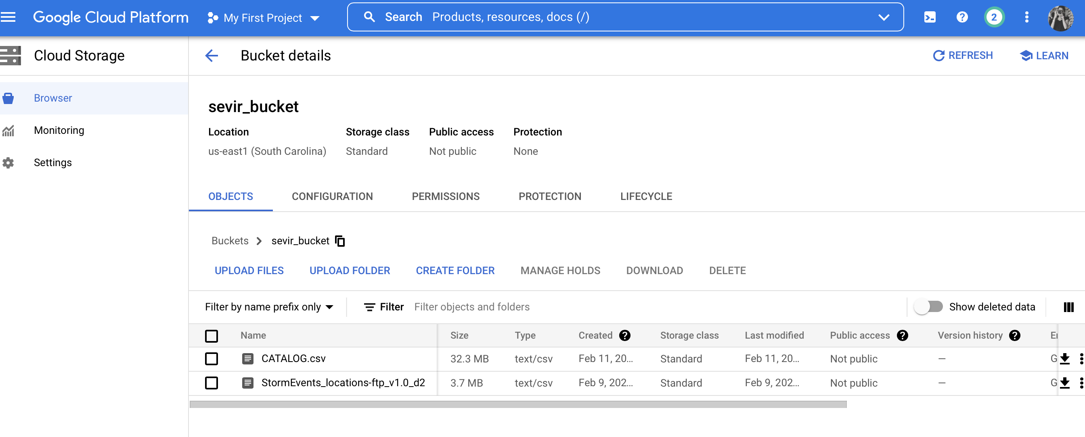

**Part 2 : BigQuery and Data Studio**

* Based on the file in Storage bucket, create a dataset in Big Query
* Give the dataset a name of your choice

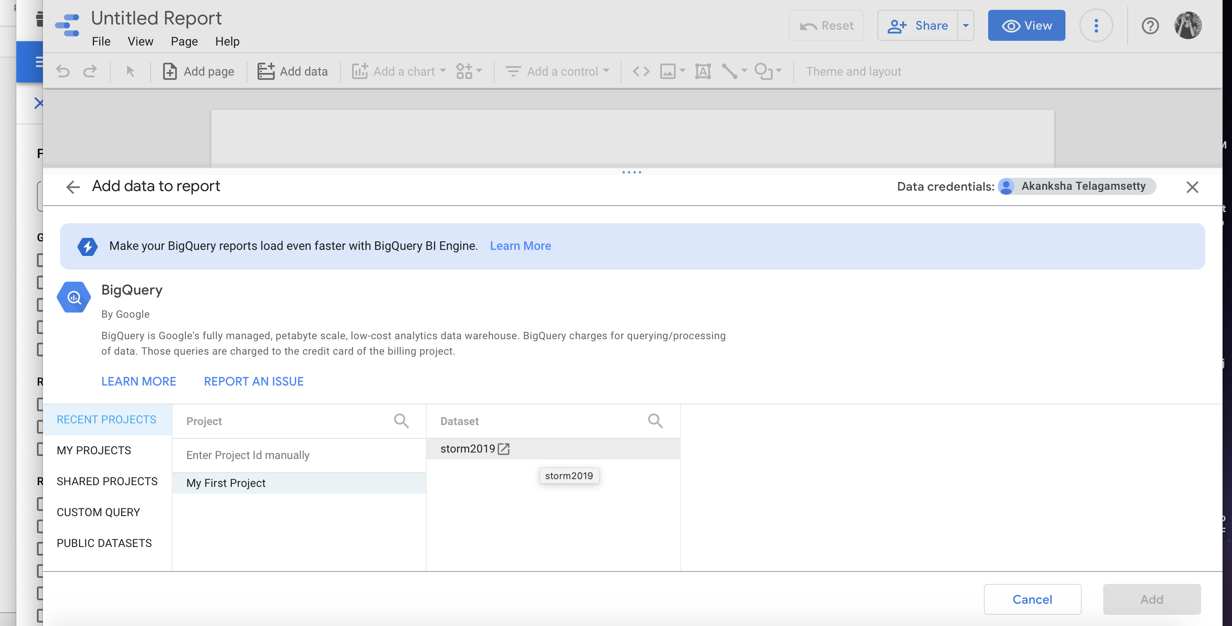

* Create a table within the dataset by selecting source as “Google Cloud Storage”

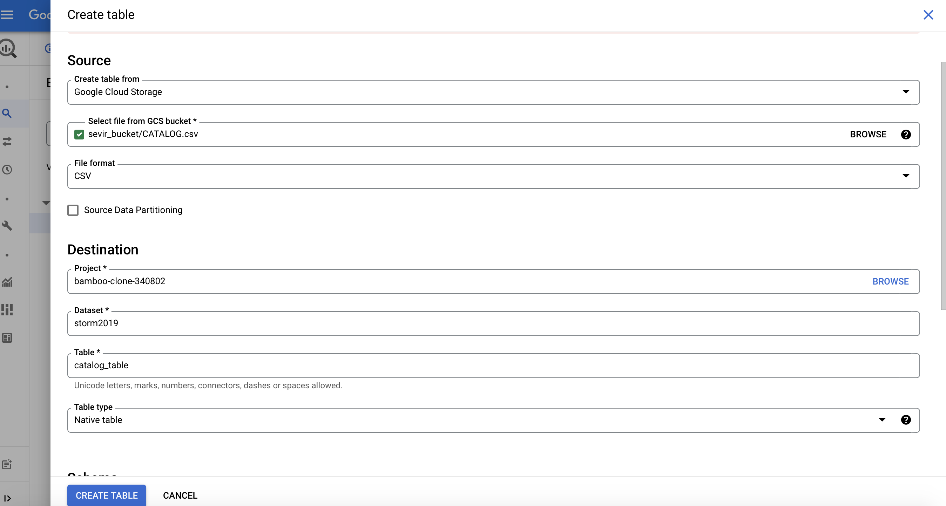

* Now, for connecting the data using Google Data Studio
  + Open Google Data Studio
  + Choose Big Query Connector
  + Choose the table created using Big Query under Projects in Data Studio

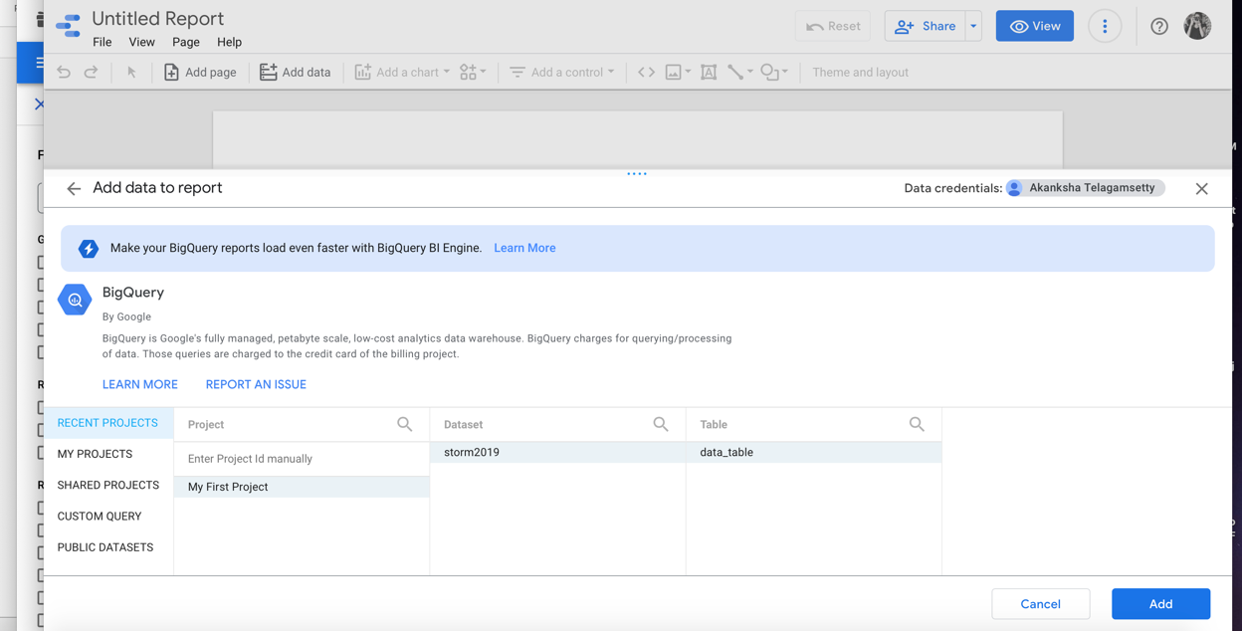

* And we have data accessible on Data Studio

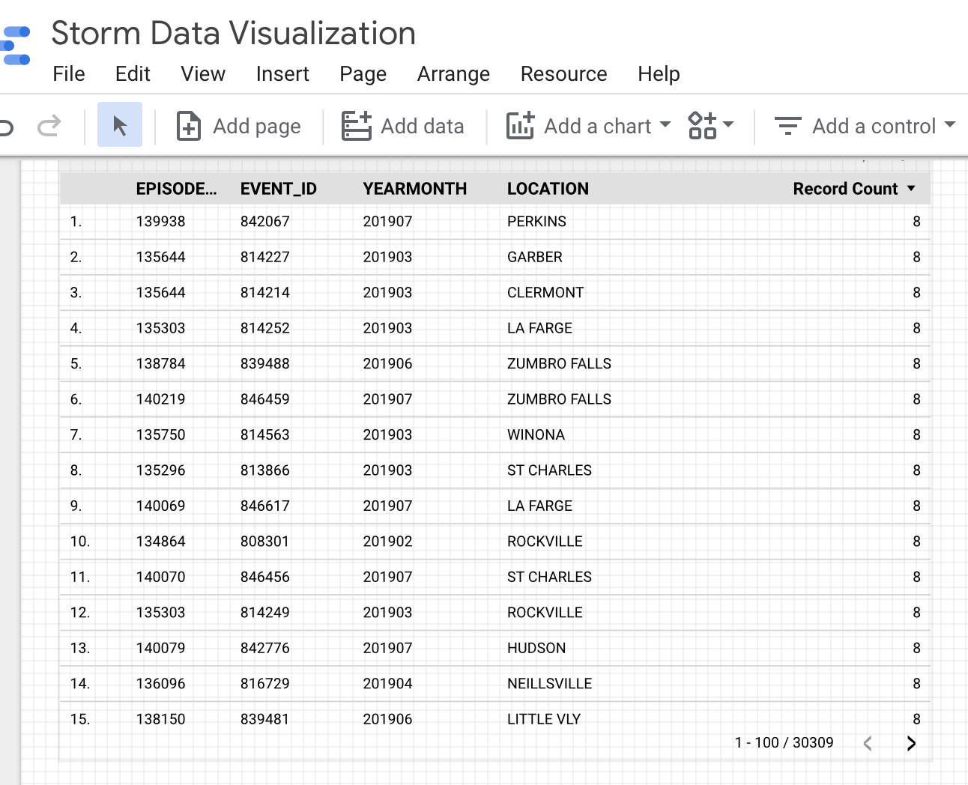

* Analyze the data and obtain visualizations according to your interest, by choosing bars and charts from the Insert option

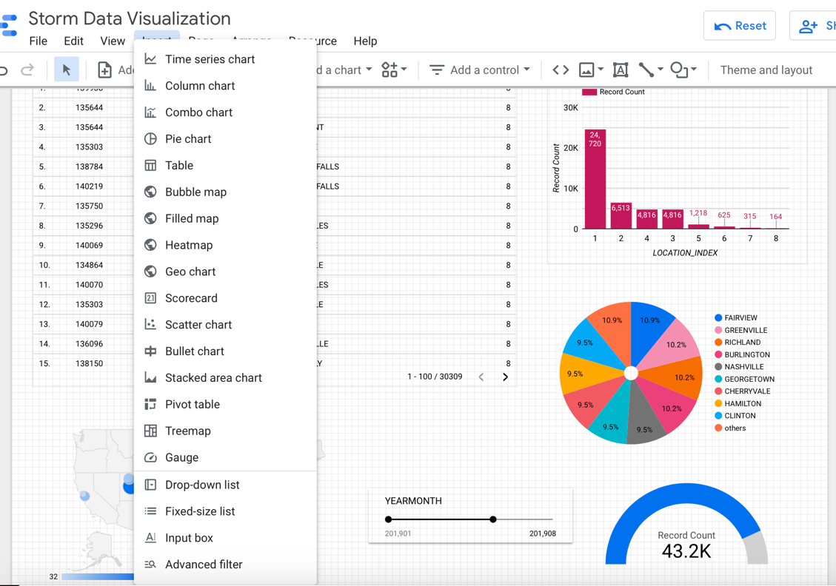

**References:**

**Part 1:**

[**https://github.com/MIT-AI-Accelerator/sevir\_challenges**](https://github.com/MIT-AI-Accelerator/sevir_challenges)

[https://nbviewer.org/github/MIT-AI-Accelerator/eie-sevir/blob/master/examples/SEVIR\_Tutorial.ipynb](https://nbviewer.org/github/MIT-AI-Accelerator/eie-sevir/blob/master/examples/SEVIR_Tutorial.ipynb" \t "_blank)

**Part 2:**

[**https://michaelhoweely.com/2020/07/11/how-to-connect-google-data-studio-to-a-csv-file-using-bigquery-and-cloud-storage/**](https://michaelhoweely.com/2020/07/11/how-to-connect-google-data-studio-to-a-csv-file-using-bigquery-and-cloud-storage/)

[**https://cloud.google.com/bigquery/docs/visualize-data-studio**](https://cloud.google.com/bigquery/docs/visualize-data-studio)

**Deliverables:**

Notebook Link: <https://colab.research.google.com/drive/119SxDtV4olsBGmhZWmjxt1B_d_Xz8vxP?usp=sharing>

Data Studio Link : <https://datastudio.google.com/reporting/11e21fc2-f80d-4657-ae18-cf8b82d7df20>