**Assignment: Creating Database for Lift Management System**

**Assignment Coordinator: Suresh Burde**

**Submitted By: Akanksha Anil Jadhav**

Class diagram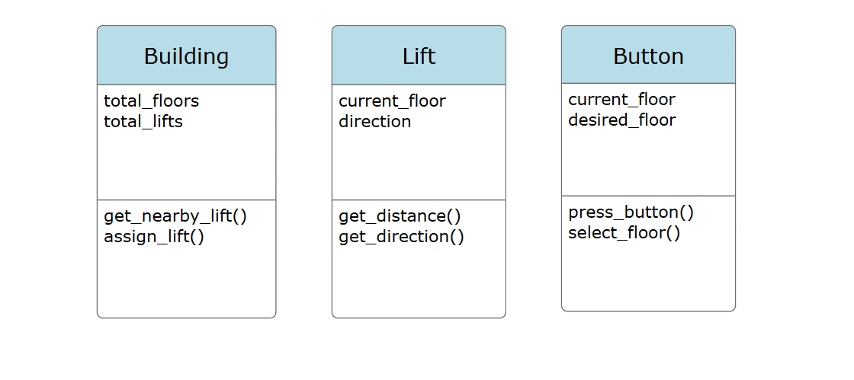

ERD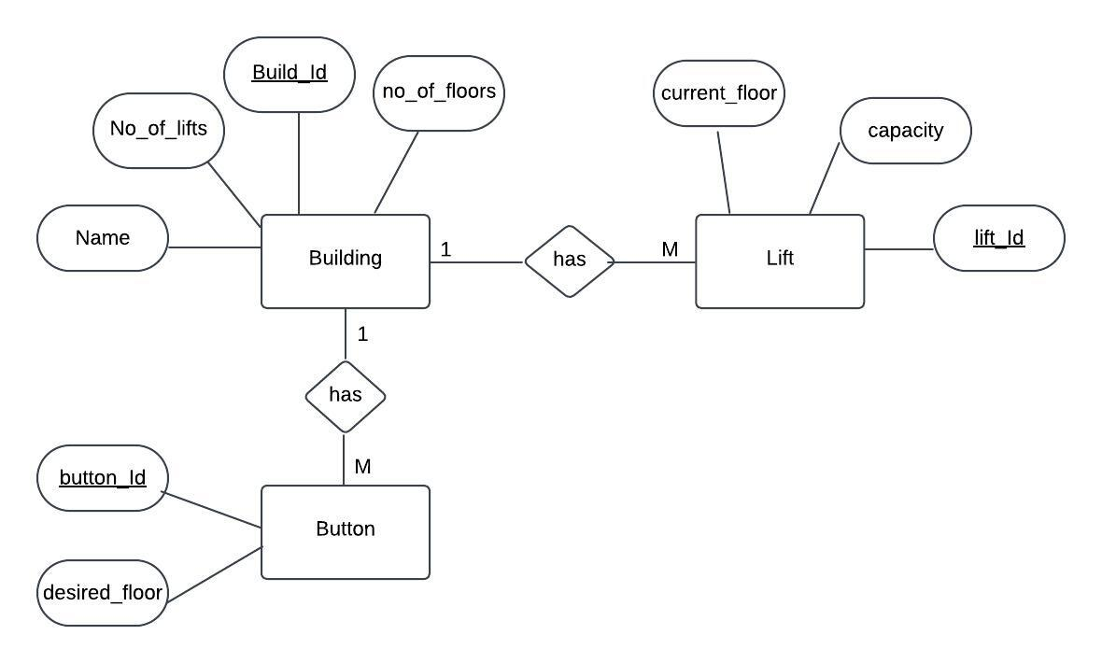

Database : Postgres

Total tables : 3 (building , lift, button)

1. **Building table :**

CREATE TABLE building(

build_id integer primary key NOT NULL,

name varchar(20),

no_of_floors integer NOT NULL,

no_of_lifts integer);



Inserting values –

insert into building(build_id,name,no_of_floors,no_of_lifts) values(1,'Building1',10,5);

values(2,'Building2',9,4);

values(3,'Building3',8,3);

values(4,'Building4',7,2);

values(5,'Building5',6,1);

1. **Lift table :**

CREATE TABLE lift(

lift_id integer NOT NULL,

capacity integer NOT NULL,

current_floor integer,

build_id integer,

FOREIGN KEY (build_id) REFERENCES building (build_id) ON DELETE CASCADE);

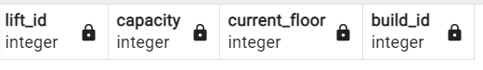

Inserting values –

insert into lift(lift_id,capacity,current_floor,build_id) values(201,3,4,1);

values(202,5,2,4);

values(203,7,1,5);

values(204,9,6,1);

values(205,11,7,2);

1. **Button table :**

CREATE TABLE button(

btn_id integer NOT NULL,

desired_floor integer,

build_id integer,

FOREIGN KEY (build_id) REFERENCES building (build_id) ON DELETE CASCADE);



Inserting values –

insert into button(btn_id,desired_floor,build_id) values(301,1,1);

values(301,2,4);

values(301,3,5);

values(301,4,1);

values(301,5,2);

# Query 1:

SELECT name, no_of_lifts FROM building ORDER BY no_of_lifts DESC LIMIT 3;

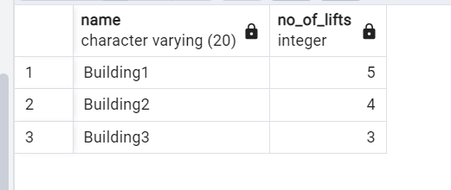

# Query 2-

UPDATE lift

SET current_floor = 3

WHERE lift_id = 201;

select * from lift;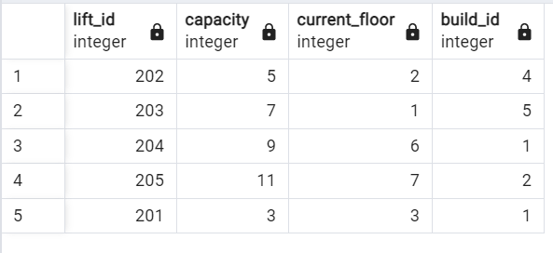

# Query 3-

SELECT capacity, COUNT(lift_id)

FROM lift

GROUP BY capacity

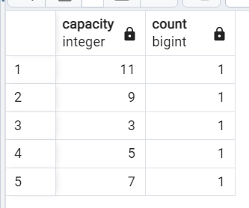

# Query 4:

SELECT *

FROM lift

WHERE build_id IN (

SELECT build_id

FROM building

WHERE no_of_lifts > 2

);

