GERMANY

AR13

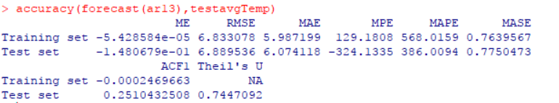

MA13

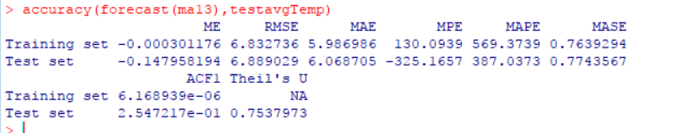

MA1

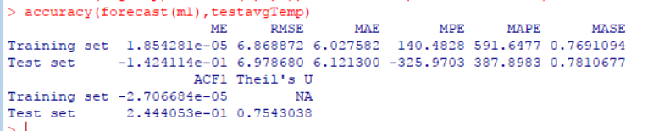

M2/model

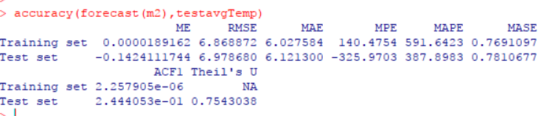

CANADA

AR2

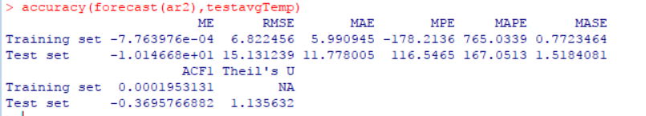

AUTO MODEL M1

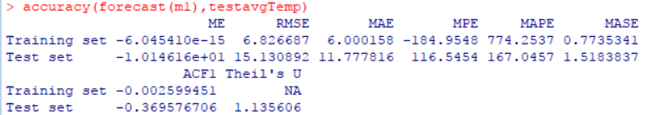

EACF MODEL M2

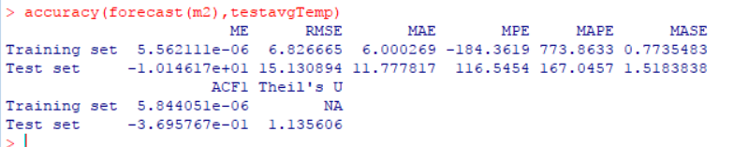

EQUATION FOR GERMANY

AR13

Xt–intercept = β1(Xt-1-intercept) + β2(Xt-2-intercept) + β3(Xt-3-intercept) + β4(Xt-4-intercept) + β5(Xt-5-intercept) + β6(Xt-6-intercept) + β7(Xt-7-intercept) + β8(Xt-8-intercept) + β9(Xt-9-intercept) + β10(Xt-10-intercept) + β11(Xt-11-intercept) + β12(Xt-12-intercept) + β13(Xt-13-intercept) + at

Xt-8.384= -0.036(Xt-1-8.384)-0.0006(Xt-2-8.384) +0.030(Xt-3-8.384) +0.021(Xt-4-8.384) +0.021(Xt-5-8.384) +0.013(Xt-6-8.384)-0.011(Xt-7-8.384) +0.033(Xt-8-8.384) +0.0008(Xt-9-8.384) +0.0133(Xt-10-8.384)-0.0122(Xt-11-8.384) +0.0019(Xt-12-8.384)-0.0684(Xt-13-8.384) +at

Xt= -0.036 Xt-1 -0.0006 Xt-2+0.030Xt-3 +0.021 Xt-4+0.021 Xt-5+0.013 Xt-6-0.011 Xt-7+0.033 Xt-8 +0.0008Xt-9+0.0133 Xt-10-0.0122 Xt-11+0.0019 Xt-12-0.068 Xt-13 +8.3334+at

MA13

rt= μ + at - θ1at-1 - θ2at-2 - θ3at-3 - θ4at-4 - θ5at-5 - θ6at-6 - θ7at-7 - θ8at-8 - θ9at-9 - θ10at-10 - θ11at-11 - θ12at-12 - θ13at-13

rt= 8.384 + at +0.039at-1 – 0.0022at-2 – 0.028at-3 – 0.0224at-4 – 0.0208at-5 – 0.0178at-6 +0.0190at-7 -0.035at-8 +0.0025at-9 – 0.0219at-10 +0.0119at-11 – 0.006at-12 +0.0732at-13

MA1

rt= μ + at - θ1at-1

rt= 8.33 + at +0.015at-1

ARMA(1,1)

rt - rt-1= 0+ at - θ1at-1

rt -0.0179rt-1 = 8.3848+ at – 0.0177at-1

CANADA

AR2

Xt–intercept = β1(Xt-1-intercept) + β2(Xt-2-intercept)+ at

Xt+4.887 = -0.0088(Xt-1+4.887) -0.0003(Xt-2+4.887)+ at

Xt = -0.0088 Xt-1-0.0003Xt-2-4.930)+ at

AUTOARIMA HERE IS (0,0,0)

ARMA(1,1)

rt - rt-1= 0+ at - θ1at-1

rt -0.0044rt-1 = -4.8876+ at – 0.0044at-1