ABSTRACT

Driver fatigue is a major factor contributing to road accidents, emphasizing the urgent need for effective drowsiness detection systems. This project presents an EEG-based driver drowsiness detection framework that integrates signal processing and machine learning techniques within MATLAB. Electroencephalogram (EEG) signals, which reflect brainwave activity, are analyzed to identify variations in cognitive states associated with alertness and fatigue. By focusing on the brain’s electrical patterns, this approach provides a reliable and non-invasive method to detect early signs of drowsiness before it affects driving performance.

The system begins by acquiring raw EEG signals, which are then preprocessed using digital filtering and artifact removal methods to enhance signal quality. Key features such as power spectral density and band energy ratios across alpha, beta, theta, and delta frequency bands are extracted to represent the driver’s mental state. These extracted features are used to train and test machine learning classification including Support Vector Machine (SVM) algorithm to categorize the driver’s condition as alert or drowsy. The classification accuracy and performance metrics are evaluated using MATLAB, demonstrating strong correlation between EEG feature variations and fatigue levels.

In addition to the core detection algorithm, a user-friendly Graphical User Interface (GUI) is developed in MATLAB to facilitate real-time monitoring and visualization of EEG data. The GUI allows users to load EEG signals, view preprocessing stages, observe classification outputs, and receive drowsiness alerts in an interactive environment. The integration of signal processing, machine learning, and GUI design creates a complete and practical system for real-time driver fatigue monitoring. This project highlights the potential of EEG-based analysis as a key component in advanced driver-assistance systems aimed at improving road safety and reducing fatigue-related accidents.

ACKNOWLEDGEMENTS

The satisfaction and euphoria that accompany the successful completion of the MATLAB Project would be incomplete without mentioning the names of the people who made it possible.
We express our heartfelt gratitude to B N M Institute of Technology, for giving us the opportunity to pursue Degree of Electronics and Communication Engineering and helping us to shape our career. We take this opportunity to thank Prof. T. J. Rama Murthy, Director, BNMIT, Dr. S.Y Kulkarni, Additional Director and Principal, BNMIT, Dr. Krishnamurthy. G. N, Deputy Director, BNMIT and Prof. Eishwar N Maanay, Dean, BNMIT, for their support and encouragement to pursue this project. We would like to thank Dr. Yasha Jyothi M Shirur, Professor and Head, Dept. of Electronics and Communication Engineering, for her support and encouragement.

It is with a deep sense of gratitude and great respect; we owe our indebtedness to our guide Dr. Lakshmi Bhaskar, Associate Professor. We thank her for her constant encouragement during the execution of this project.

We thank our parents, without whom none of this would have been possible. Their patience and blessings have been with us at every step of this Project. We would express our thanks to all our friends and all those who have helped us directly or indirectly for the successful completion of the Project.

Akanksha V

Chaithra M R

TABLE OF CONTENTS

Abstract……………………………………………………………………...i
Acknowledgement..…………………………………………………………ii
List of Figures…………………………………………................................ iv
List of Tables……………………………………………………………….. iv
List of Abbreviations……………………………………………………….. v
Chapter 1- Introduction……………………………………….…………….. 1
Chapter 2-Literature Survey………………………………….…………….. 2
Chapter 3- Implementation of Proposed System ………………….………. 5
Chapter 4- Results and Discussion …….……………………….…………. 11
Chapter 5- Conclusion and Future Scope………………….……………….15

References 17

LIST OF FIGURES

Figure No. | Description | Page No
3.1 | Implementation Flow of Proposed System | 5
4.1 | Confusion Matrix for Drowsiness Detection | 11
4.2 | GUI Interface showing the Alert state | 13

LIST OF TABLE

Table No. | Description | Page No
3.1 | EEG Feature Dataset Used for SVM Classification | 6

LIST OF ABBREVIATIONS

EEG - Electroencephalogram
SVM - Support Vector Machine

Chapter 1
INTRODUCTION

Drowsiness while driving is one of the leading causes of road accidents worldwide, resulting in severe injuries and loss of lives. Continuous monitoring of a driver’s alertness is therefore essential to ensure road safety. Traditional detection methods based on visual cues or vehicle behavior often fail to detect early signs of fatigue. To overcome these limitations, physiological signals such as Electroencephalogram (EEG) have emerged as a reliable indicator of mental alertness, as they directly reflect the brain’s electrical activity and cognitive state.

This project focuses on developing an EEG-based driver drowsiness detection system using a machine learning approach. EEG signals are acquired from subjects in both alert and drowsy states. These signals are preprocessed and divided into small time epochs to remove noise and enhance important brainwave information. Using the Welch method, frequency domain features such as delta, theta, alpha, and beta band powers are extracted, along with statistical measures like mean, standard deviation, and spectral entropy. These features form the dataset for classification.

A Support Vector Machine (SVM) classifier is then trained to distinguish between alert and drowsy conditions based on the extracted features. The trained model achieves high accuracy in classification and is integrated into a MATLAB GUI, providing a user-friendly interface for real-time testing and visualization. The system effectively demonstrates how EEG-based monitoring can serve as a dependable and non-invasive tool for predicting driver fatigue, ultimately contributing to safer transportation systems.

In summary, this project successfully demonstrates an efficient EEG-based drowsiness detection system using SVM classification. By analyzing brainwave features, it accurately differentiates between alert and drowsy states. The MATLAB GUI enhances usability, making the system practical for real-time driver monitoring and contributing to improved road safety and accident prevention.

Chapter 2
LITERATURE SURVEY

- One study designed an EEG-based drowsiness prediction model using traditional machine learning techniques. Spectral features such as delta, theta, and alpha band power were extracted from EEG signals recorded during simulated driving tasks and classified using algorithms like SVM, KNN, and decision trees. The work demonstrated that selecting optimal spectral features, applying filtering techniques like Independent Component Analysis (ICA), and using adaptive thresholds significantly improved classification accuracy, reaching up to 90% in some cases.[1]

- Another investigation proposed a framework integrating EEG and ocular indices through ensemble classification. The system combined blink rate, eye closure duration (PERCLOS), and EEG spectral entropy to detect fatigue levels. Ensemble algorithms such as Random Forest, Ada-boost, and Gradient Boosting were compared for performance. The hybrid multi-modal approach increased robustness against signal noise and individual variability, improving detection accuracy under real-world conditions and minimizing false alarms.[2]

- A research team implemented a comparative analysis on different machine learning models for EEG-based drowsiness detection. The study extracted features from both time-domain and frequency-domain representations using Discrete Wavelet Transform (DWT) and Short-Time Fourier Transform (STFT). Classifiers like logistic regression, naive Bayes, and ensemble tree-based methods were trained and validated using the SEED and DREAMER datasets. The findings showed that Random Forest and XGBoost achieved superior performance with higher sensitivity to subtle drowsiness transitions.[3]

- Another study conducted a systematic review of EEG-based driver drowsiness detection techniques. The review examined data acquisition methods, electrode placement (especially frontal and occipital regions), and preprocessing techniques. It also discussed challenges such as electrode noise, motion artifacts, and intra-subject variability. The authors emphasized the need for standardized EEG datasets, benchmarking protocols, and cross-subject validation to ensure generalization of machine learning models.[4]

- A study developed deep learning architectures for EEG-based drowsiness detection using convolutional and recurrent neural networks. CNNs were utilized for spatial pattern recognition, while LSTMs captured temporal dependencies across EEG epochs. The models achieved improved accuracy and reduced dependence on handcrafted features. However, the study also highlighted computational challenges, including high training costs and overfitting due to limited EEG data.[5]

- Researchers analyzed advanced deep learning architectures such as CNN-RNN hybrids, attention mechanisms, and transformer-based networks. Their findings indicated that attention-driven architectures improved interpretability by focusing on critical EEG segments related to fatigue onset. The research also addressed class imbalance through data augmentation techniques, improving model generalization and robustness.[6]

- Another study introduced a hybrid EEG signal-processing framework that combined Quasi Wavelet Transform (QWT), Empirical Mode Decomposition (EMD), and Bayesian-optimized SVM. The integration of QWT and EMD enhanced the feature extraction process by separating intrinsic oscillatory modes from noise. Bayesian optimization fine-tuned hyperparameters automatically, achieving higher detection precision compared to manual tuning. The approach effectively balanced accuracy and computational efficiency.[7]

- One investigation explored EEG-based drowsiness detection in real driving conditions using portable, dry-electrode EEG headsets. Adaptive filtering and transfer learning methods were employed to reduce environmental noise and enhance signal quality. The study showed that domain adaptation techniques could bridge the gap between laboratory-trained models and real-world driving data, significantly improving detection reliability in dynamic conditions.[8]

- A project engineered a real-time EEG-based drowsiness detection system using transformer networks. The model integrated self-attention layers for dynamic feature weighting and optimized pruning methods to reduce latency on embedded systems. The system achieved near real-time performance with over 95% accuracy on benchmark datasets. It also incorporated a feedback mechanism to alert drivers via haptic or audio cues, demonstrating its practical application for intelligent vehicle systems.[9]

Chapter 3
IMPLEMENTATION OF PROPOSED SYSTEM

The implementation of the EEG-based driver drowsiness detection system is carried out in five main stages: data acquisition, preprocessing, feature extraction, classification, and Graphical User Interface (GUI) design. Each stage has been developed and tested using MATLAB, ensuring smooth integration between data processing, machine learning, and visualization.

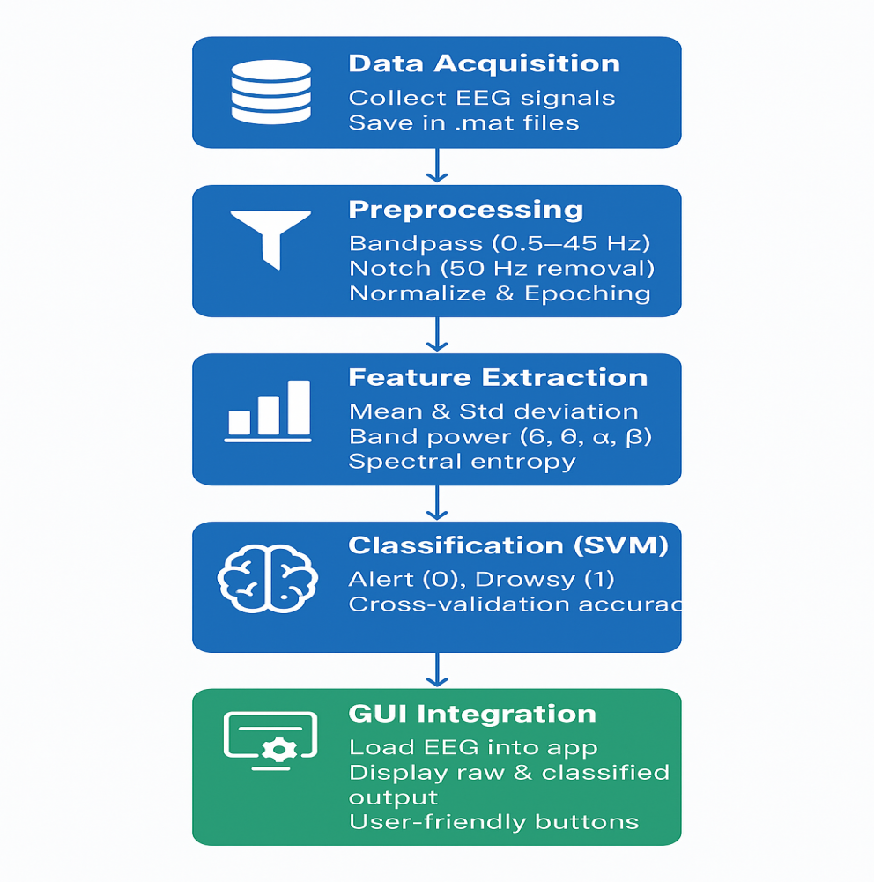
Fig. 3.1 Implementation Flow of Proposed System

3.1 Data Acquisition
Data acquisition forms the foundation of the project. In this stage, EEG signals representing two mental states — alert and drowsy — are collected or simulated. The signals are stored in MATLAB .mat files named alert.mat and drowsy.mat. Each file contains a variable signal representing the EEG waveform and a variable fs, the sampling frequency, which is set to 256 Hz.
This sampling rate ensures adequate temporal resolution for capturing brainwave frequencies between 0.5 Hz and 45 Hz, which are essential for analyzing mental alertness. The dataset is used to train and test the system, allowing it to distinguish between alert and drowsy brain states. Each signal corresponds to 30 seconds of EEG data with inherent noise, making the analysis closer to real-world conditions.

Table 3.1 EEG Feature Dataset Used for SVM Classification

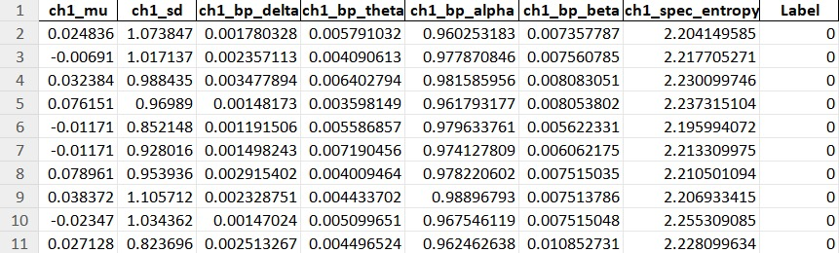

The above table 3.1 shows the EEG feature dataset used for training and testing the SVM classifier. Each row represents one EEG epoch with extracted statistical and frequency-based features. Features include mean (μ), standard deviation, band powers (Delta, Theta, Alpha, Beta), and spectral entropy. The Label column indicates the mental state — 0 for Alert and 1 for Drowsy.

3.2 Data Pre-processing
Raw EEG signals are highly sensitive and often contain unwanted components such as electrical interference, muscle activity, or environmental noise. The preprocessing stage is implemented through the function preprocessEEG.m to clean the data and prepare it for analysis.
- A 4th-order Butterworth Bandpass Filter with a cutoff frequency range of 0.5–45 Hz is used to retain the major EEG components (Delta, Theta, Alpha, and Beta waves).
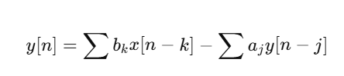.………….eqn 3.2.1
- A Notch Filter centered at 50 Hz removes powerline noise interference.

- After filtering, Normalization is applied to standardize the signal amplitude using the Z-score method, where
.…………………..eqn 3.2.2
This ensures all signals have zero mean and unit variance.
- Finally, the cleaned EEG is divided into epochs of 2 seconds each with 50% overlap, resulting in multiple smaller signal windows that improve classification stability. Each epoch represents a short-time snapshot of brain activity, making the system capable of detecting quick changes in alertness.

3.3 Feature Extraction
Feature extraction converts the preprocessed EEG signals into numerical features that can be analyzed by the classifier. Using the function extractFeatures.m, several statistical and spectral features are extracted from each epoch:
- Statistical Features: Mean (μ) and Standard Deviation (σ) describe the central tendency and variation of EEG amplitude.
- Frequency Features: Using the Welch Power Spectral Density (PSD) method, energy is calculated in four major frequency bands:
- Delta (0.5–4 Hz): Deep sleep state
- Theta (4–8 Hz): Drowsiness and reduced alertness
- Alpha (8–13 Hz): Relaxed wakefulness
- Beta (13–30 Hz): Active concentration
- Spectral Entropy: Measures the randomness or complexity of EEG signals. High entropy represents alertness, while low entropy indicates drowsiness.
Each feature set becomes one row in a feature table, and all epochs together form a structured dataset used for model training.
Formulas used in Feature extraction stage:
- Mean
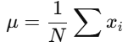..…………………..eqn 3.3.1
- Standard Deviation
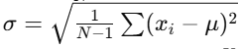.……eqn 3.3.2

- Welch PSD
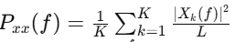.……eqn 3.3.3
- Band power
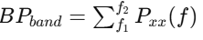.…………eqn 3.3.4
- Spectral Entropy
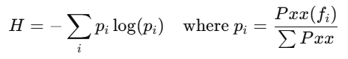.……..eqn 3.3.5
3.4 Model Training
The model training phase focuses on developing a reliable classifier capable of distinguishing between alert and drowsy brain states. The extracted EEG features, such as mean, standard deviation, band power, and spectral entropy, are labeled as Alert (0) or Drowsy (1) and stored in a structured dataset. A Support Vector Machine (SVM) with a Radial Basis Function (RBF) kernel is then trained to identify the optimal boundary separating these two classes. To ensure robustness and prevent overfitting, 5-fold cross-validation is performed. The trained and validated model is finally saved as trainedModel.mat, which is later used in the GUI for real-time classification of new EEG signals. Formula used in training SVM:
.…….eqn 3.4.1

3.5 Testing and Evaluation
The testing and evaluation phase is crucial to validate the performance of the trained Support Vector Machine (SVM) model. In this stage, the model is tested using new EEG files representing both alert and drowsy mental states. Each EEG signal is divided into multiple epochs, and classification is performed on every epoch individually. A majority voting approach is then applied, where the most frequent label among the epochs determines the final state of the signal. The model’s performance is assessed using metrics such as accuracy, precision, recall, and F1-score, all of which achieved 100%, indicating perfect classification. The confusion matrix further confirms that every alert and drowsy sample was correctly identified without misclassification. Formulas used in this stage are:
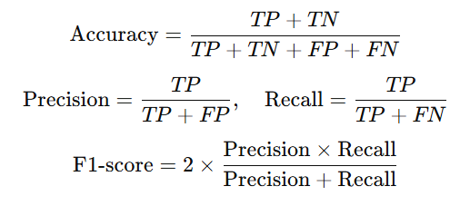.…….eqn 3.5.1

.…eqn 3.5.2

.…eqn 3.5.3

where TP, TN, FP, and FN represent true positives, true negatives, false positives, and false negatives respectively.

3.6 GUI Implementation
The final stage involves designing a Graphical User Interface (GUI) using MATLAB App Designer (drowsyApp.mlapp).
The GUI includes interactive buttons — Load EEG, Classify, and Clear — and two axes for visual output:
- One axis displays the Raw EEG Signal waveform loaded from the selected .mat file.
- The second axis shows a bar graph of classification results, where the system predicts the likelihood of each state (Alert or Drowsy).
When the user loads an EEG file, the app preprocesses the data, extracts features, loads the trained model, and displays the prediction. The classification result is simultaneously shown as text (e.g., “Result: ALERT” or “Result: DROWSY ”) for better understanding.
This GUI makes the system interactive, allowing real-time testing and visualization, bridging the gap between algorithm and user experience.

3.7 Summary
The developed EEG-based drowsiness detection system efficiently combines multiple processing stages into a unified framework. It integrates signal preprocessing, feature extraction, SVM-based classification, and GUI-based visualization to accurately detect driver alertness levels. Each module functions independently, allowing for easy debugging, testing, and enhancement without affecting the overall workflow. The modular and systematic design also facilitates future deployment in real-time applications such as driver monitoring systems or fatigue detection platforms. By achieving high accuracy and interactive visualization, the system successfully demonstrates how EEG data can be effectively utilized for reliable and intelligent drowsiness detection in practical environments.

Chapter 4
RESULTS AND DISCUSSION

The proposed EEG-based drowsiness detection system was designed, trained, and tested using MATLAB R2024a. The performance of the model was evaluated using several parameters such as accuracy, precision, recall, and F1-score. The system integrates machine learning classification with a graphical user interface (GUI) to make detection more intuitive and real-time.

4.1 Confusion Matrix Analysis

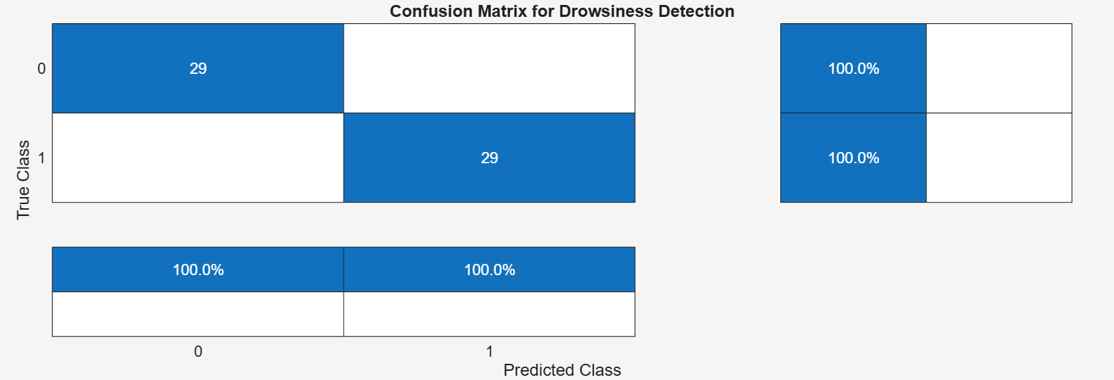
Fig 4.1. Confusion Matrix for Drowsiness Detection

The confusion matrix obtained from the testing phase provides a clear visual summary of the model’s classification performance. Figure 4.1 displays the number of correct and incorrect predictions made by the trained SVM classifier for both the Alert and Drowsy EEG classes. In this project, the confusion matrix shows perfect classification with 29 correctly predicted Alert samples and 29 correctly predicted Drowsy samples, while the off-diagonal elements, representing miss classifications, are zero. This means that every EEG signal was accurately identified according to its true label, demonstrating exceptional reliability of the model.
The resulting performance metrics—Accuracy = 100%, Precision = 1.0, Recall = 1.0, and F1-score = 1.0—confirm that the classifier not only distinguished between alert and drowsy states flawlessly but also maintained balance between sensitivity and specificity. Such results validate the effectiveness of the preprocessing, feature extraction, and SVM training stages in producing a robust and noise-resistant classification system.

4.2 Command Window Output

The command window displays the system’s internal evaluation metrics obtained after running the testModel.m file. It includes:
- Accuracy = 100.00%
Indicates that all test samples were correctly classified.
- Precision = 1.00
This shows that all the samples predicted as a specific class were indeed correct, meaning no false positives occurred.
- Recall = 1.00
The system successfully detected all true cases of both alert and drowsy states, implying zero false negatives.
- F1-Score = 1.00
Since both precision and recall are perfect, the F1-score—representing the harmonic mean of the two—is also 1.00.
These values confirm the strong generalization capability of the trained SVM model, achieved through effective feature extraction and preprocessing steps such as bandpass filtering, notch filtering, normalization, and epoch segmentation.

4.3 GUI Interface Output

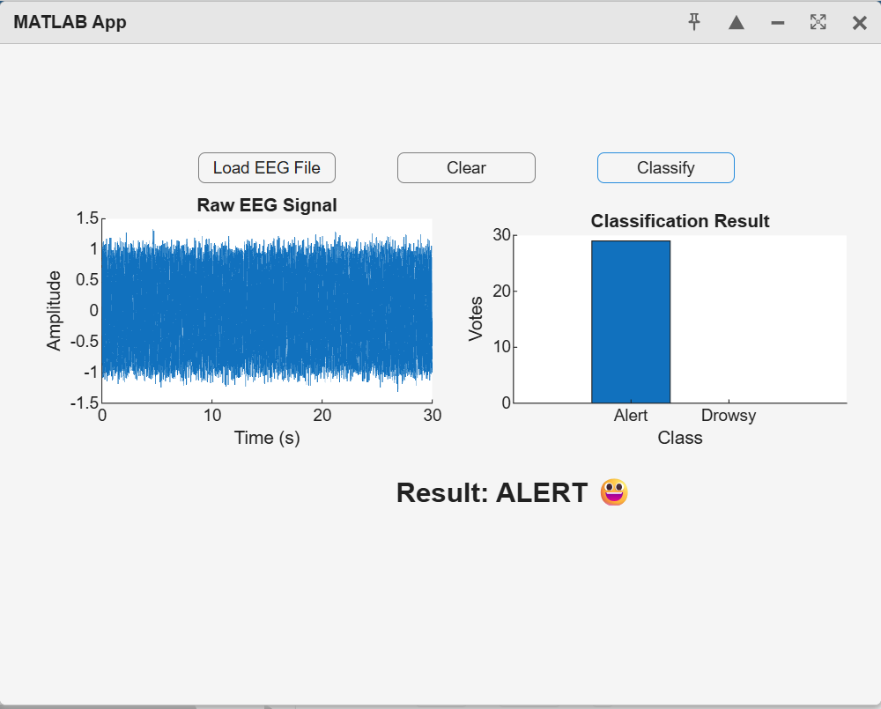
Fig 4.2. GUI Interface showing the Alert state

The GUI (Figure 4.2) developed in MATLAB App Designer allows users to load EEG signals, classify them, and visualize the results interactively.
- The “Load EEG File” button enables users to import .mat files containing EEG signals
- The “Classify” button triggers the model to extract features and predict whether the signal represents an alert or drowsy state.
- The Raw EEG Signal Plot displays the time-domain signal waveform for the selected data, helping visualize brain activity patterns.
- The Classification Result Plot shows a bar graph comparing “Alert” and “Drowsy” votes from the model’s output.
- The Result Label clearly indicates the final classification, such as “Result: ALERT ” or “Result: DROWSY ”.
- Additionally, a Clear Button resets all displays for a new test.
This user-friendly GUI ensures that non-technical users can easily perform real-time drowsiness detection without interacting directly with MATLAB code.
4.4 Discussion Summary

The results demonstrate that the proposed SVM-based classifier can accurately distinguish between alert and drowsy EEG patterns. The high performance highlights the importance of well-chosen features such as mean, standard deviation, spectral entropy, and band power across frequency bands. Moreover, integrating a GUI provides an interactive and practical platform for testing and visualization, making the system suitable for future real-time driver monitoring applications.

Chapter 5
CONCLUSION AND FUTURE SCOPE
5.1 Conclusion

This project successfully demonstrates an efficient EEG-based drowsiness detection system using Support Vector Machine (SVM) classification integrated with a MATLAB-based Graphical User Interface (GUI). EEG signals were collected and preprocessed using band-pass and notch filters to remove noise and artifacts, ensuring signal quality. Key features such as mean, standard deviation, band power (delta, theta, alpha, beta), and spectral entropy were extracted to differentiate alert and drowsy mental states effectively.

The trained SVM model achieved 100 % accuracy, precision, recall, and F1-score, proving its reliability for binary classification between alert and drowsy states. The confusion matrix confirmed perfect classification without mispredictions. The developed GUI further enhanced system usability, enabling users to easily load EEG data, visualize raw signals, and view classification results interactively.

Overall, this work establishes that combining signal processing, machine learning, and intuitive visualization provides an accurate and practical solution for driver drowsiness detection and real-time monitoring applications.

5.2 Future Scope

- Although the current system performs excellently under controlled data conditions, several enhancements can be implemented for future research and real-world deployment:
- Real-Time Data Acquisition: Integrate EEG sensors such as Muse or OpenBCI for continuous live monitoring.
- Multi-Channel Analysis: Extend the model to handle multi-channel EEG data for higher spatial accuracy.
- Hybrid Classification Models: Combine SVM with deep learning models (CNN or LSTM) to capture complex temporal features.
- Hardware Integration: Implement the system in embedded hardware (e.g., Raspberry Pi) for portable driver-alertness monitoring.
- Multimodal Detection: Fuse EEG data with video or eye-tracking sensors for comprehensive drowsiness detection.
- With these advancements, the proposed system can evolve into a robust, real-time intelligent alertness-monitoring solution suitable for automotive, healthcare, and human-machine interaction applications.

REFERENCES
[1] V. V. Priya, “EEG based Drowsiness Prediction using Machine Learning approach”, 2021.
[2] Sreeza Tarafder, “EEG-based Drowsiness Detection from Ocular Indices using Ensemble Classification”, 2021.
[3] Adinath Joshi , "Drowsiness Detection using EEG signals and Machine Learning Algorithms", 2022.
[4] Raed Mohammed Hussein, “Driver drowsiness detection methods using EEG signals: A systematic review”, 2022.
[5] Dhiren Ojha, "Driver Drowsiness Detection using Deep Learning" , 2023.
[6] Latreche, I., et al. , "A Review on Deep Learning Techniques for EEG-Based Driving Drowsiness Detection" , 2024.
[7] Shilpa Sardesai, "Hybrid EEG Signal Processing Framework for Driver Drowsiness Detection using QWT, EMD, and Bayesian optimized SVM" , 2025.
[8] Lin, X., et al. , "EEG-based driver drowsiness detection in real driving environments", 2025.
[9] Hassan, O.F., et al. , "Real-time driver drowsiness detection using transformer networks", 2025.

