Q.1] Write a C# program to create a window application to perform following basic arithmetic operations.

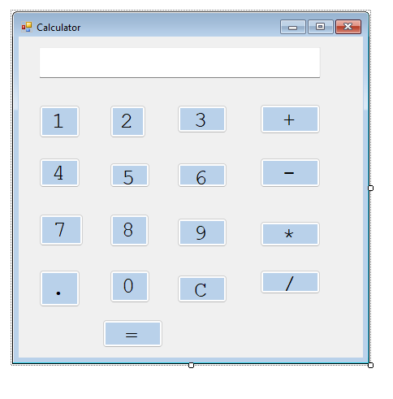

Properties:
Sr. No | Control | Properties
1 | Textbox | Backcolor-ContolLightLight
 |  | Font-Courier New 20
 |  | Readonly-True
 |  | TextAlign-Right
2 | Button | Text- 0 to 9
 | 0 to 9 | Name- no to n9
 |  | Backcolor - GradientActiveCaption
 |  | Font – Courier new 20
3 | Button
 | = | Name-bequal ,Text-=, Backcolor – GradientActiveCaption, Font – Courier new 20
 | + | Name-badd ,Text-+, Backcolor – GradientActiveCaption, Font – Courier new 20
 | - | Name-bsub ,Text - - , Backcolor – GradientActiveCaption, Font – Courier new 20
 | * | Name-bmult ,Text- *, Backcolor – GradientActiveCaption, Font – Courier new 20
 | / | Name-bdiv ,Text- /, Backcolor – GradientActiveCaption, Font – Courier new 20
 | . | Name-bdot ,Text- ., Backcolor – GradientActiveCaption, Font – Courier new 20
 | C | Name-bclear ,Text-C, Backcolor – GradientActiveCaption, Font – Courier new 20

Code:
using System;
using System.Collections.Generic;
using System.ComponentModel;
using System.Data;
using System.Drawing;
using System.Linq;
using System.Text;
using System.Windows.Forms;

namespace Calculator
{
public partial class Form1 : Form
{
double FirstNumber;
string Operation;
public Form1()
{
InitializeComponent();
}

private void n1_Click(object sender, EventArgs e)
{
if (textBox1.Text == "0" && textBox1.Text != null)
{
textBox1.Text = "1";
}
else
{
textBox1.Text = textBox1.Text + "1";
}
}

private void n2_Click(object sender, EventArgs e)
{
if (textBox1.Text == "0" && textBox1.Text != null)
{
textBox1.Text = "2";
}
else
{
textBox1.Text = textBox1.Text + "2";
}
}

private void n3_Click(object sender, EventArgs e)
{
if (textBox1.Text == "0" && textBox1.Text != null)
{
textBox1.Text = "3";
}
else
{
textBox1.Text = textBox1.Text + "3";
}
}

private void n4_Click(object sender, EventArgs e)
{
if (textBox1.Text == "0" && textBox1.Text != null)
{
textBox1.Text = "4";
}
else
{
textBox1.Text = textBox1.Text + "4";
}
}

private void n5_Click(object sender, EventArgs e)
{
if (textBox1.Text == "0" && textBox1.Text != null)
{
textBox1.Text = "5";
}
else
{
textBox1.Text = textBox1.Text + "5";
}
}

private void n6_Click(object sender, EventArgs e)
{
if (textBox1.Text == "0" && textBox1.Text != null)
{
textBox1.Text = "6";
}
else
{
textBox1.Text = textBox1.Text + "6";
}
}

private void n7_Click(object sender, EventArgs e)
{

if (textBox1.Text == "0" && textBox1.Text != null)
{
textBox1.Text = "7";
}
else
{
textBox1.Text = textBox1.Text + "7";
}
}

private void n8_Click(object sender, EventArgs e)
{
if (textBox1.Text == "0" && textBox1.Text != null)
{
textBox1.Text = "8";
}
else
{
textBox1.Text = textBox1.Text + "8";
}
}

private void n9_Click(object sender, EventArgs e)
{
if (textBox1.Text == "" && textBox1.Text != null)
{
textBox1.Text = "9";
}
else
{
textBox1.Text = textBox1.Text + "9";
}
}

private void n0_Click(object sender, EventArgs e)
{
textBox1.Text = textBox1.Text + "0";
}

private void badd_Click(object sender, EventArgs e)
{
FirstNumber = Convert.ToDouble(textBox1.Text);
textBox1.Text = "0";
Operation = "+";
}

private void bsub_Click(object sender, EventArgs e)
{
FirstNumber = Convert.ToDouble(textBox1.Text);
textBox1.Text = "0";
Operation = "-";
}

private void bmult_Click(object sender, EventArgs e)
{
FirstNumber = Convert.ToDouble(textBox1.Text);
textBox1.Text = "0";
Operation = "*";
}

private void bdiv_Click(object sender, EventArgs e)
{
FirstNumber = Convert.ToDouble(textBox1.Text);
textBox1.Text = "0";
Operation = "/";
}

private void ndot_Click(object sender, EventArgs e)
{
textBox1.Text = textBox1.Text + ".";
}

private void bequal_Click(object sender, EventArgs e)
{
double SecondNumber;
double Result;

SecondNumber = Convert.ToDouble(textBox1.Text);

if (Operation == "+")
{
Result = (FirstNumber + SecondNumber);
textBox1.Text = Convert.ToString(Result);
FirstNumber = Result;
}
if (Operation == "-")
{
Result = (FirstNumber - SecondNumber);
textBox1.Text = Convert.ToString(Result);
FirstNumber = Result;
}
if (Operation == "*")
{
Result = (FirstNumber * SecondNumber);
textBox1.Text = Convert.ToString(Result);
FirstNumber = Result;
}
if (Operation == "/")
{
if (SecondNumber == 0)
{
textBox1.Text = "Cannot divide by zero";

}
else
{
Result = (FirstNumber / SecondNumber);
textBox1.Text = Convert.ToString(Result);
FirstNumber = Result;
}
}
}

private void nclear_Click(object sender, EventArgs e)
{
textBox1.Text = "0";
}
}
}

Output:
