Library Management System (Java)
Programming in Java – BYOP Project Report (Vityarthi)

Name- Akankshya Dibyadarsinee Rout
Reg. Number- 24BAI10724
Slot- F11+F12
Faculty- Dr. Ganesan G
Date of Submission-25th March 2026

# Abstract
This project presents a Java-based Library Management System designed to automate basic library operations such as adding, viewing, searching, issuing, returning, and deleting books, while ensuring data persistence using file handling techniques, and the system demonstrates the practical application of object-oriented programming concepts, dynamic data structures, and modular programming to solve a real-world problem in a simple and efficient manner.

1. Introduction
In the rapidly evolving digital era, the need for efficient data management systems has become increasingly significant across all domains, including educational institutions and libraries, where the management of books, records, and transactions plays a crucial role in maintaining operational efficiency, and traditional manual systems that rely on physical registers and human intervention are not only time-consuming but also prone to errors such as duplication, misplacement of records, and lack of scalability, and therefore, this project titled Library Management System has been designed and developed using the Java programming language with the objective of creating a structured, reliable, and user-friendly system that automates the management of library records, while simultaneously demonstrating the practical implementation of object-oriented programming principles, dynamic data structures, and file handling techniques in solving a real-world problem through a menu-driven console-based application.

2. Problem Statement
The manual handling of library operations involves several limitations, including difficulty in maintaining accurate records of books, inefficiency in searching and updating information, and lack of data persistence, which can lead to loss of valuable information when records are not properly stored, and as the number of books increases, the complexity of managing these records grows exponentially, making it essential to develop a digital solution that can automate these processes, ensure accuracy, provide quick access to information, and maintain persistent storage so that data remains available even after the program is terminated.

3. Objectives
The primary objective of this project is to design and implement a Java-based Library Management System that enables users to efficiently manage library operations by providing functionalities such as adding new books, viewing all available books, searching for specific books using unique identifiers, issuing and returning books while updating their availability status dynamically, and deleting book records when necessary, while also incorporating file handling mechanisms to ensure that all data is stored persistently in a file, thereby enabling the system to maintain continuity across multiple executions and providing a realistic simulation of a real-world library management system.

4. System Features
The system provides several core functionalities including adding new book records, viewing all stored books, searching books using unique IDs, issuing and returning books by updating their status dynamically, deleting records when required, and maintaining persistent storage of all data using file handling, ensuring that information is retained even after program execution ends.

5. Methodology / Approach
The development of this project follows a structured and modular approach, where the problem is divided into smaller components and each component is implemented using appropriate programming constructs, and object-oriented programming is used to model real-world entities by creating a Book class that encapsulates all relevant attributes of a book, while an ArrayList is used as a dynamic data structure to store and manage multiple book objects efficiently during runtime, and a menu-driven interface is implemented using iterative loops and conditional branching to facilitate user interaction, and file handling is integrated using BufferedReader and BufferedWriter classes to ensure that data is written to and read from a file in a structured format, thereby maintaining synchronization between in-memory data and persistent storage and ensuring that the system behaves consistently across multiple executions.

6. Key Design Decisions
In this project, several important design decisions were made to ensure simplicity, efficiency, and scalability of the system, such as choosing ArrayList over arrays to allow dynamic resizing of data, using a menu-driven approach to make the program user-friendly and interactive, and implementing file handling instead of a database to keep the system lightweight and suitable for beginner-level implementation, while also ensuring data persistence across program executions, and additionally, the use of a Book class helped in organizing data using object-oriented principles, making the code more structured and maintainable.

7. Technologies Used
- Java Programming Language (Core Logic Implementation)
- Object-Oriented Programming (Encapsulation, Abstraction)
- ArrayList (Dynamic Storage of Objects)
- File Handling (BufferedReader, BufferedWriter, FileReader, FileWriter)
- VS Code (Development Environment)

8. Detailed Code Explanation
The following section presents the complete implementation of the Library Management System along with detailed explanations of each part of the code to provide a clear understanding of how the system works.

8.1 Package Declaration
package LibraryManagementSystem;
This line specifies the package name, which helps in organizing the project into a structured format and avoids naming conflicts in larger applications.

8.2 Import Statements
import java.io.*;
import java.util.*;
These import statements are required to use file handling classes such as BufferedReader, BufferedWriter, and utility classes such as ArrayList and Scanner for dynamic storage and user input.

8.3 Book Class
class Book {
int id;
String title;
String author;
boolean isIssued;

Book(int id, String title, String author, boolean isIssued) {
this.id = id;
this.title = title;
this.author = author;
this.isIssued = isIssued;
}
}
The Book class represents the structure of a book object, where each book has an ID, title, author, and issue status, and the constructor initializes these values when a new object is created.

8.4 Main Class and Variables
public class LibrarySystem {
static ArrayList<Book> books = new ArrayList<>();
static Scanner sc = new Scanner(System.in);
static final String FILE_NAME = "books.txt";
The main class contains global variables including:
- books: stores all book objects dynamically
- sc: used for user input
- FILE_NAME: stores the file name for persistence

8.5 Main Method
public static void main(String[] args) {
loadFromFile();

int choice;
do {
System.out.println("\n--- Library Menu ---");
System.out.println("1. Add Book");
System.out.println("2. View Books");
System.out.println("3. Search Book");
System.out.println("4. Issue Book");
System.out.println("5. Return Book");
System.out.println("6. Delete Book");
System.out.println("0. Exit");

System.out.print("Enter choice: ");
choice = sc.nextInt();

switch (choice) {
case 1: addBook(); break;
case 2: viewBooks(); break;
case 3: searchBook(); break;
case 4: issueBook(); break;
case 5: returnBook(); break;
case 6: deleteBook(); break;
}

} while (choice != 0);
}
The main method controls program execution, displays the menu, takes user input, and calls appropriate functions using a switch-case structure, while the loop ensures continuous execution until the user exits.
8.6 Add Book Function
static void addBook() {
System.out.print("Enter ID: ");
int id = sc.nextInt();
sc.nextLine();

System.out.print("Enter Title: ");
String title = sc.nextLine();

System.out.print("Enter Author: ");
String author = sc.nextLine();

books.add(new Book(id, title, author, false));
saveToFile();

System.out.println("Book added!");
}
This function collects user input, creates a new Book object, adds it to the list, and saves it to the file, ensuring persistence.

8.7 View Books Function
static void viewBooks() {
if (books.isEmpty()) {
System.out.println("No books available!");
return;
}

for (Book b : books) {
System.out.println("ID: " + b.id + " | Title: " + b.title + " | Author: " + b.author + " | Issued: " + b.isIssued);
}
}
This function displays all books stored in the system using an enhanced for-loop.

8.8 Search Book Function
static void searchBook() {
System.out.print("Enter ID: ");
int id = sc.nextInt();

for (Book b : books) {
if (b.id == id) {
System.out.println("Found: " + b.title + " by " + b.author);
return;
}
}
System.out.println("Not found!");
}
This function searches for a book by ID and displays its details if found.

8.9 Issue Book Function
static void issueBook() {
System.out.print("Enter ID: ");
int id = sc.nextInt();

for (Book b : books) {
if (b.id == id && !b.isIssued) {
b.isIssued = true;
saveToFile();
System.out.println("Book issued!");
return;
}
}
System.out.println("Not available!");
}
This function checks availability and marks the book as issued.

8.10 Return Book Function
static void returnBook() {
System.out.print("Enter ID: ");
int id = sc.nextInt();

for (Book b : books) {
if (b.id == id && b.isIssued) {
b.isIssued = false;
saveToFile();
System.out.println("Book returned!");
return;
}
}
System.out.println("Invalid!");
}
This function updates the book status to available after return.

8.11 Delete Book Function
static void deleteBook() {
System.out.print("Enter ID: ");
int id = sc.nextInt();

books.removeIf(b -> b.id == id);
saveToFile();

System.out.println("Book deleted!");
}
This function removes a book using a lambda expression and updates the file.

8.12 Save to File Function
static void saveToFile() {
try (BufferedWriter bw = new BufferedWriter(new FileWriter(FILE_NAME))) {
for (Book b : books) {
bw.write(b.id + "," + b.title + "," + b.author + "," + b.isIssued);
bw.newLine();
}
} catch (IOException e) {
System.out.println("Error saving file!");
}
}
This function writes all book data to the file in CSV format, ensuring persistent storage.

8.13 Load from File Function
static void loadFromFile() {
try (BufferedReader br = new BufferedReader(new FileReader(FILE_NAME))) {
String line;
while ((line = br.readLine()) != null) {
String[] data = line.split(",");
int id = Integer.parseInt(data[0]);
String title = data[1];
String author = data[2];
boolean isIssued = Boolean.parseBoolean(data[3]);

books.add(new Book(id, title, author, isIssued));
}
} catch (IOException e) {
System.out.println("No previous data found.");
}
}
This function reads data from the file, splits it into components, and reconstructs book objects.

9. GitHub Repository
The complete project is available at:
👉 https://github.com/Akankshya-35-45/Library-Management-System-Java
The repository includes the source code, README file explaining setup and usage, and the data file, ensuring transparency and reproducibility.

10. Results/Output
The system was successfully implemented and tested, and it was observed that all functionalities such as adding, viewing, searching, issuing, returning, and deleting books work correctly, and the file handling mechanism ensures that all data is stored and retrieved accurately from the file, demonstrating the reliability and effectiveness of the system.
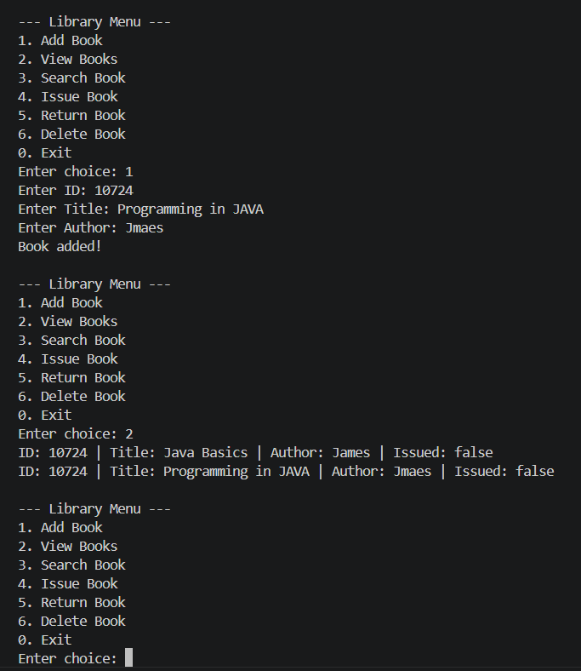
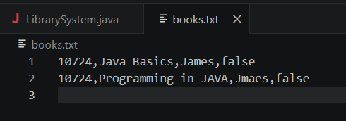

11. Challenges Faced
During the development of this project, significant challenges were encountered in implementing file handling correctly, particularly in ensuring that data is written in a structured format and accurately parsed during reading, and managing user input without causing runtime errors required careful handling of input streams, while maintaining synchronization between the ArrayList and file storage required continuous updates after every operation.

12. Limitations
Although the system performs essential operations effectively, it has certain limitations such as the absence of a graphical user interface, reliance on file-based storage instead of a database which may not scale well for large datasets, and lack of user authentication, which restricts controlled access to the system.

13. Depth of Reflection
Through the process of designing and implementing this project, I developed a deeper understanding of how theoretical concepts such as object-oriented programming, dynamic data structures, and file handling can be effectively applied to solve real-world problems, and I realized that even a simple application requires careful planning, debugging, and iterative improvement, and this experience significantly enhanced my problem-solving skills, improved my understanding of Java, and provided valuable insight into software development practices.
14. What You Learned
Through this project, I learned how to apply object-oriented programming concepts in a practical scenario, gained hands-on experience with file handling for persistent data storage, improved my understanding of dynamic data structures like ArrayList, and developed better problem-solving and debugging skills while building and testing the system, which has strengthened my overall programming foundation.

15. Conclusion
In conclusion, the development of the Library Management System using Java has provided a comprehensive understanding of how fundamental programming concepts can be effectively applied to solve practical, real-world problems in a structured and efficient manner, and through this project, I was able to integrate various core concepts such as object-oriented programming, dynamic data handling using ArrayList, and file handling techniques to create a system that not only performs essential library operations but also ensures data persistence across multiple executions, thereby enhancing both functionality and reliability, and the implementation of a menu-driven interface further improved the usability of the system by allowing intuitive interaction between the user and the program, while the modular design of the code ensured clarity, maintainability, and scalability, and overall, this project has significantly strengthened my understanding of Java programming, improved my logical thinking and problem-solving abilities, and provided valuable insight into how software systems are designed, developed, tested, and maintained in real-world scenarios, making it a meaningful and enriching learning experience that lays a strong foundation for future development of more advanced and complex applications.

16. Future Scope
Although the current implementation of the Library Management System successfully fulfills the basic requirements of managing book records and ensuring data persistence using file handling, there are several areas where the system can be further enhanced to make it more robust, scalable, and user-friendly, and one of the most significant improvements would be the development of a graphical user interface (GUI) using Java Swing or JavaFX, which would provide a more interactive and visually appealing experience compared to the current console-based system, and additionally, the system can be integrated with a relational database such as MySQL or PostgreSQL to replace file-based storage, thereby improving data security, efficiency, and scalability, especially when handling a large number of records, and another important enhancement would be the implementation of a user authentication system that allows different types of users such as administrators and members to log in with credentials, ensuring controlled access and improved security, and further features such as book reservation, fine calculation for late returns, and advanced search options based on multiple parameters can also be incorporated to make the system more realistic and comprehensive, and finally, the system can be extended into a web-based or mobile application using modern frameworks and technologies, enabling remote access and making it more adaptable to real-world deployment scenarios.

