VITyarthi | Open Source Software



The Open Source Audit

A Capstone Project for OSS NGMC Course

Course: Open Source Software

Student Name | Registration Number
Akankshya Dibyadarsinee Rout | 24BAI10724
Slot | Date of Submission
E11 | 25th March 2026

Introduction

The basis of contemporary computer systems is now open source software. Open-source principles are used in the development of many modern tools, platforms, and technologies. These systems are created cooperatively by a global community of developers rather than being under the control of a single organization.

Transparency, freedom, and cooperation are the cornerstones of the open source concept. The software can be studied, altered, and distributed by users in addition to being used.

Python is an open-source programming language that I have selected for this project in order to examine its history, philosophy, license, ecosystem, and real-world application on Linux systems. Python is widely used in many fields, including automation, data science, web development, and artificial intelligence.
Your choice | Write your chosen software here before submission: Python

Part A — Origin and Philosophy (Units 1 & 2)

A1. The problem this software was created to solve
When Guido van Rossum created Python in 1991, the majority of programming languages were very difficult to use. Widely used languages like C and C++, in contrast to Python, required intricate syntax, manual memory management, and a thorough comprehension of system-level concepts with complicated structure and syntax. This made learning and coding programming challenging, particularly for novices and those seeking rapid development.
The absence of a language that struck a balance between power and simplicity was one of the main issues at the time. Existing languages were either too restrictive and not adaptable enough for various application purposes, or too low-level (like C), which made them difficult to learn and time-consuming to use because they were compiled languages.
Guido van Rossum wanted to solve this issue by creating a language that:
- Was easy to read and write code efficiently
- Reduced the complexity of coding by having easy syntax
- Allowed developers to focus more on logic rather than syntax as python introduced indentations
- Could be used for multiple purposes like scripting, automation, gaming, animation and software development
Developer productivity, in my opinion, was another major issue. Simple tasks in programming languages like C and C++ required numerous lines of code. This increased the likelihood of errors and slowed down development. In order to address this, Python introduced a simple, clean syntax that made programs shorter and easier to comprehend.
Additionally, Python introduced object-oriented programming (OOP) to address the problem of code readability. At the time, a lot of programming languages permitted complex code syntax. Python's indentation-based structure allowed programmers to write clear, well-formatted code with the right comprehension. This enhanced maintainability and facilitated teamwork. Developers should work together in a cooperative setting.

Another crucial choice was to make Python open source. Guido van Rossum made it public so that anyone could use, alter, and enhance it in accordance with their needs rather than keeping it confidential and unavailable for free. This sparked contributions and usage from the entire worldwide community of developers and novices, which contributed to Python's rapid evolution.

In summary, Python was developed to address the issues of existing programming languages' slow development, poor readability, and complexity. Because of its many benefits, it is currently one of the most well-liked and extensively used programming languages. Its open-source nature further ensured that it could grow exponentially continuously through contributions from the global community.

A2. The license — what it actually says
In May 2000, Guido and the Python core development team moved to BeOpen.com to form the BeOpen PythonLabs team. In October of the same year, the PythonLabs team moved to Digital Creations, which became Zope Corporation. In 2001, the Python Software Foundation (PSF, see https://www.python.org/psf/) was formed, a non-profit organization created specifically to own Python-related Intellectual Property. Zope Corporation was a sponsoring member of the PSF.
- What are the four freedoms of free software? Does your software's license grant all four?
1-Freedom to run the program for any needed purpose
2-Freedom to study how the program works, designs and access the source code efficiently
3-Freedom to modify the software if required
4-Freedom to distribute copies if needed
Python provides all four freedoms. Users can access its source code, modify it according to their needs, and share it with others if needed in case according to my opinion as I read in the python license. In my opinion, this is one of the most main reasons why Python has become so popular, because it gives full control to developers and beginners to learn in layman words and syntax with interpreted language.

- Can a company take this software, modify it, and sell it without sharing their changes? Why or why not?
Yes, a company can take Python, modify it, and even use it in commercial products and whenever and wherever required without sharing their changes publicly as mentioned int the Python License. This is because the PSF license is an allowing permission license, which does not require companies to release their modified source code. Unlike strict and restrictive licenses like GPL, it gives more permission and easy-to-use. However, the companies willing to do this still need to know and follow the certain basic conditions and rules like giving proper credit to the original source and all etc.

- What is the difference between GPL and MIT licensing? Which would you choose for something you built, and why?
GPL and MIT are two common open-source licenses, but they are quite different in ways of how they are strict.
-GPL License is more strict (copyleft license).
If someone modifies the software and distributes it, they must also share the modified source code according to the license as owing to this software always stays in open-source form.
-MIT License is very flexible and allowing as compared to MIT License (permissive license).
It allows people to modify and use the software even in private projects without sharing changes according to the license policies.
-Python’s PSF license is way similar to the MIT license because it is also flexible, permissive, easy-to-use and business-friendly too.
-If I build my own software, I would prefer to choose a permissive and beginner-friendly license like MIT or PSF because it allows more people to use, and even adopt my software easily.
- Is there a difference between 'free as in free beer' and 'free as in freedom'? Give an example from your chosen software.
There is a difference between:
-Free as in free beer → no cost at all
-Free as in freedom → freedom to modify, use and even adopt
Python is free in both ways. It does not cost anything to use, and it also allows users to modify and distribute it freely and publicly according to the policies and we all use it for free we all know this CSE students it’s the very base language and we are using it in free of cost.
For example, as we all know anyone can download Python for free and also customize it, modify it according to their needs and requirements if required. This shows that Python supports both cost-free usage and user freedom equally.

A3. The ethics of open source
Open source is not only about making software available at zero cost, moreover it also tells and educates about the idea of sharing knowledge and collaboration among users and developers in effective and efficient ways. Python is a very good example of this, as we all know it has been developed and improved by a global community over time for the purpose of simplicity.
- Should all software be open source? Make an argument for and against.
There are arguments both for and against this statement or question raised.
- On one hand, open source software like Python allows anyone to learn, modify, and use it freely and publicly. This helps students and developers understand programming more easily as it use indentation which makes it very easy to code and understand with interpreted language type. In my opinion, this makes technology more accessible and encourages learning for everyone who wish to educate themselves about this and takes the chance and make it happen.
-On the other hand, not all software can be open source. Some companies invest a lot of time and money with their day-night hardwork in developing software and making it this efficient, so they may want to keep it private to protect their business so that the only required should buy it and di their work. Many people can misuse it in very different ways and security issues will be there and anyone using it will not be encrypted anymore. Also, certain systems related to security should not always be fully open according to my opinion.
So, I truly feel that while open source is actually very beneficial, it may not be suitable and permissive for every type of software.

- Is it ethical for a company to build a profitable product entirely on top of free community labor? (Think about how companies like Red Hat, Google, and Meta use Linux.)
This is a debatable issue no doubt.
Many companies use Python in their products and services. It can be considered ethical because they often improve the software, provide tools to modify it, and support the community as well. However, if a company uses open-source software one-sided that is only using it for profit and not contributing back, it may not be fair and it is not fair. As of me, companies should contribute back to the community in some other way, for example contributing code or supporting development and all etc.
- What does 'standing on the shoulders of giants' mean in the context of software? Does open source enable or undermine original innovation?
-In my opinion, open source enables idea, innovation, and creation. Python itself has grown because of contributions from developers worldwide and the global community. It allows people to experiment, learn, and build or innovate or create new things quickly. While some others may think it reduces originality and clarity, I strongly feel it actually supports creativity by providing a strong base to work on and to innovate and create more and more.

Part B — Linux Footprint (Unit 2)
In this section, I explored how Python works within a Linux environmental system when I installed python in my system along with linux settings. is widely used for development, and Python is one of the most commonly available programming languages on it. I installed Python on my system and observed how it is managed, where its files are stored, and how it interacts with the operating system.
This helped me understand how open-source software actually works in a real Linux system. It also gave me practical experience.
- Installation method — is it available via RPM, apt, or must it be compiled from source?
-Python is usually pre-installed on most Linux distributions. Sometimes, if it isn’t available, it can be installed using the package manager.
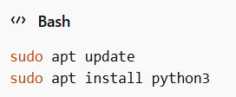
This shows that Python can be easily available and installed through APT (Advanced Package Tool), and there is no need to compile it manually in most of the cases.
- Key directories — where are its binaries, config files, and logs stored? (e.g., /usr/bin, /etc, /var/log)
-After installation, Python files are stored in different directories in the Linux system:
- /usr/bin/python3 → contains the Python executable files
- /usr/lib/python3 → contains standard libraries
- /etc/python3 → contains configuration files
- /var/log → stores system logs (not specific to Python but useful for debugging)
These directories help in organizing the software and separating executable files, libraries, and configurations.
- User and group — what Linux user and group does it run under? Why does this matter for security?
-Python runs under the current logged-in user by default. It does not require a special system user like some services (e.g., web servers).
This is important for security because:
- It limits access based on user permissions
- Prevents unauthorized system-level changes
- Ensures that users only access their own files and not others
In my opinion, this makes Python safer and easier to use for regular users.

- Service management — can it be started, stopped, or restarted as a service? Show the commands.
-Python itself is not a background service, so it cannot be directly started or stopped like a service using systemctl.
However, Python scripts can be used to create services. For example, a Python-based application can be managed using systemd with commands like:
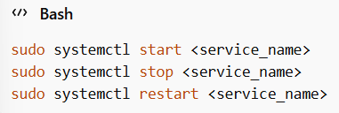
This shows that Python can still be used in service-based applications even though it is not a service itself.
- Update model — how does the open-source community push security patches to your machine?
-Python is updated through the Linux package manager and the open-source community.
Users can update Python using:
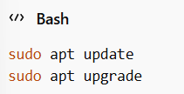
The open-source community regularly releases updates, bug fixes, and security patches. These updates are then distributed through Linux repositories. In my opinion, this update system is reliable because it ensures that users get secure and updated versions without much effort.

Part C — The FOSS Ecosystem (Units 3 & 4)
No open-source software works alone. It is always connected with other tools, libraries, built-in functions and modules and communities. As of me Python is a great example of this, as it has a large ecosystem that supports different types of applications like web development, data science, gaming, app development data analysis and automation and many more.

- What other open-source tools does it depend on? (Libraries, compilers, runtimes)
-Python depends on several system-level components to function properly.
- It is mainly written in C, so it depends on a C compiler like GCC.
- It uses standard system libraries such as libc.
- It also includes its own standard library, which provides built-in modules for various tasks.
For all these dependencies and flexibilities it helps Python run efficiently and interact with the operating system efficiently.

- What has it enabled or inspired? (Forks, spin-offs, tools built on top of it)
-Python has enabled the development of many powerful tools and frameworks.
- Django → used for web development
- Flask → lightweight web framework
- Pandas → data analysis
- TensorFlow → machine learning
- As we all know Python has also inspired many projects and tools because of its simplicity and flexibility with easy syntax indentations. Many developers prefer Python for building applications quickly and efficiently.
- Where does it fit in the LAMP stack, or how does it relate to the web?
-Python plays an important role in web development. In the traditional LAMP stack (Linux, Apache, MySQL, PHP), Python is often used as an alternative to PHP. It can be used to build backend applications using frameworks like Django and Flask.
-Python works well with:
- Linux (operating system)
- Apache or Nginx (web servers)
- MySQL or PostgreSQL (databases)
This all the above mentioned shows that Python integrates or combines well into modern web development environments.

- Is there a community — mailing lists, forums, conferences, IRC channels? Who governs it?
-Python has a very large and active community.
- It is managed by the Python Software Foundation (PSF)
- Developers contribute through platforms like GitHub
- There are mailing lists, forums, and conferences like PyCon
I observed that the community plays a very important role in improving Python, fixing bugs, and adding new features. In my opinion, this strong community support is one of the biggest reasons for Python’s success.

Part D — Open Source vs Proprietary (Critical Analysis)
Dimension | Open Source (PYTHON) | Proprietary Alternative (MATLAB)
Cost | Free to use and download | Paid software, requires license
Security (who can audit the code?) | Source code is open, anyone can review it | Source code is closed, only company can access
Support and reliability | Community support (forums, GitHub, documentation) | Official company support and updates
Freedom to modify | Users can modify and distribute freely | Cannot modify source code
Community vs corporate control | Community-driven (Python Software Foundation) | Controlled by company (MathWorks)
Your overall verdict | In my opinion, Python is easy to use, flexible, and free, which makes it suitable for most users. | Proprietary software like MATLAB offers better official support but is expensive and less flexible.

I have personally used Python. After comparing Python with an alternative like MATLAB I found that both have their own advantages in different ways.
Python is open source, which makes it easy for students, beginners and developers to use.
It is also widely used and has a global community. Many people use Python for applications like web development, data science, data analysis, gaming, data mining, app development and machine learning.
MATLAB on the other hand provides professional support and specialized features. These can be useful in industries. However, MATLAB is expensive and not as flexible as Python.
I think Python is great for real-world use. It is easy to learn and flexible.
The Python community is very supportive. People all over the world use it.
Users can use Python freely which is very useful, for developers and beginners.
In the future I would like to contribute to Python by learning more about it.
I may also contribute to open-source projects. This project helped me understand how important open source is and how it affects the software industry.

4. Shell Script Tasks

Script 1 — System Identity Report (Unit 1 & 2)
Write a script that introduces the Linux system like a welcome screen. It should display:
- The Linux distribution name and kernel version
- The current logged-in user and their home directory
- System uptime and current date/time
- A message stating which open-source license covers the OS
Concepts to use: variables, echo, command substitution ($()), basic output formatting.

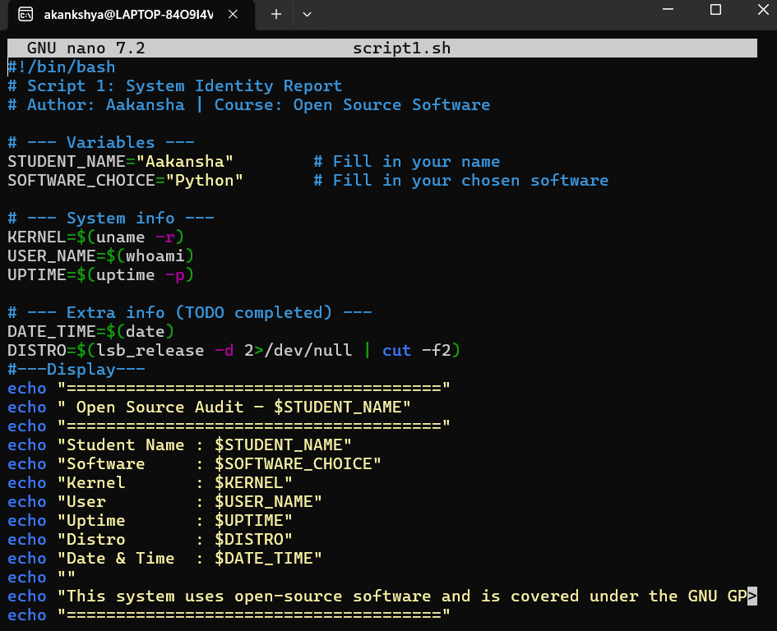
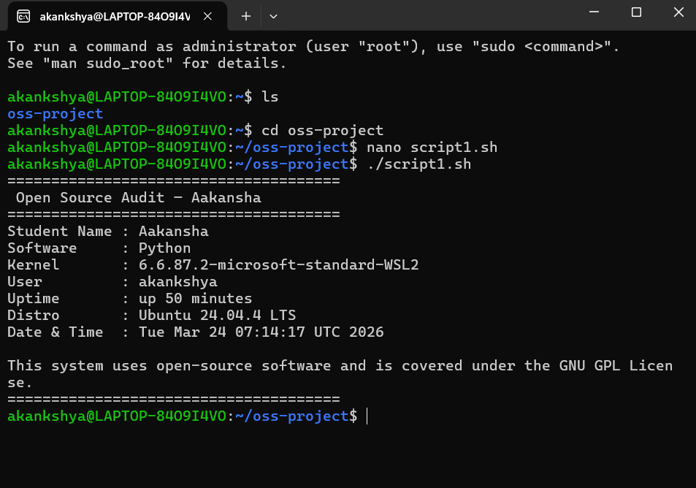
This script displays basic information about my Linux system in a simple and organized way. It shows details like the kernel version, the current user, home directory, system uptime, and the current date and time. While running this script, I understood how commands like uname, whoami, and uptime can be used to fetch real system data. I also learned how variables and command substitution help in making the script more dynamic and readable. Overall, this script gave me a clear idea of how shell scripting can be used to present system information in a user-friendly format.

Script 2 — FOSS Package Inspector (Unit 2)
Write a script that checks whether your chosen software is installed on the system, finds its version, and uses a case statement to print a short description of its purpose based on the package name.Concepts to use: if-then-else, case statement, rpm -qi or dpkg -l, pipe with grep.
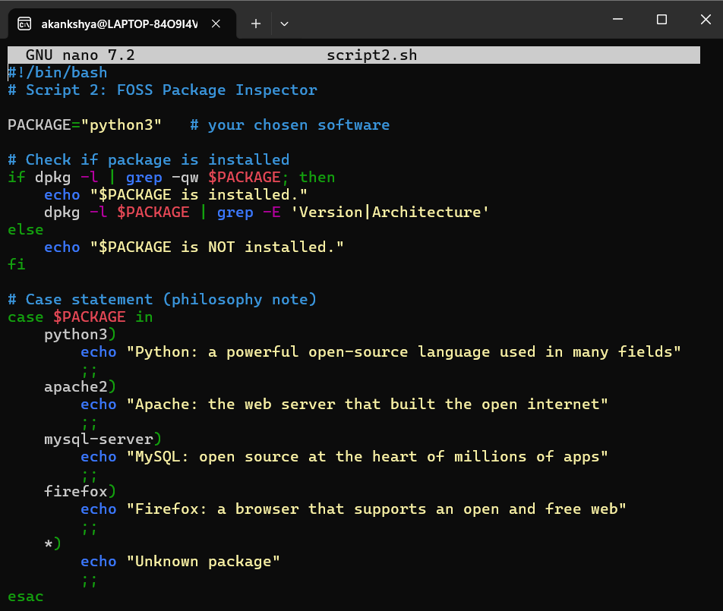
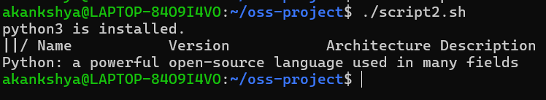
This script checks if Python is installed on my system. When I ran it, it confirmed that Python is already installed and showed its version details. If the software wasn’t installed, it would just display a message saying it is not available. I also used a case statement to give a brief description of Python. In the process, I learned how conditions work in shell scripting and how to check software details using simple commands. This script helped me understand how to access system-level information easily.

Script 3 — Disk and Permission Auditor (Unit 2)
Write a script that loops through a list of important system directories and reports: how much space each uses, and the owner and permissions of the directory. Use a for loop.
Concepts to use: for loop, df, ls -ld, awk or cut to extract fields.
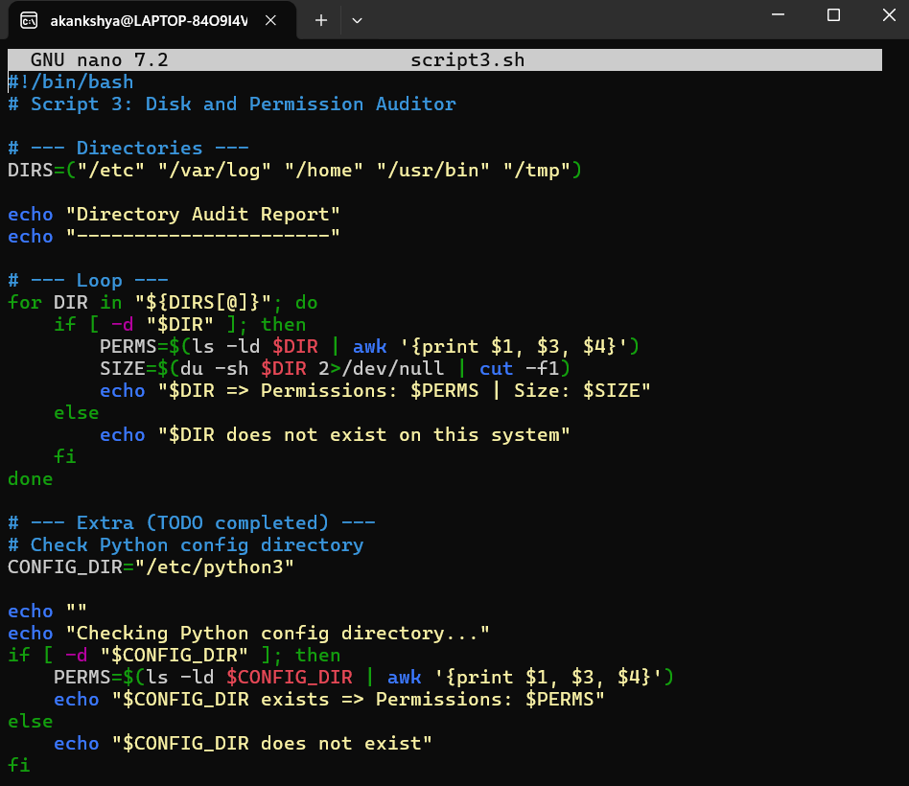

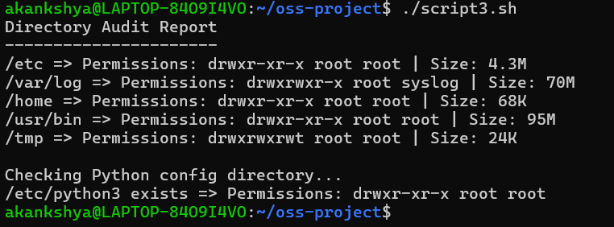

This output shows the details of important system directories on my Linux system. It displays the permissions, owner, group, and size of each directory using basic Linux commands.

While running the script, I observed how different directories have different sizes and permissions. The script also checks the Python configuration directory and confirms whether it exists along with its permissions.

In my opinion, this script helped me understand how file system information can be accessed and analysed using shell scripting in a simple and practical way.

Script 4 — Log File Analyzer (Units 2 & 5)
Write a script that reads a log file line by line, counts how many lines contain a keyword (like ERROR or WARNING), and prints a summary. Use a while-read loop and an if-then inside it.
Concepts to use: while read loop, if-then, counter variables, command-line arguments ($1).
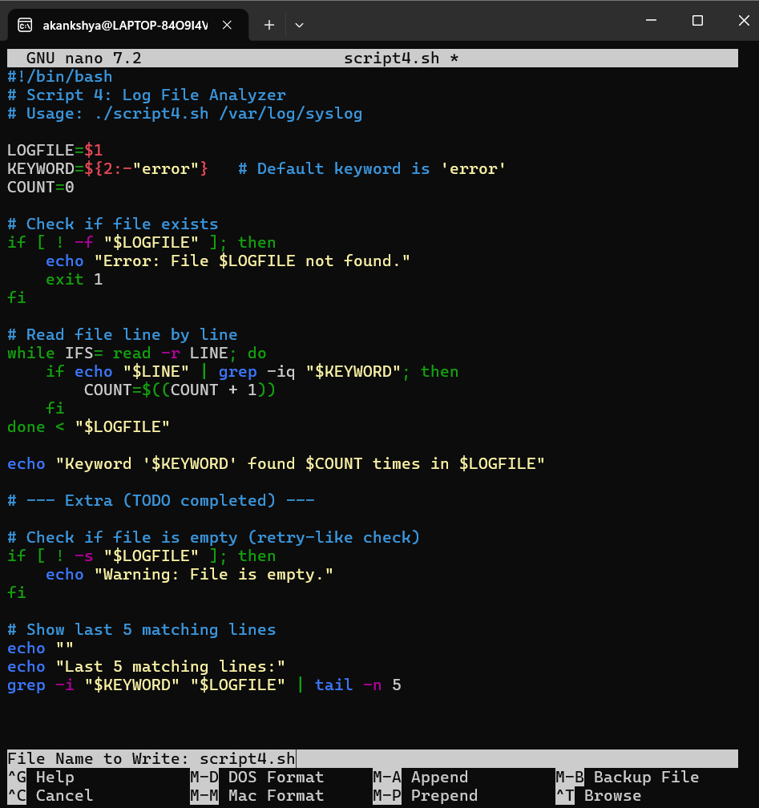
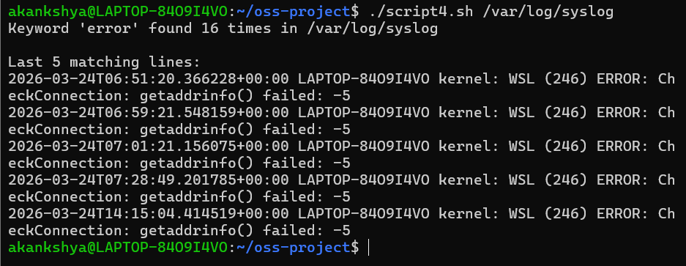This script counts the instances of a particular keyword (such as "error") in a log file. The script accurately counted the occurrences and displayed the final few lines from the file that matched.
I learned how to read a file line by line using a while loop and how conditions aid in verifying each line while doing this. Additionally, it taught me how to use basic shell commands to analyze log files. All things considered, this script helped me understand how errors can be monitored in a system.

Script 5 — The Open Source Manifesto Generator (Unit 5)
This is the most creative script. Write a script that generates a personalised open source philosophy statement by asking the user three questions interactively, then composing a short paragraph using their answers and saving it to a .txt file.

Concepts to use: read for user input, string concatenation, writing to a file with >, date command, aliases concept demonstrated via a comment.
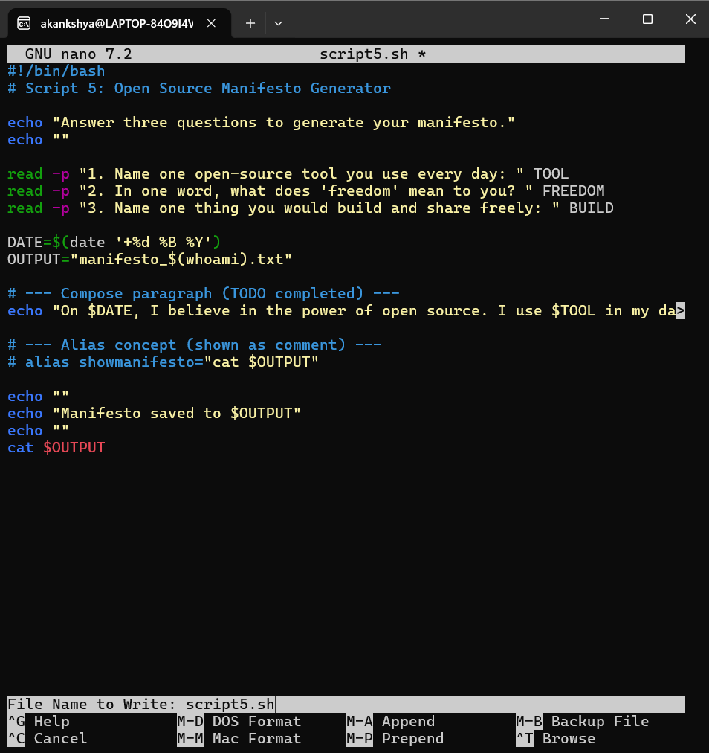
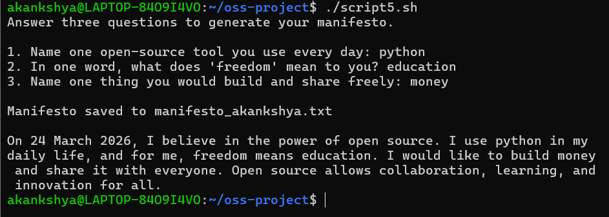
This script creates a simple open-source manifesto by asking a few questions to the user. It took my inputs and produced a brief paragraph based on my responses when I ran it; this paragraph was also saved in a text file. As I worked on this script, I learned how to use the read command to capture user input and how to combine various inputs to create a useful output. I also learned how to write data into a file thanks to it. All things considered, this script was enjoyable to write and demonstrated how shell scripting can be used to produce customized content.

