PROJECT REPORT
SAMPLE SUPERSTORE SALES PERFORMANCE DASHBOARD
A data analytics portfolio project made in Microsoft Excel
Dataset
Sample Superstore (Orders, Returns and People sheets)
Tools used
Microsoft Excel: formulas, pivot tables, charts and dashboard

1. AIM
The goal of the project is to analyse the performance of product, category and sub-category across different regions and different segments, and to identify the patterns and trends over the months.

2. OBJECTIVE
- Measure overall business performance through headline KPIs: total sales, total profit, average sales, total orders and total customers.
- Compare sales across the four regions (Central, East, South, West) and across the three product categories (Furniture, Office Supplies, Technology).
- Identify the top 10 products and top 10 customers by sales contribution.
- Study month-wise sales to find the seasonal pattern and the peak and low periods.
- Understand customer buying behaviour by segment (Consumer, Corporate, Home Office) and preferred shipping mode.
- Convert the findings into clear, actionable business recommendations.

3. DATASET DESCRIPTION
The analysis uses the Sample Superstore dataset, a retail transaction dataset of a US-based superstore. Each row represents one order line (one product within an order).

Attribute | Detail
Number of records | 9,994 order line items
Number of columns (raw) | 21
Date range | 3 January 2014 to 30 December 2017 (4 full years)
Regions | 4 (Central, East, South, West)
States | 49
Cities | 531
Customer segments | 3 (Consumer, Corporate, Home Office)
Product categories | 3 (Furniture, Office Supplies, Technology)
Product sub-categories | 17
Unique customers | 793
Shipping modes | 4 (Standard Class, Second Class, First Class, Same Day)

3.1 Orders sheet (main table)
The raw columns are Row ID, Order ID, Order Date, Ship Date, Ship Mode, Customer ID, Customer Name, Segment, Country, City, State, Postal Code, Region, Product ID, Category, Sub-Category, Product Name, Sales, Quantity, Discount and Profit.

3.2 Returns sheet
This sheet lists 296 Order IDs that customers returned, with one "Returned" flag column. I kept it only for reference in case a return-rate analysis is done later, and did not merge it into the Orders table in this phase.

3.3 People sheet
A small lookup table that gives the regional manager for each of the 4 regions: Anna Andreadi (West), Chuck Magee (East), Kelly Williams (Central) and Cassandra Brandow (South). It was used as the lookup range for the "Assigning Manager" column explained in Section 3.

4. DATA CLEANING
The data was already clean, but I still did a proper preparation pass before making any pivot tables or charts. The reasons were to confirm the quality of the data, and to create the extra fields needed to answer the questions. All of this was done on the Orders sheet of the working file (Sample_superstore_Main_rough.xlsm).

4.1 Verification checks
- Checked every column for blank cells using Go To Special > Blanks and COUNTBLANK(). Result: zero blanks in all 21 raw columns.
- Checked for duplicate rows using UNIQUE() on the Order ID and Product ID combination, to make sure repeated Order IDs were real multi-item orders and not duplicate entries.
- Checked the data types. Order Date and Ship Date are proper dates (not text), and Sales, Quantity, Discount and Profit are numbers.
- Compared the totals (Total Sales, Total Profit, Total Quantity, Average Discount) on the working sheet with the raw file using SUM(), AVERAGE(), COUNTA() and COUNTIF(), to confirm that no rows were lost or changed while adding the helper columns.

4.2 Splitting the dates
So that pivot tables could group sales by time period, Order Date and Ship Date were split into separate columns:
- Month: MONTH(Order Date)
- Year: YEAR(Order Date)
- Day: DAY(Order Date)
- Week Day: TEXT(Order Date, "dddd") to get the day name
- No. of Days: shipping time, calculated as Ship Date minus Order Date

4.3 Classification columns
Ten more columns were created with formulas, to group the data in different ways in the pivot tables and to practise IF, nested IF, IFS and array formulas. They are listed below.
New column | Logic used
Low / High Discount | IF(Discount > 0.45, "High Discount", "Low Discount")
Normal / Bulk Order | IF(Quantity > 6, "Bulk Order", "Normal Order")
Profit / Loss | IF(Profit > 0, "Profit", "Loss")
Low / Medium / High Discount | Nested IF on discount: below 20%, below 40%, else
Loss / Break Even / High Profit | Nested IF on profit: below 0, below 28, else
Low / Medium / High Discount (IFS) | Same three-way split, rebuilt with IFS()
Low / Medium / High Profit (by Ship Mode) | Array formula using profit thresholds along with Ship Mode
Assigning Manager | Array formula lookup against the Region and Manager table in the People sheet
Good / Bad Sales | IF(OR(Discount > 0.45, Profit < 0), "Bad Sales", "Good Sales")
Bulk / Normal Order (v2) | IF(OR(Quantity > 5, Segment = "Corporate"), "Bulk Order", "Normal Order")
High / Low Value Customer | IF(AND(Sales > 300, Profit > 0), "High Value Customer", "Low Value Customer")

4.4 Text cleaning practice
I used a separate practice sheet (Text Func) to try the text functions UPPER(), LOWER(), PROPER(), TRIM() and PROPER(TRIM()) on sample text with uneven capitals and extra spaces. The Orders data itself did not need any text cleaning, because fields like Region, Category and Ship Mode were already written consistently.

4.5 Result of the cleaning stage
After this stage the Orders table had the original 21 raw fields plus 15 new fields (5 date and time fields and 10 classification fields). All totals matched the source file exactly. This table was the only source used for every pivot table, KPI and chart in the rest of the project
The Orders sheet was then used as the single source for the pivot tables and pivot charts behind the dashboard. The KPI figures in this report are recalculated directly from the 9,994 order lines.

5. RESULT
The dashboard presents six visuals built from the cleaned data, together with the headline KPIs.

Key Performance Indicators
$2.30M  Total Sales | $286.4K  Total Profit | 12.5%  Profit Margin | $229.86  Avg. Sales / Order Line
5,009  Total Orders | 793  Total Customers | 37,873  Units Sold | 2014 – 2017  Period Covered

Dashboard Visuals
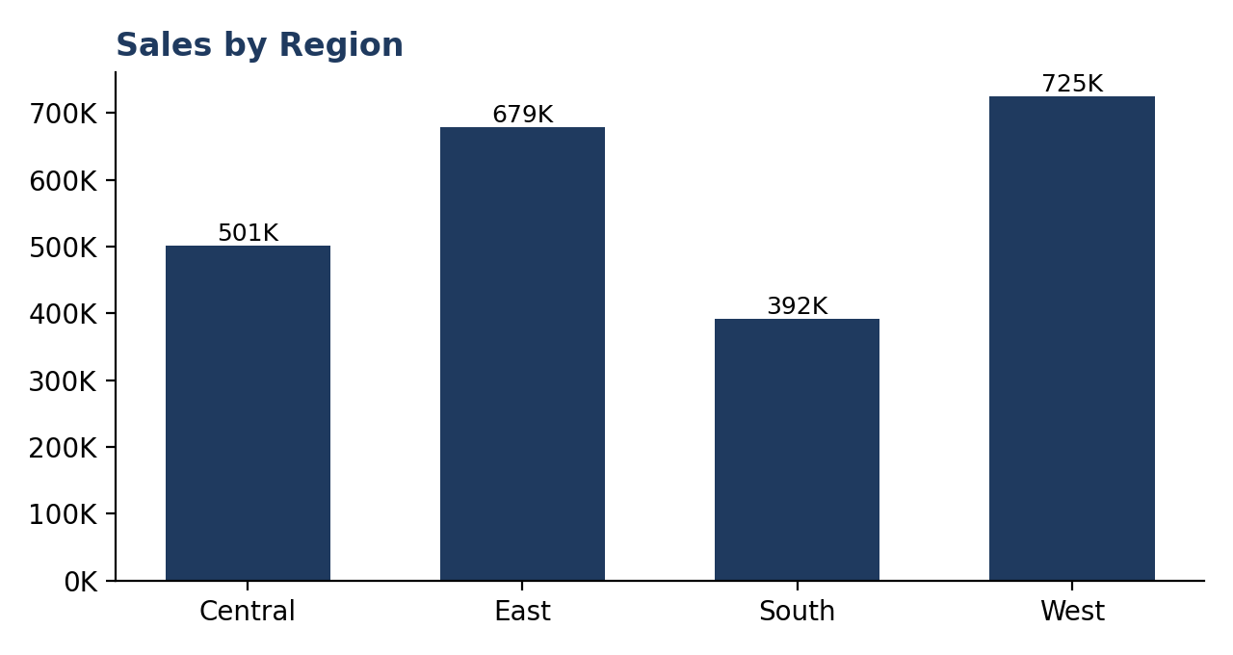
Figure 1: Sales by Region
West is the largest region at about $725K, followed by East ($679K), Central ($501K) and South ($392K).
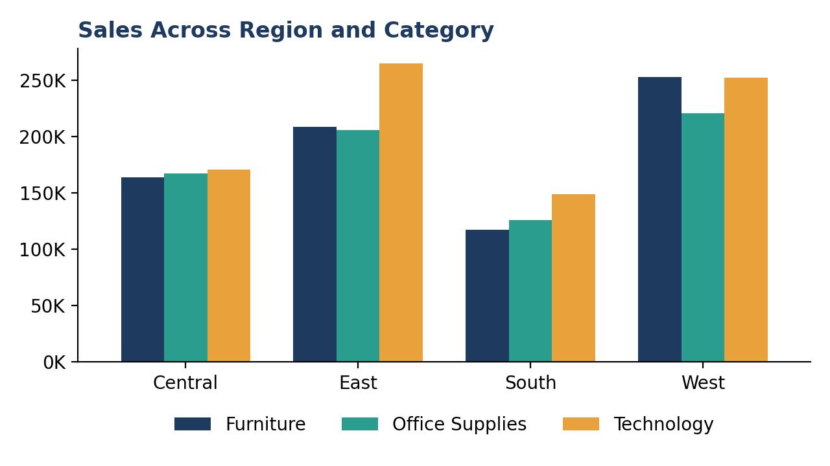
Figure 2: Sales Across Region and Category
Technology leads in East ($265K), while West is strongest in Furniture ($253K). South is the lowest in every category, and Central is evenly balanced at roughly $164K–$170K per category.
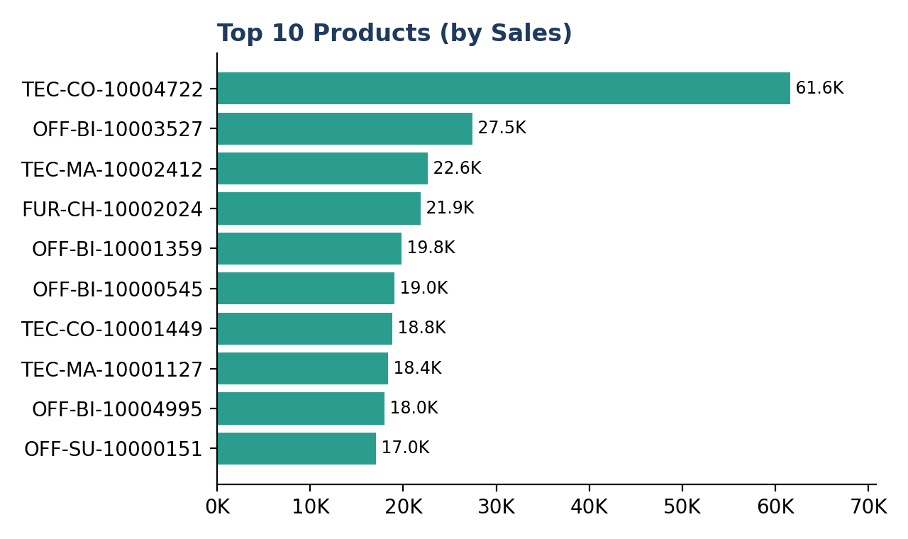
Figure 3: Top 10 Products by Sales
The Canon imageCLASS 2200 Advanced Copier (TEC-CO-10004722) is the top product at about $61.6K, more than double the second product ($27.5K).
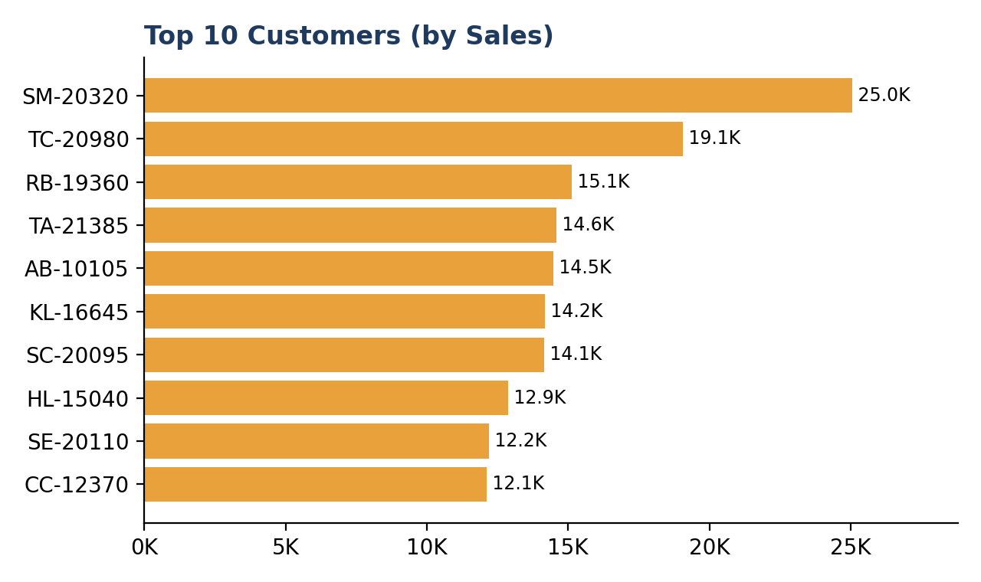
Figure 4: Top 10 Customers by Sales
The top customer, Sean Miller (SM-20320), contributes about $25.0K. The top 10 customers together account for about $153.8K, only 6.7% of total sales.
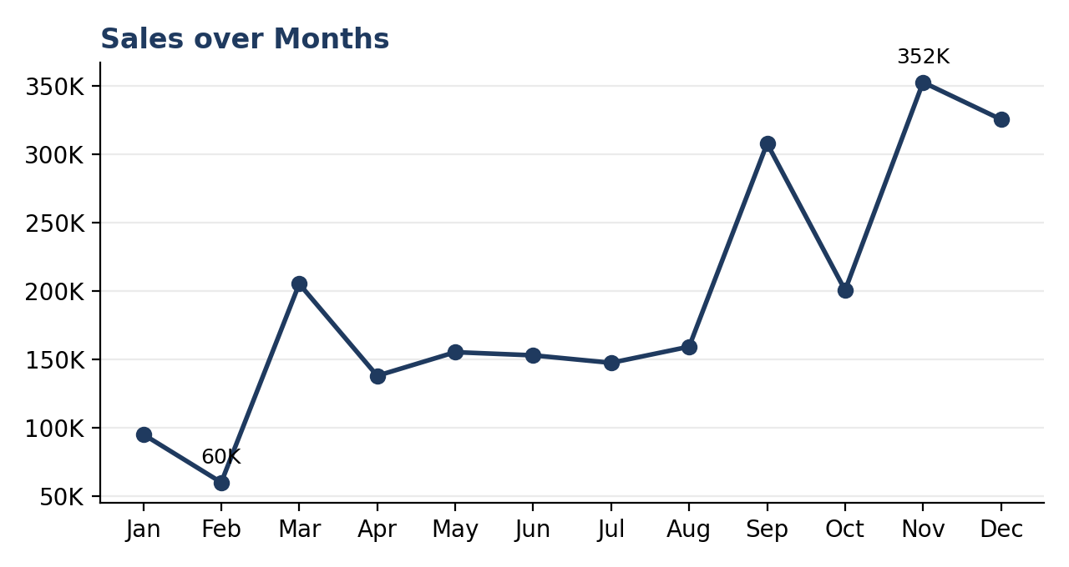
Figure 5: Sales over Months
Sales rise sharply in the second half of the year, peaking in November ($352K) and staying high in December ($325K) and September ($308K). February is the lowest month ($60K).
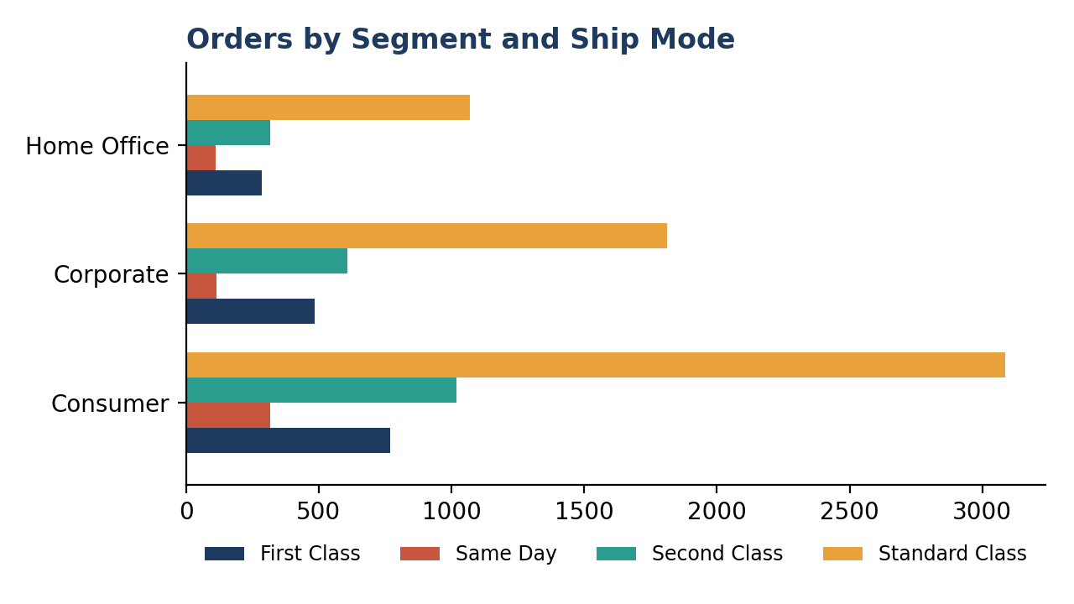
Figure 6: Orders by Segment and Ship Mode
Standard Class is the dominant shipping mode in every segment (5,968 of 9,994 order lines). Consumer is the largest segment with 5,191 order lines.

Summary by Category and Region
Category | Sales ($) | Profit ($) | Margin
Technology | 836,154 | 145,455 | 17.4%
Furniture | 741,999 | 18,451 | 2.5%
Office Supplies | 719,047 | 122,491 | 17.0%

Region | Sales ($) | Profit ($) | Margin
West | 725,458 | 108,418 | 14.9%
East | 678,781 | 91,523 | 13.5%
Central | 501,240 | 39,706 | 7.9%
South | 391,722 | 46,749 | 11.9%

6. INSIGHTS AND RECOMMENDATION

Insights
- Regional performance: West and East together generate about 61% of total sales. Central has the weakest margin (7.9%) despite being the third-largest region, and South is the smallest by sales.
- Category performance: Technology gives the highest sales and the best margin (17.4%). Furniture brings in $742K of sales but earns only 2.5% margin.
- Sub-category performance: Phones ($330K) and Chairs ($328K) are the top sellers. Copiers are the most profitable sub-category ($55.6K profit). Tables (–$17.7K), Bookcases (–$3.5K) and Supplies (–$1.2K) are loss-making.
- Product concentration: A single copier model contributes about 2.7% of total sales, so the top products have an outsized impact.
- Customer base: Sales are widely spread. The top 10 customers contribute under 7%, which means low dependence on any one customer.
- Seasonality: September to December produces the majority of revenue, with Q4 alone contributing about 38% of annual sales. January and February are the weakest months.
- Growth trend: Yearly sales moved from $484K (2014) to $471K (2015), then grew to $609K (2016) and $733K (2017), a 20% rise in the latest year with profit growing alongside.
- Segments and shipping: Consumer contributes about 51% of sales, while Home Office has the best margin (14.0%). Standard Class is used for about 60% of order lines; Same Day is under 6%.
- Discounting: About 19% of order lines are loss-making, and every discount level of 30% or more results in a net loss (about –$135K combined).

Recommendations
- Limit discounts above 30% and set approval rules for deep discounts; this is the clearest route to protecting profit.
- Review pricing, supplier cost and discounting for Tables, Bookcases and Supplies, or reduce their promotion.
- Invest in Technology (Phones, Copiers, Accessories) and Office Supplies, which deliver 17%+ margins, especially in East and West.
- Run a profitability review in the Central region to find out why margin is only 7.9%, and design growth campaigns for South.
- Build inventory and marketing plans around the September–December peak, and use targeted offers or bundles to lift sales in January and February.
- Protect and grow the strong performers: keep the top products well stocked and run loyalty programmes for the top customers.
- Grow the Corporate and Home Office segments, which have better margins than Consumer.

7. OUTCOMES
- Built an interactive Excel dashboard with KPI cards and six pivot charts covering region, category, product, customer, month and ship mode.
- Prepared the raw data with validation checks and derived columns, enabling month, year and weekday analysis.
- Identified the best and weakest regions, categories and sub-categories on both sales and profit.
- Detected the seasonal sales pattern (Q4 peak, early-year slump) and the 2014–2017 growth trend.
- Found the main profit leaks: heavy discounting and loss-making sub-categories.
- Turned the analysis into practical recommendations for pricing, inventory, regional focus and marketing.
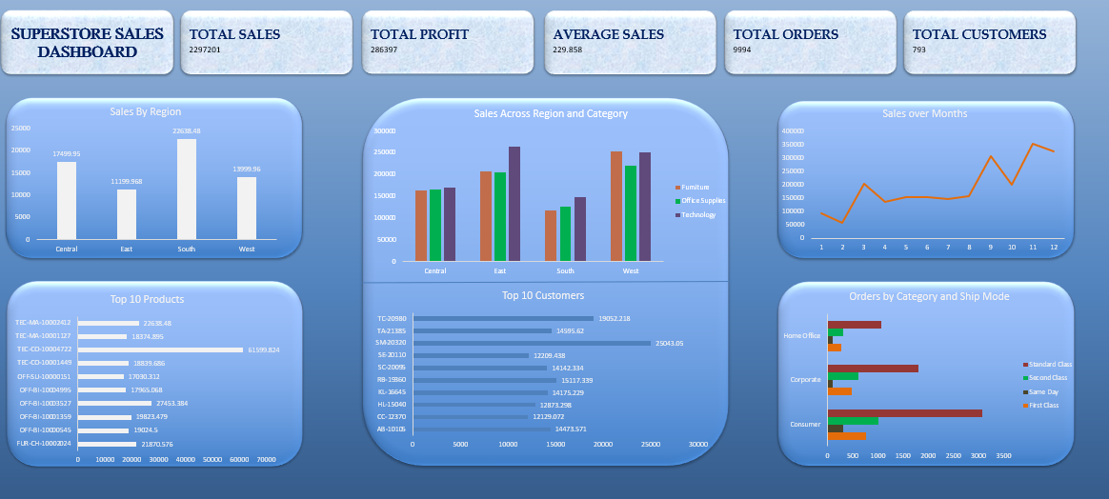

8. CONCLUSION
The Superstore dashboard shows a business with healthy overall performance: $2.30M in sales and $286K in profit at a 12.5% margin, with steady growth since 2015. Sales are strongest in the West and East regions and in the Technology category, and demand peaks in the last four months of the year.
At the same time, the analysis exposes where profit is being lost: heavy discounts, the Furniture category (especially Tables and Bookcases) and the Central region. By controlling discounts, focusing on high-margin products and planning around seasonality, the business can grow sales while improving profitability. The project demonstrates end-to-end analytical skills: data preparation, KPI design, pivot analysis, dashboard visualization and business-focused storytelling.

