**Oracle Client Linux Installation on Sleep Number POC**

**Run the file:**

[sbldev@sblpocapp13 install]$ ./runInstaller.sh

Starting Oracle Universal Installer...

Checking Temp space: must be greater than 415 MB.   Actual 13558 MB    Passed

Checking swap space: must be greater than 150 MB.   Actual 3967 MB    Passed

Checking monitor: must be configured to display at least 256 colors.    Actual 16777216    Passed

Preparing to launch Oracle Universal Installer from /tmp/OraInstall2019-12-13_08-40-02AM. Please wait ...[sbldev@sblpocapp13 install]$ Exception in thread "main" java.lang.UnsatisfiedLinkError: **/tmp/OraInstall2019-12-13_08-40-02AM/jdk/jre/lib/i386/libawt_xawt.so: libXrender.so.1: cannot open shared object file: No such file or directory**

        at java.lang.ClassLoader$NativeLibrary.load(Native Method)

        at java.lang.ClassLoader.loadLibrary0(ClassLoader.java:1941)

        at java.lang.ClassLoader.loadLibrary(ClassLoader.java:1824)

        at java.lang.Runtime.load0(Runtime.java:809)

        at java.lang.System.load(System.java:1086)

        at java.lang.ClassLoader$NativeLibrary.load(Native Method)

        at java.lang.ClassLoader.loadLibrary0(ClassLoader.java:1941)

        at java.lang.ClassLoader.loadLibrary(ClassLoader.java:1845)

        at java.lang.Runtime.loadLibrary0(Runtime.java:870)

        at java.lang.System.loadLibrary(System.java:1122)

        at java.awt.Toolkit$3.run(Toolkit.java:1636)

**Solution:**

* Install the libXrender.i686 (32-bit version)
* Check whether the below libraries are installed.

[root@sblpocapp13 lib]# yum list installed | egrep "libXext|libXrender|libXtst"

libXext.i686                        1.3.3-3.el7              @anaconda/7.4

libXext.x86_64                      1.3.3-3.el7              @anaconda/7.4

libXext-devel.x86_64                1.3.3-3.el7              @anaconda/7.4

libXrender.x86_64                   0.9.10-1.el7             @anaconda/7.4

libXrender-devel.x86_64             0.9.10-1.el7             @anaconda/7.4

libXtst.i686                        1.2.3-1.el7              @anaconda/7.4

libXtst.x86_64                      1.2.3-1.el7              @anaconda/7.4

[root@sblpocapp13 lib]# ls -al /usr/lib/libXext.so*

lrwxrwxrwx. 1 root root    16 May 14  2019 /usr/lib/libXext.so.6 -> libXext.so.6.4.0

-rwxr-xr-x. 1 root root 74524 Apr  9  2015 /usr/lib/libXext.so.6.4.0

[root@sblpocapp13 lib]# ls -al /usr/lib64/libXrender.so*

lrwxrwxrwx. 1 root root    19 May 14  2019 /usr/lib64/libXrender.so -> libXrender.so.1.3.0

lrwxrwxrwx. 1 root root    19 May 14  2019 /usr/lib64/libXrender.so.1 -> libXrender.so.1.3.0

-rwxr-xr-x. 1 root root 44736 Feb  7  2017 /usr/lib64/libXrender.so.1.3.0

* Please set you LD_LIBRARY_PATH to include /usr/lib64.

LD_LIBRARY_PATH=$LD_LIBRARY_PATH:/usr/lib64 ; export PATH

* export LD_LIBRARY_PATH=${LD_LIBRARY_PATH}:/usr/lib64:/usr/lib

**Now Again Run the file:**

[sbldev@sblpocapp13 install]$ ./runInstaller.sh

Starting Oracle Universal Installer...

Checking Temp space: must be greater than 415 MB.   Actual 13558 MB    Passed

Checking swap space: must be greater than 150 MB.   Actual 3967 MB    Passed

Checking monitor: must be configured to display at least 256 colors.    Actual 16777216    Passed

Preparing to launch Oracle Universal Installer from /tmp/OraInstall2019-12-13_08-40-02AM. Please wait ...[sbldev@sblpocapp13 install]

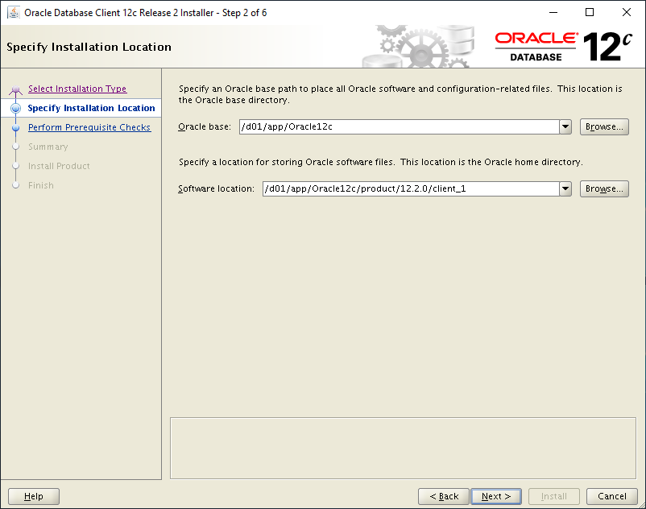

Click on Next

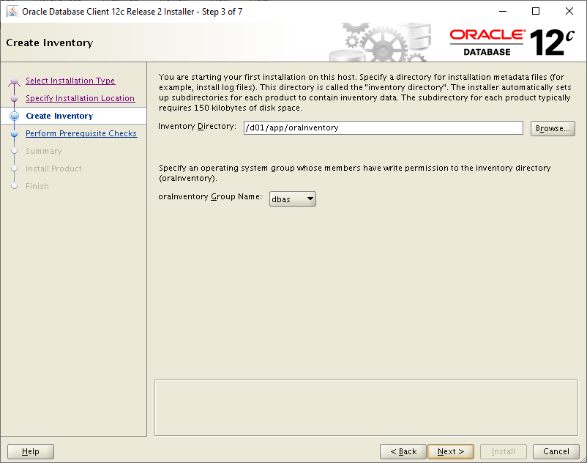

Browse the oraInventory and click on Next

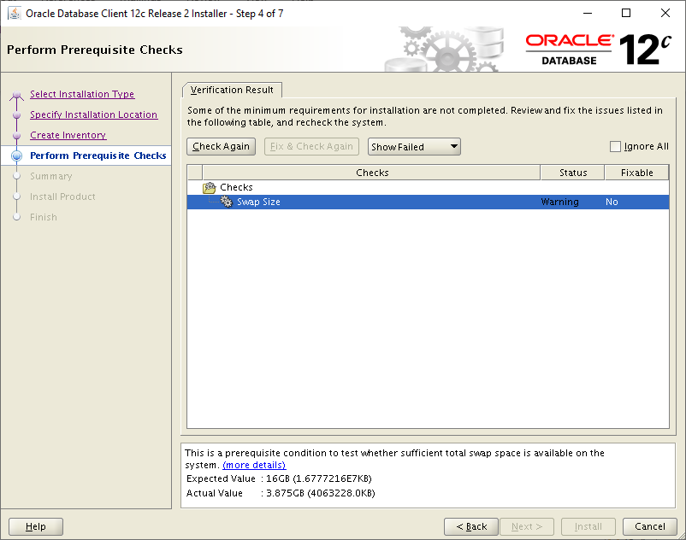

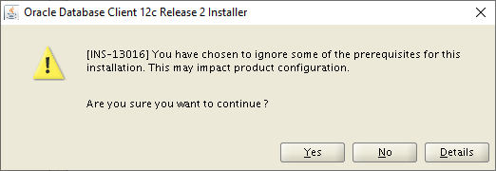

Click on Yes

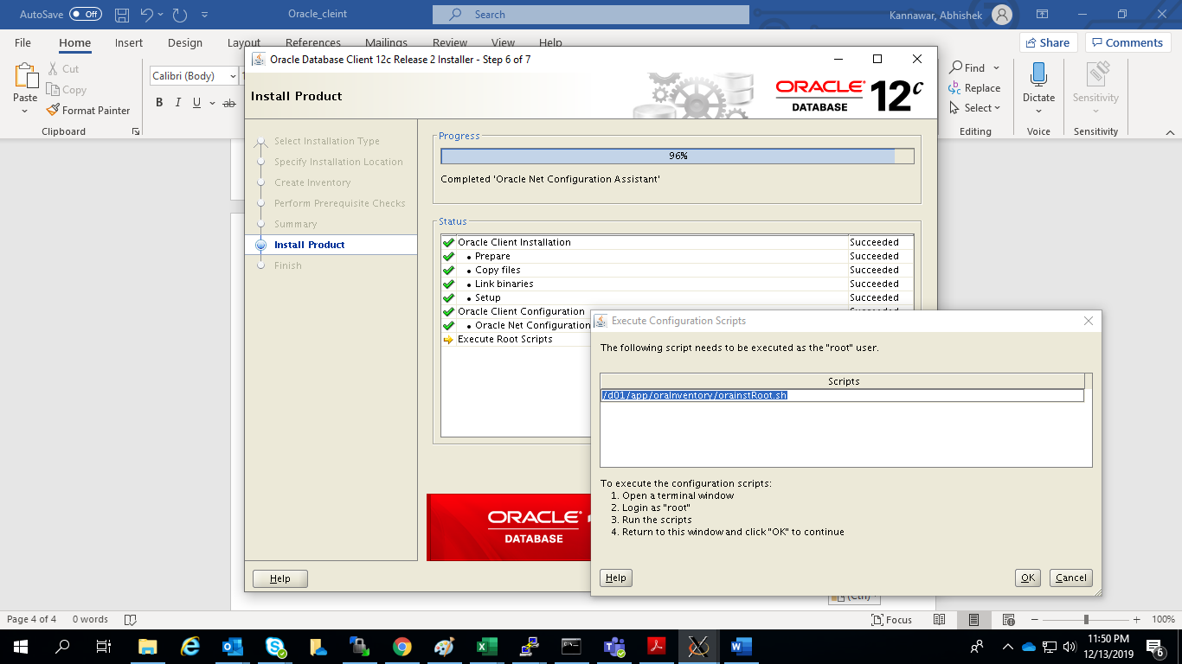

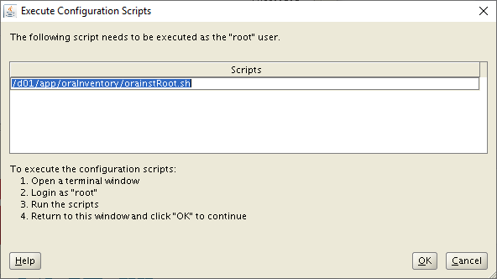

Login with root and execute the above script and click on OK

**The output of root.sh script:**

[root@sblpocweb13 ~]# /d01/app/oraInventory/orainstRoot.sh

Changing permissions of /d01/app/oraInventory.

Adding read,write permissions for group.

Removing read,write,execute permissions for world.

Changing groupname of /d01/app/oraInventory to dbas.

The execution of the script is complete.

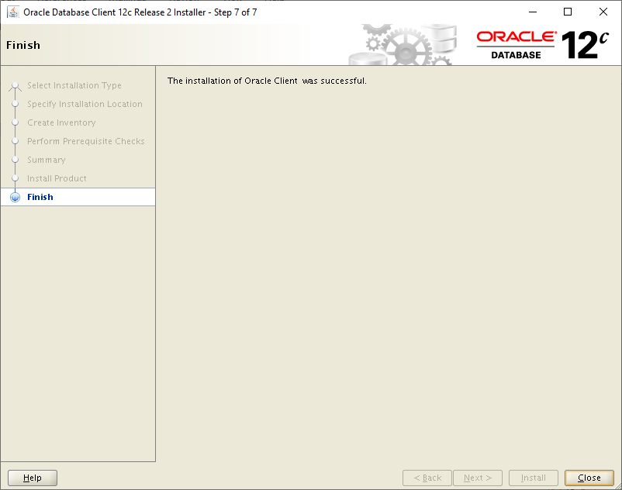

The installation is successful click on Close.