**Assignment-01**



**Apex Institute Technology (AIT)**

**Submitted by:**

**Name:** Akansh Arya

**UID**: 22BDO10027

**Subject Name:** Git and GitHub

**Subject Code:** 22CSH-293

**Section:**22BCD-1A

**Submitted to:**

**Dr. Kamaljit Singh Saini (E3040)**

**Department of AIT - CSE**

**Q1) Create a public repository on your GitHub profile and in its README.md file, list the link of your GitHub repositories of the practical’s you are performing in the current semester.**

# 1) For Git and GitHub practical’s: -

* Go to your GitHub account and create a repository over there for your practices.
* Click on ‘**+**’ icon on the GitHub and then select create ‘New repository’.
* Enter the name of your repository i.e. (Git_Exps) then select ‘Public/Private’**.**
* Now add a README.md file in your repository then click on create new repository.

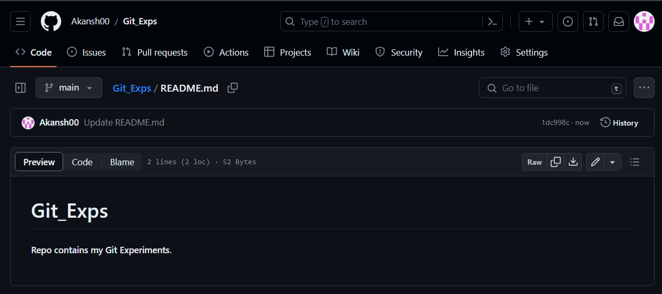

* Now click on the ‘Add file’ then select upload file from your PC and select all the G_Exps which we have to upload on GitHub.

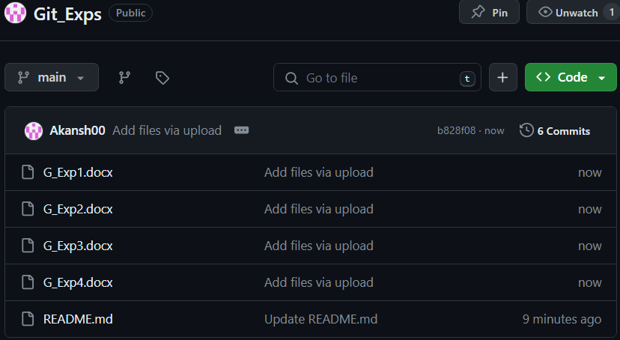

# 2) For DAA (Design and Analysis of Algorithm): -

Design and Analysis of Algorithms covers the concepts of designing an algorithm as to solve various problems in computer science and information technology, and also analyse the complexity of these algorithms designed. The main aim of designing an algorithm is to provide a optimal solution for a problem.

* Now again create a new repository for (DAA_Exps).
* Follow the same steps as we created the previous repository.

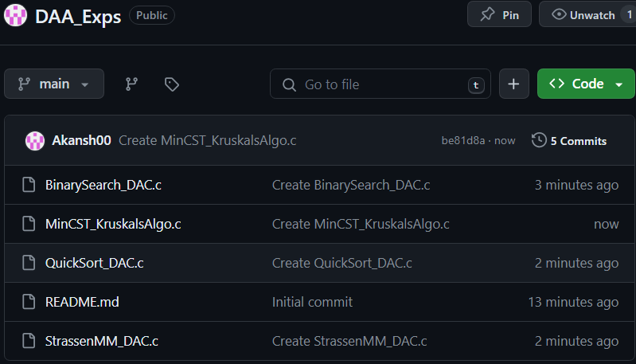

# 3) For Agile Practices: -

Agile Software Development is an iterative and incremental approach to software development that emphasizes the importance of delivering a working product quickly and frequently. It involves close collaboration between the development team and the customer to ensure that the product meets their needs and expectations.

* Now again create a new repository for (Agile_Exps).
* Follow the same steps as we created the previous repository.

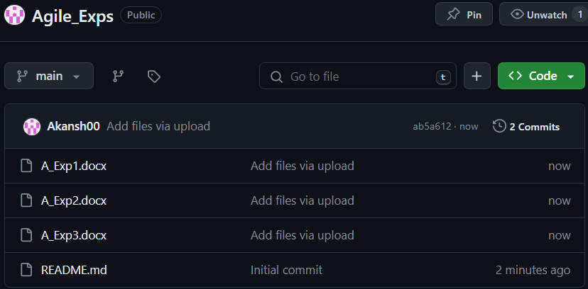

**Q2) Create a repository on GitHub related to your current semester mini project and link a project section to it which you can maintain the workflow of your project.**

* Create a new repository on GitHub i.e. (**Mini_Proj**) and add all your project related information.

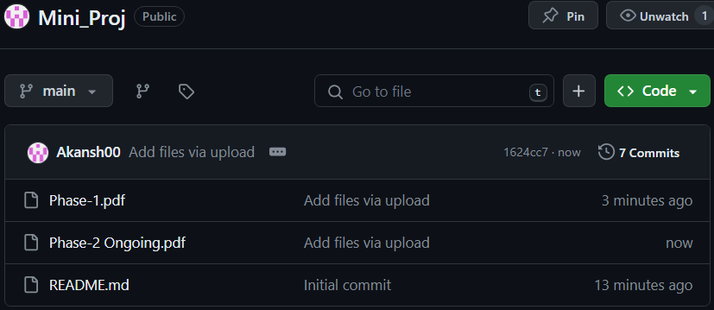

* Now go to ‘**Project option**’ click on create new project. Enter the name of the i.e. (**Automated Teller Machine**).
* Now choose a template for your project i.e. (**Team collaborative**).

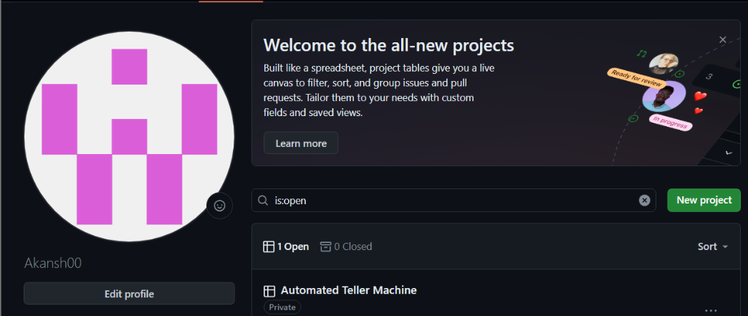

* Now add all your team member by clicking on the “Manage Access”. And all your team members by (@username).

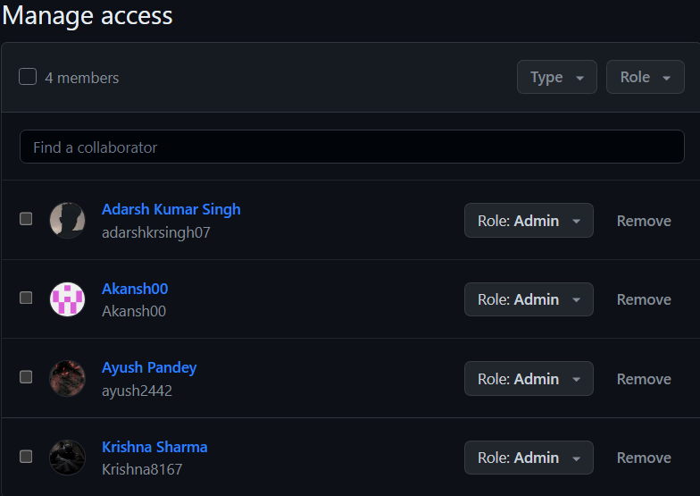

* Now create issue related to your project progress and ask your team members to add some content related to your project.

