**Experiment -1.3**

**Student Name:** Akansh Arya **UID:** 22BDO10027

**Branch:** CSE(DevOps) **Section/Group**: 22BCD-1 A

**Semester:** 4th **Date of Performance:** 31/01/2024 **Subject Name**: Git and Hub **Subject Code:** 22CSH-293

1. **Aim/Overview of the practical:** To create and explore pull requests.
2. **Software Used:** Git Bash, GitHub.
3. **Steps for experiment/practical:**
   * Create or clone a repository on your local machine and open GIT BASH.
   * Move to the directory using the **cd** command.

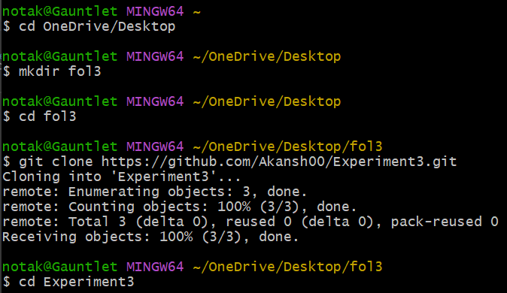

* + Create a file in the master or main branch **text.txt** and add some text to the file.
  + Add the file to the staging area using **git add text.txt** and then commit the changes using the **git commit** command.

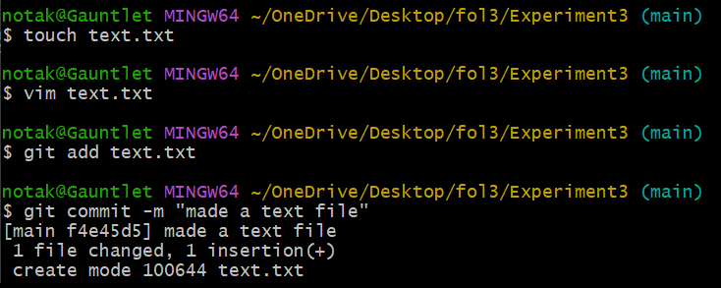

* + Create a new branch and enter it using **git checkout -b branch1**.
  + Open the **text.txt** on the **vim** editor and make some changes in it.
  + 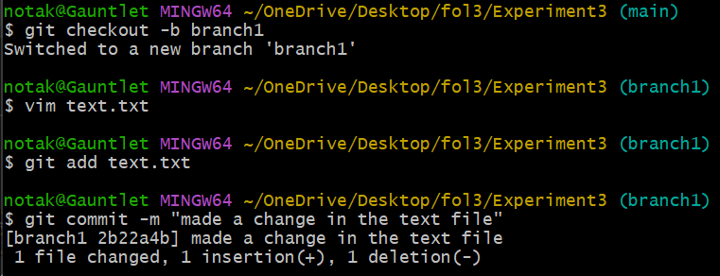Add the file to the staging area using **git add text.txt** and then commit the changes using **git commit -m “enter a message”**.
  + 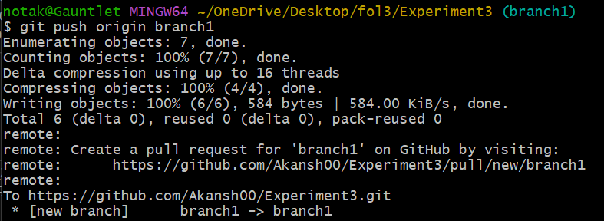Now, push your changes to the remote repository using **git push origin branch1**.
  + 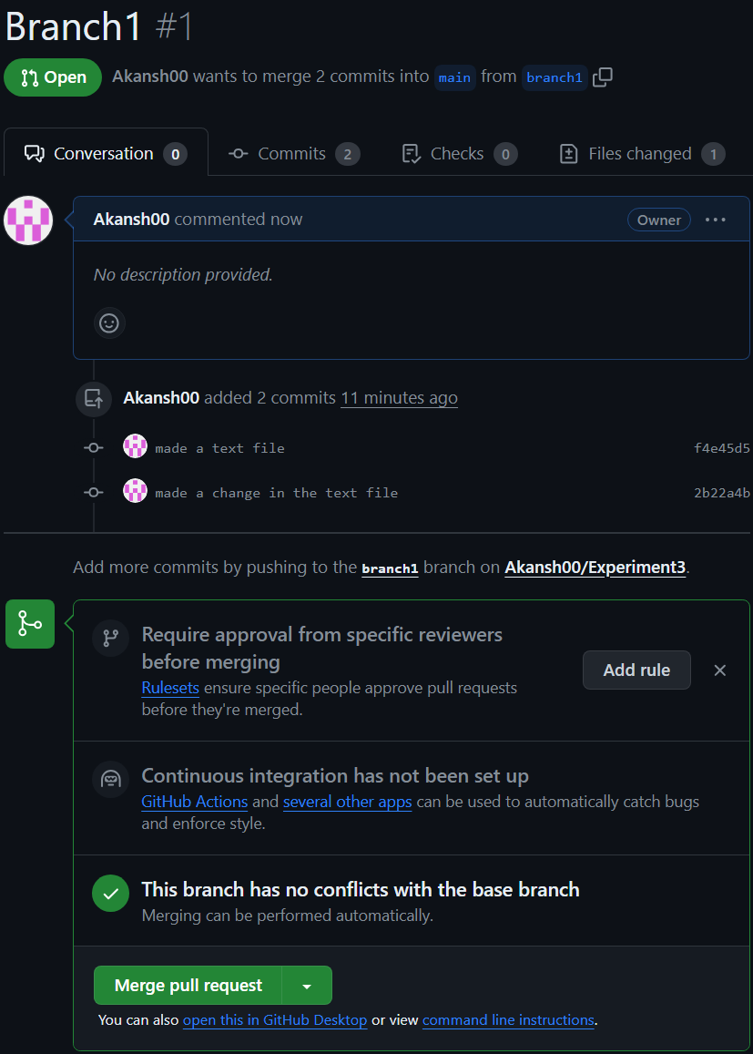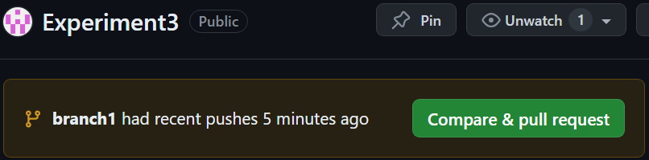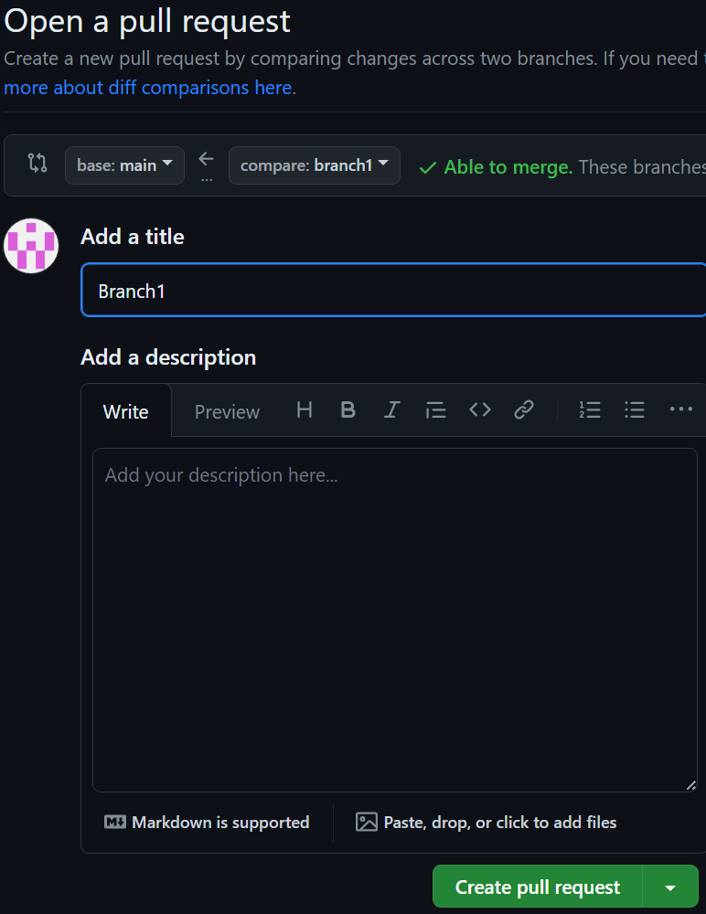Now, go to GitHub, open the repository and you will see a prompt stating that **branch1** had recent pushes, click on **Compare & pull request**, then **Create pull request** and **Merge pull Request.**
  + 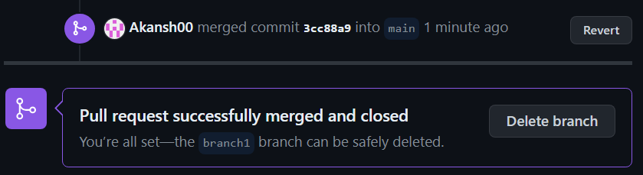After the merging, you may choose to delete your branch.
  + 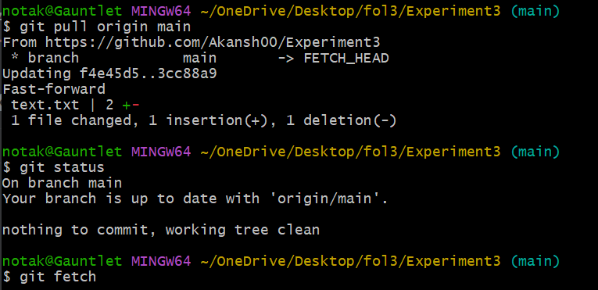In the Git Bash, you may get the changes in your local repository using **git pull origin main** andif you want the references of the commits, use **git fetch**.
  + Now, after **git pull**, we will be seeing the changes in **text.txt**, using **cat text.txt**

1. **Result/Output/Writing Summary:**

In this experiment, we have created and explored the pull requests. We have created a new branch, made some changes in the files in that new branch and then merged the changes with the main branch by resolving merge conflicts by using both GitHub and Git Bash.

**Learning outcomes (What I have learnt):**

* + 1. Learnt how to create a branch.
    2. Learnt how to push the changes to the remote repository.
    3. Learnt how to pull the changes from the remote repository.
    4. Learnt to merge two branches.
    5. Learnt how to resolve merge conflicts.

**Evaluation Grid (To be created as per the SOP and Assessment guidelines by the faculty):**

|  |  |  |  |
| --- | --- | --- | --- |
| Sr. No. | Parameters | Marks Obtained | Maximum Marks |
| 1. |  |  |  |
| 2. |  |  |  |
| 3. |  |  |  |
|  |  |  |  |