**COMPUTER GRAPHICS LAB FILE**

**CSE DEVOPS SEM-V (2018-22)**

**Submitted by: Akansha Bansiya**

**SAP: 500067027**

**Rno: R171218009**

**1. GREEN TRIANGLE**

#include<GL/glut.h>

#include<GL/gl.h>

void triangle(void){

glClear(GL_COLOR_BUFFER_BIT);

glBegin(GL_TRIANGLES);

glColor3f(0,1,0);

glVertex2f(0,1);

glVertex2f(-1,0);

glVertex2f(1,0);

glEnd();

glFlush();

}

int main(int argc,char** argv){

glutInit(&argc,argv);

glutInitDisplayMode(GLUT_SINGLE);

glutInitWindowSize(500,500);

glutCreateWindow("Triangle");

//init();

//drawstring();

glutDisplayFunc(triangle);

glutMainLoop();

return 0;

}

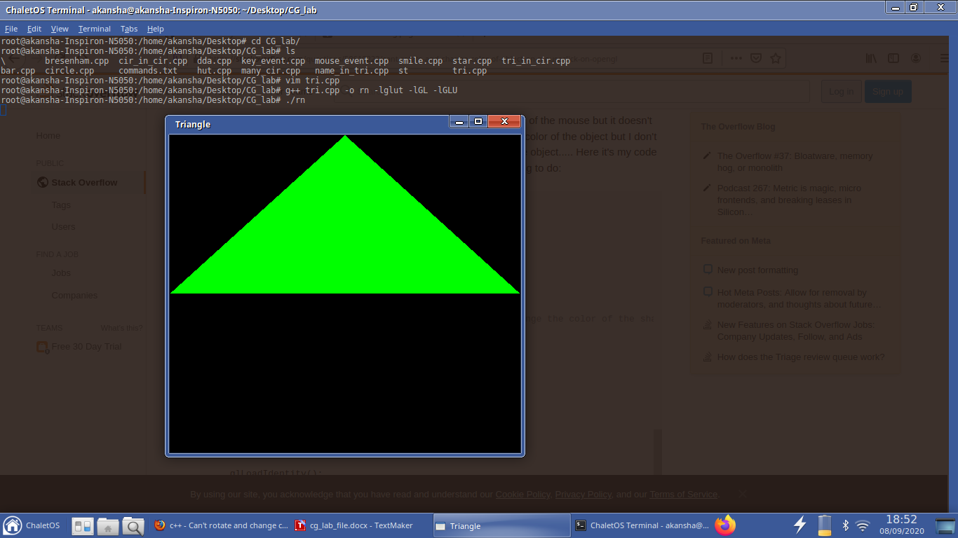

**2. DISPLAY NAME IN TRIANGLE**

#include<GL/glut.h>

#include<GL/gl.h>

void drawstring()

{

char d[7]={'A','k','a','n','s','h','a'};

char *s=d;

char *c;

glRasterPos3f(-0.1,0.4,0);

for(c=s;*c!='\0';c++)

{ glColor3f(1,0,0);

glutBitmapCharacter(GLUT_BITMAP_9_BY_15,*c);

}

}

void triangle(void){

glClear(GL_COLOR_BUFFER_BIT);

glBegin(GL_LINES);

glColor3f(0,1,0);

glVertex2f(0,1);

glVertex2f(-1,0);

glEnd();

glBegin(GL_LINES);

glColor3f(0,1,0);

glVertex2f(-1,0);

glVertex2f(1,0);

glEnd();

glBegin(GL_LINES);

glColor3f(0,1,0);

glVertex2f(1,0);

glVertex2f(0,1);

glEnd();

drawstring();

glFlush();

}

int main(int argc,char** argv){

glutInit(&argc,argv);

glutInitDisplayMode(GLUT_SINGLE);

glutInitWindowSize(500,500);

glutCreateWindow("Triangle");

glutDisplayFunc(triangle);

glutMainLoop();

return 0;

}

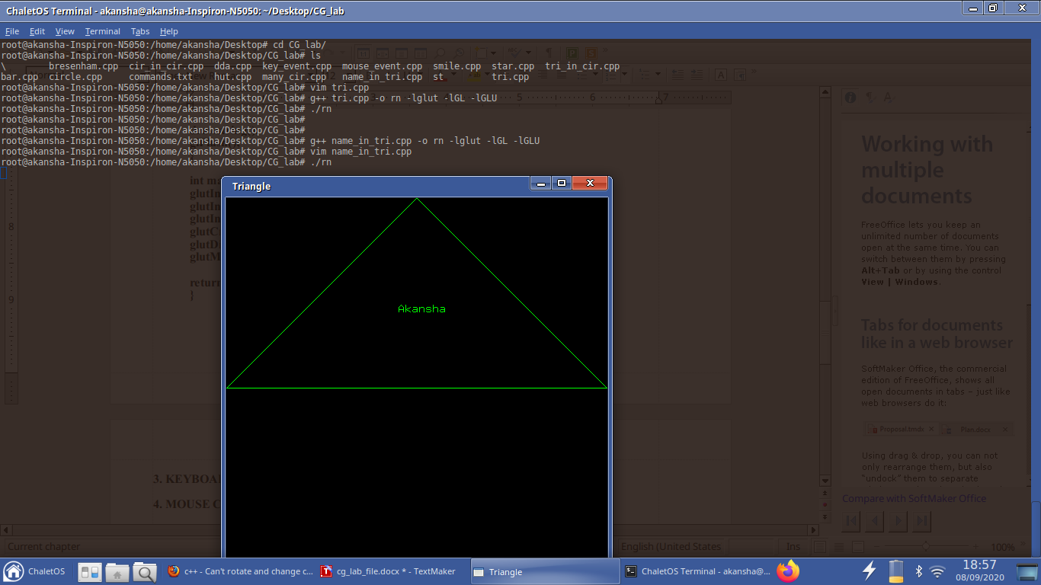

**3. KEYBOARD KEY PRESS EVENT**

#include<GL/glut.h>

#include<GL/gl.h>

int r=1,g=1,b=1;

void ch_color(unsigned char key,int x,int y)

{

switch (key) {

case 'b':

r = 0;

g = 0;

b = 1;

break;

case 'r':

r = 1;

g = 0;

b = 0;

break;

case 'g':

r = 0;

g = 1;

b = 0;

break;

}

glutPostRedisplay();

}

void triangle(void){

glClear(GL_COLOR_BUFFER_BIT);

glBegin(GL_TRIANGLES);

glColor3f(r,g,b);

glVertex2f(0,1);

glVertex2f(-1,0);

glVertex2f(1,0);

glEnd();

glFlush();

}

int main(int argc,char** argv){

glutInit(&argc,argv);

glutInitDisplayMode(GLUT_SINGLE);

glutInitWindowSize(500,500);

glutCreateWindow("Triangle");

glutDisplayFunc(triangle);

glutKeyboardFunc(ch_color);

glutMainLoop();

return 0;

}

**Initially:**

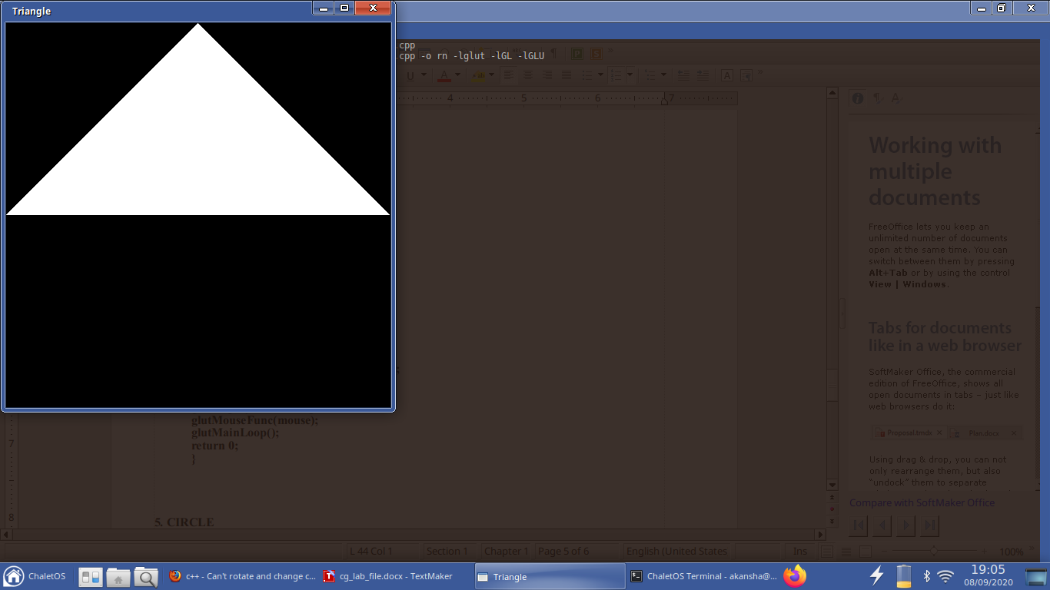

**on pressing ‘r’ key:**

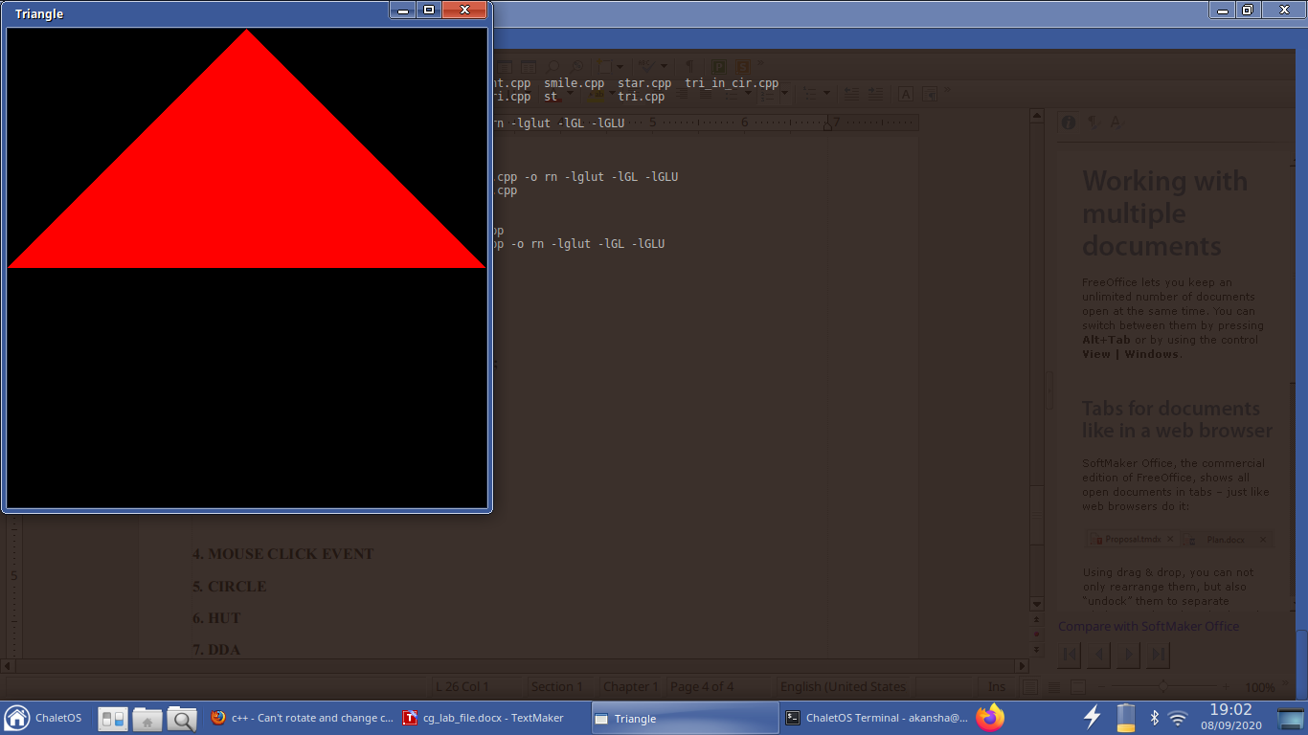

**on pressing ‘g’ key:**

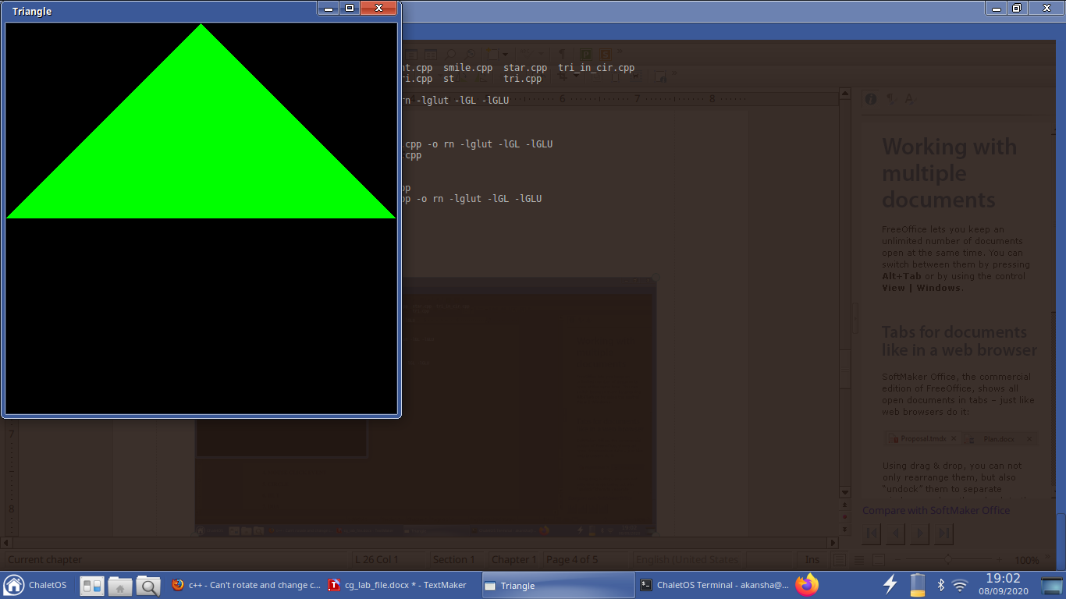

**4. MOUSE CLICK EVENT**

#include<GL/glut.h>

#include<GL/gl.h>

int r=1,g=1,b=1;

void mouse(int button,int state,int x,int y)

{ switch (button) {

case GLUT_LEFT_BUTTON:

{ r=0;g=1;b=0;

break;}

case GLUT_RIGHT_BUTTON:

{ r=1;g=0;b=0;

break;}

}

glutPostRedisplay();

}

void triangle(void){

glClear(GL_COLOR_BUFFER_BIT);

glBegin(GL_TRIANGLES);

glColor3f(r,g,b);

glVertex2f(0,1);

glVertex2f(-1,0);

glVertex2f(1,0);

glEnd();

glFlush();

}

int main(int argc,char** argv){

glutInit(&argc,argv);

glutInitDisplayMode(GLUT_SINGLE);

glutInitWindowSize(500,500);

glutCreateWindow("Triangle");

glutDisplayFunc(triangle);

glutMouseFunc(mouse);

glutMainLoop();

return 0;

}

**Initially:**



**on left click:**



**on right click:**



**5. CIRCLE**

#include<GL/glut.h>

#include<GL/gl.h>

#include<cmath>

void circle(void){

glClear(GL_COLOR_BUFFER_BIT);

glBegin(GL_POINTS);

for(int i=0;i<180;++i)

{

glVertex3f(cos(2*3.14159*i/180),sin(2*3.14159*i/180),0);

}

glEnd();

glFlush();

}

int main(int argc,char** argv){

glutInit(&argc,argv);

glutInitDisplayMode(GLUT_SINGLE);

glutInitWindowSize(200,200);

glutCreateWindow("Circle");

glutDisplayFunc(circle);

glutMainLoop();

return 0;

}

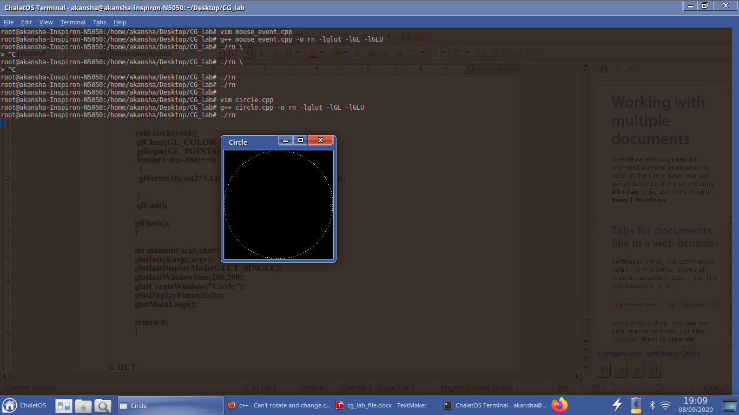

**6. HUT**

#include<GL/glut.h>

#include<GL/gl.h>

void hut(void){

glClear(GL_COLOR_BUFFER_BIT);

glBegin(GL_LINES);

glColor3f(0,1,0);

glVertex2f(20,20);

glVertex2f(20,200);

glEnd();

glBegin(GL_LINES);

glColor3f(0,1,0);

glVertex2f(20,200);

glVertex2f(280,200);

glEnd();

glBegin(GL_LINES);

glColor3f(0,1,0);

glVertex2f(280,200);

glVertex2f(280,20);

glEnd();

glBegin(GL_LINES);

glColor3f(0,1,0);

glVertex2f(150,200);

glVertex2f(150,20);

glEnd();

glBegin(GL_LINES);

glColor3f(0,1,0);

glVertex2f(280,20);

glVertex2f(20,20);

glEnd();

glBegin(GL_LINES);

glColor3f(1,0,0);

glVertex2f(150,200);

glVertex2f(215,250);

glEnd();

glBegin(GL_LINES);

glColor3f(1,0,0);

glVertex2f(215,250);

glVertex2f(280,200);

glEnd();

glBegin(GL_LINES);

glColor3f(1,0,0);

glVertex2f(20,200);

glVertex2f(85,250);

glEnd();

glBegin(GL_LINES);

glColor3f(1,0,0);

glVertex2f(85,250);

glVertex2f(150,200);

glEnd();

glBegin(GL_LINES);

glColor3f(0,1,1);

glVertex2f(70,70);

glVertex2f(70,110);

glEnd();

glBegin(GL_LINES);

glColor3f(0,1,1);

glVertex2f(70,110);

glVertex2f(100,110);

glEnd();

glBegin(GL_LINES);

glColor3f(0,1,1);

glVertex2f(100,110);

glVertex2f(100,70);

glEnd();

glBegin(GL_LINES);

glColor3f(0,1,1);

glVertex2f(100,70);

glVertex2f(70,70);

glEnd();

glBegin(GL_LINES);

glColor3f(0,1,1);

glVertex2f(210,20);

glVertex2f(210,100);

glEnd();

glBegin(GL_LINES);

glColor3f(0,1,1);

glVertex2f(210,100);

glVertex2f(230,100);

glEnd();

glBegin(GL_LINES);

glColor3f(0,1,1);

glVertex2f(230,100);

glVertex2f(230,20);

glEnd();

glBegin(GL_LINES);

glColor3f(0,1,1);

glVertex2f(230,20);

glVertex2f(210,20);

glEnd();

glFlush();

}

int main(int argc,char** argv){

glutInit(&argc,argv);

glutInitDisplayMode(GLUT_SINGLE);

glutInitWindowSize(1000,1000);

glutCreateWindow("HUT");

glMatrixMode(GL_PROJECTION);

glLoadIdentity();

gluOrtho2D(0,500,0,500);

glutDisplayFunc(hut);

glutMainLoop();

return 0;

}

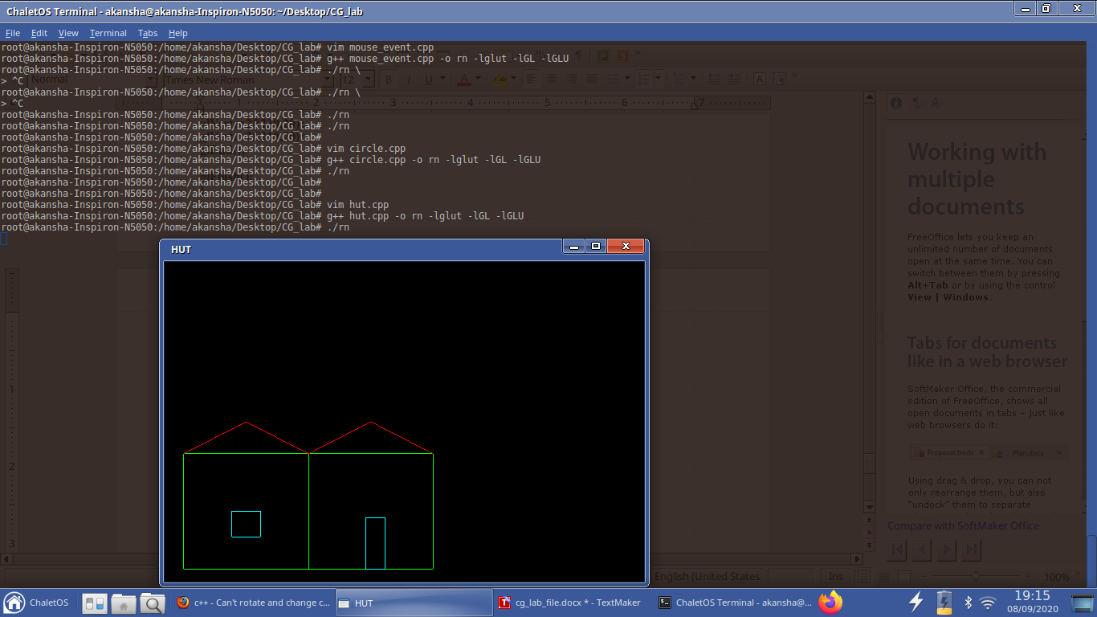

**7. DDA**

#include<GL/glut.h>

#include<GL/gl.h>

#include<cmath>

#include<iostream>

using namespace std;

float x1,yp1,x2,y2;

void dda_line(){

float dx,dy;

dx=x2-x1;

dy=y2-yp1;

int step;

if( abs(dx) >= abs(dy) )

{step=abs(dx);}

else

{step=abs(dy);}

dx=dx/step;

dy=dy/step;

glClear(GL_COLOR_BUFFER_BIT);

glMatrixMode(GL_PROJECTION);

glLoadIdentity();

gluOrtho2D(0,200,0,200);

glPointSize(1.0);

glBegin(GL_POINTS);

glColor3f(0,1,1);

glVertex2f(round(x1),round(yp1));

for(int i=1;i<=step;i++)

{

//glBegin(GL_POINTS);

x1=x1+dx;

yp1=yp1+dy;

glVertex2f(round(x1),round(yp1));

}

glEnd();

glFlush();

}

int main(int argc,char** argv){

glutInit(&argc,argv);

cout<<"x1: ";

cin>>x1;

cout<<"y1: ";

cin>>yp1;

cout<<"x2: ";

cin>>x2;

cout<<"y2: ";

cin>>y2;

glutInitDisplayMode(GLUT_SINGLE);

glutInitWindowSize(500,500);

glutCreateWindow("DDA");

glutDisplayFunc(dda_line);

glutMainLoop();

return 0;

}

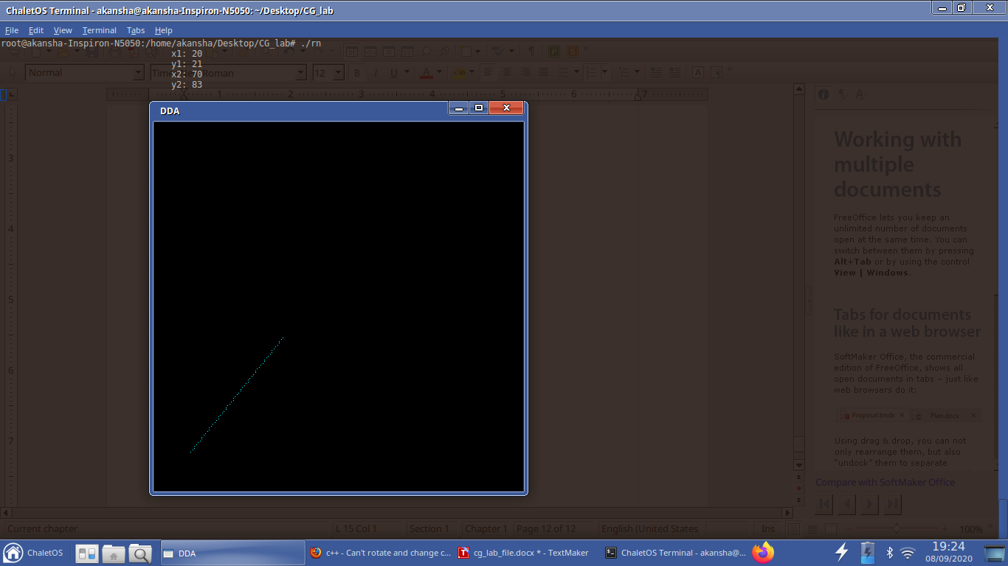

**8. BRESENHAM**

#include<GL/glut.h>

#include<GL/gl.h>

#include<cmath>

#include<iostream>

using namespace std;

int x1,yp1,x2,y2;

void br_line(){

int dx,dy;

dx=x2-x1;

dy=y2-yp1;

int p;

p=2*dy-dx;

glClear(GL_COLOR_BUFFER_BIT);

glMatrixMode(GL_PROJECTION);

glLoadIdentity();

gluOrtho2D(0,200,0,200);

glPointSize(1.0);

glBegin(GL_POINTS);

glColor3f(0,1,1);

while(x1<=x2)

{

glVertex2f(x1,yp1);

x1=x1+1;

if(p>0)

{

yp1=yp1+1;

p=p+2*dy-2*dx;

}

else{

p=p+2*dy;

}

}

glEnd();

glFlush();

}

int main(int argc,char** argv){

glutInit(&argc,argv);

//double x1,y1,x2,y2;

cout<<"x1: ";

cin>>x1;

cout<<"y1: ";

cin>>yp1;

cout<<"x2: ";

cin>>x2;

cout<<"y2: ";

cin>>y2;

if(x1>x2 || yp1>y2){

cout<<"Invalid Points \n";

return 0;

}

glutInitDisplayMode(GLUT_SINGLE);

glutInitWindowSize(500,500);

glutCreateWindow("BRESENHAM");

glutDisplayFunc(br_line);

glutMainLoop();

return 0;

}

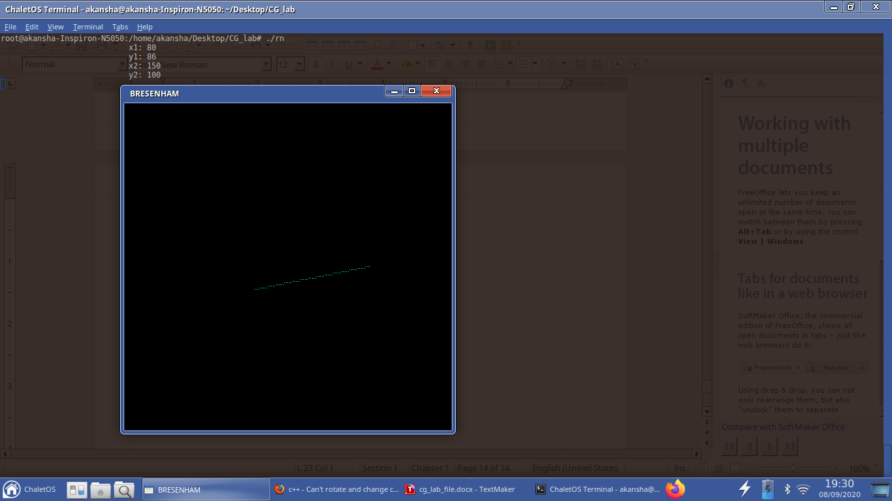

**9. STAR**

#include<GL/glut.h>

#include<GL/gl.h>

void star(void){

glClear(GL_COLOR_BUFFER_BIT);

glBegin(GL_LINES);

glColor3f(0,1,0);

glVertex2f(0,1);

glVertex2f(0.5,-0.25);

glEnd();

glBegin(GL_LINES);

glColor3f(0,1,0);

glVertex2f(0.5,-0.25);

glVertex2f(-0.5,-0.25);

glEnd();

glBegin(GL_LINES);

glColor3f(0,1,0);

glVertex2f(-0.5,-0.25);

glVertex2f(0,1);

glEnd();

glBegin(GL_LINES);

glColor3f(1,0,0);

glVertex2f(-0.5,0.5);

glVertex2f(0.5,0.5);

glEnd();

glBegin(GL_LINES);

glColor3f(1,0,0);

glVertex2f(0.5,0.5);

glVertex2f(0,-0.5);

glEnd();

glBegin(GL_LINES);

glColor3f(1,0,0);

glVertex2f(0,-0.5);

glVertex2f(-0.5,0.5);

glEnd();

glBegin(GL_LINES);

glColor3f(0,0,1);

glVertex2f(0,0.5);

glVertex2f(0.25,0);

glEnd();

//drawstring();

glBegin(GL_LINES);

glColor3f(0,0,1);

glVertex2f(0.25,0);

glVertex2f(-0.25,0);

glEnd();

//drawstring();

glBegin(GL_LINES);

glColor3f(0,0,1);

glVertex2f(-0.25,0);

glVertex2f(0,0.5);

glEnd();

//drawstring();

glBegin(GL_LINES);

glColor3f(0,1,1);

glVertex2f(0.125,0.25);

glVertex2f(-0.125,0.25);

glEnd();

//drawstring();

glBegin(GL_LINES);

glColor3f(0,1,1);

glVertex2f(0.125,0.25);

glVertex2f(0,0);

glEnd();

//drawstring();

glBegin(GL_LINES);

glColor3f(0,1,1);

glVertex2f(0,0);

glVertex2f(-0.125,0.25);

glEnd();

//drawstring();

glFlush();

}

int main(int argc,char** argv){

glutInit(&argc,argv);

glutInitDisplayMode(GLUT_SINGLE);

glutInitWindowSize(2000,2000);

glutCreateWindow("STAR");

glutDisplayFunc(star);

return 0;

}

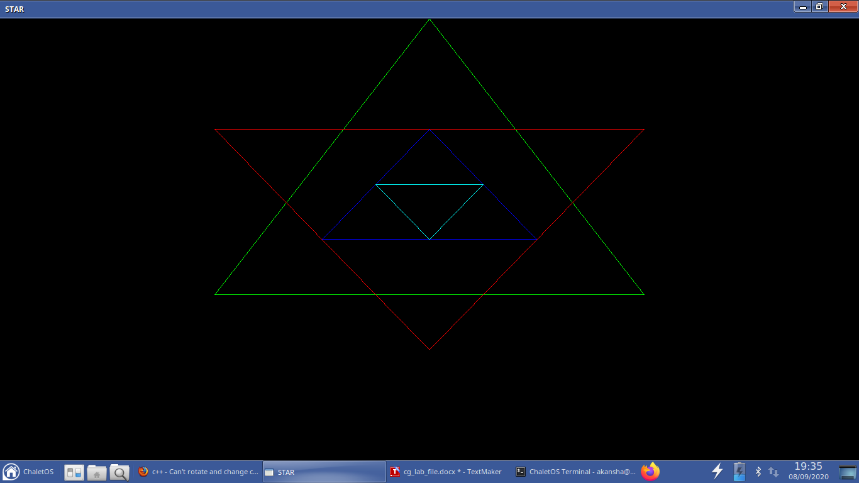

**10. TRIANGLE (FILLED WITH LINES) IN CIRCLE**

#include<GL/glut.h>

#include<GL/gl.h>

#include<cmath>

#include<iostream>

using namespace std;

//float x1,yp1,x2,y2;

float arr1[8][2];

float arr2[8][2];

void dda_line(int c,float x1,float yp1,float x2,float y2){

float dx,dy;

dx=x2-x1;

dy=y2-yp1;

int step;

if( abs(dx) >= abs(dy) )

{step=abs(dx);}

else

{step=abs(dy);}

dx=dx/step;

dy=dy/step;

//glClear(GL_COLOR_BUFFER_BIT);

int temp;

if(c==3){

temp=step/10;

c=1;

}

else{

temp=step/8;

}

int tc=0;

glPointSize(1.0);

glBegin(GL_POINTS);

glColor3f(0,1,1);

glVertex2f(round(x1),round(yp1));

for(int i=1;i<=step;i++)

{

//glBegin(GL_POINTS);

x1=x1+dx;

yp1=yp1+dy;

glVertex2f(round(x1),round(yp1));

if(c!=0 && tc!=8 && i%temp==0){

if(c==1)

{arr1[tc][0]=round(x1);

arr1[tc][1]=round(yp1);

tc++;

}

else if(c==2)

{arr2[tc][0]=round(x1);

arr2[tc][1]=round(yp1);

tc++;

}

}

}

glEnd();

glFlush();

}

void d(){

glClear(GL_COLOR_BUFFER_BIT);

float t1,t2,t3,t4,t5,t6;

glBegin(GL_POINTS);

for(int i=0;i<360;i++)

{

glVertex3f(200+150*cos(3.14159*i/180),200+150*sin(3.14159*i/180),0);

if(i==90)

{

t1=200+150*cos(3.14159*i/180.0);

t2=200+150*sin(3.14159*i/180.0);

}

else if(i==225)

{

t3=200+150*cos(3.14159*i/180.0);

t4=200+150*sin(3.14159*i/180.0);

}

else if(i==315)

{

t5=200+150*cos(3.14159*i/180.0);

t6=200+150*sin(3.14159*i/180.0);

t6=200+150*sin(3.14159*i/180.0);

}

}

dda_line(1,t1,t2,t3,t4);

dda_line(0,t5,t6,t3,t4);

float x1,yp1,x2,y2;

x1=t1;

yp1=t2;

x2=(t3+t5)/2;

y2=(t4+t6)/2;

dda_line(2,x1,yp1,x2,y2);

for(int j=0;j<8;j++){

x1=arr1[j][0];

yp1=arr1[j][1];

x2=arr2[j][0];

y2=arr2[j][1];

glColor3f(0,1,1);

glBegin(GL_LINES);

glVertex2f(x1,yp1);

glVertex2f(x2,y2);

glEnd();

}

dda_line(3,t1,t2,t5,t6);

for(int j=0;j<8;j++){

x1=arr1[j][0];

yp1=arr1[j][1];

x2=arr2[j][0];

y2=arr2[j][1];

glColor3f(1,0,0);

glBegin(GL_LINES);

glVertex2f(x1,yp1);

glVertex2f(x2,y2);

glEnd();

}

glFlush();

}

int main(int argc,char** argv){

glutInit(&argc,argv);

glutInitDisplayMode(GLUT_SINGLE);

glutInitWindowSize(500,500);

glutCreateWindow("tri in circle");

glMatrixMode(GL_PROJECTION);

glLoadIdentity();

gluOrtho2D(0,500,0,500);

glutDisplayFunc(d);

glutMainLoop();

return 0;

}

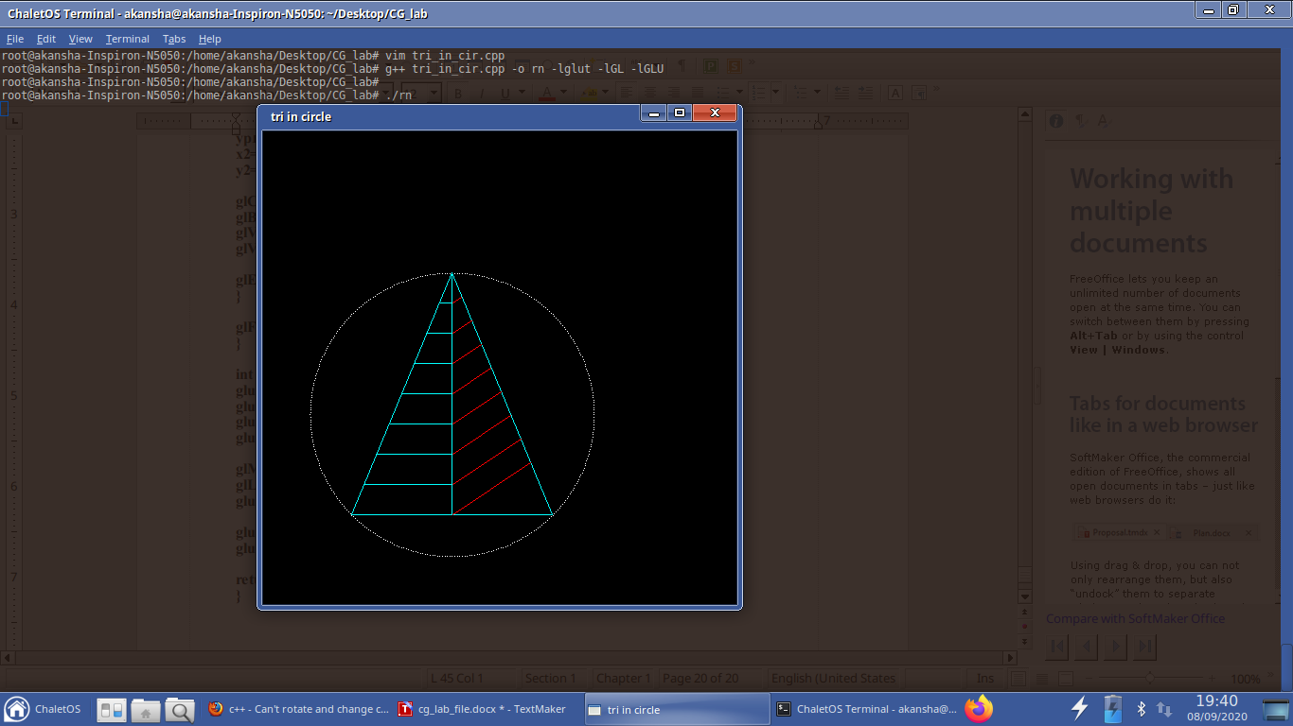

**11. SMILE FACE**

#include<GL/glut.h>

#include<GL/gl.h>

#include<cmath>

void draw(void){

glClear(GL_COLOR_BUFFER_BIT);

float t1,t2,t3,t4,t5,t6;

glPointSize(2);

glBegin(GL_POINTS);

for(int i=0;i<360;i++)

{

glVertex3f(200+150*cos(3.14159*i/180),200+150*sin(3.14159*i/180),0);

}

glEnd();

glPointSize(2);

glBegin(GL_POINTS);

for(int i=0;i<360;i++)

{

glVertex3f(240+10*cos(3.14159*i/180),290+10*sin(3.14159*i/180),0);

}

glEnd();

glPointSize(2);

glBegin(GL_POINTS);

for(int i=0;i<360;i++)

{

glVertex3f(155+10*cos(3.14159*i/180),290+10*sin(3.14159*i/180),0);

}

glEnd();

glPointSize(2);

glBegin(GL_POINTS);

for(int i=225;i<315;i++)

{

glVertex3f(200+50*cos(3.14159*i/180),200+50*sin(3.14159*i/180),0);

}

glEnd();

glBegin(GL_LINES);

glVertex2f(200,250);

glVertex2f(200,220);

glEnd();

glFlush();

}

int main(int argc,char** argv){

glutInit(&argc,argv);

glutInitDisplayMode(GLUT_SINGLE);

glutInitWindowSize(500,500);

glutCreateWindow("SMILE");

//init();

//glClearColor(0,0,0,1);

glMatrixMode(GL_PROJECTION);

glLoadIdentity();

gluOrtho2D(0,500,0,500);

glutDisplayFunc(draw);

glutMainLoop();

return 0;

}

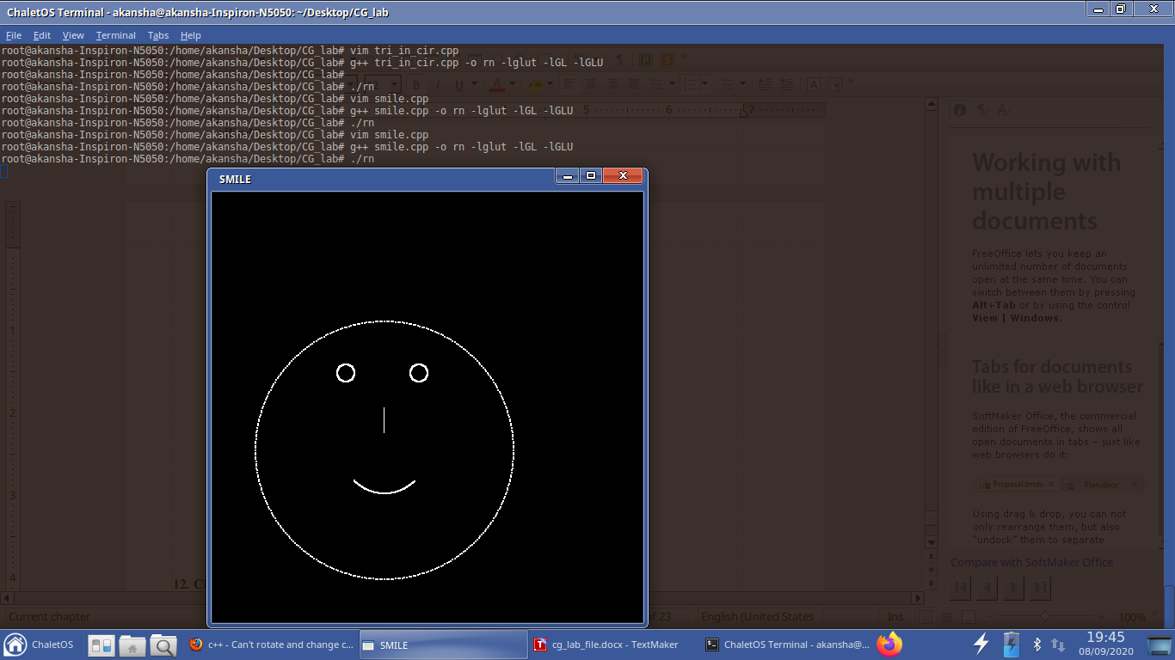

**12. CIRCLES INSIDE CIRCLE (FILL SPACE WITH LINES)**

#include<GL/glut.h>

#include<GL/gl.h>

#include<cmath>

int x1,yp1,x2,y2;

void dda_line();

float dx,dy;

dx=x2-x1;

dy=y2-yp1;

int step;

if( abs(dx) >= abs(dy) )

{step=abs(dx);}

else

{step=abs(dy);}

dx=dx/step;

dy=dy/step;

//glPointSize(2.0);

glBegin(GL_POINTS);

//glColor3f(0,1,0);

glVertex2f(round(x1),round(yp1));

for(int i=1;i<=step;i++)

{

//glBegin(GL_POINTS);

x1=x1+dx;

yp1=yp1+dy;

glVertex2f(round(x1),round(yp1));

}

glEnd();

glFlush();

}

void draw(void){

glClear(GL_COLOR_BUFFER_BIT);

for(int i=0;i<360;i++)

{

x1=200+150*cos(3.14159*i/180);

yp1=200+150*sin(3.14159*i/180);

x2=200+130*cos(3.14159*i/180);

y2=200+130*sin(3.14159*i/180);

if(i%2==0)

{

glColor3f(0,1,0);

glBegin(GL_LINES);

glVertex2f(x1,yp1);

glVertex2f(x2,y2);

glEnd();

}

x1=200+110*cos(3.14159*(i+4)/180);

yp1=200+110*sin(3.14159*(i+4)/180);

if(i%2==0){

glColor3f(0,0,1);

glBegin(GL_LINES);

glVertex2f(x1,yp1);

glVertex2f(x2,y2);

glEnd();}

//dda_line();

}

for(int i=0;i<360;i++)

{

x1=200+110*cos(3.14159*i/180);

yp1=200+110*sin(3.14159*i/180);

x2=200+90*cos(3.14159*i/180);

y2=200+90*sin(3.14159*i/180);

if(i%4==0)

{

glColor3f(1,1,1);

glBegin(GL_LINES);

glVertex2f(x1,yp1);

glVertex2f(x2,y2);

glEnd();

}

}

for(int i=0;i<360;i++)

{

x1=200+110*cos(3.14159*i/180);

yp1=200+110*sin(3.14159*i/180);

x2=200+90*cos(3.14159*(i+40)/180);

y2=200+90*sin(3.14159*(i+40)/180);

if(i%4==0)

{

glColor3f(1,1,1);

glBegin(GL_LINES);

glVertex2f(x1,yp1);

glVertex2f(x2,y2);

glEnd();

}

}

for(int i=0;i<360;i++)

{

x1=200+90*cos(3.14159*i/180);

yp1=200+90*sin(3.14159*i/180);

x2=200+70*cos(3.14159*i/180);

y2=200+70*sin(3.14159*i/180);

if(i%2==0)

{

glColor3f(1,0,0);

glBegin(GL_LINES);

glVertex2f(x1,yp1);

glVertex2f(x2,y2);

glEnd();

}

x1=200+40*cos(3.14159*(i+4)/180);

yp1=200+40*sin(3.14159*(i+4)/180);

if(i%4==0){

glColor3f(0,1,1);

glBegin(GL_LINES);

glVertex2f(x1,yp1);

glVertex2f(x2,y2);

glEnd();}

//dda_line();

}

for(int i=0;i<360;i++)

{

x1=200+70*cos(3.14159*i/180);

yp1=200+70*sin(3.14159*i/180);

x2=200+40*cos(3.14159*(i+40)/180);

y2=200+40*sin(3.14159*(i+40)/180);

if(i%4==0)

{

glColor3f(0,1,1);

glBegin(GL_LINES);

glVertex2f(x1,yp1);

glVertex2f(x2,y2);

glEnd();

}

x1=200+10*cos(3.14159*(i+20)/180);

yp1=200+10*sin(3.14159*(i+20)/180);

if(i%4==0)

{

glColor3f(1,1,0);

glBegin(GL_LINES);

glVertex2f(x1,yp1);

glVertex2f(x2,y2);

glEnd();

}

}

glFlush();

}

int main(int argc,char** argv){

glutInit(&argc,argv);

glutInitDisplayMode(GLUT_SINGLE);

glutInitWindowSize(500,500);

glutCreateWindow("CIRCLES");

glMatrixMode(GL_PROJECTION);

glLoadIdentity();

gluOrtho2D(0,500,0,500);

glutDisplayFunc(draw);

glutMainLoop();

return 0;

}

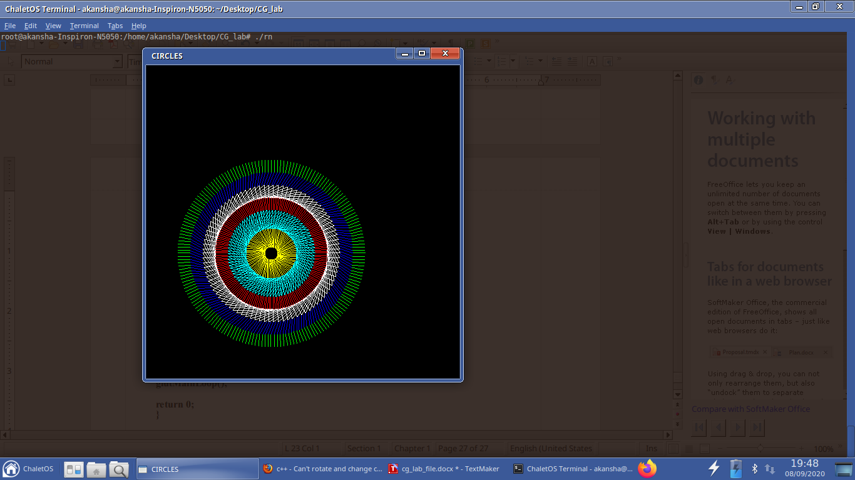

**13. BAR GRAPH**

#include<GL/glut.h>

#include<GL/gl.h>

#include<cmath>

void drawstring()

{

//glClear(GL_COLOR_BUFFER_BIT);

char v='x';

glRasterPos3f(405,20,0);

glColor3f(1,1,1);

glutBitmapCharacter(GLUT_BITMAP_9_BY_15,v);

v='y';

glRasterPos3f(20,409,0);

glColor3f(1,1,1);

glutBitmapCharacter(GLUT_BITMAP_9_BY_15,v);

v='o';

glRasterPos3f(12,12,0);

glColor3f(1,1,1);

glutBitmapCharacter(GLUT_BITMAP_9_BY_15,v);

v='>';

glRasterPos3f(395,16,0);

glColor3f(1,1,1);

glutBitmapCharacter(GLUT_BITMAP_9_BY_15,v);

v='^';

glRasterPos3f(16,395,0);

glColor3f(1,1,1);

glutBitmapCharacter(GLUT_BITMAP_9_BY_15,v);

}

void bar(void){

glClear(GL_COLOR_BUFFER_BIT);

drawstring();

glBegin(GL_LINES);

glColor3f(1,1,1);

glVertex2f(20,20);

glVertex2f(20,400);

glEnd();

glBegin(GL_LINES);

glColor3f(1,1,1);

glVertex2f(20,20);

glVertex2f(400,20);

glEnd();

glBegin(GL_POLYGON);

glColor3f(1,0,0);

glVertex2f(40,20);

glVertex2f(40,300);

glVertex2f(60,300);

glVertex2f(60,20);

glEnd();

glBegin(GL_POLYGON);

glColor3f(1,1,0);

glVertex2f(80,20);

glVertex2f(80,250);

glVertex2f(100,250);

glVertex2f(100,20);

glEnd();

glBegin(GL_POLYGON);

glColor3f(0,0,1);

glVertex2f(120,20);

glVertex2f(120,350);

glVertex2f(140,350);

glVertex2f(140,20);

glEnd();

glBegin(GL_POLYGON);

glColor3f(0,1,1);

glVertex2f(160,20);

glVertex2f(160,200);

glVertex2f(180,200);

glVertex2f(180,20);

glEnd();

glFlush();

}

int main(int argc,char** argv){

glutInit(&argc,argv);

glutInitDisplayMode(GLUT_SINGLE);

glutInitWindowSize(500,500);

glutCreateWindow("bar graph");

glMatrixMode(GL_PROJECTION);

glLoadIdentity();

gluOrtho2D(0,500,0,500);

glutDisplayFunc(bar);

glutMainLoop();

return 0;

}

