**NAME: AKANSHA SHETTY USN: 22BTRAD002 COURSE: AI/DE SECTION: A**

**DATE: 12/09/2023**

**Problem statement:** Write a Scala program to check two given integers, and return true if one of them is 30 or if their sum is 30.

**GITHUB:** <https://github.com/Akansha-S1/SCALA_PROGRAMMING>

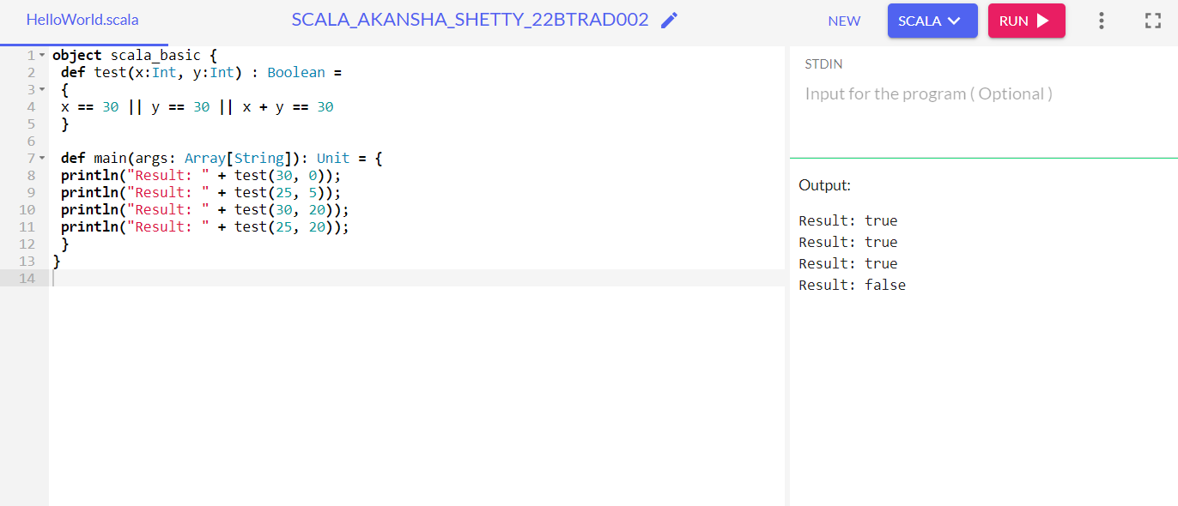

* In this Scala code, we define an object named scala_basic containing a method called test.
* The test method serves the purpose of checking specific conditions involving two integer values, x and y.
* It returns true if any of the following conditions are satisfied:
* x is equal to 30.
* y is equal to 30.
* The sum of x and y equals 30.
* Otherwise, it returns false.
* In the main method, we demonstrate the usage of the test method with various input values.
* We print the results of these tests using println.

Test Cases:

* test(30, 0) returns true because x is equal to 30.
* test(25, 5) returns true because the sum of x and y is 30 (25 + 5).
* test(30, 20) returns true because x is equal to 30.
* test(25, 20) returns false because none of the specified conditions are met in this case.