**NAME: AKANSHA SHETTY USN: 22BTRAD002 COURSE: AI/DE SECTION: A**

**DATE: 14/09/2023**

**GITHUB:** <https://github.com/Akansha-S1/SCALA_PROGRAMMING>

**Problem statement : 13 : The "MathUtils" object contains the factorial method.**

**This method calculates the factorial of a given number using recursion.**

**If the number is 0 or 1, it returns 1. Otherwise, it recursively calls itself with n - 1 and multiplies the result by n.**

**The "Main" object contains the main method where you can test the factorial method.**

**In this example, it calculates the factorial of the number 4 and 10 and prints the result.**

**Notes:**

* **This is called ‘Recursive Function’**
* **BigInt is the return type: i.e. it stores the result of the factorial calculation to ensure that it can handle large factorial values.**
* **Drawback of recursive function: If there is no base case the system might crash.**

**TEST CASE 1:** Use given data:

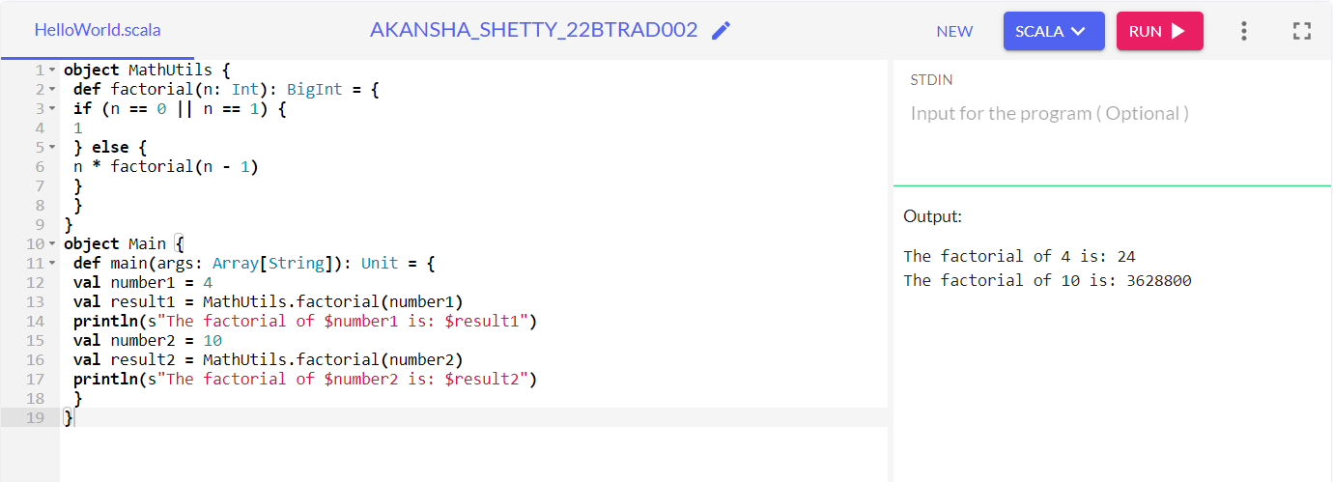

**TEST CASE 2:** Update with your own data:

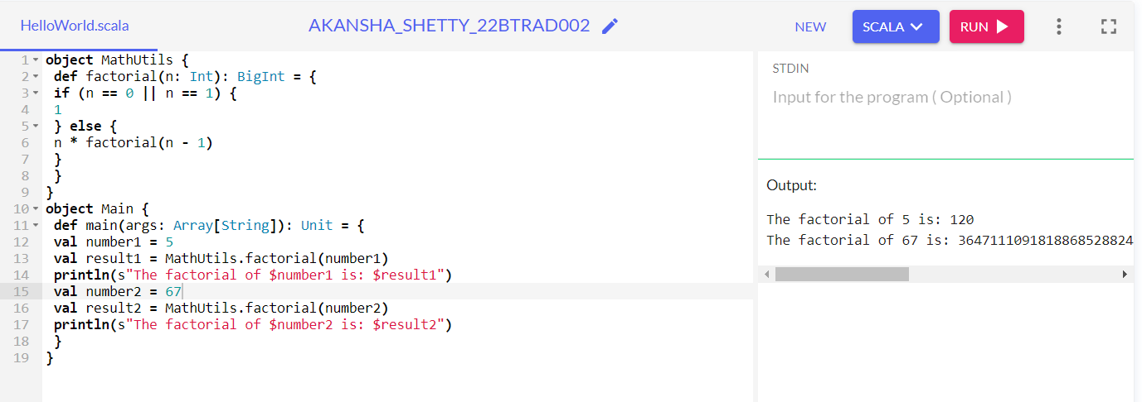

**TEST CASE 3:** Using the values as 1 and 0 : ( it returns 1)

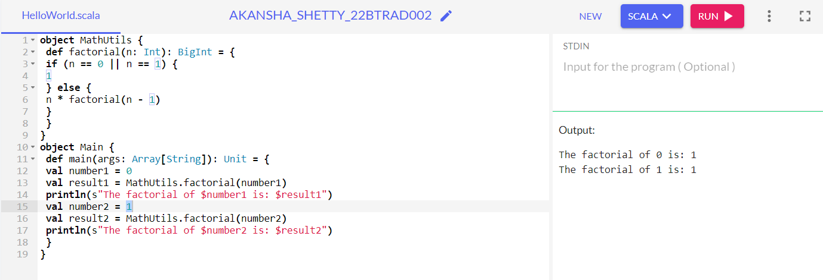

**TEST CASE 3:** Taking user inputs instead of predefined variables:

**Modification in code:** We have used ‘scala.io.StdIn.readInt()’ to read an integer input from the user.

Taking the user input as 3, we get the following output:

