**NAME: AKANSHA SHETTY USN: 22BTRAD002 COURSE: AI/DE SECTION: A**

**DATE: 12/09/2023**

**Problem statement:** Run functional commands in Scala command promt....

**The commands below:**

**println(“Hello”)**

**prints the string "Hello" to the console.**

**var name = "Season"**

**This command declares a mutable variable name of type String and assigns it the value "Season".**

**val age = 19**

**This command declares an immutable variable age of type Int and assigns it the value 19.**

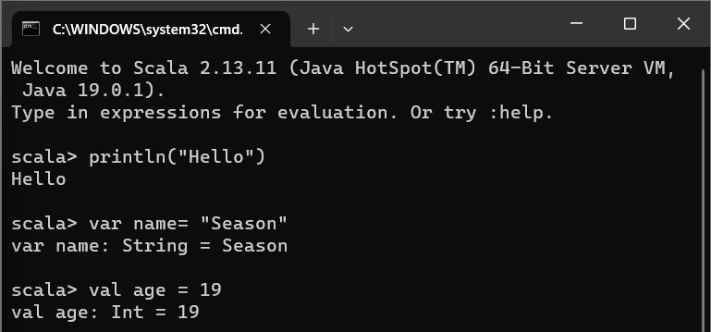

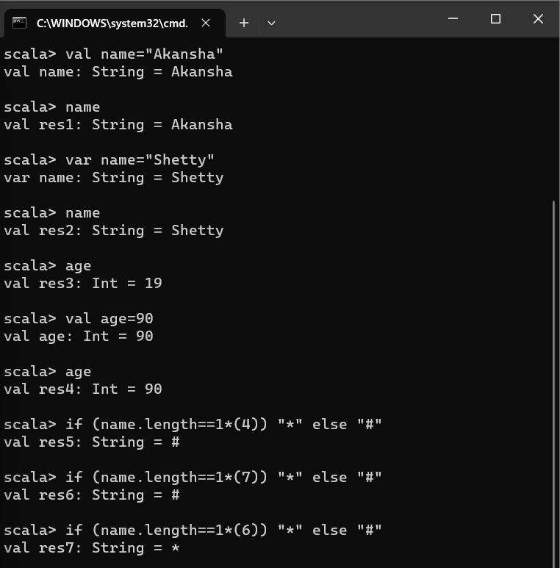

* **First we have assigned the string "Akansha" to a variable called’ ‘name’.**
* **When we reference ‘name’ , it displays "Akansha" as the output.**
* **Next, we reassign ‘name’ with the new value "Shetty," and upon referencing it again, we see that it now contains "Shetty" as the output.**
* **The age variable initially holds the value 19, and referencing it displays "19" as the output.**
* **An attempt is made to reassign it with the value 90 using val age = 90, but this doesn't change the value of age because it was declared as a val. Thus, when we reference age again, it still shows "19."**
* **Finally we involve conditional checks based on the length of the name string.**
* **For example, if (name.length == 1 * (6)) "*" else "#" checks if the length of the string in name is equal to 1 multiplied by 6, which is 6.**
* **Since the length of "Shetty" is indeed 6, this condition is true, and it returns "*" as the result.**
* **Conversely, when similar checks are performed with different values, such as 4 or 7, they return "#" as the result since the conditions are false in those cases.**

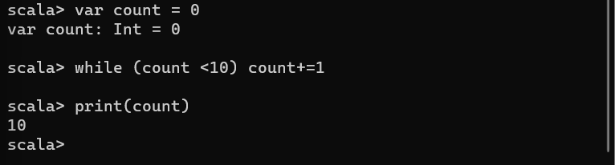

* **In this snippet a mutable integer variable count is initialized with the value 0.**
* **A while loop is then employed to increment count by 1 iteratively until it reaches 10.**
* **Subsequently, the final value of count, which is 10, is printed.**
* **This code effectively counts from 0 to 9 and outputs the final count of 10.**