**NAME: AKANSHA SHETTY USN: 22BTRAD002 COURSE: AI/DE SECTION: A**

**GITHUB:** <https://github.com/Akansha-S1/SCALA_PROGRAMMING>

**Problem statement : 19: Write a Scala program to create a map and find the difference between two maps.**

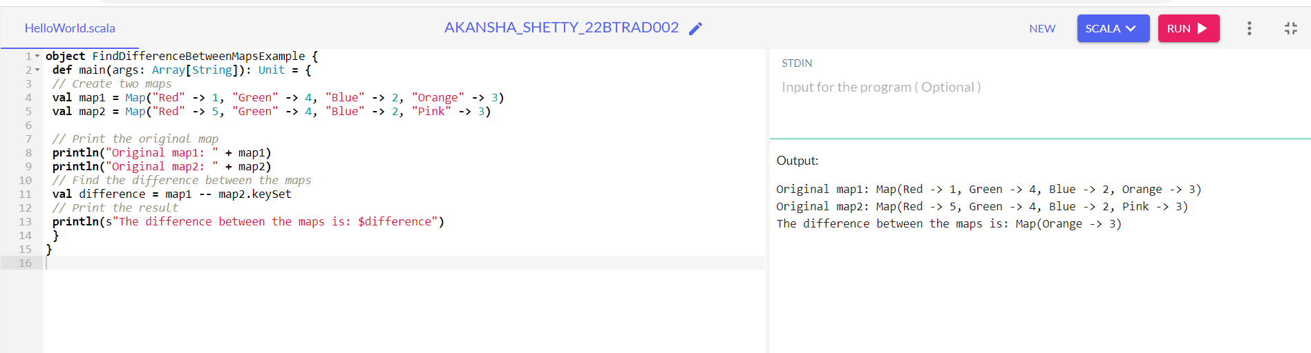

EXPLANATION:

* map1 contains key-value pairs representing colors as keys (e.g., "Red," "Green," "Blue," "Orange") and integer values.
* map2 is a different map compared to map1. It includes some shared keys with map1 ("Red," "Green," "Blue") and introduces a new key ("Pink").
* It first prints the original content of both map1 and map2 to the console using println. This step allows you to see the initial key-value pairs in each map.
* The difference between the maps, the program uses the -- operator. This operator performs a set difference operation on the keys of map1 and map2.keySet. In simpler terms, it identifies the keys that exist in map1 but are absent in map2.
* Then the result is stored in the difference variable.
* The outcome is a new map that contains the key-value pairs from map1 that do not have corresponding keys in map2.
* The colors present in map1 but not in map2, providing insight into the differences between the two maps.