**NAME: AKANSHA SHETTY USN: 22BTRAD002 COURSE: AI/DE SECTION: A**

**DATE: 24/08/2023**

**Assignment 1**

1. Write a Scala program to print "Hello, world" and version of the Scala language.

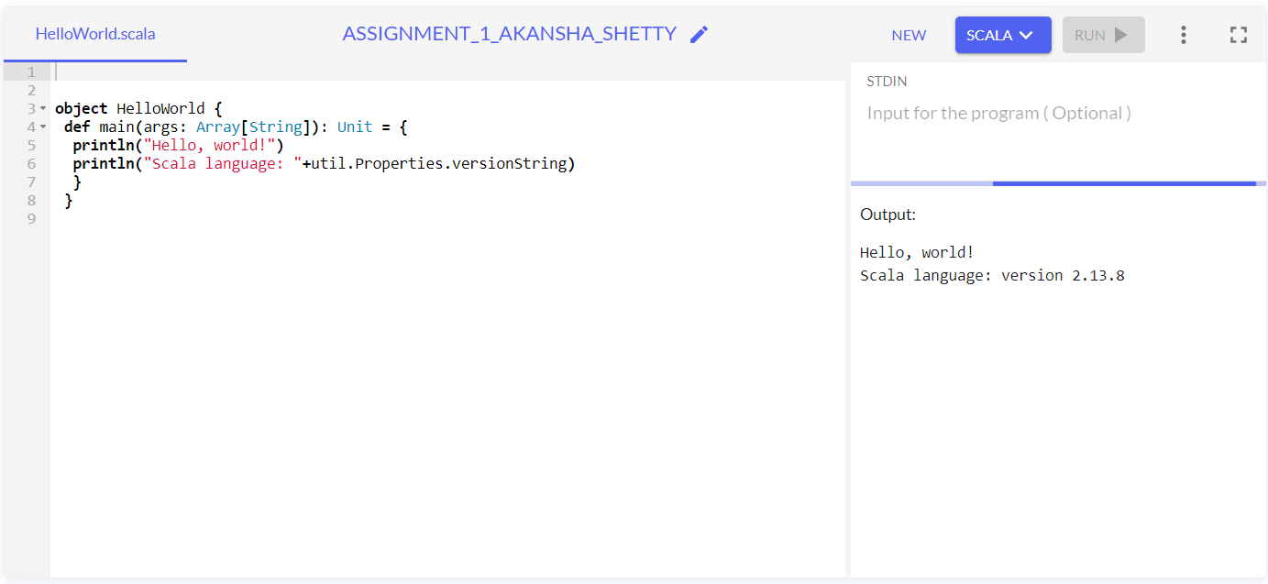

Functional approach:

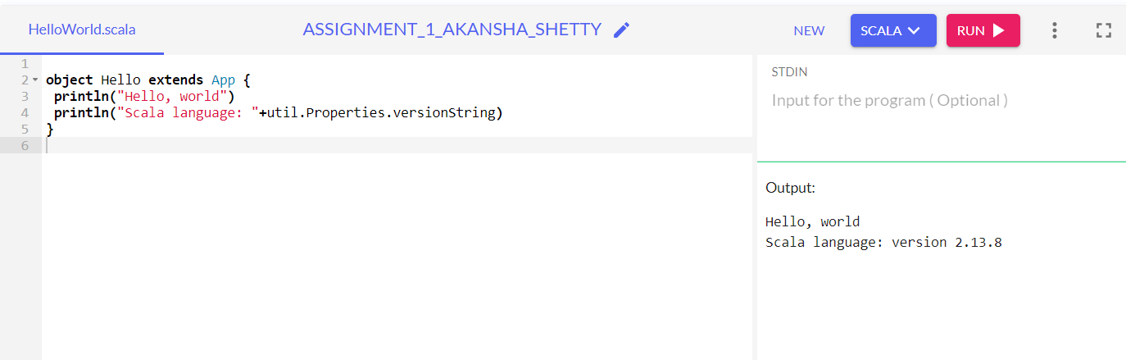

Cannot use two types of approaches at once:

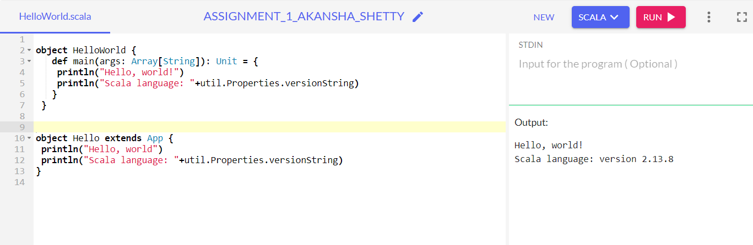

VERSION: 2.13.8: Version 2, release 13, trials 8