**NAME: AKANSHA SHETTY USN: 22BTRAD002 COURSE: AI/DE SECTION: A**

**DATE: 12/09/2023**

**GITHUB:** https://github.com/Akansha-S1/SCALA_PROGRAMMING

**Task: Write any two Scala programs from Lab manual, and upload the output to the LMS assignment .**

**The programs must be strings based..**

**Problem statement 1: Write a Scala program to create a new string where 'if' is added to the front of a given string. If the string already begins with 'if', return the string unchanged.**

**CODE:**

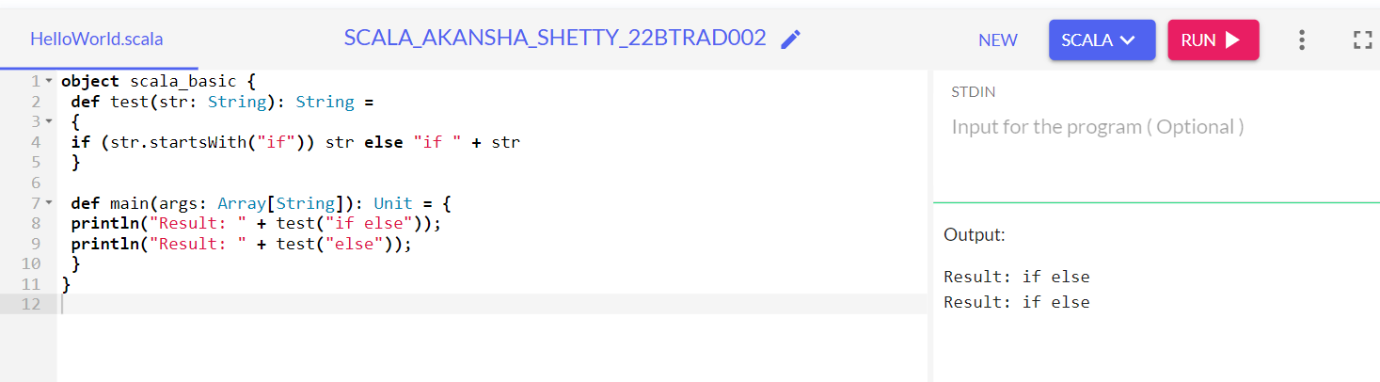

**Explanation:**

* We first define an object named scala_basic with two methods: test and main.
* The test method is designed to modify a given string, str.
* It checks if the string begins with the characters "if."
* If it does, the method returns str as is.
* However, if the string doesn't start with "if," it adds "if " to the beginning of the string and then returns the modified string.
* Next, in the main method, we run two test cases using the test method:
* println("Result: " + test("if else")) calls test with "if else" as the input.
* Since "if else" already starts with "if," the test method leaves it unchanged.
* Thus, the output for this line is "Result: if else."
* println("Result: " + test("else")) calls test with "else" as the input.
* Since "else" doesn't start with "if," the test method adds "if " to the beginning of "else" and then returns "if else" as the result.
* The output for this line is "Result: if else."

**Problem statement 2: Write a Scala program to exchange the first and last characters in a given string and return the new string.**

**CODE:**

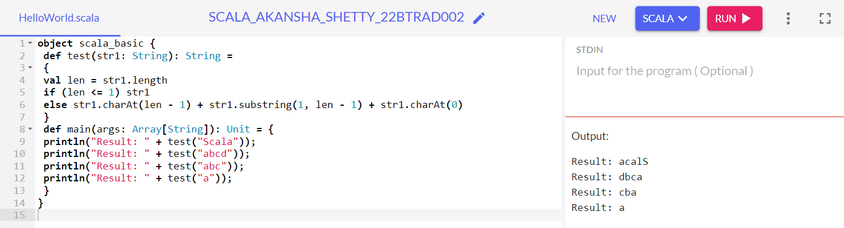

**Explanation:**

* In this code we have defined an object named scala_basic with two methods: test and main.
* Test Method:
  + test takes a string str1 as an argument.
  + If the string has a length of 1 or less, it returns the original string; otherwise, it rearranges the string by moving the last character to the front and the first character to the end.
* Main Method:
  + main serves as the entry point.
  + It demonstrates the test method by calling it with various input strings and printing the results.
* Example Outputs:
  + test("Scala") returns "aScal".
  + test("abcd") returns "dbca".
  + test("ab") returns "ba".
  + test("a") returns "a".