**REPORT**

**WIPER CONTROL SYSTEM**

**Abstract**

* In automobiles, particularly cars, autos and heavy vehicles, there are wipers.
* Wipers are used to clean the windshield of the cars
* To operate these wipers, motors are used. these motors are designed to operate in 90 degrees or 150 degrees, depending on the use.
* I have not used 180 degrees here, because no wiper in real time rotates 180 degrees.
* As STM32IDE is used, along with Qemu, we will show this operation using only 4 LEDs and a switch.
* This is so because Qemu supports only those things.
* We use single press and long press to denote ON/OFF and frequencies to denote various wiper operations.

**Introduction**

* Wipers are a common feature in all automobiles now a days (except bikes).
* Wipers are used to keep the windshield clear of anything that blocks the vision of the driver.
* It can be rain, snow, sand, etc.

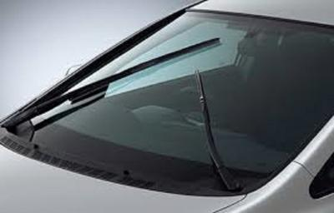

The image shown above is a wiper from a car.

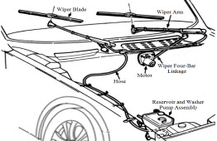

1. Flowchart

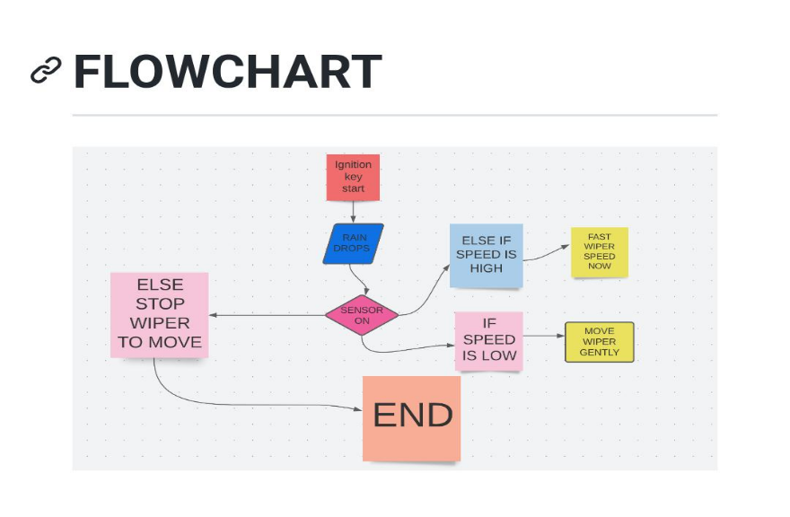

1. Block Diagram

