RemindU
Business Requirements Document
Goal-anchored focus app with forced check-ins — Android MVP build guide
Item | Detail
Document | RemindU — Business Requirements Document (BRD) and build guide
Version | 1.0 (draft for team review)
Date | 1 October 2026
Product owner | Akansha
Engineering | Developer co-founder
Platform | Android first (iOS on hold)
Stack | Expo React Native (TypeScript) + custom Kotlin native module + Supabase, Bun as package manager
Repository | github.com/Akansha2401/RemindU
Source inputs | Clickable prototype (7 screens), project README (Bun, Git and commit conventions), product decisions to date

How to read this: Items marked [Decision] are proposals made while writing this BRD, where the prototype or earlier discussions left a gap. They are collected in Section 18 (Open questions) so the team can confirm or change them before the related milestone starts.
Contents
1. Executive summary
2. Business objectives and success metrics
3. Scope
4. Users and personas
5. Assumptions and constraints
6. Functional requirements
7. Check-in task catalogue
8. Business rules
9. Screen specifications
10. Non-functional requirements
11. Technical architecture
12. Data model and sync
13. Analytics events
14. Delivery plan
15. Development workflow (from the project README)
16. Testing plan
17. Risks and mitigations
18. Open questions and decisions
19. Glossary
Tip: in Word, open View → Navigation Pane to jump between sections.

1. Executive summary
RemindU helps people who want to stop mindless scrolling without giving up their phone. The user writes a goal ("Building my startup, not scrolling"), picks which apps count as distracting, and starts a session. A countdown runs only while a distracting app is open. When the budget runs out, RemindU takes over the screen, shows the user their own goal, and gives them a small real-world task (photograph something orange, do 20 jumping jacks, type your goal out in full). The phone is handed back only after the task is done.
The idea is to interrupt autopilot, not to punish. Study apps, messaging and everything else the user did not select never count against them. Streaks, history and a shareable progress card give the habit a visible reward and double as the main marketing channel.

1.1 Why this product, for this team
- Simple to explain: "Your phone makes you do a task before you can keep scrolling." One sentence, one screenshot.
- Simple to build: seven core screens, one native module, no marketplace, no content moderation, no two-sided network effects.
- Low-effort marketing: the shareable progress card and the check-in moment are naturally filmable for short-form creator content aimed at Gen Z.
- Hard to replace with a general AI tool: the value is on-device enforcement, which a chatbot cannot provide.

1.2 What makes it different
Most screen-time tools either block apps outright (easy to switch off) or add a short pause before an app opens (easy to tap through). RemindU combines three things that are rarely put together: the user's own goal as the interruption message, counting only distracting time, and a forced real-world micro-task that breaks the scroll loop.

2. Business objectives and success metrics
Targets below are starting proposals for a two-person part-time team. Review them after the first closed test.
# | Objective | Metric | Target [Decision]
O1 | Ship a working Android MVP | App live in Play Store closed testing | ~10 weeks of part-time work
O2 | Get users through setup | Activation: installs that grant all permissions and start a first session | ≥ 50%
O3 | Build a habit | Day-7 retention | ≥ 25%
O4 | Check-ins feel doable, not hostile | Check-in completion rate (completed ÷ triggered) | ≥ 70%
O5 | Organic growth | Weekly active users who share a progress card | ≥ 10%
O6 | Early revenue | First paying Pro users | Within 30 days of Pro launch (Phase 2)

3. Scope

3.1 In scope — MVP (Phase 1, Android)
- Onboarding, Google sign-in, and a guided permission setup with clear explanations.
- Session setup: goal, session length, check-in frequency, distracting-apps picker grouped by category.
- Session engine running natively in an Android foreground service that detects the foreground app.
- Full-screen check-in (goal screen, then task screen) with six task types and validation.
- History with streak, Progress and Insights with four metrics, and a Share Progress image card.
- Settings: permission health, task types on/off, account and account deletion.
- Offline-first local storage with background sync to Supabase.

3.2 Phase 2 (after the MVP is stable)
- Per-app daily session limits (e.g. Instagram 30 min/day) that trigger a check-in outside of sessions.
- RemindU Pro subscription through Google Play Billing.
- On-device photo verification (dominant colour check for "photograph something orange").
- Home-screen widget, scheduled sessions (e.g. auto-start weekdays 9 AM), Hinglish copy.

3.3 Out of scope
- iOS app (on hold; see Risk R8 for what iOS would need).
- Parental control, monitoring another person's phone, or any remote control.
- Social feed, friends, leaderboards, chat.
- Uploading screenshots, photos or detailed app-usage logs to the cloud.

4. Users and personas
Persona | Who | Pain | What they need from RemindU
Riya, 20 | College student preparing for placements | Opens Instagram "for 2 minutes" while studying and loses an hour | Only Reels time counts; a nudge that reminds her why she is studying
Arjun, 24 | Early-career professional building a side project after work | Evenings disappear into YouTube and X | A goal-anchored evening session, a visible streak, something to share
Creator (channel) | Productivity and study-with-me creators | Needs fresh, filmable content | A dramatic check-in moment and a good-looking progress card

5. Assumptions and constraints
- Both team members work full-time jobs; the product, code and operations must stay small enough for evenings and weekends.
- Android first. The team has no Mac, so iOS builds and Apple's Screen Time APIs are not practical right now.
- Stack is fixed: Expo React Native + Supabase, TypeScript, Bun as package manager (see Section 15).
- Because RemindU needs a custom native module, it cannot run in Expo Go. Development uses an Expo development build on a physical Android phone.
- Android does not let a normal app truly lock the phone. RemindU is a commitment tool: a determined user can revoke permissions or uninstall. The product accepts this and records it honestly.
- The first market is India (Gen Z), so testing must cover aggressive battery managers on Xiaomi, Oppo, Vivo, Realme and Samsung phones. TikTok is not available in India, so suggested apps should use locally relevant names.

6. Functional requirements
Priority uses MoSCoW: Must (MVP cannot ship without it), Should (MVP target, can slip), Could (nice to have). Each requirement has an ID so that branches, commits and issues can reference it, for example feat(checkin): add hold-still task, with Refs CHK-05 in the footer.

6.1 Onboarding, sign-in and permissions (ONB)
ID | Requirement | Priority | Acceptance criteria
ONB-01 | Welcome intro of 2–3 slides explaining goal → session → check-in. | Should | Skippable; shown only on first launch.
ONB-02 | Sign in with Google via Supabase Auth. | Must | Session persists across restarts; sign-out clears local user data after sync.
ONB-03 | Sign in with email one-time code. | Should | Code expires; clear error on a wrong code.
ONB-04 | Guided permission setup: Usage Access, Display over other apps, Notifications, battery optimisation. | Must | Each permission has an in-app explanation screen before the system settings page opens. On return, status is re-checked automatically.
ONB-05 | Permission health check. | Must | If any required permission is missing, Setup shows a banner and Start Session is disabled with the reason.
ONB-06 | Phone-brand-specific "keep RemindU running" guide (autostart, background restrictions). | Should | Detects the manufacturer and shows the matching steps; links to dontkillmyapp.com.

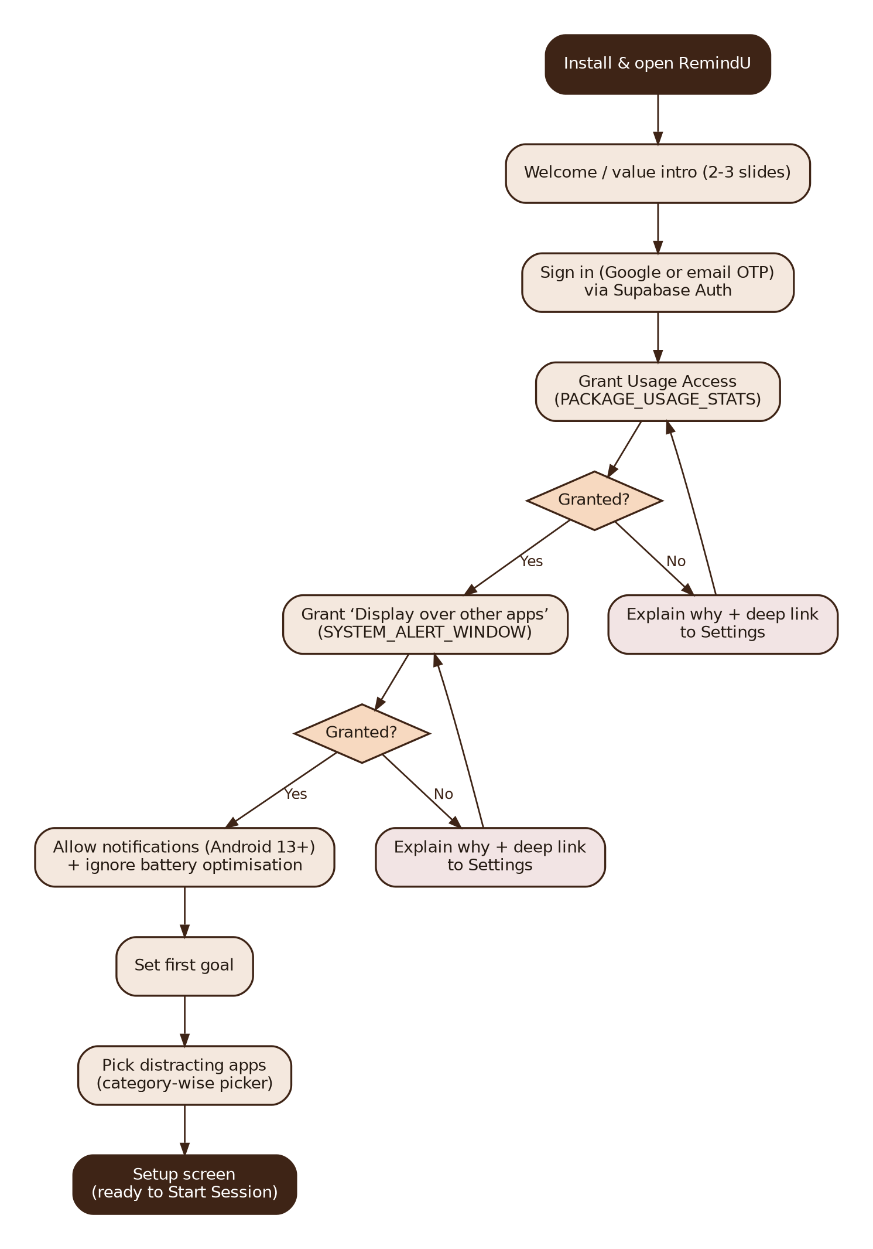
Figure 1. Onboarding and permission flow

6.2 Session setup screen (SET)
ID | Requirement | Priority | Acceptance criteria
SET-01 | Goal text field. | Must | 3–80 characters. Placeholder "Building my startup, not scrolling". Saved as the active goal.
SET-02 | Session length: chips 1 hr / 2 hr / 3 hr, plus Custom (0–12 h, minutes in steps of 5). | Must | Exactly one option selected. Minimum 5 minutes. Custom fields disabled until Custom is chosen.
SET-03 | Check-in frequency: Once / Every X hrs / Continuous. | Must | "Every X hrs" shows a − / + stepper, range 1–12 h. Behaviour per BR-03.
SET-04 | Distracting apps summary row with Edit. | Must | Shows comma-separated app names or "None selected", with helper text that everything else doesn't count against you.
SET-05 | Start Session button. | Must | Disabled unless the goal is valid, ≥ 1 app is selected, length > 0 and permissions are OK.
SET-06 | Header shortcuts to History (clock icon) and Progress (chart icon). | Must | Both icons navigate correctly.
SET-07 | Remember last configuration. | Should | Re-opening Setup pre-fills the previous goal, length, frequency and apps.
SET-08 | Settings entry point (gear icon). | Must | Not in prototype; add to the header.

6.3 Distracting apps picker (APP)
ID | Requirement | Priority | Acceptance criteria
APP-01 | List installed, launchable apps with icon and name. | Must | System apps without a launcher icon are hidden. List loads in < 1.5 s.
APP-02 | Group apps by category (Social, Video, Games, Entertainment, Other) using Android's app category. | Must | Apps with no category fall into Other; known apps can be mapped by package name as a fallback.
APP-03 | Suggested apps pre-toggled on first run. | Should | Instagram, YouTube, Snapchat, Facebook, X, Reddit, ShareChat, Moj, Josh — only if installed.
APP-04 | Per-app toggle and "select whole category". | Must | Toggle styling as in the prototype (orange track when on).
APP-05 | Search box. | Could | Filters by app name while typing.
APP-06 | Per-app daily limit (minutes). | Should (Phase 2) | When a limited app exceeds its daily limit, a check-in fires on the next open, even with no session running.

6.4 Session engine (ENG) — runs natively
ID | Requirement | Priority | Acceptance criteria
ENG-01 | Run the active session inside an Android foreground service. | Must | A persistent notification shows remaining budget and status. The session keeps running when the app is swiped away.
ENG-02 | Detect the foreground app using UsageStatsManager events. | Must | Detection latency ≤ 2 s after switching apps.
ENG-03 | Count down only while a distracting app is in the foreground and the screen is on. | Must | Timer pauses when the user is in any other app or the screen is off.
ENG-04 | Trigger a check-in when the budget reaches 0. | Must | Check-in appears within 2 s.
ENG-05 | Apply frequency behaviour after a completed check-in. | Must | Per BR-03.
ENG-06 | Restore the session after process death or reboot. | Must | Remaining budget accurate to ±5 s after the service restarts.
ENG-07 | Send live events to the React Native layer. | Must | Running screen updates the ring, time and "Detected foreground app" label every second.
ENG-08 | End session manually. | Must | Confirmation dialog; saved with end reason user_ended.
ENG-09 | Edit goal, time or frequency mid-session. | Should | Goal and frequency editable anytime. Budget can be lowered anytime but raised only straight after a completed check-in (BR-08).
ENG-10 | Battery-friendly polling. | Must | Polling stops while the screen is off and resumes on unlock.

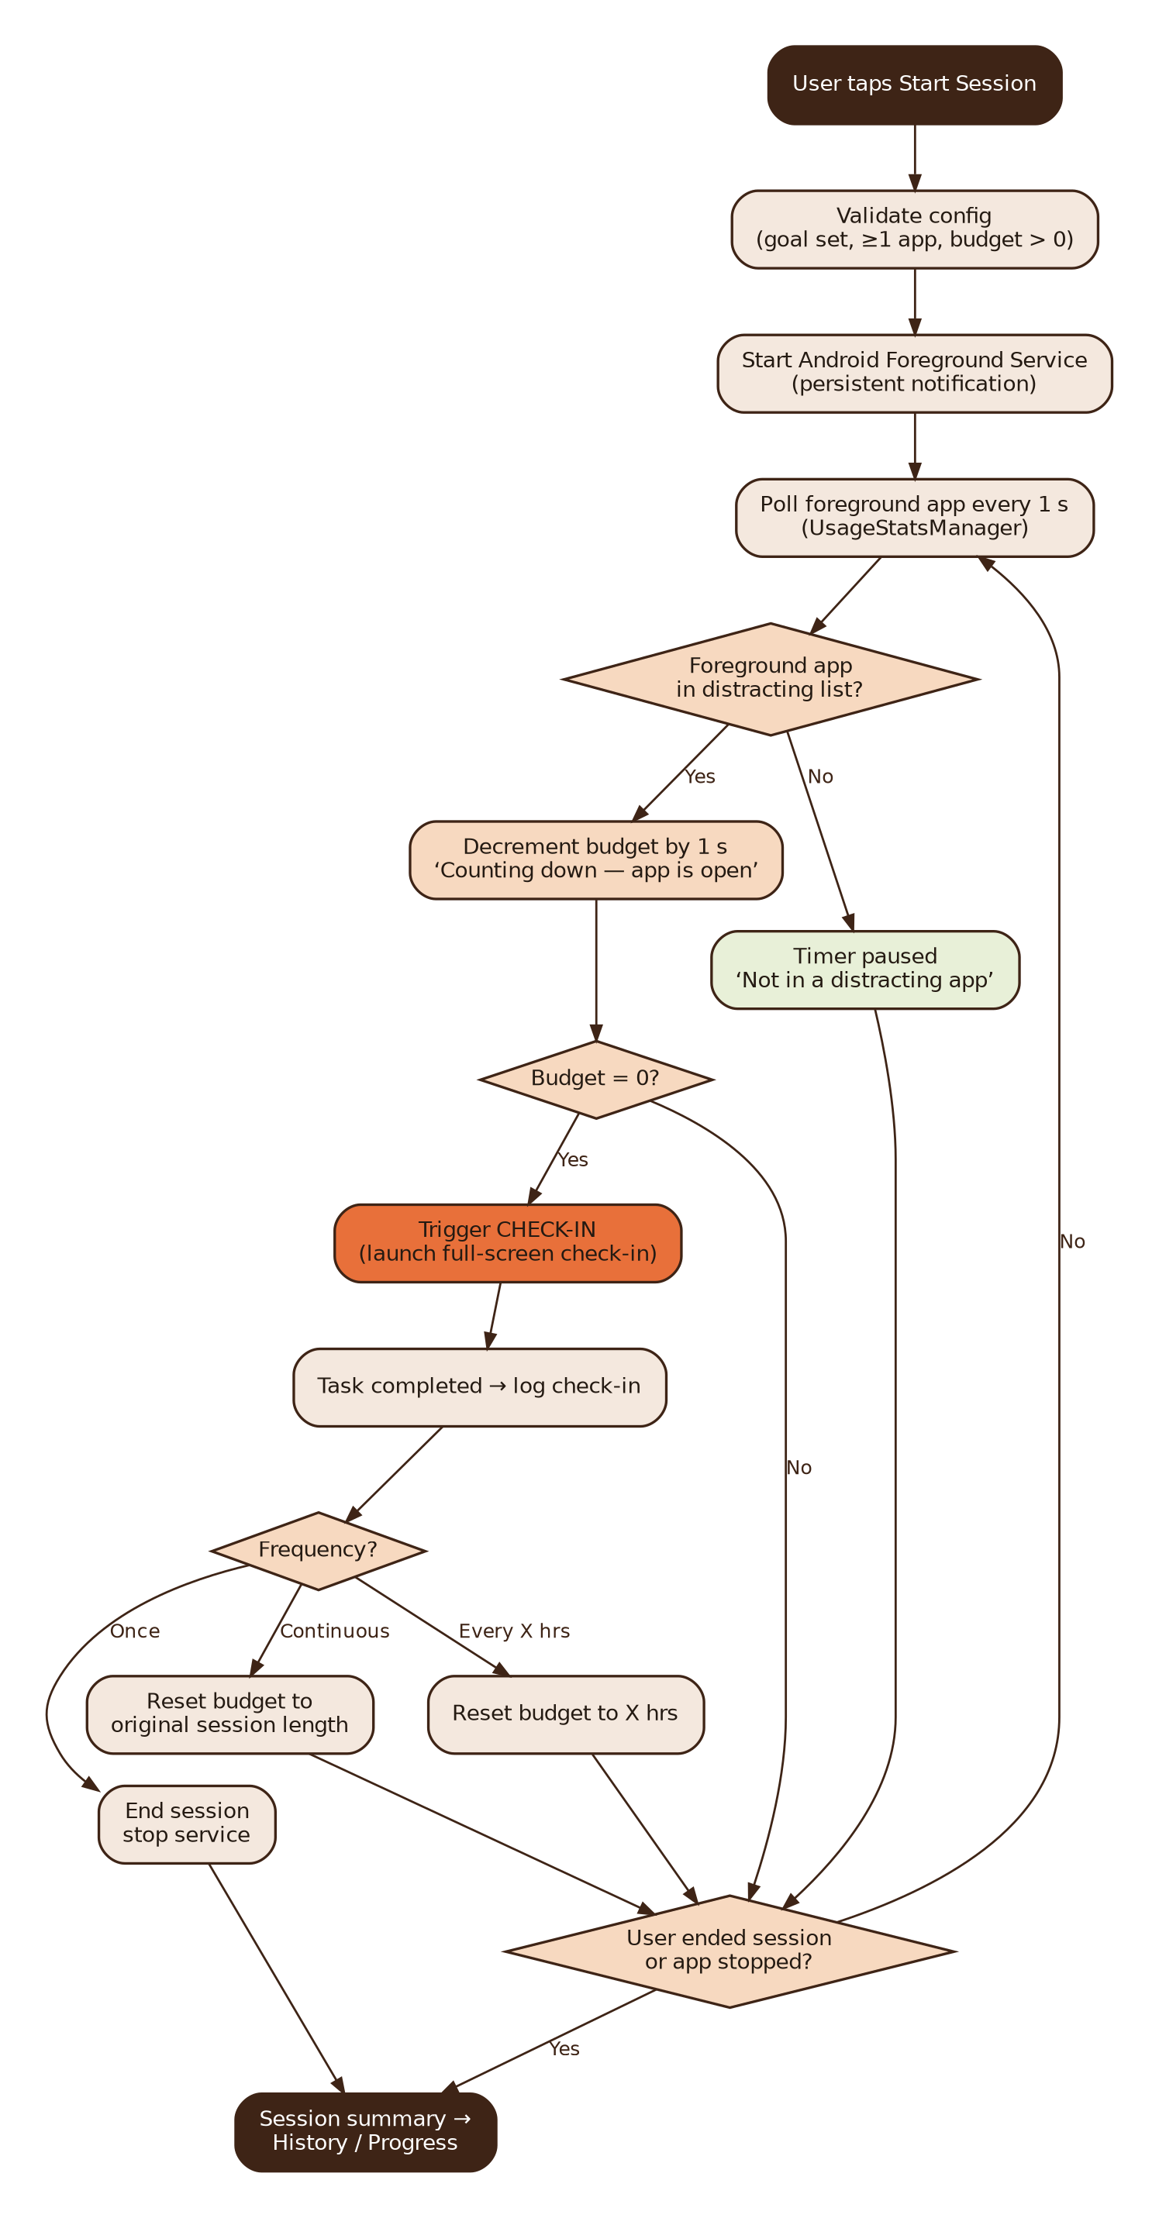
Figure 2. Session lifecycle (runs inside the foreground service)

6.5 Check-in (CHK)
ID | Requirement | Priority | Acceptance criteria
CHK-01 | Step 1: dark full-screen takeover showing the goal in quotes and "This is what you said you wanted." | Must | "Show my task" moves to step 2.
CHK-02 | Step 2: one task with "No skip. No snooze. Complete it to get your phone back." | Must | Primary button "Submit & unlock".
CHK-03 | Re-lock if the user escapes to a distracting app. | Must | Check-in re-appears within 1 s. Non-distracting apps (calls, maps, study apps) are allowed.
CHK-04 | Back button and gestures do not dismiss the check-in. | Must | Hardware back is consumed on both check-in screens.
CHK-05 | Validate the task before unlocking. | Must | Rules per Section 7. Failure shows an inline message; the user stays on the task.
CHK-06 | Emergency exit. | Must | Small "Emergency exit" link; press-and-hold 5 s, then confirm. Logs the check-in as Not completed and ends the session.
CHK-07 | Never block essentials. | Must | Dialer, incoming calls and emergency calls are never blocked; an incoming call pauses the check-in.
CHK-08 | Task selection. | Should | Random, no repeat of the last two tasks, skips task types disabled in Settings.
CHK-09 | Haptic buzz on trigger. | Could | Respects silent / do-not-disturb mode.

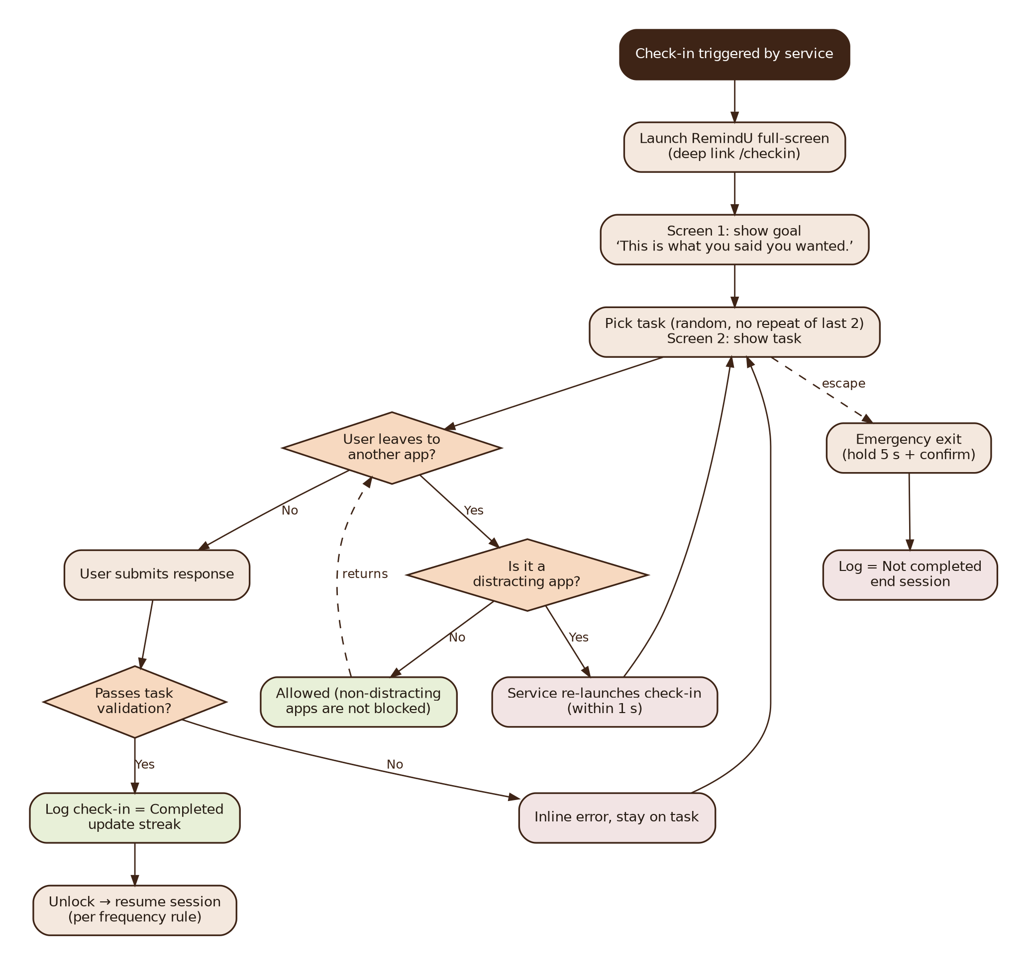
Figure 3. Check-in enforcement flow

6.6 History (HIS)
ID | Requirement | Priority | Acceptance criteria
HIS-01 | Streak card ("6-day streak — Keep showing up for your goal."). | Must | Streak computed per BR-06.
HIS-02 | Check-in list, newest first: task icon, task text, time, status pill. | Must | Green "Completed" / red "Not completed" pills as in the prototype.
HIS-03 | Group by day with lazy loading. | Should | Smooth scrolling with 500+ entries.
HIS-04 | "Insights" link to Progress. | Must | Navigates to Progress.

6.7 Progress and insights (PRG)
ID | Requirement | Priority | Acceptance criteria
PRG-01 | Four percentage bars: Focus kept, Check-ins done, Task streak, Distraction avoided. | Must | Formulas in BR-07; values for the current week.
PRG-02 | "This week" card: check-ins, focus time, tasks done (x/y), streak. | Must | Numbers match History.
PRG-03 | Share Progress. | Must | Generates a branded 1080×1920 image (story format) with streak and bars, then opens the Android share sheet. No personal data beyond what is shown.
PRG-04 | Week selector. | Could | Previous weeks can be browsed.

6.8 Settings and account (STG)
ID | Requirement | Priority | Acceptance criteria
STG-01 | Permission status list with "Fix" buttons. | Must | Mirrors ONB-05.
STG-02 | Enable / disable task types (e.g. turn off camera tasks). | Should | At least two task types must stay enabled.
STG-03 | Account: sign out, delete account. | Must | Delete removes server and local data (Google Play requires in-app account deletion).
STG-04 | Privacy policy and support links. | Must | Required for the Play listing.

6.9 Monetisation (PAY) — Phase 2
[Decision] Freemium. Free: one goal, up to 3 distracting apps, all basic tasks, weekly insights. Pro: unlimited apps, per-app daily limits, scheduled sessions, full insight history, card themes. Implement with Google Play Billing (a wrapper such as RevenueCat reduces the work). Price to be tested; see Q6.

7. Check-in task catalogue
The six tasks come directly from the prototype. MVP validation is intentionally simple: enough friction to break autopilot without needing machine learning.
Task ID | Text shown to user | MVP validation | Later improvement
photo_color | Photograph something {orange | blue | green | red | yellow} | Live camera capture required (gallery disabled). Any photo passes. | On-device dominant-colour check
photo_workspace | Photograph your current workspace or task | Live camera capture required. | —
exercise | Do 15 pushups / Do 20 jumping jacks (self-reported) | 30-second minimum timer, then an "I did it" button. | Motion-sensor rep counting
type_goal | Type out your goal, in full — no copy-paste | Paste disabled. Trimmed, case-insensitive text must match the goal (≥ 90% similarity to allow small typos). | —
gratitude | Name 3 things you're grateful for (typed) | Three fields, each ≥ 3 characters, all different. | —
hold_still | Hold your phone still for 15 seconds | Accelerometer movement below threshold for 15 continuous seconds; the progress ring resets on movement. | —

Privacy: Photos stay on the device, are never uploaded in the MVP, and are deleted automatically after 7 days (BR-09).

8. Business rules
ID | Rule
BR-01 | Only foreground time in apps the user marked as distracting counts toward the budget. All other apps, and screen-off time, never count.
BR-02 | [Decision] Session length = distraction budget. It is the amount of distracting-app time allowed before the first check-in. The ring shows "until next check-in".
BR-03 | [Decision] After a completed check-in: Once → session ends. Every X hrs → budget resets to X hours of distracting time. Continuous → budget resets to the original session length, repeating until the user ends the session.
BR-04 | A check-in is Completed only when the task passes validation.
BR-05 | A check-in is Not completed if the user uses Emergency exit or ends the session while a check-in is open.
BR-06 | [Decision] Streak: a calendar day (user's local time) counts if it has at least one completed check-in and no emergency exit. A day without a qualifying check-in resets the streak to 0.
BR-07 | Weekly metrics: Focus kept = 1 − distracting time ÷ total session time. Check-ins done = completed ÷ triggered. Task streak = min(streak, 7) ÷ 7. Distraction avoided [Decision] = distracting-app visits during sessions that ended within 60 s ÷ all such visits.
BR-08 | Mid-session, the budget can be increased only immediately after a completed check-in, so users cannot dodge a check-in by adding time.
BR-09 | Task photos are stored only on the device and deleted after 7 days.
BR-10 | Day boundaries use the device's local time zone at midnight.

9. Screen specifications
Screens and copy follow the clickable prototype (https://claude.ai/artifact/FtwhRBEcKyhfPJ46zvVpXW). The last column lists the gaps the build must fill.
Screen | Key elements | Actions | Change from prototype
Setup (New session) | Title, subtitle "Set once. Edit anytime, even mid-session.", goal field, length chips + custom, frequency chips + stepper, apps summary | Edit apps, History, Progress, Start Session | Add Settings icon and permission banner; enforce validation
Distracting apps | Back and home buttons, helper text, app rows with icon and toggle | Toggle, Done | Real app icons, category sections, search
Session running | "Session running" label, progress ring with time, status pill, goal card, detected-app row | Edit goal/time/frequency, End session | Remove the demo "Skip ahead" button; add End session
Check-in · Goal | Dark takeover, goal in quotes, supporting line | Show my task | Add Emergency exit link
Check-in · Task | Task icon, task text, "No skip. No snooze…", input area | Submit & unlock | Task-specific input (camera, timer, three fields, hold ring)
History | Streak card, check-in list with status pills | Insights, back, home | Group by day; real data
Progress & insights | Four bars, This week card | Share Progress, back, home | Wire the share card; real data
Onboarding / Permissions (new) | Intro slides, sign-in, one screen per permission | Continue, Open settings | Not in prototype
Settings (new) | Permission status, task toggles, account, links | Fix, toggle, sign out, delete | Not in prototype

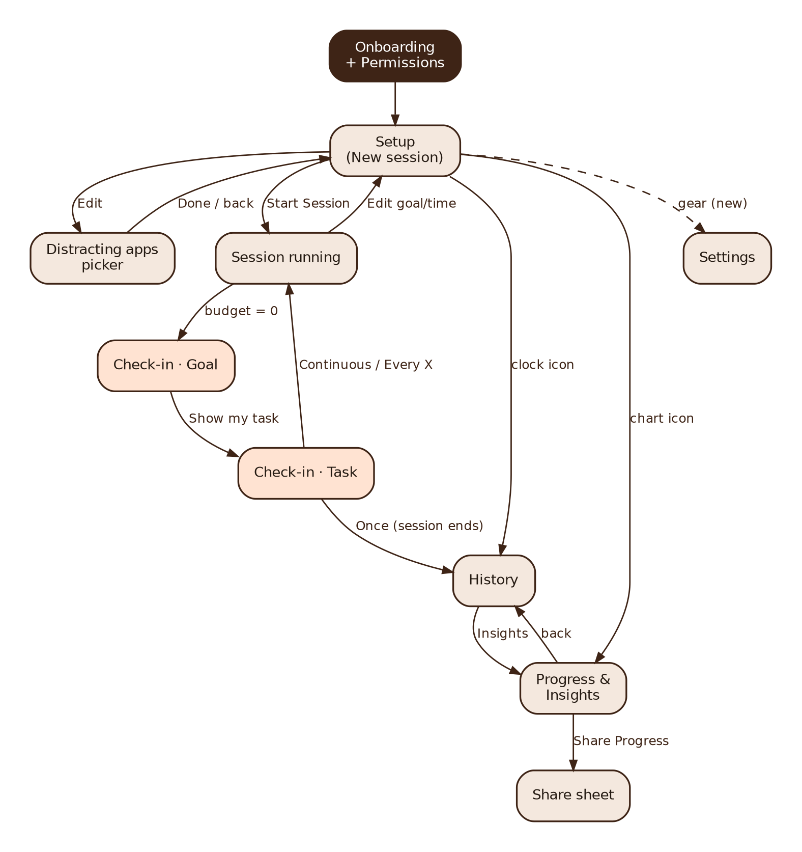
Figure 4. Screen navigation map

9.1 Design tokens (from the prototype)
Token | Value | Use
Primary / accent | #E8703A (orange) | Primary buttons, active toggles, links, ring progress
Brand dark | #3E2416 (brown) | Selected chips, streak card
Background | #F4E8DE (cream) | Main app background
Takeover background | #2A1B10 | Check-in screens
Text / muted | #241A12 / #8C7C70 | Body text / secondary text
Success / error pills | #E8F0D8 with #5B7A2E / #F2E4E4 with #A0453E | Completed / Not completed
Font | Plus Jakarta Sans (400–800) | All text; load with expo-font
Shapes | Pill buttons (fully rounded), cards 16–20 px radius | Consistent across screens

10. Non-functional requirements
Area | Requirement
Performance | Cold start < 2 s on a mid-range phone. Foreground-app detection ≤ 2 s. Check-in appears ≤ 2 s after the budget ends.
Battery | Target < 3% battery per hour of active session on a mid-range phone; no polling while the screen is off.
Reliability | Session survives app swipe-away, low-memory kills and reboots on the test device list (Section 16).
Offline | Everything works offline; sync resumes automatically when connectivity returns.
Privacy | No photos or raw app-by-app timelines leave the device. The server stores only settings, sessions, check-in outcomes and daily totals.
Security | Supabase Row Level Security on every table; only the anon key ships in the app; never a service-role key in the client.
Accessibility | Supports system font scaling, TalkBack labels on all buttons, text contrast of at least 4.5:1.
Compatibility | Minimum Android 8.0 (API 26, needed for app categories). Target SDK = whatever level Google Play currently requires.
Localisation | English for the MVP; all strings in one file so Hindi or Hinglish can be added later.

11. Technical architecture
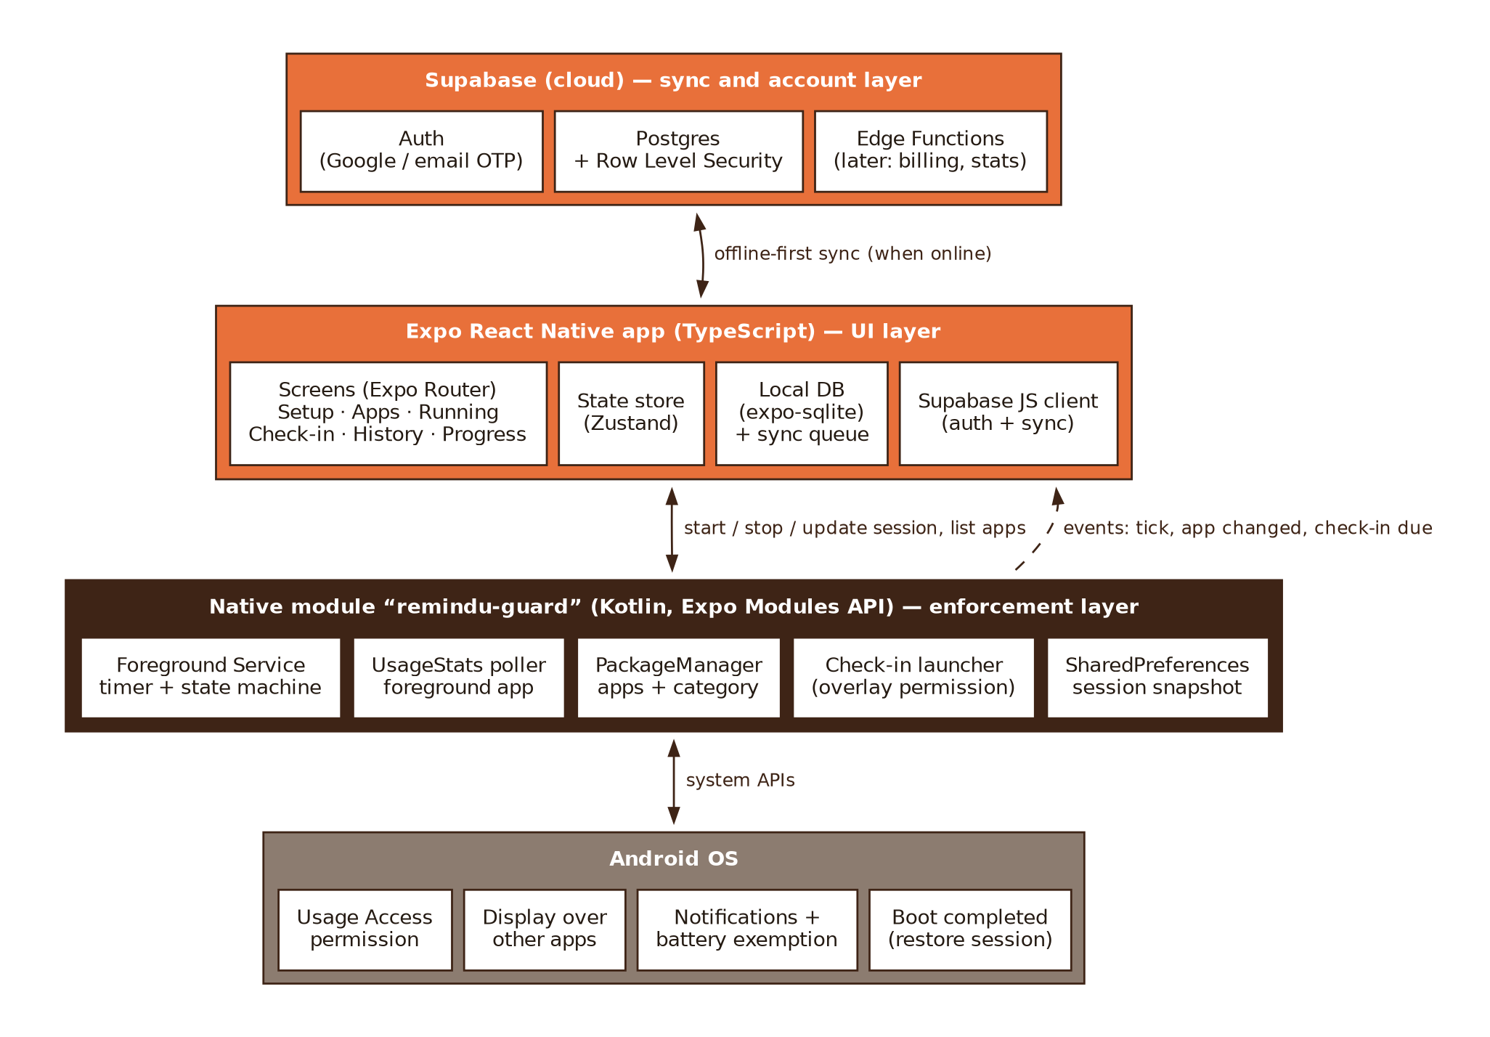
Figure 5. System architecture

11.1 Why a native module is needed
JavaScript timers stop when a React Native app goes to the background, and Expo has no built-in API for reading which app is in the foreground. So the enforcement logic (timer, foreground detection, check-in launch) must live in Kotlin inside a foreground service. React Native owns the UI, local data and sync; the native module owns the clock.
Build it with the Expo Modules API as a local module (for example modules/remindu-guard), plus an Expo config plugin that adds the permissions, the service and the boot receiver to AndroidManifest.xml during prebuild. Run it with a development build (bun expo run:android, or EAS Build).

11.2 Tech stack
Layer | Choice | Notes
Framework | Expo (latest stable SDK), React Native, TypeScript | Development build, not Expo Go
Navigation | Expo Router | File-based routes; /checkin route opened by deep link
State | Zustand | Small, hook-based
Local storage | expo-sqlite | Sessions, check-ins, sync queue
Backend | Supabase (Auth, Postgres, RLS) | Edge Functions later for billing webhooks
Camera / sensors | expo-camera, expo-sensors | Photo and hold-still tasks
Share card | react-native-view-shot + expo-sharing | Render a view to PNG and share
Notifications | Native foreground-service notification; expo-notifications for reminders | —
Package manager | Bun | Never mix with npm or yarn lockfiles
Testing | Jest + React Native Testing Library; manual device matrix | Section 16

11.3 Android permissions and Play Store policy
Permission / declaration | Why RemindU needs it | Policy note
PACKAGE_USAGE_STATS (Usage Access) | Know which app is in the foreground | Special access granted by the user in Settings; show a clear disclosure first
SYSTEM_ALERT_WINDOW (Display over other apps) | Bring the check-in to the front from the background | Also exempts the app from Android's background activity-start limits
FOREGROUND_SERVICE + FOREGROUND_SERVICE_SPECIAL_USE | Keep the timer running reliably (Android 14+ needs a service type) | Justify "special use" in the Play Console declaration
POST_NOTIFICATIONS | Persistent session notification | Runtime prompt on Android 13+
RECEIVE_BOOT_COMPLETED | Restore an active session after reboot | Standard
CAMERA | Photo tasks | Runtime prompt only when a photo task first appears
<queries> for the launcher intent | List installed apps for the picker | Avoids the restricted QUERY_ALL_PACKAGES permission
Battery optimisation settings (intent only) | Help the user exempt RemindU | Open the settings screen rather than requesting REQUEST_IGNORE_BATTERY_OPTIMIZATIONS

Important: Do not use an AccessibilityService for app detection in the MVP. It gives faster detection but draws heavy Google Play review scrutiny. Usage Access is enough for a 1-second poll.

11.4 Native module contract
Agree this interface first so UI and native work can run in parallel. The UI can use a mock implementation until the Kotlin side is ready.
// modules/remindu-guard/index.ts
type Frequency = "once" | "every" | "continuous";
type SessionConfig = { sessionId: string; goal: string; budgetSec: number;
frequency: Frequency; everyHours?: number; packages: string[] };

startSession(config: SessionConfig): Promise<void>
updateSession(patch: Partial<SessionConfig>): Promise<void>
endSession(reason: "user_ended" | "emergency_exit"): Promise<void>
resolveCheckin(r: { checkinId: string; completed: boolean }): Promise<void>
getState(): Promise<SessionState | null>
getInstalledApps(): Promise<{ packageName; label; category; iconBase64 }[]>
getPermissionStatus(): Promise<{ usage; overlay; notifications; battery }>
openPermissionSettings(kind): void

// events
onTick({ remainingSec, foregroundPackage })
onCheckinDue({ checkinId })
onSessionEnded({ sessionId, reason, distractingSec })

11.5 Suggested folder structure
app/ # Expo Router screens
(onboarding)/ setup.tsx apps.tsx running.tsx
checkin/[id].tsx history.tsx progress.tsx settings.tsx
components/ # Ring, Chip, Toggle, StatusPill, TaskViews/*
features/ # session/, checkin/, stats/, sync/
lib/ # supabase.ts, db.ts, analytics.ts
modules/remindu-guard/ # Kotlin native module + TS bindings
plugins/ # Expo config plugin for manifest changes
supabase/migrations/ # SQL for tables and RLS

12. Data model and sync
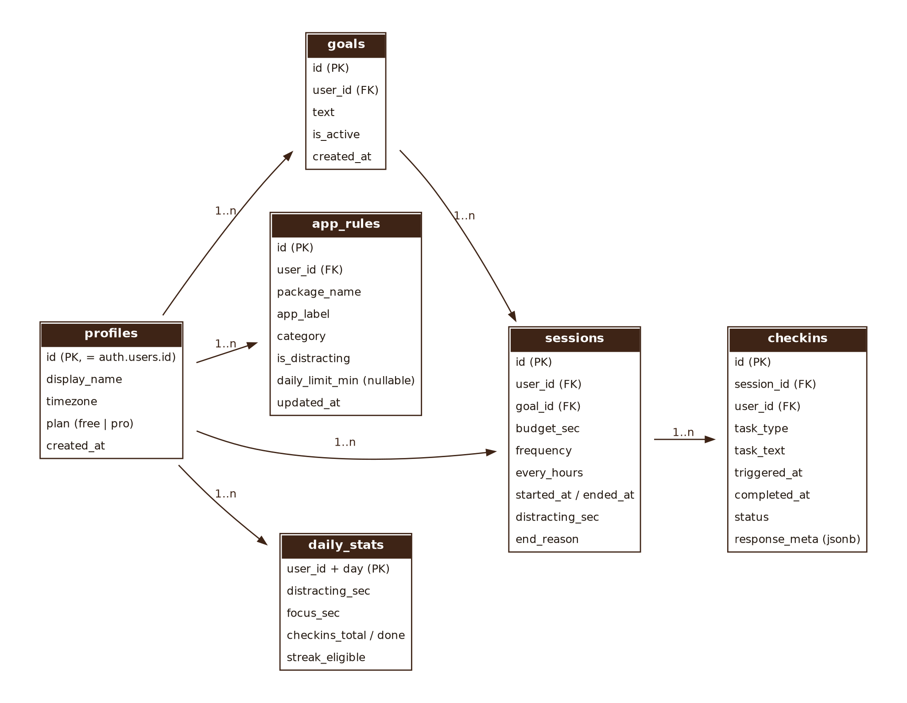
Figure 6. Supabase data model
Table | Purpose | Key notes
profiles | One row per user | Created by a trigger on sign-up; holds plan (free / pro) and time zone
goals | Goal history | Only one active goal per user
app_rules | Distracting apps and (Phase 2) daily limits | Unique (user_id, package_name)
sessions | One row per session | end_reason: completed | user_ended | emergency_exit | interrupted
checkins | One row per check-in | status: completed | not_completed; response_meta holds non-sensitive data only (e.g. hold duration), never photos
daily_stats | Pre-computed daily totals | Feeds the Progress screen and streak

12.1 Row Level Security
alter table sessions enable row level security;
create policy "own sessions" on sessions
for all using (auth.uid() = user_id) with check (auth.uid() = user_id);
-- repeat for goals, app_rules, checkins, daily_stats

12.2 Offline-first sync
- Every write goes to SQLite first with a client-generated UUID and is added to a sync queue.
- When the device is online and signed in, the queue is pushed with upserts keyed by UUID, so retries are safe.
- On a new install or sign-in, the latest 30 days are pulled down.
- Conflicts: last write wins by updated_at. Sessions and check-ins are append-only, so conflicts are rare.

13. Analytics events
Keep analytics minimal and privacy-friendly. [Decision] Use PostHog (free tier) or a simple Supabase events table.
Event | Properties | Answers
onboarding_step | step, permission, granted | Where people drop off in setup (O2)
session_started | budget_sec, frequency, apps_count | Which configurations are popular
checkin_triggered | task_type | Check-in volume
checkin_completed | task_type, seconds_to_complete | Completion rate by task (O4)
emergency_exit | task_type | Which tasks feel too hard
session_ended | reason, distracting_sec | Session outcomes
progress_shared | streak | Organic growth (O5)

14. Delivery plan
Milestones assume roughly 8–10 hours a week each. The riskiest part (native detection and check-in launch on real phones) comes first, before any polished UI.
Milestone | Scope | Requirement IDs | Estimate
M0 — Foundation | Repo, Expo + Bun, TypeScript, lint, dev build on a physical phone, Supabase project, design tokens and base components | — | Week 1
M1 — Native spike | Kotlin module: foreground service, UsageStats detection, launch check-in over Instagram, restore after kill. Test on 3 phone brands | ENG-01–04, 06 | Weeks 1–3
M2 — Setup & apps | Setup screen, apps picker with categories, validation, local persistence | SET-*, APP-01–05 | Weeks 3–4
M3 — Session integration | Wire JS ↔ native, Running screen, frequency rules, mid-session edits, end session | ENG-05, 07–10 | Weeks 4–6
M4 — Check-in & tasks | Both check-in screens, six tasks with validation, re-lock, emergency exit | CHK-* | Weeks 6–7
M5 — Data & insights | Auth, onboarding and permissions, History, Progress, share card, SQLite + sync, Settings | ONB-*, HIS-*, PRG-*, STG-* | Weeks 7–9
M6 — Release | Polish, privacy policy, Play listing, permission declarations, closed testing | NFRs | Weeks 9–10
Phase 2 | Per-app daily limits, Pro + billing, photo colour check, widget, scheduled sessions | APP-06, PAY | After MVP

Plan ahead: New personal Google Play developer accounts must run a closed test with a minimum number of testers for a set period before production access (the rule has been 12 testers for 14 days). Check the current rule in Play Console and start recruiting testers during M5.

14.1 Suggested ownership
Area | Owner
BRD, open decisions, copy, UX review, Play listing, privacy policy, tester recruitment, creator outreach | Akansha
Native module, session engine, JS bridge, build pipeline | Developer
React Native screens, Supabase schema and sync | Shared (split by feature branch)

14.2 Definition of done (every feature)
- Acceptance criteria for the requirement IDs are met on a physical Android phone.
- development was merged into the feature branch and the app re-tested before merging back, as the README requires.
- Unit tests exist for pure logic: timer maths, task validators, streak and metric calculations.
- No new warnings; strings are in the strings file; commit messages follow Conventional Commits.

15. Development workflow (from the project README)

15.1 Tooling
Task | Command
Install dependencies | bun install
Start the Expo dev server | bun expo start (r to reload, j for the debugger)
Build and run the dev client on Android | bun expo run:android (needed because of the native module)
Add a package / dev dependency | bun add <pkg> / bun add -d <pkg>
Remove a package | bun remove <pkg>
Expo plugin for Claude Code | claude plugin install expo@claude-plugins-official

Reminder: Bun is the package manager, but Expo CLI and Metro still run on Node.js, so keep a current Node.js LTS installed. Never commit a package-lock.json or yarn.lock.

15.2 Branching
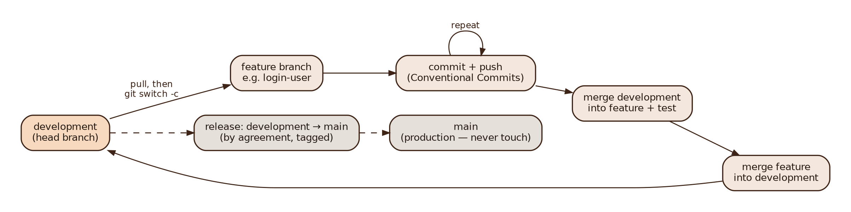
Figure 7. Branching model
main is production and is never touched directly. development is the head branch; every feature branch is created from the latest development and merged back only after development has been merged into it and the app re-tested. Suggested branches for this BRD: onboarding-permissions, native-guard-spike, session-setup, apps-picker, session-engine, checkin-tasks, history-progress, share-card, supabase-sync, settings-account.

15.3 Commit messages
Format <type>(<scope>): <subject> — imperative mood, lowercase, no trailing period, ≤ 50 characters. Types: feat, fix, refactor, perf, style (formatting only, never UI changes), docs, test, chore, build, ci, revert. Put requirement IDs or issue numbers in the footer.
feat(guard): add foreground app detection
feat(checkin): add hold-still task with sensor check
fix(engine): restore budget after service restart
build(plugin): add overlay and usage permissions

16. Testing plan

16.1 Device matrix
Test on real phones, not only emulators, because battery managers differ by brand: Samsung (One UI), Xiaomi / Redmi / POCO (HyperOS), Realme or Oppo (ColorOS), Vivo, plus one Pixel or emulator as a stock Android baseline.

16.2 Critical scenarios
# | Scenario | Expected result
T1 | Swipe RemindU away from recents mid-session | Notification stays; timer keeps counting in distracting apps
T2 | Reboot during a session | Session restored; budget correct to ±5 s
T3 | Revoke Usage Access mid-session | Session pauses; notification asks the user to fix it; logged as interrupted
T4 | Incoming call during a check-in | Call works; check-in returns after the call
T5 | User opens a distracting app during a check-in | Check-in re-appears within 1 s
T6 | User opens a non-distracting app during a check-in | Allowed; check-in waits
T7 | Battery saver on | Detection still ≤ 2 s, or a clear warning is shown
T8 | YouTube picture-in-picture or split screen | Document behaviour (PiP may not count as foreground) and decide
T9 | Offline for a day, then online | All sessions and check-ins sync without duplicates
T10 | Time-zone change or midnight during a session | Streak and daily stats attribute time to the right day

17. Risks and mitigations
# | Risk | Impact | Mitigation
R1 | Phone-brand battery managers kill the service | High | Foreground service, brand-specific guide (ONB-06), restore on restart, periodic WorkManager watchdog
R2 | Google Play rejects sensitive permissions | High | Prominent disclosures, no AccessibilityService, clear "special use" justification with a demo video
R3 | Users bypass by revoking permissions or uninstalling | Medium | Accept it — RemindU is a commitment tool; show interruptions honestly in History
R4 | Check-ins feel annoying and users churn | High | Task toggles, sensible default budget, track emergency exits by task and tune
R5 | Timer rules confuse users | Medium | Confirm BR-02/03 before M3; short explainer in onboarding
R6 | Scope creep with limited part-time hours | High | MoSCoW discipline; park ideas in the Phase 2 list; finish M1 before any polish
R7 | Learning curve of Kotlin + Expo Modules | Medium | Time-boxed spike (M1); keep the native surface small (Section 11.4)
R8 | iOS later | Medium | iOS needs Apple's Screen Time (FamilyControls) APIs, a special entitlement from Apple, and a Mac or cloud Mac for builds. Keep business logic in TypeScript so only the native layer is rewritten

18. Open questions and decisions
Proposed defaults are already written into this BRD. Confirm or change them before the milestone listed.
# | Question | Proposed default | Needed by
Q1 | Does "session length" mean distraction budget or wall-clock time? Add 15 / 30 min options? | Distraction budget; add 15 and 30 min chips | M2
Q2 | Exact behaviour of "Every X hrs" | Budget resets to X hrs of distracting time (BR-03) | M3
Q3 | Streak rule | As in BR-06 | M5
Q4 | Mandatory sign-in or guest mode? | Google sign-in required (simpler sync); revisit if activation is low | M5
Q5 | Limit emergency exits per day? | No limit in MVP; track and review | M4
Q6 | Pro price and free-tier limits | Test two price points in closed testing | Phase 2
Q7 | Definition of "Distraction avoided" | As in BR-07 (visits ending within 60 s) | M5
Q8 | Is the name "RemindU" free to use on the Play Store? | Run a store and trademark search now | M0

19. Glossary
Term | Meaning
Session | A period the user starts from Setup, with a goal, budget, frequency and set of distracting apps
Budget | Distracting-app time left before the next check-in
Check-in | The full-screen takeover showing the goal and a task
Distracting app | An app the user toggled on in the picker; only these count
Foreground service | An Android background process with a visible notification that the system keeps alive
Development build | A custom Expo app build that includes native code; replaces Expo Go for this project
RLS | Row Level Security — Postgres rules that let each user read and write only their own rows

